Assignment4PartA

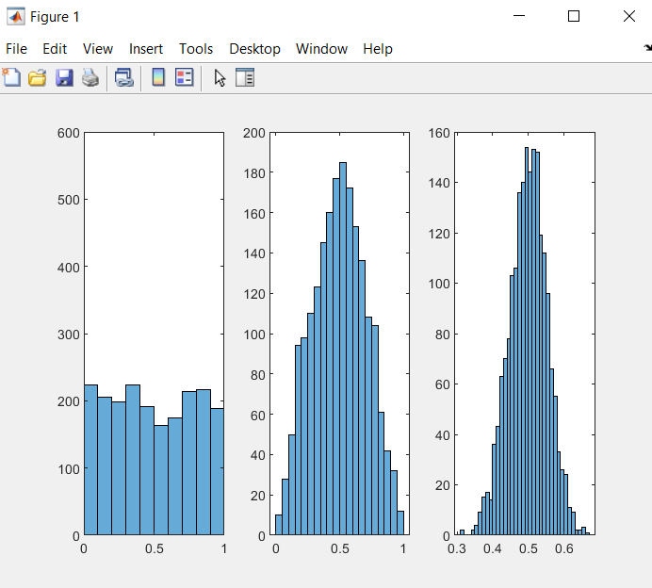**clear**

**x = rand(1,2000)**

**subplot(1,3,1)**

**histogram(x)**

**axis([0 1 0 600]);**

**y = rand(1,2000);**

**% combine x and y**

**%x + y;**

**z = [x;y];**

**agg1 = mean(z);**

**subplot(1,3,2)**

**histogram(agg1);**

**agg2 = mean(rand(30,2000));**

**subplot(1,3,3)**

**histogram(agg2);**

Assignment4PartB

**clear**

**x1 = rand(1,1000)*.4;**

**x2 = .6+rand(1,1000)*.4;**

**subplot(1,3,1);**

**x=[x1 x2];**

**x=x(randperm(2000));**

**histogram(x)**

**y1=rand(1,1000)*.4;**

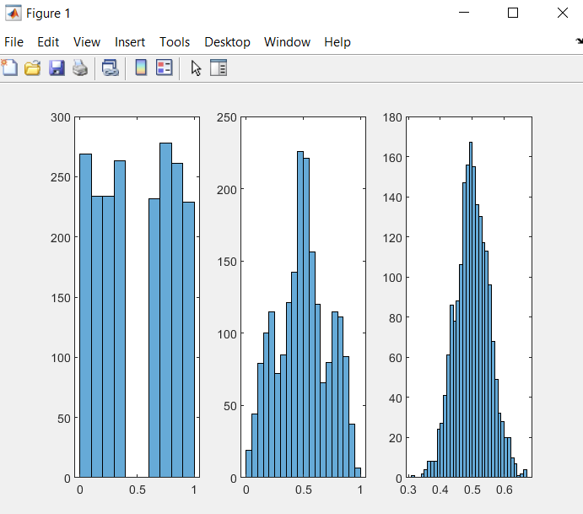**y2=.6+rand(1,1000)*.4;**

**y=[y1 y2];**

**%randperm your y**

**y = y(randperm(2000));**

**z = [x;y];**

**agg1 = mean(z);**

**subplot(1,3,2)**

**histogram(agg1);**

**agg2 = mean(rand(30,2000));**

**subplot(1,3,3)**

**histogram(agg2);**

Assignment4PartC

**clear**

**x1 = rand(1,1000)*.4;**

**x2 = .6+rand(1,1000)*.4;**

**subplot(1,3,1);**

**x=[x1 x2];**

**x=x(randperm(2000));**

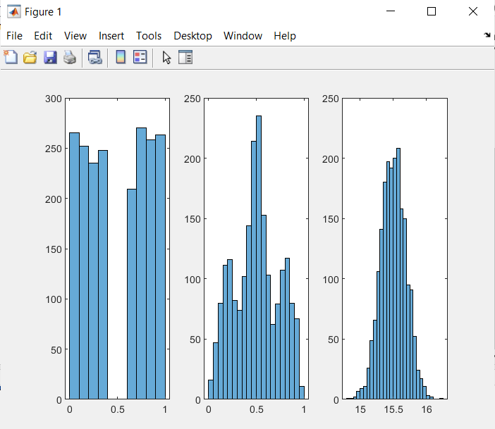**histogram(x)**

**y1=rand(1,1000)*.4;**

**y2=.6+rand(1,1000)*.4;**

**y=[y1 y2];**

**%randperm your y**

**y = y(randperm(2000));**

**z = [x;y];**

**agg1 = mean(z);**

**subplot(1,3,2)**

**histogram(agg1);**

**agg2 = mean(randi(30,2000));**

**subplot(1,3,3)**

**histogram(agg2);**