Alexandra Rezk
In Java, to design a program you must first break up your program in classes. A class is the name relevant to the program you want to design. A class then contains all the information that is required to make it a program; such as: methods, parameters, fields, and constructors. Classes also hold objects. An object in Java is an area or instance that is virtually stored in the classes’ database. After the object is created, it can be manipulated based of the code that is created for it.
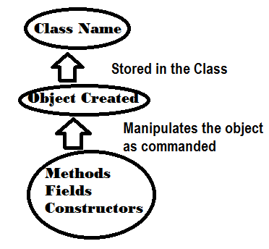

There are three relationships between objects and classes. They can have: the has-a relationship, the is-a relationship and the uses-a relationship. The has-a relationship is defined by the fact that the base class has subclasses that link together that allows the base class to use it’s contents. The is-a relationship is defined by extending classes using inheritance and polymorphism. It allows classes and objects to use material from the base class because they are similar to one another. The uses-a relationship is defined by interfaces. It allows one class with many methods that are null or empty to be used by different classes as needed. It is also similar to a has-a relationship.

Example of a has-a and an uses-a relationship:
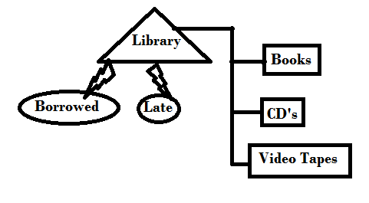
A Library has books, CD’s, and videotapes. So the Library class uses the information from the Books, CD’s and Videotapes classes because it is needed to run the program. And from there the Library program is used by the borrowed and late classes.
Example of an is-a relationship:
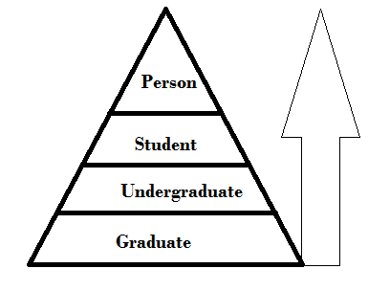
This pyramid shows the is-a relationship, by showing that it is all the same thing just with different names. The Person is the Student (who is in school), who is the Undergraduate (in college), who is the Graduate. They are all the same object, just with different titles and advancing to the next class.

