**Simulation Results for N = 2, 4 , 8 and 16**

Note – The “Collisions Per Packets” Pie chart shows the distribution of the number of collisions experienced by different packets. The green section indicates the percentage of packets experiencing 0 collisions, the orange section indicates the percentage of packets experiencing 1-8 collisions and the red section indicates the percentage of packets experiencing more than 8 collisions.

**N = 2 nodes**

**Overall Summary :**

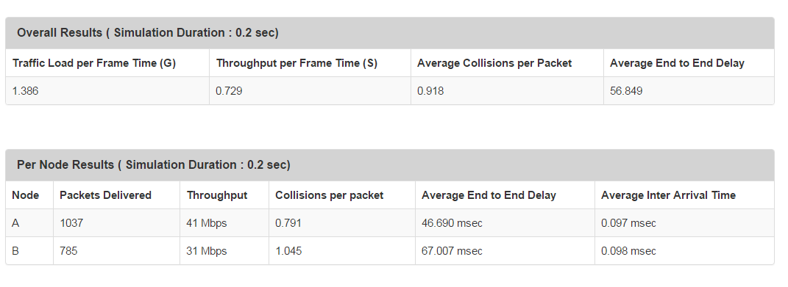

**Collisions Per Packet ( Node A ):**

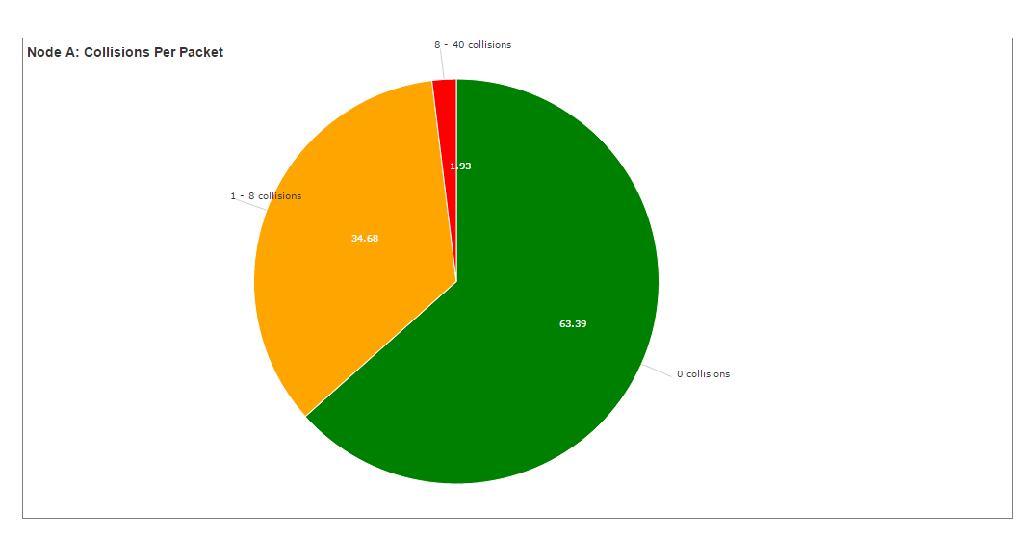

**N = 3 Nodes**

**Overall Results :**

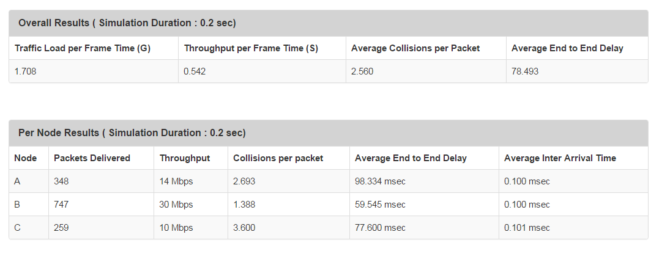

**Collisions Per Packet : ( for Node A )**

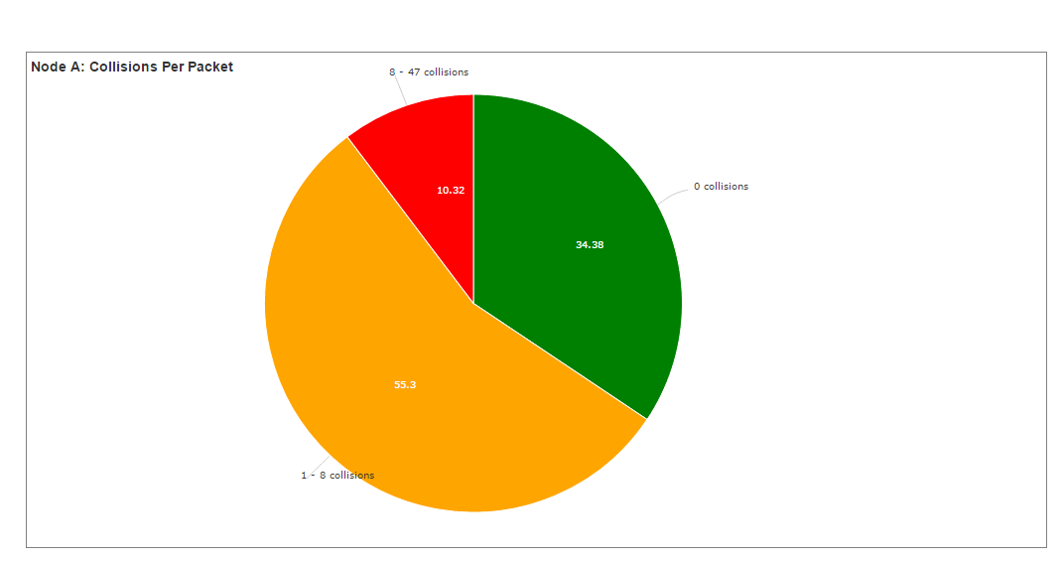

**End to End Delay Histogram : ( for Node A )**

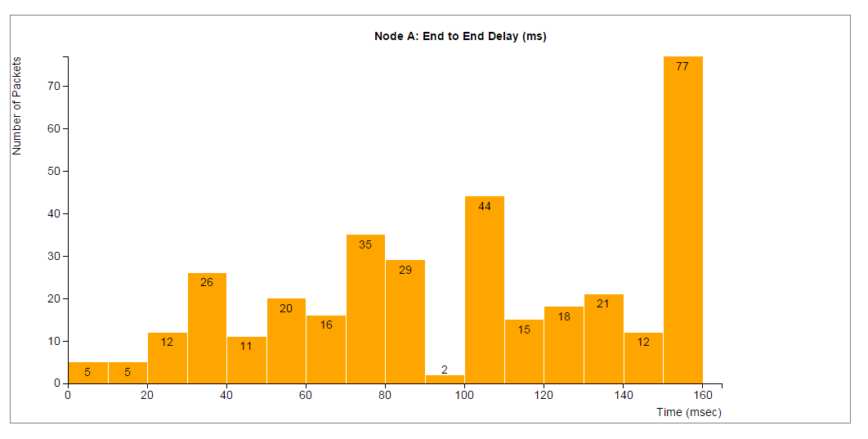

**Queue Delay ( for Node A ):**

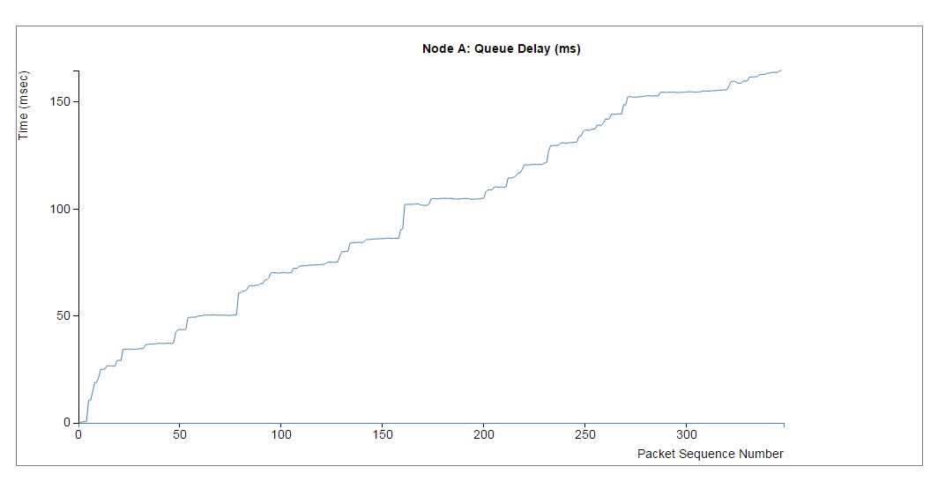

**N = 4 nodes**

**Overall Results :**

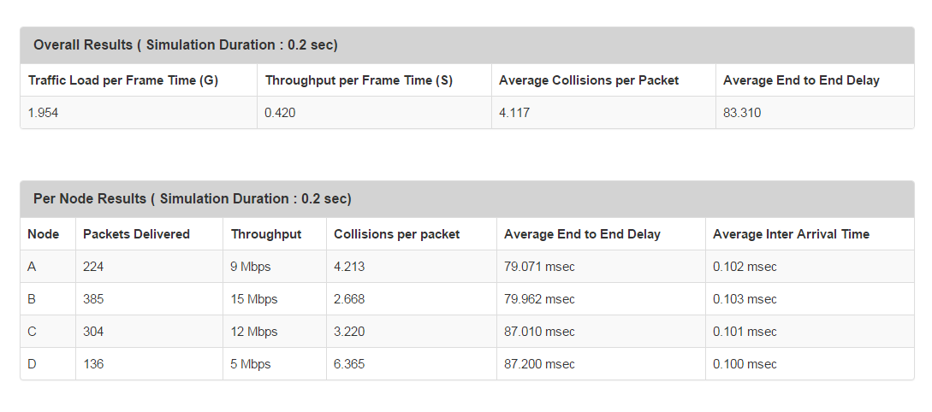

**Collisions Per Packet ( Node A ) :**

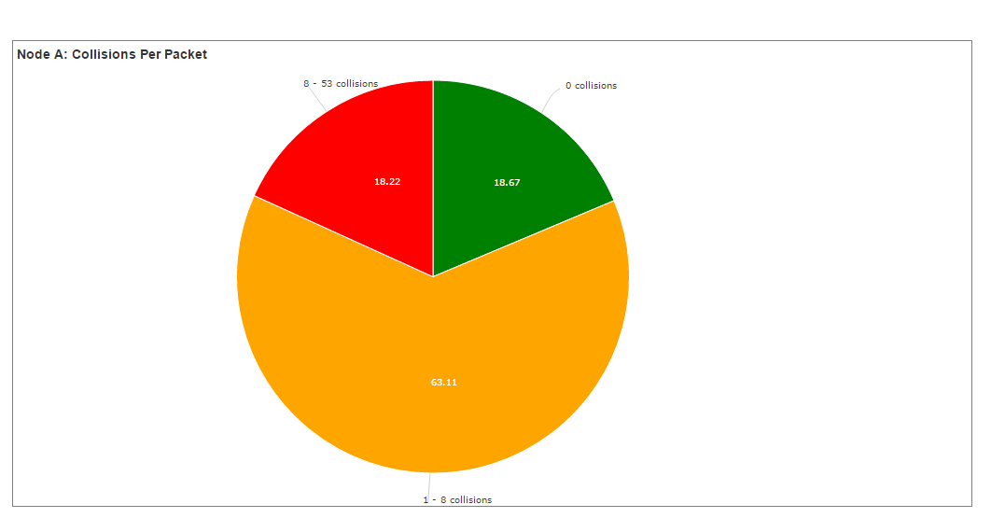

**End to End Delay Histogram ( Node A ):**

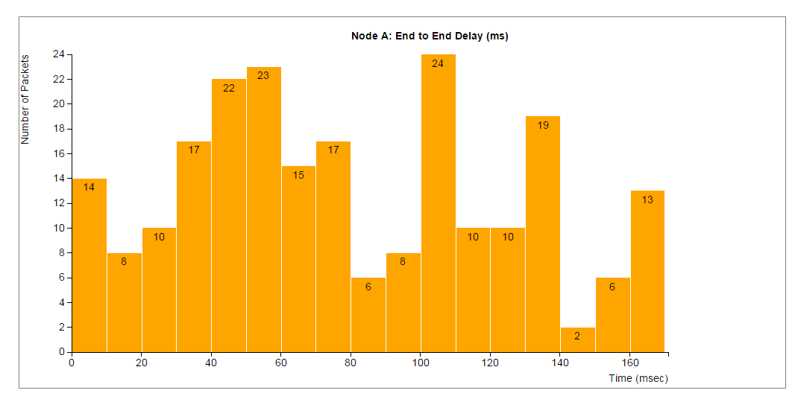

**Queue Delay ( Node A ):**

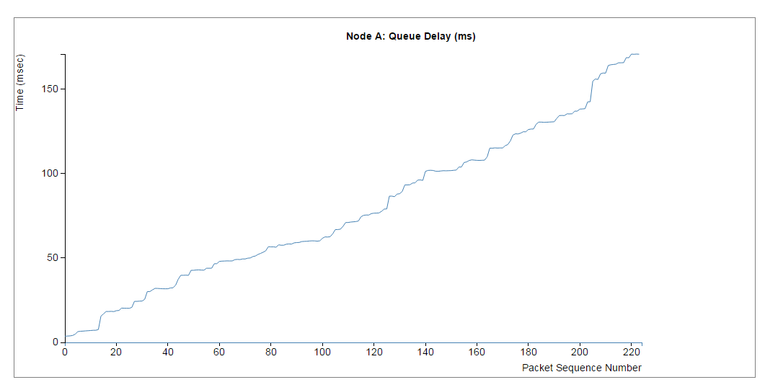

**N = 8 nodes**

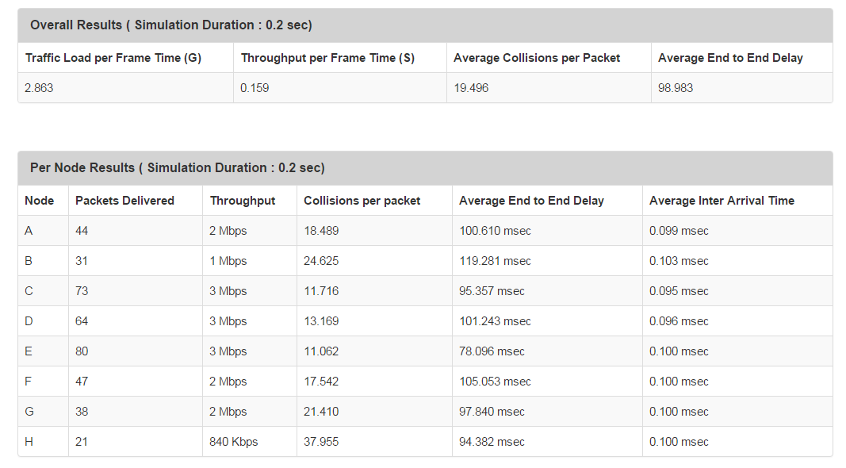

**Collisions Per Packet ( Node A ):**

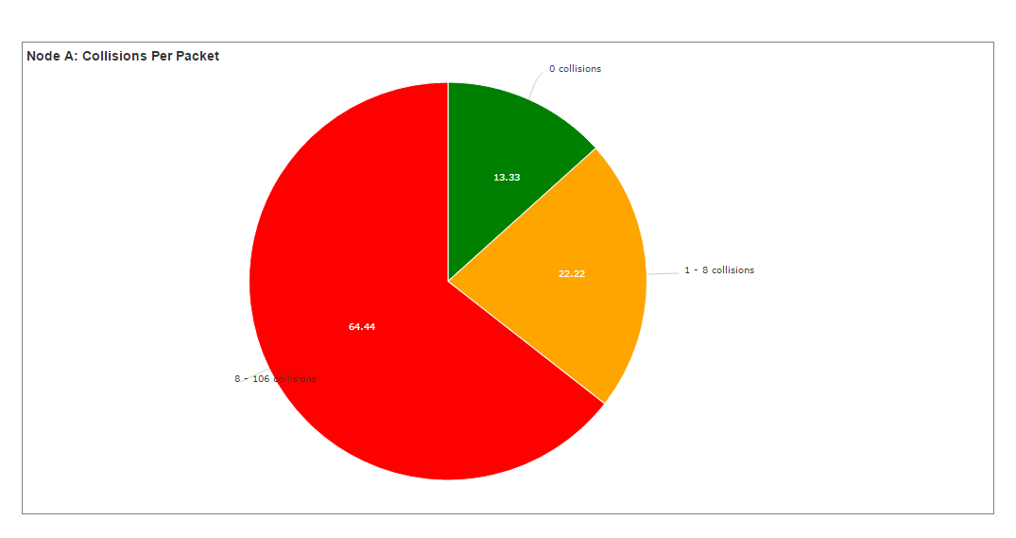

**End to End Delay ( Node A ) :**

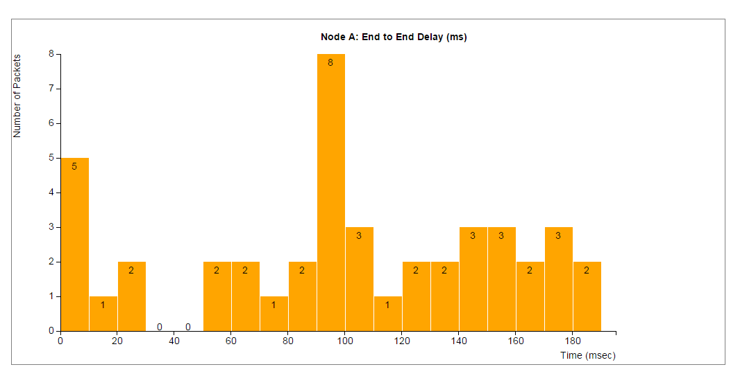

**Queue Delay ( Node A ):**

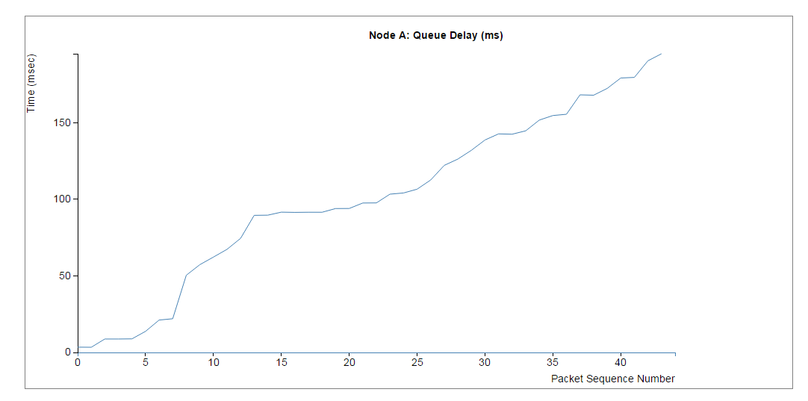

**N = 16 nodes**

**Overall Results :**

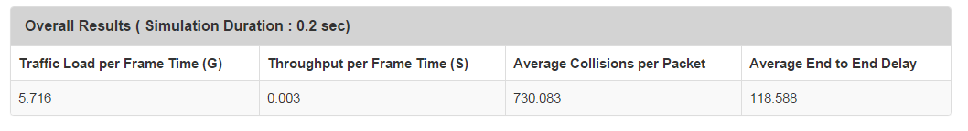

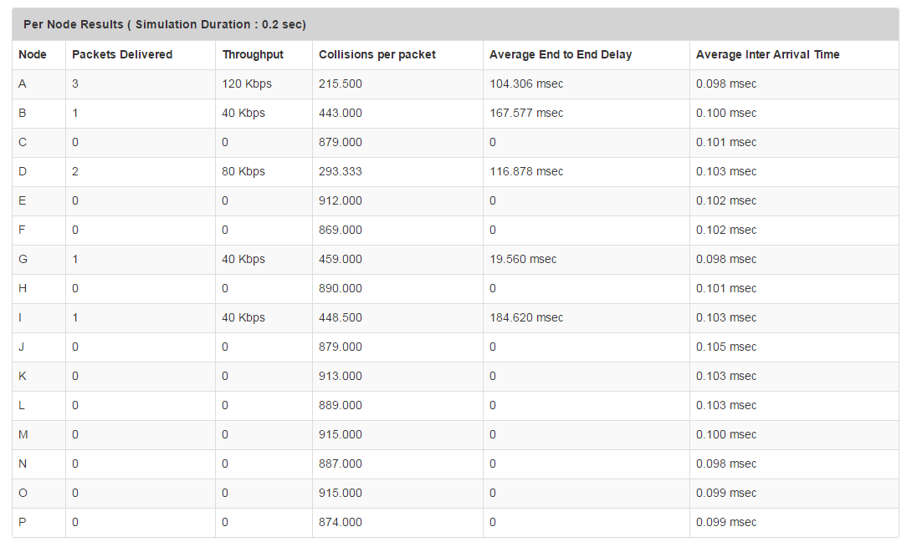

**Collisions Per Packet ( Node A ):**

