**Coursera Capstone- Accident Severity**

1. **Introduction**

**1.1 Background**

While a reduction in number has been observed over the last decades, car accidents are still counted in thousands in Switzerland in 2020. Because the direct and indirect consequences of such events (injuries, death, psychological damages, material damages, etc.) are sizeable, there is value in identifying what are the causes of the accidents so that adequate prevention measures can be put in place. Moreover, it would be valuable to society - not the least from a resource planning standpoint - to understand when accidents are most likely to occur, and respectively what outcome severity (light injuries, severe injuries, fatal outcome) can be expected depending on when and under what circumstances the accident took place. Since 1992, the Swiss Federal Statistics Office (OFS) is collecting data on car accidents country-wide and making such information available to the public. This analysis will leverage this data.

**1.2 Problem**

The objective is to explore a year 2019 dataset from the Swiss Federal Statistics Office (OFS) and determine what are the **key factors** that drive the **outcome** of an accident for the involved car(s)' passengers: light injuries, severe injuries, fatal outcome. Additionally, the outcomes of this analysis can be used as a prescriptive tool to : (1) Have the appropriate medical emergency resources allocated for the times, locations and circumstances when accidents are most likely to occur, with a particular emphasis on the severe and life-threatening cases. (2) Design prevention measures based on those accident factors identified as having the largest influence on accident outcomes.

**1.3 Interest**

By being able to allocate medical emergency resources more efficiently and by being able to reduce injuries and deaths through prevention campaigns, society as a whole will **reduce the economic impact of road hazards**. This analysis is therefore **aimed at decision-makers of the Swiss Confederation, notably those in charge of Transportation and Medical Affairs**. Beyond economic considerations, there is also a moral value in **reducing the suffering and deaths** of the thousands of people affected by road accidents.

**2. Data Sources and Cleaning**

**2.1 Data Sources**

The dataset used here is defined as "Road accidents where at least one of the parties was injured or worse". As a result, this dataset does not report on material damages or other consequences than bodily injuries. It is also worth noting that this dataset does not distinguish between what exact type of vehicle was involved, whether a car, bicycle, motorcycle, tractor, pedestrian, skater, etc. The dataset used in this analysis was obtained from the website of the Swiss Federal Statistics Office (OFS). A data browser allows the user to select the dimensions and time range of interest, within the limits of the Office's data structure. The used time range is the calendar year 2019. No other data source was used.

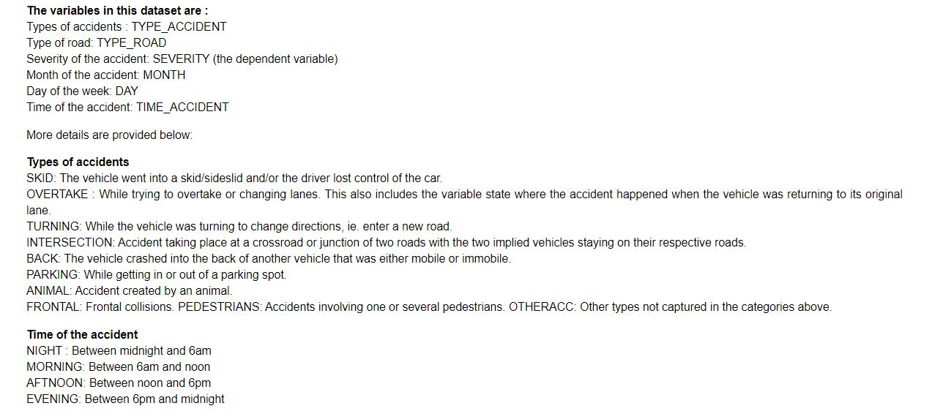

**Day of the week** The days were grouped into two categories : Weekday (WEEKDAY) and Weekend (WEEKEND)

**Month** For simplicity, the data has been grouped into seasons which are representative of average road conditions. WINTER: Dec-Feb #Icy roads SPRING: Mar-May #Can be misty or rainy SUMMER: Jun-Aug #Generally good road conditions FALL: Sep-Nov #Slippery fallen leaves and rains

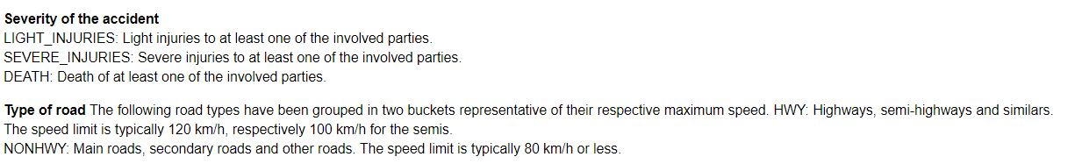

**2.2 Data Cleaning**

Data cleaning consisted first in the following basic steps :

(1) Translating the labels from French to English. This was performed in Excel directly on the CSV file.

(2) Shortening the labels, for easier coding purposes. This was performed in Excel directly on the CSV file.

(3) Transforming the non-numerical classifiers into dummy variables usable by the Machine Learning model discussed below. This was performed in the Jupyter Notebook.

The data was extractable only in a form where each row represents a unique combination of explanatory variables (such as time, day of the week, type of road, etc.). There are then 10 columns corresponding to the years 2010-2019, where it is reported in each column how many accidents happened in the said year for the given set of explanatory variables of the row. Because a time-evolution is not the primary concern of this analysis, it was decided to :

(4) Focus the analysis on the year 2019 (as opposed to using the full dataset tracing back to 1992), as it is most likely more representative of the current road conditions and car technology. This dataset contains over 17'000 accidents, hence is a fairly significative dataset. This was performed in the Jupyter Notebook.

(5) Itemize into individual rows the rows where the number of occurences in superior to 1. (so that each row represents an individual accident).

(6) Group certain variable values into more general bins, as described in section 2.1. This was performed in Excel directly on the CSV file.

**2.3 Feature Selection**

For this analysis, all features in the set were preserved, with the note that some values were grouped as explained just above.

**3. Methodology**

**3.1 Exploratory Data Analysis**

The exploratory data analysis was conducted by analysing the leading causes of accidents.  
This was done using all the classifiers to be able to identify which are more prone to creating accidents.  
The results are presented in the Results section.

**3.2 Machine Learning Approach**

This is a typical classification project, where instances have to be classified in 3 possible classes (death, severe injuries, light injuries) using certain classifiers. Because the classifiers and the target at hand are non-numerical, it was decided to use a decision tree. The independent variables had to be transformed into floats (dummy variables approach). KNN was not selected because it requires numerical independent variables to make sense.

Virtual Decision Tree:

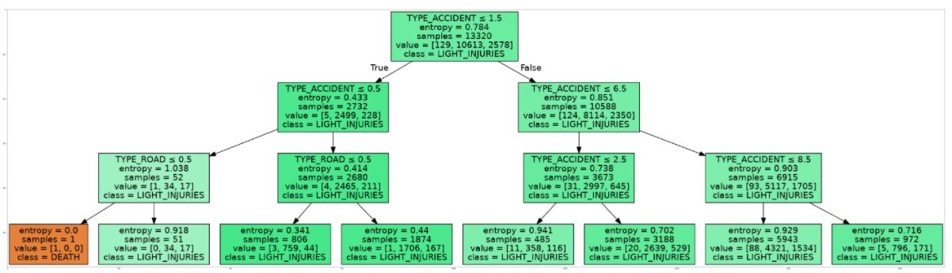

## 4. Results

### 4.2 Machine Learning modeling

Here we used a Decision Tree approach with dummied classifiers as all of them were non-numerical. At first sight, the tree gives a good 79% accuracy. However, looking closer at the data, one realizes that its performance is quite poor. The model is effectively only able to classify the data into "Light injury" buckets and the non-accuracy ends up corresponding to the ratio of severe injuries & deaths to the total of accidents. After trying with a Gini maximization, the results were exactly the same, at 79%. Changing the tree depth to 2, 4, 5 did not help either. From that standpoint, one can conclude that this ML model is not a success. One can see particularly that dummying variables such as the accident type (skid, turning, takeover, etc.) does not work as these are strictly discrete categories. And from a conceptual standpoint, it appears normal that one cannot predict with a lot of precision the outcome of an accident with the classifiers at hand. One would therefore recommend discarding this ML analysis and focusing on the traditional results presented above.

## 5. Discussion of the Results

At the end of this analysis, it appears clearly that not much can be done with simple Machine Learning techniques with the dataset as provided by the Swiss authorities. Indeed, the categorical classifiers complexify the analysis a lot and one would need more advanced techniques (not taught in this course) to be able to complete a more meaningful analysis. Conversely, one can also notice that quite a few insights are already obtained from the traditional data analysis methods, and that there is limited interest in exploring a dataset of that type with an ML approach.

## 6. Conclusion

In conclusion, the reader will have taken note that key factors. of accidents in Switzerland over the year 2019 have been as follows :  
...The summer is a critical period.  
...Accidents seem to overly take place in the late afternoon and evenings, possibly when people come back from work.  
...Skidding is still the number one factor of accidents, suggesting that people get distracted and/or that their judgement of road conditions and vehicle physics should be improved.  
...In the weekends, there is an over-proportionate number of skidding-generated accidents, suggesting that measures need to be taken in prevention or those, f.ex. in the areas of alcohol consumption and judgement alteration.

Measures should therefore be implemented in priority against these factors. Additionnally, it would be commendable to organize the allocation of emergency medical resources and personal for those times identified as critical, such as for instance the summer, the weekdays and the afternoons.