OBSERVATION

Incisional hernia patients, who were operated in the Department of General Surgery, Nalanda Medical College and Hospital, Patna between July 2019 to June 2021, were studied preoperatively, operatively, postoperatively and followed up to 6 months.

**AGE INCIDENCE**

The age group of patients at the time of operation in case of incisional hernia is tabulated as below.

**TABLE :1**

|  |  |  |
| --- | --- | --- |
| **AGE GROUP (years)** | **NO. OF CASES** | **PERCENTAGES** |
| <20 | 0 | 0 |
| 21-30 | 4 | 6.6 |
| 31-40 | 22 | 36.6 |
| 41-50 | 24 | 40 |
| 51-60 | 9 | 15 |
| >60 | 1 | 1.6 |

The above table shows maximum no of patients coming for treatment of incisional hernia were the age group of 31-40 years (36.6 %) and 41-50 years (40%).

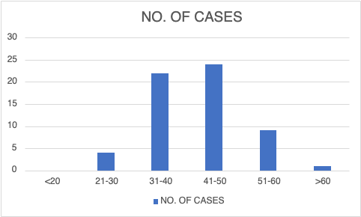

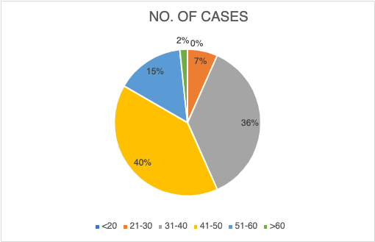

**SEX**

Sex incidence in case of incisional hernia studied in present series is tabulated as below.

|  |  |  |
| --- | --- | --- |
| **SEX** | **NO. OF CASES** | **PERCENTAGE** |
| MALE | 12 | 20 |
| FEMALE | 48 | 80 |

Female cases in present series are 80 percent and male are 20 percent.

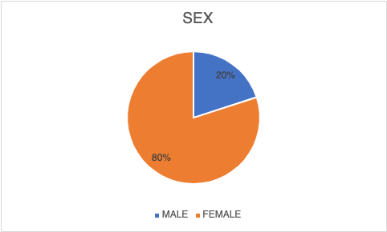

**TYPES OF INCISIONS DURING PREVIOUS SURGERY**

Next table shows relation between incisional hernia and various type of standard incisions used in inciting operation in the present series.

**TABLE :3**

|  |  |  |
| --- | --- | --- |
| **ABDOMINAL INCISIONS** | **NO. OF CASES** | **PERCENTAGE** |
| INFRAUMBILICAL MIDLINE | 36 | 60 |
| SUPRAUMBILICAL MIDLINE | 16 | 26.6 |
| PFANNENSEIL | 3 | 5 |
| McBurney | 1 | 1.66 |
| KOCHERS | 2 | 3.33 |
| UMBILICAL PORT SITE | 1 | 1.66 |
| ACCIDENTAL WOUND SITE | 1 | 1.66 |
| OTHERS (LUMBAR etc.) | 0 | 0 |

