**OBSERVATION**

Incisional hernia patients, who were operated in the Department of General Surgery, Nalanda Medical College and Hospital, Patna between July 2019 to June 2021, were studied preoperatively, operatively, postoperatively and followed up to 6 months.

**AGE INCIDENCE**

The age group of patients at the time of operation in case of incisional hernia is tabulated as below.

**TABLE :1**

|  |  |  |
| --- | --- | --- |
| **AGE GROUP (years)** | **NO. OF CASES** | **PERCENTAGES** |
| <20 | 0 | 0 |
| 21-30 | 4 | 6.6 |
| 31-40 | 22 | 36.6 |
| 41-50 | 24 | 40 |
| 51-60 | 9 | 15 |
| >60 | 1 | 1.6 |

The above table shows maximum no of patients coming for treatment of incisional hernia were the age group of 31-40 years (36.6 %) and 41-50 years (40%).

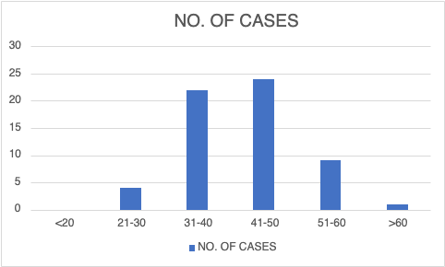

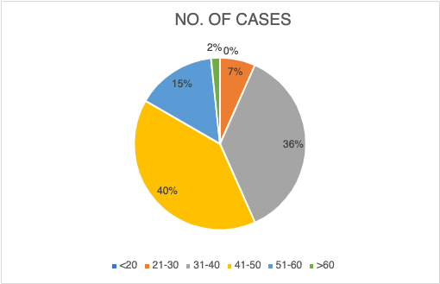

**SEX**

Sex incidence in case of incisional hernia studied in present series is tabulated as below.

|  |  |  |
| --- | --- | --- |
| **SEX** | **NO. OF CASES** | **PERCENTAGE** |
| MALE | 12 | 20 |
| FEMALE | 48 | 80 |

Female cases in present series are 80 percent and male are 20 percent.

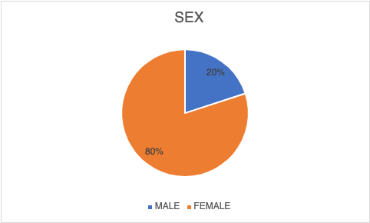

**TYPES OF INCISIONS DURING PREVIOUS SURGERY**

Next table shows relation between incisional hernia and various type of standard incisions used in inciting operation in the present series.

**TABLE :3**

|  |  |  |
| --- | --- | --- |
| **ABDOMINAL INCISIONS** | **NO. OF CASES** | **PERCENTAGE** |
| INFRAUMBILICAL MIDLINE | 36 | 60 |
| SUPRAUMBILICAL MIDLINE | 16 | 26.6 |
| PFANNENSEIL | 3 | 5 |
| McBurney | 1 | 1.66 |
| KOCHERS | 2 | 3.33 |
| UMBILICAL PORT SITE | 1 | 1.66 |
| ACCIDENTAL WOUND SITE | 1 | 1.66 |
| OTHERS (LUMBAR etc.) | 0 | 0 |

Incisional hernia more in lower midline incision than any other incisions.

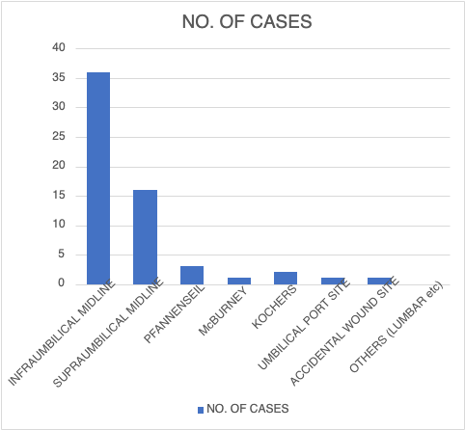

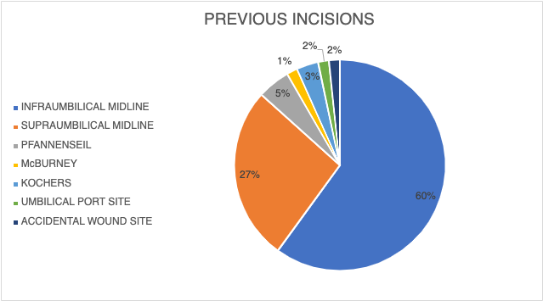

**DEFECT SIZE**

Table shows the average size of defect of the hernia in 60 cases of incisional hernia repair.

**TABLE :4**

|  |  |  |
| --- | --- | --- |
| **DEFECT SIZE** | **NO. OF CASES** | **PERCENTAGE** |
| 4 CM OR LESS | 18 | 30 |
| 4.1- 7 CM | 21 | 35 |
| MORE THAN 7CM | 21 | 35 |

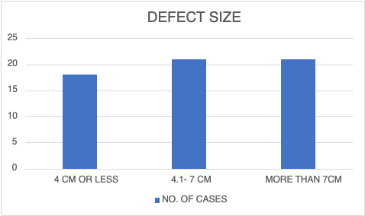

**CONTENT OF SAC**

Next table evaluates the content of sac in cases of present series of incisional hernia.

**TABLE :5**

|  |  |  |
| --- | --- | --- |
| **CONTENT OF SAC** | **NO. OF CASES** | **PERCENTAGE** |
| OMENTUM | 11 | 18.33 |
| OMENTUM + SMALL BOWEL | 48 | 80 |
| OMENTUM+ SMALL BOWEL+ LARGE BOWEL | 1 | 1.66 |
| OMENTUM + LARGE BOWEL | 0 | 0 |

In 80 percent cases of incisional hernia of present series, the content of sac is omentum and small bowel.

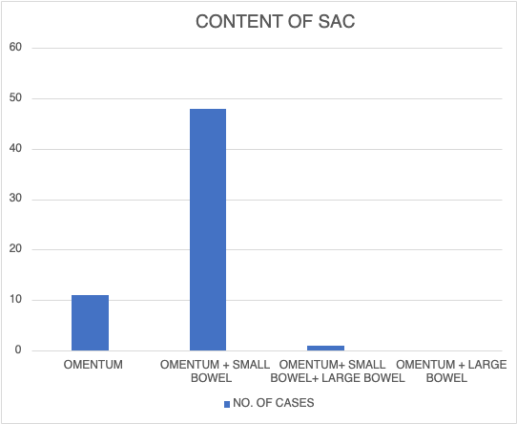

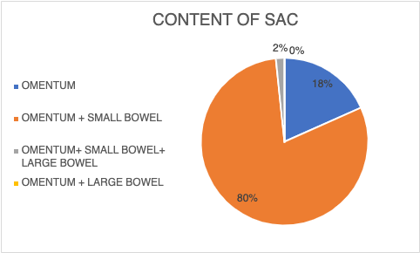

**TECHINIQUES OF REPAIR**

Upcoming table shows various treatments employed in present series of work.

**TABLE :6**

|  |  |  |
| --- | --- | --- |
| **TECHNIQUES OF REPAIR** | **NO. OF CASES** | **PERCENTAGE** |
| PRIMARY SUTURE REPAIR | 20 | 33.33 |
| ONLAY MESH REPAIR | 15 | 25 |
| SUBLAY MESH REPAIR | 25 | 41.66 |

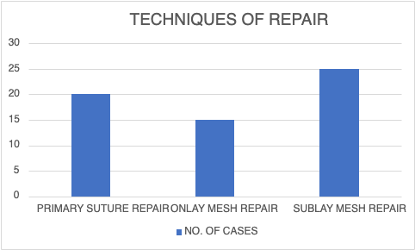

**POSTOPERATIVE PAIN**

Postoperative pain was calculated by using the visual analog scale (VAS) of 1–10, and those with a pain scale of more than 5 were considered significant.

**TABLE :7**

|  |  |  |  |
| --- | --- | --- | --- |
| **POSTOPERATIVE PAIN (VAS)** | **PRIMARY SUTURE REPAIR**  **(n= 20)** | **ONLAY MESH REPAIR**  **(n= 15)** | **SUBLAY MESH REPAIR**  **(n= 25)** |
| <5 | 16 | 10 | 10 |
| >5 | 4 | 5 | 15 |

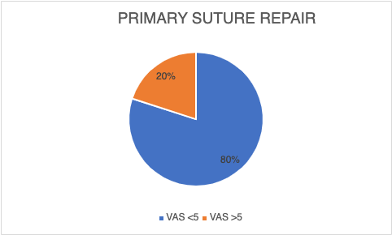

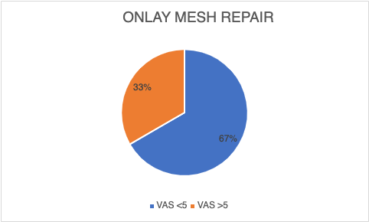



**POSTOPERATIVE COMPLICATIONS**

Table shows postoperative complications following incisional hernia repair in present series of cases.

|  |  |  |
| --- | --- | --- |
| **POSTOPRATIVE COMPLICATIONS** | **NO. OF CASES** | **PERCENTAGE** |
| WOUND INFECTION | 3 | 5 |
| SEROMA | 7 | 11.66 |
| FLAP NECROSIS | 1 | 1.6 |
| OTHERS | 6 | 10 |

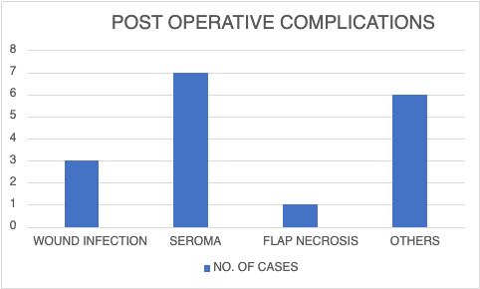

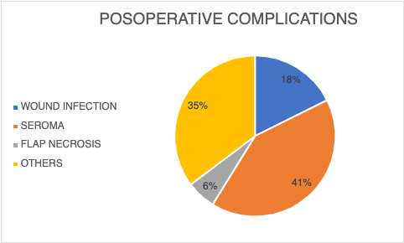

**HOSPITAL STAY**

Following table shows postoperative hospital stay in all 3 grops of patients.

**TABLE :8**

|  |  |  |  |
| --- | --- | --- | --- |
| **HOSPITAL STAY**  **(days)** | **PRIMARY SUTURE REPAIR**  **(n= 20)** | **ONLAY MESH REPAIR**  **(n= 15)** | **SUBLAY MESH REPAIR**  **(n= 25)** |
| **7** | **13** | **1** | **10** |
| **>7** | **7** | **14** | **15** |

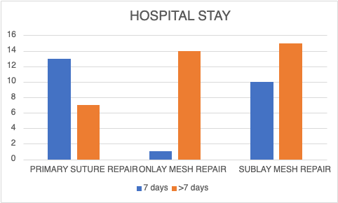

**RETURN TO WORK**

Following table shows return to daily physical activity in all 3 groups of patients.

**TABLE :9**

|  |  |  |  |
| --- | --- | --- | --- |
| **RETURN TO WORK**  **(days)** | **PRIMARY SUTURE REPAIR**  **(n= 20)** | **ONLAY MESH REPAIR**  **(n= 15)** | **SUBLAY MESH REPAIR**  **(n= 25)** |
| Within 10 | 15 | 9 | 8 |
| 10-20 | 4 | 5 | 15 |
| More than 20 | 1 | 1 | 2 |

