Before deploying any mediation projects on runtime, we first need to host the default TIBCO ActiveMatrix Mediation template application. To do this, go to Admin UI - Applications - New – Select Existing Application Template - Next - TIBCO ActiveMatrix Mediation Implementation Type Application Template – Next – go with default options and say deploy. Once this is listed as Start with deploy successful in the applications list, only then we must deploy our mediation projects on top of it.

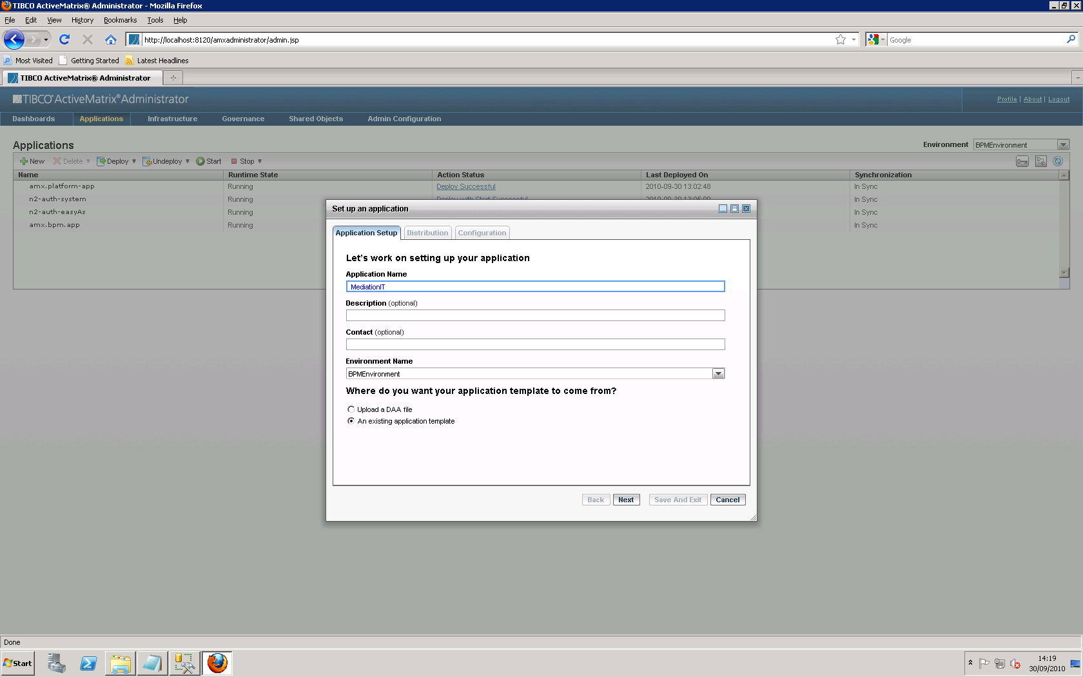

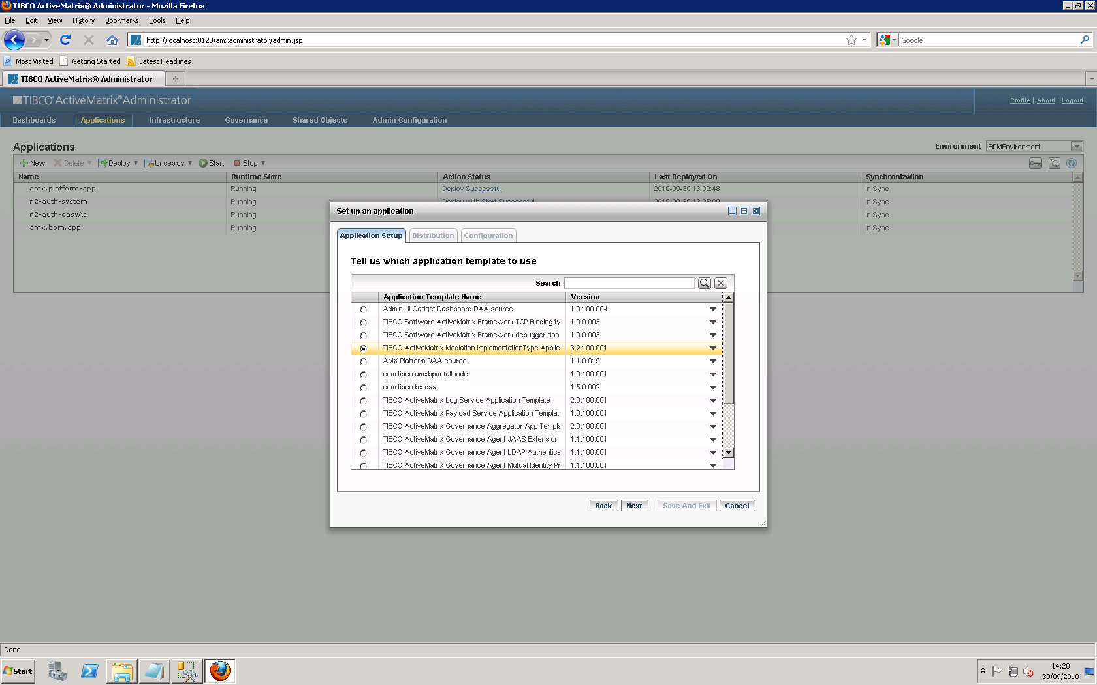

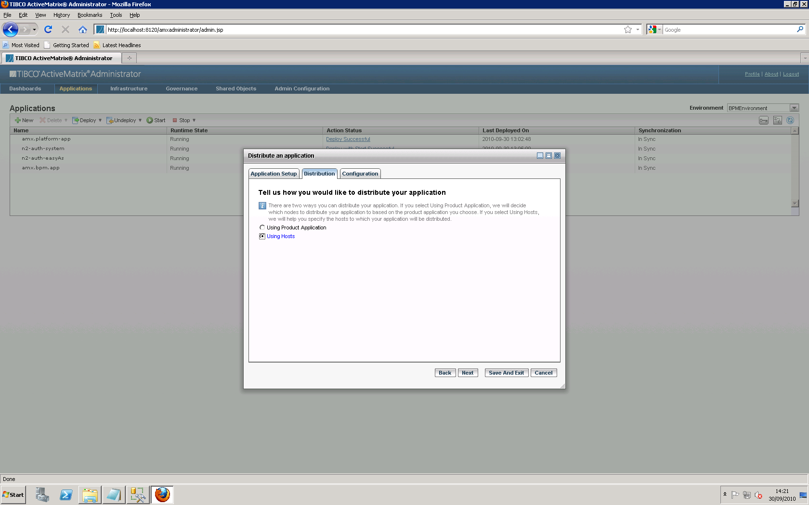

You can say save and exit here and click deploy for MediationIT and ensure you see Deploy with Start Successful before proceeding

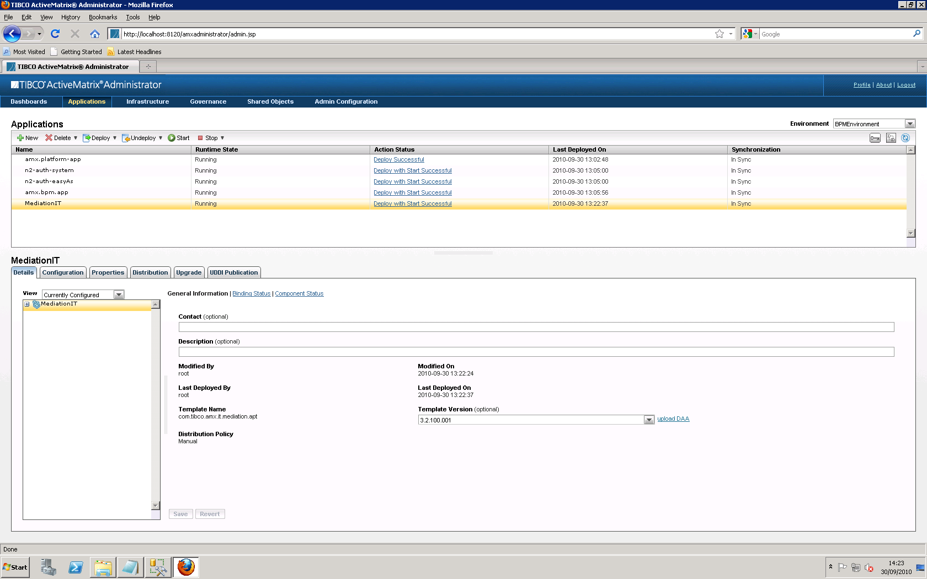

Now upload user defined soa application

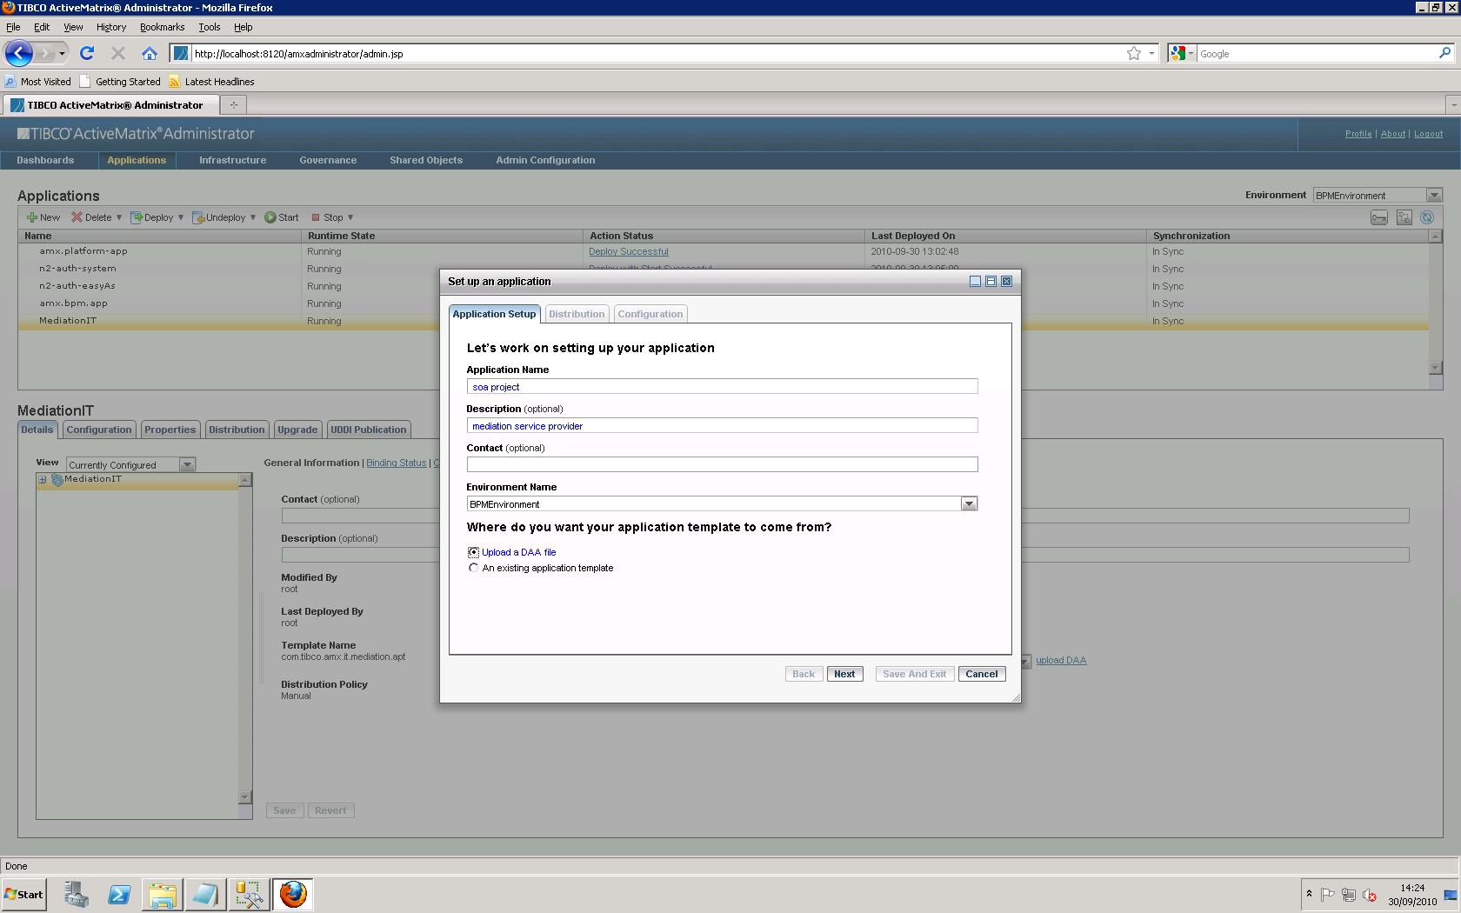

Select Using Product Application

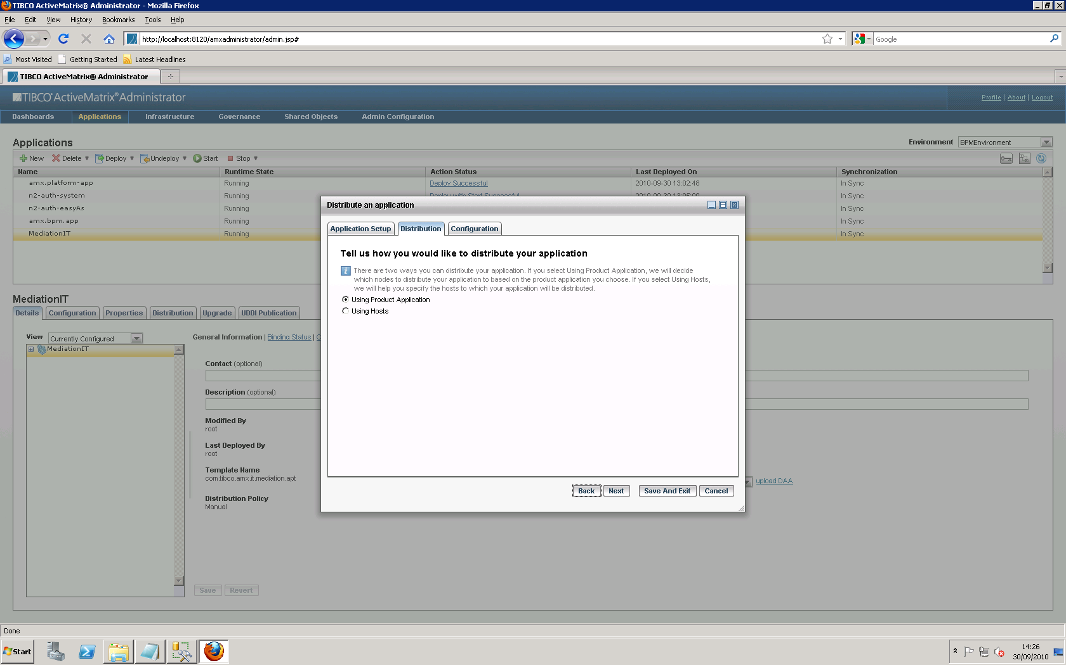

Select the MediationIT that we deployed earlier to host our application onto and can say save and exit.

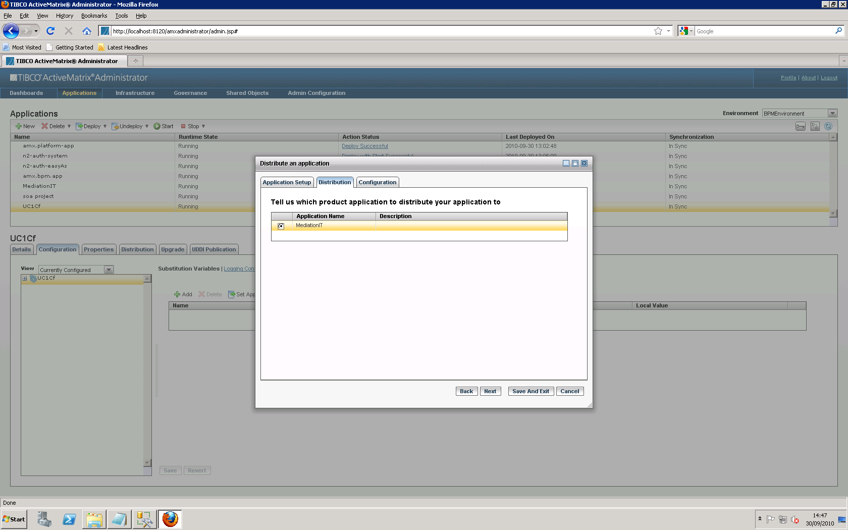

Refresh the Applications Admin UI and deploy the soa project. And ensure that you see Deploy with Start Successful before proceeding

Now deploy the consumer application

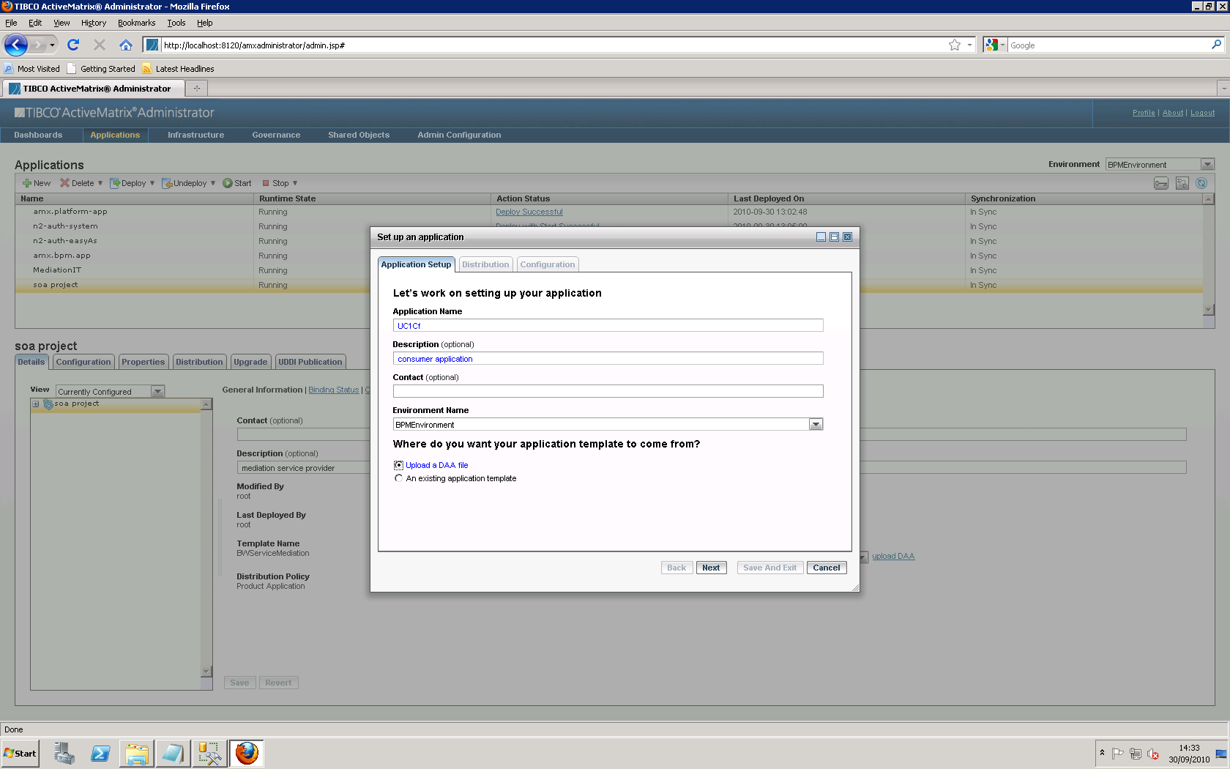

Go with default options for application set up.

For distribution select the following option and go ahead with defaults and save and exit.

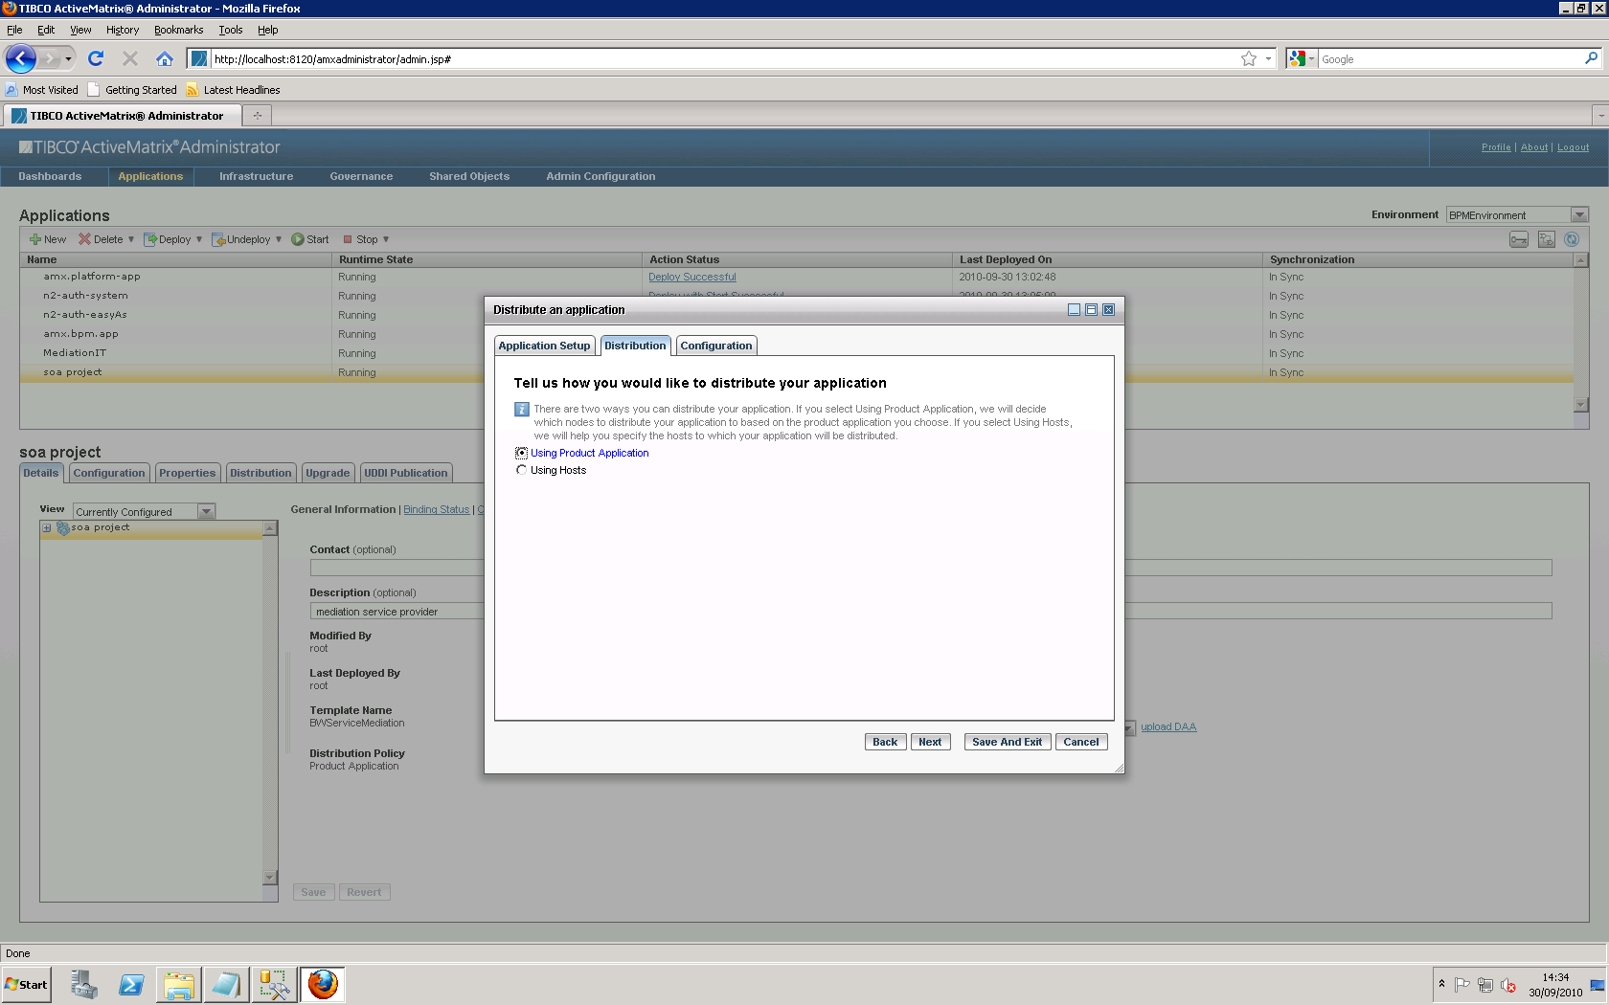

For configuration select the application in the applications list and select the second option Wire to Binding and click on the arrow on right side

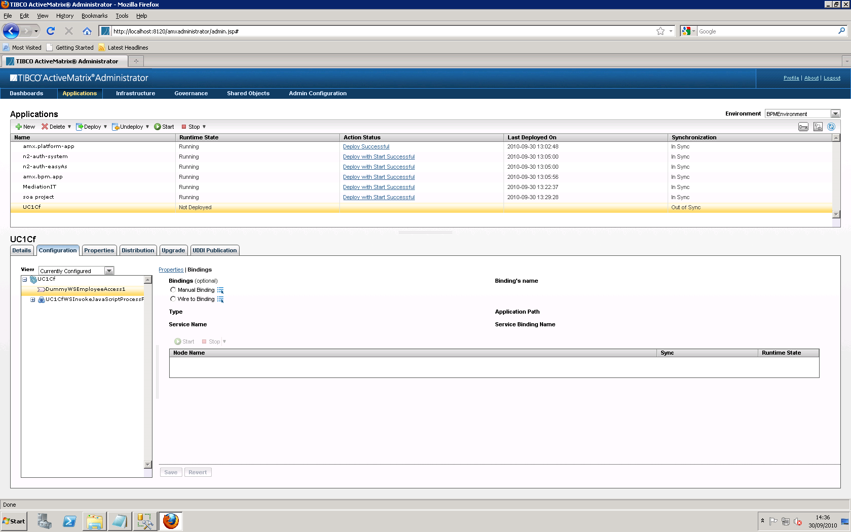

And select deployed virtualisation option (maximise the window for appropriate selection)

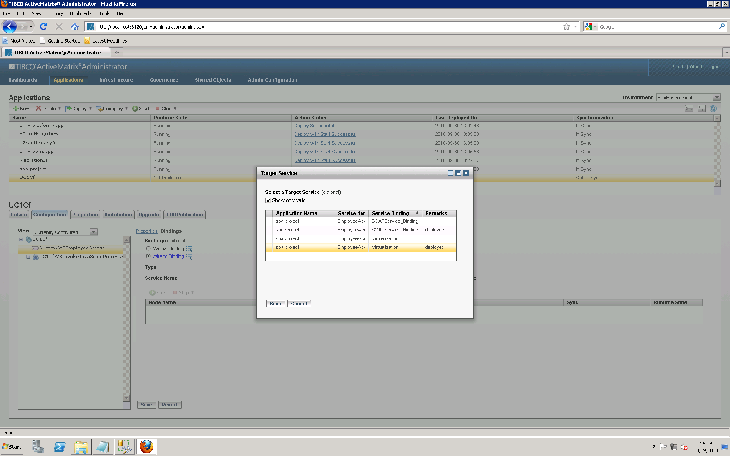

Save and deploy

