**Essentials of Generative AI, Prompt Engineering & ChatGPT**

*Course End Project*

Samuel Sisk

# Defining a Story Theme

For this project I have selected the theme to be science fiction.

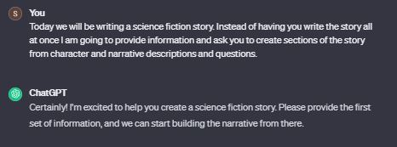

# 

# Introducing the Main Characters

To design the character in my story I asked ChatGPT to generate 10 characters with attributes of name, personality, and background. From this I will select four to be our main characters.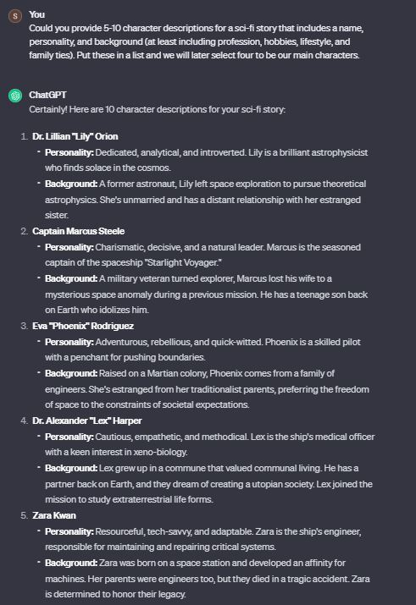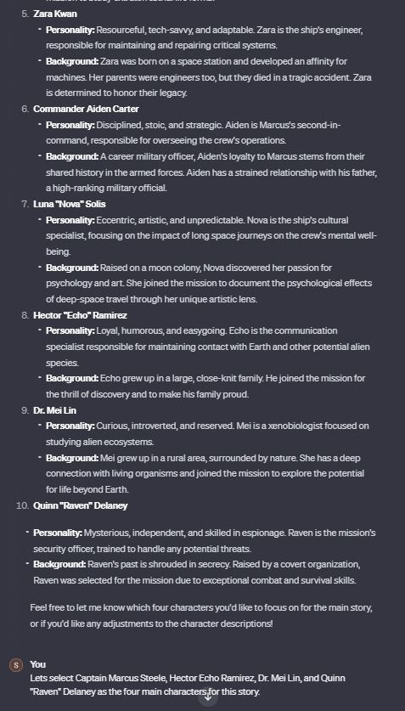

# Beginning the Story

After creating the characters, ChatGPT took the wheel and immediately spit out some basic storyline. Most of it is rather vague and uninteresting, which can be fixed with introducing a solid narrative arc to guide it, but the opening seems fine.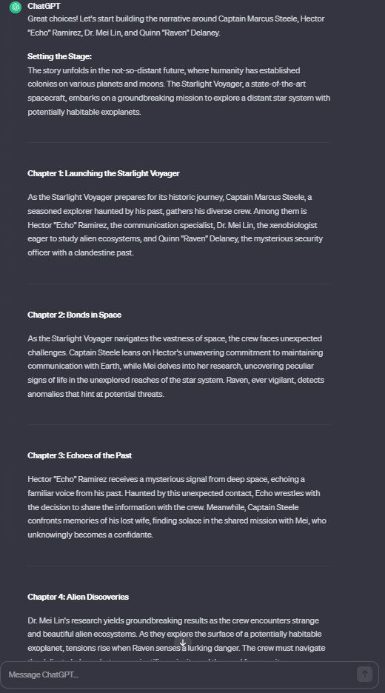

**Participant input**

Based on the core (underlined) aspects of the selected characters I was able to introduce a reasonable storyline using the opening briefing as a beginning to a mission to survey anomalous readings. The crew seems to have a general theme of researching, communicating, and “handling” alien life. This is the basis for their narrative goals. Here is the finalized first chapter I created by feeding ChatGPT this info.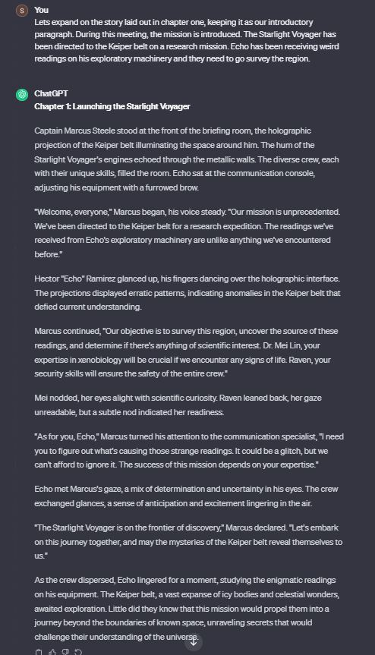

# Continue the Story With GPT Responses

After reading chapter one, I realized that this seemed like a pretty strong setup for a good story, but what should be told? I recently visited the *Adler Planetarium* in Chicago and saw a presentation on “Planet Nine”. Essentially, using extremely powerful telescopes, astrophysics, and computer simulations, scientists have been discovering a lot of strange rocks and planets with rather unusual orbits. One of these is a planet that is only visible to Earth for 250 of its 10000+ year orbit. Incredible that we are alive to see it but it makes you wonder how many other widely orbiting planets there could be outside of our visible range. This will be the premise of our story.

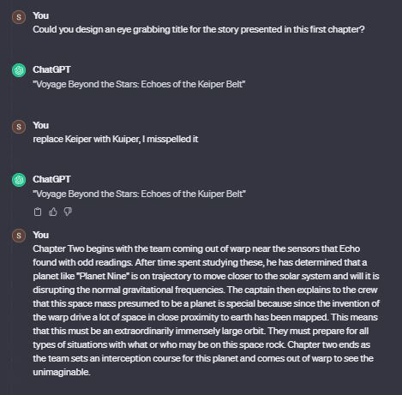

# 

# Create Branching Paths Through Prompted Decision Making

ChatGPT was prompted to create several “creative” outcomes for chapter three.

# 

# Iterate and Refine Your Inputs

I really liked the third option presented in the first narrative option segment. It allowed my two other characters, who frankly haven't done anything, to take the wheel and guide the story along.

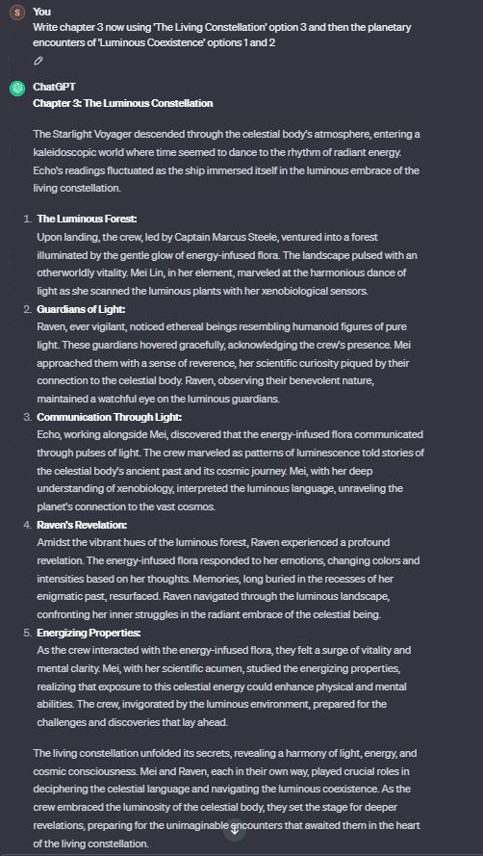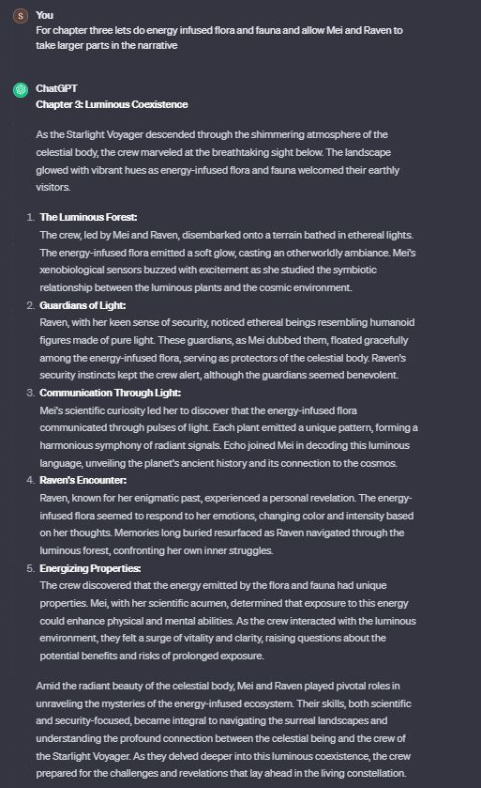

# 

# 

# Wrap It All Up

Prompting ChatGPT for options once again I really liked option three. It provides a nice climax in action as they deal with the trial. Then, given the option of many different individual trials I choose for each character (except Echo who is on the ship) to be forced into a personal trial alone. They each triumph creating a team success and moving them into the resulting conclusion in their journey.

