NAME: PRIYANSHU CHAUHAN
REG NO.:21BIT0588
1.Login.html
CODE:
<!DOCTYPE html>
<html lang="en">
<head>
<title>Login</title>
</head>
<style>
.login-box{
min-height: 70vh;
background-color: black;
color: white;
font-family: 'Varela Round', sans-serif;
display: flex;
margin: 100px auto;
width: 25%;
height: 40%;
border-radius: 12px;
justify-content: left;
padding-left: 90px;
}
.login-footer{
height: 400px;
background-color: black;
color: white;
bottom: 0;
display: flex;
align-items: left;
flex-direction: column;
border: auto;
margin: 12px 0;
width: 100%;
padding-bottom: 20px;
position: relative;
}
#input{
height: 50px;
width: 350px;
background-color:rgb(58, 56, 56);
border-radius: 5px;
font-size: 25px;
color:white
}
::placeholder {
padding: 24px;
font-size: 25px;
}
#button{
height: 50px;
width: 350px;
background-color:rgb(255, 0, 0);
border-radius: 5px;
color: white;
font-size: 20px;
}
#login-container{
font-size: 25px;
padding-right: 15%;
}
#rem_me{
color: white;
}
#remember{
font-size: 18px;
}
.footer-items{
color: grey;
padding-left: 17%;
padding-top: 12px;
justify-content: center;
}
#help{
font-size: 18px;
}
a:link,a:visited {
color: grey;
background-color: transparent;
text-decoration: none;
}
#form{
height: 30px;
width: 100px;
font-size: 20px;
}
#data-box{
text-align: left;
width: 360px;
height: 100px;
font-size: 20px;
}
#signup{
color: blue;
}
#signin{
color: white;
}
</style>
<body background="bg.jpg" width="300" height="500">
<img src="LOGO.svg" width="190" height="60" style="padding:20px">
<div class="login-box">
<div id="login-container">
<h1>Sign In</h1><br>
<input id="input" type="text" name="Email" placeholder="Email"/><br><br>
<input id="input" type="password" name="Pass" placeholder="Password"/><br><br><br>
<button id="button"><a id="signin"href="login.html">Sign In</a></button><br>
<input type="checkbox" id="rem_me" name="rem" value="Remember Me">
<label for="vehicle1" id="remember"> Remember Me</label>&nbsp;&nbsp;&nbsp;&nbsp;&nbsp;&nbsp;&nbsp;&nbsp;&nbsp;&nbsp;&nbsp;&nbsp;&nbsp;&nbsp;
<a href="" id="help">Need Help?</a>
<h6>New to Netflix? <a id="signup"href="signup.html">Sign up now.</a></h6>
<h6>This page is protected by Google reCAPTCHA to ensure you're not a bot. Learn more.</h6>
</div>
</div>
<div class="login-footer">
<div class="footer-items">
<h2>Questions? Call 0120-996-012</h2><br>
<table >
<tr>
<th id="data-box"><a href="">FAQ</a></th>
<th id="data-box"><a href="">Help Center</a></th>
<th id="data-box"><a href="">Netflix Shop</a></th>
<th id="data-box"><a href="">Terms of Use</a></th>
</tr>
<tr>
<th id="data-box"><a href="">Privacy</a></th>
<th id="data-box"><a href="">Cookie Preferences</a></th>
<th id="data-box"><a href="">Corporate Information</a></th>
<th id="data-box"><a href="">Act on Commercial Transactions</a></th>
</tr>
</table>
<form>
<select name="dropdown" id="form">
<option value="English">English</option>
<option value="Hindi">हिंदी</option>
<option value="Tamil">தமிழ்</option>
<option value="Telegu">తెలుగు</option>
</form>
</div>
</div>
</body>
</html>

Screenshots:
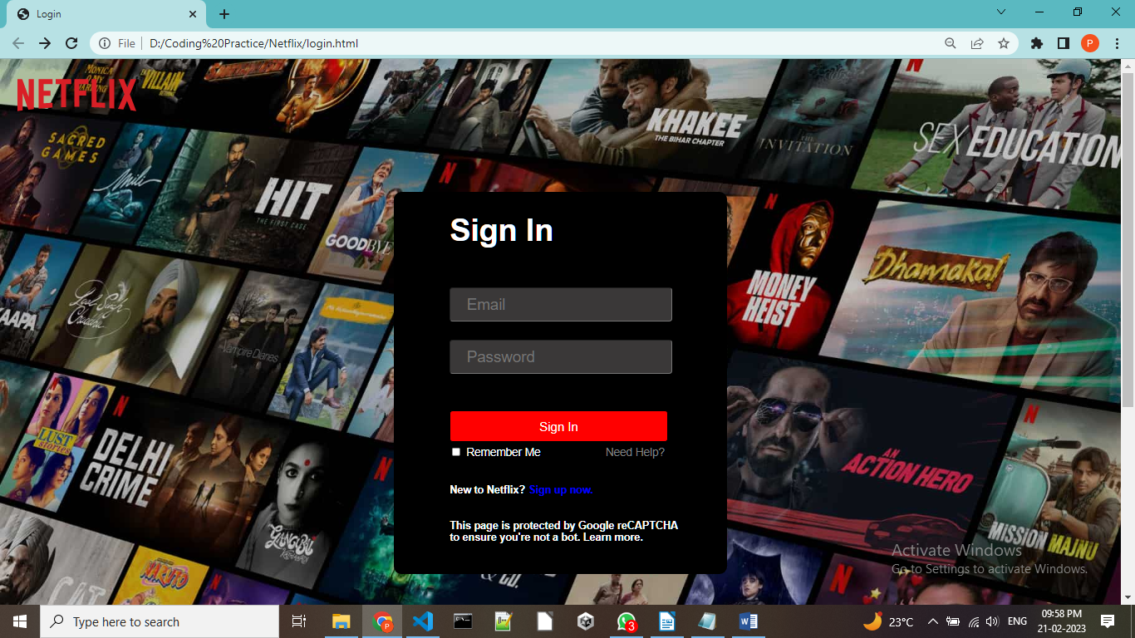
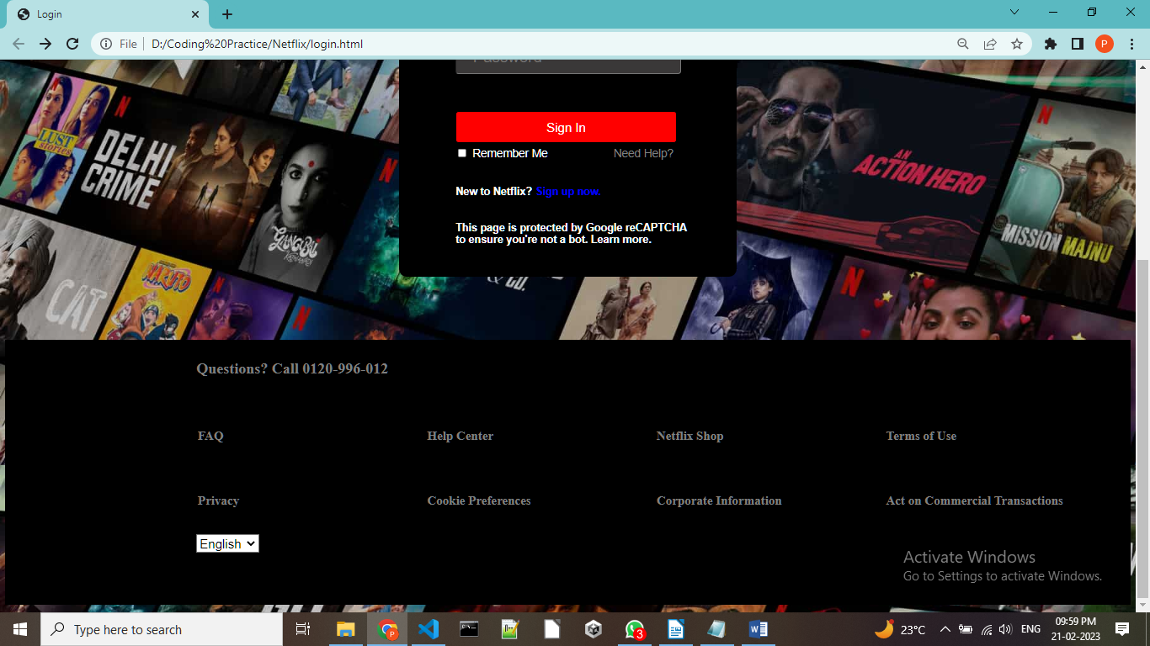

2.Signup.html

CODE:
<!DOCTYPE html>
<html lang="en">
<head>
<title>Sign Up</title>
</head>
<style>

.signup-footer{
height: 400px;
background-color: rgb(218, 213, 213);
color: white;
bottom: 0;
display: flex;
align-items: left;
flex-direction: column;
border: auto;
margin: 12px 0;
width: 100%;
padding-bottom: 20px;
position: relative;
}
.footer-items{
color: rgb(41, 39, 39);
padding-left: 17%;
padding-top: 12px;
justify-content: center;
}

#signup-container{
font-size: 25px;
padding-right: 15%;
justify-content: center;
align-items: center;
}
.signup-box{
min-height: 70vh;
background-color: white;
color: black;
font-family: 'Varela Round', sans-serif;
display: flex;
margin: 100px auto;
width: 35%;
height: 50%;
border-radius: 12px;
justify-content: center;
padding-left: 90px;
text-align: center;
}
#button{
background-color: rgb(226, 43, 43);
color:white;
font-size: larger;
height: 80px;
width: 350px;
border: 0px;
}
.logo{
padding-left: 20px;
padding-top: 20px;
}
#des1{
font-size: 20px;
text-align: center;
}

#des2{
width: 80%;
height: 25%;
font-size: 25px;
padding-left: 10%;
text-align: center;
}

.n,a:link,a:visited{

color: white;
background-color: transparent;
text-decoration: none;
}
a:link,a:visited{

color: black;
background-color: transparent;
text-decoration: none;
}

#form{
height: 30px;
width: 100px;
font-size: 20px;
}
#data-box{
text-align: left;
width: 360px;
height: 100px;
font-size: 20px;
}
#next{
color: white;
}
</style>

<body>
<div class="logo">
<img src="LOGO.svg" width="190" height="60">
</div>
<div class="signup-box">
<div id="signup-container">
<img src="temp.JPG" width="390" height="150">
<h6>STEP 1 OF 3</h6>
<div id="des1"><h1>Finish setting up your account</h1></div>
<div id="des2">Netflix is personalised for you. Create a password to watch on any device at any time.</div>
<button id="button"><a id="next" href="register.html">Next</a></button><br>
</div>
</div>
<div class="signup-footer">
<div class="footer-items">
<h2>Questions? Call 0120-996-012</h2><br>
<table >
<tr>
<th id="data-box"><a href="">FAQ</a></th>
<th id="data-box"><a href="">Help Center</a></th>
<th id="data-box"><a href="">Netflix Shop</a></th>
<th id="data-box"><a href="">Terms of Use</a></th>
</tr>
<tr>
<th id="data-box"><a href="">Privacy</a></th>
<th id="data-box"><a href="">Cookie Preferences</a></th>
<th id="data-box"><a href="">Corporate Information</a></th>
<th id="data-box"><a href="">Act on Commercial Transactions</a></th>
</tr>
</table>
<form>
<select name="dropdown" id="form">
<option value="English">English</option>
<option value="Hindi">हिंदी</option>
<option value="Tamil">தமிழ்</option>
<option value="Telegu">తెలుగు</option>
</form>
</div>
</div>
</body>
</html>

Screenshots:
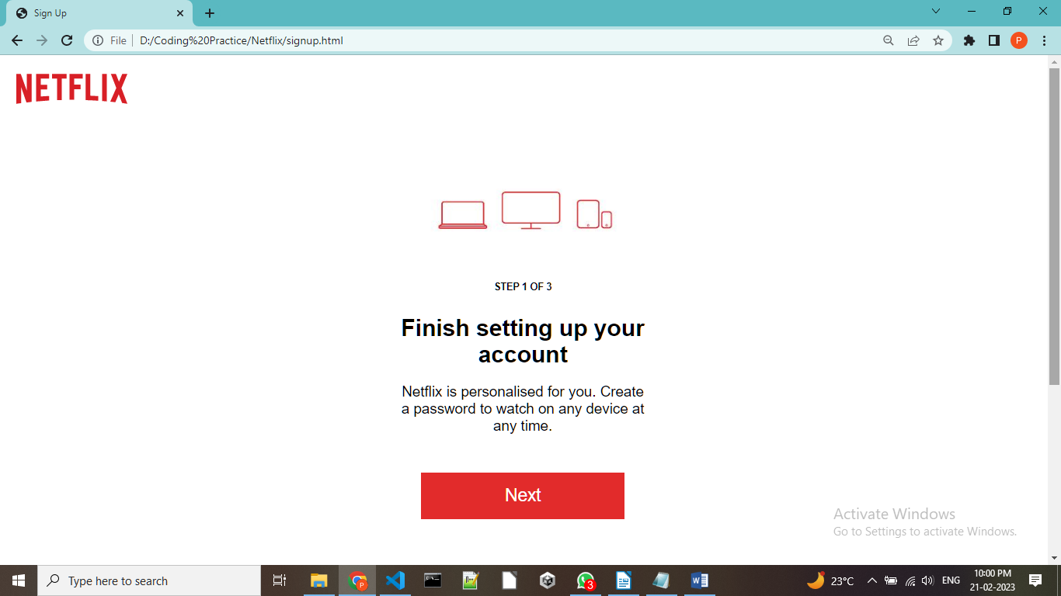
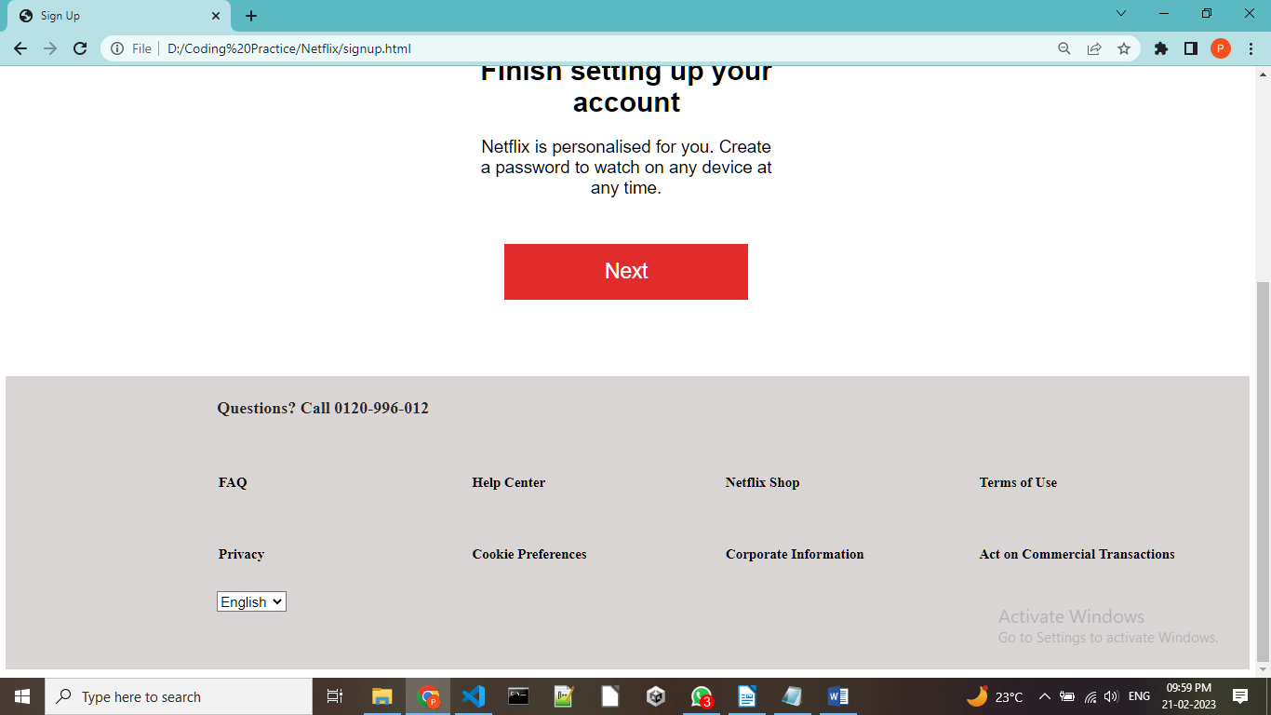

3.Register.html:

CODE:
<!DOCTYPE html>
<html lang="en">
<head>
<title>Register</title>
</head>
<style>

.register-footer{
height: 400px;
background-color: rgb(218, 213, 213);
color: white;
bottom: 0;
display: flex;
align-items: left;
flex-direction: column;
border: auto;
margin: 12px 0;
width: 100%;
padding-bottom: 20px;
position: relative;
}
.footer-items{
color: rgb(41, 39, 39);
padding-left: 17%;
padding-top: 12px;
justify-content: center;
}

#register-container{
font-size: 25px;
padding-right: 15%;
justify-content: center;
align-items: left;
text-align: left;
padding-bottom: 20%;
}
.register-box{
min-height: 70vh;
background-color: white;
color: black;
font-family: 'Varela Round', sans-serif;
display: flex;
margin: 100px auto;
width: 35%;
height: 50%;
border-radius: 12px;
justify-content: center;
padding-left: 90px;
text-align: center;
}
#button{
background-color: rgb(226, 43, 43);
color:white;
font-size: larger;
height: 80px;
width: 100%;
border: 0px;
}
.logo{
padding-left: 20px;
padding-top: 20px;
}
#des1{
font-size: 20px;
text-align: left;
}

#des2{
width: 90%;
height: 17%;
font-size: 25px;
text-align: left;
}

#input{
height: 75px;
width: 98%;
background-color: white;
border-radius: 5px;
font-size: 25px;
color: black;
}
::placeholder {
padding: 24px;
font-size: 25px;
}
a:link , a:visited {
color: black;
background-color: transparent;
text-decoration: none;
}

#form{
height: 30px;
width: 100px;
font-size: 20px;
}
#data-box{
text-align: left;
width: 360px;
height: 100px;
font-size: 20px;
}
#next{
color: white;
}
</style>

<body>
<div class="logo">
<img src="LOGO.svg" width="190" height="60">
</div>
<div class="register-box">
<div id="register-container">
<h6>STEP 1 OF 3</h6>
<div id="des1"><h1>Create a password to start your membership</h1></div>
<div id="des2">Just a few more steps and you're done!<br>We hate paperwork, too.</div>
<form>
<input id="input" type="text" name="Email" placeholder="Email"/><br><br>
<input id="input" type="password" name="Pass" placeholder="Add a Password"/><br><br><br>
</form>
<button id="button"><a id="next"href="subscription.html">Next</a></button><br>
</div>
</div>
<div class="register-footer">
<div class="footer-items">
<h2>Questions? Call 0120-996-012</h2><br>
<table >
<tr>
<th id="data-box"><a href="">FAQ</a></th>
<th id="data-box"><a href="">Help Center</a></th>
<th id="data-box"><a href="">Netflix Shop</a></th>
<th id="data-box"><a href="">Terms of Use</a></th>
</tr>
<tr>
<th id="data-box"><a href="">Privacy</a></th>
<th id="data-box"><a href="">Cookie Preferences</a></th>
<th id="data-box"><a href="">Corporate Information</a></th>
<th id="data-box"><a href="">Act on Commercial Transactions</a></th>
</tr>
</table>
<form>
<select name="dropdown" id="form">
<option value="English">English</option>
<option value="Hindi">हिंदी</option>
<option value="Tamil">தமிழ்</option>
<option value="Telegu">తెలుగు</option>
</form>
</div>
</div>
</body>
</html>

Screenshots:

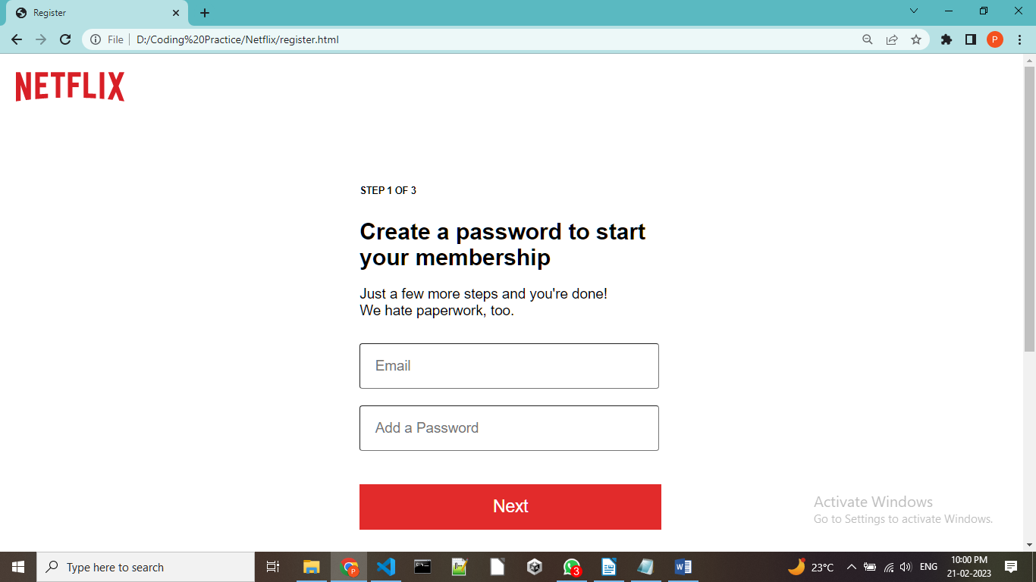
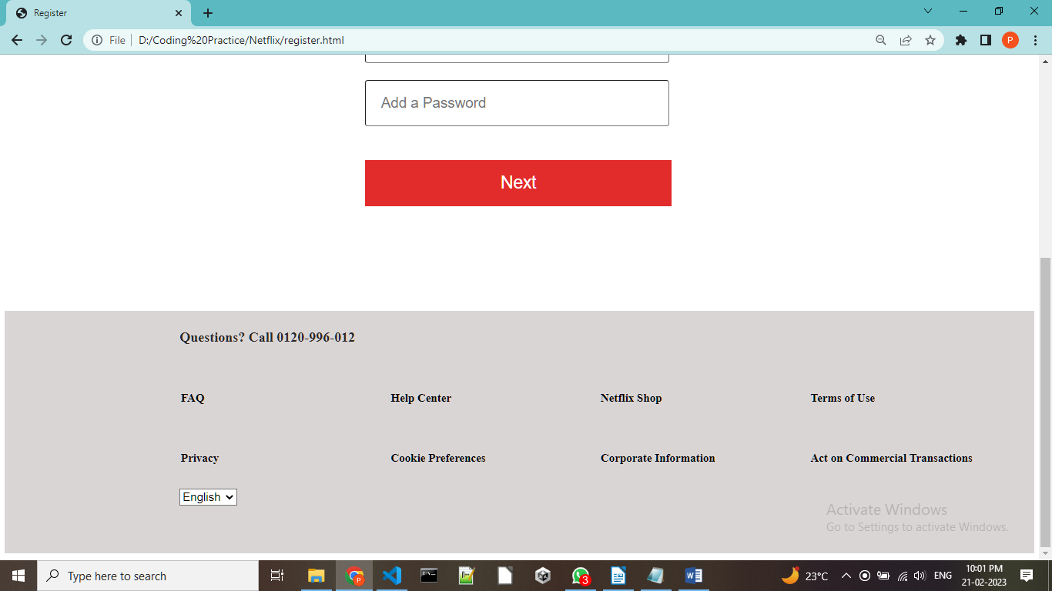

4.Subscription.html

CODE:
<!DOCTYPE html>
<html lang="en">
<head>
<title>Subscription</title>
</head>
<style>

.sub-footer{
height: 400px;
background-color: rgb(218, 213, 213);
color: white;
bottom: 0;
display: flex;
align-items: left;
flex-direction: column;
border: auto;
margin: 12px 0;
width: 100%;
padding-bottom: 20px;
position: relative;
}
.footer-items{
color: rgb(41, 39, 39);
padding-left: 17%;
padding-top: 12px;
justify-content: center;
}

#sub-container{
font-size: 25px;
padding-right: 35%;
justify-content: center;
align-items: center;
text-align: left;
padding-bottom: 20%;
}
.sub-box{
min-height: 70vh;
background-color: white;
color: black;
font-family: 'Varela Round', sans-serif;
display: flex;
margin: 100px auto;
width: 1200px;
height: 1500px;
border-radius: 12px;
justify-content: center;
padding-left: 70px;
text-align: left;
align-items: center;
padding-left: 22%;
}
#button{
background-color: rgb(226, 43, 43);
color:white;
font-size: larger;
height: 80px;
width: 100%;
border: 0px;
}
.logo{
padding-left: 20px;
padding-top: 20px;
}
#des1{
font-size: 20px;
text-align: left;
}

#des2{
width: 90%;
height: 17%;
font-size: 25px;
text-align: left;
}

#input{
height: 75px;
width: 98%;
background-color: white;
border-radius: 5px;
font-size: 25px;
color: black;
}
::placeholder {
padding: 24px;
font-size: 25px;
}
a:link, a:visited {
color: black;
background-color: transparent;
text-decoration: none;
}
.table{
width: 1000px;
height: 700px;
}
#head{
background-color: red;
color: white;
height: 120px;
width: 120px;
text-align: center;
}

#button{
background-color: rgb(226, 43, 43);
color:white;
font-size: larger;
height: 80px;
width: 550px;
border: 0px;

}
.button_div{
align-items: center;
padding-left: 22%;
}
#form{
height: 30px;
width: 100px;
font-size: 20px;
}
#data-box{
text-align: left;
width: 360px;
height: 100px;
font-size: 20px;
}
#next{
color: white;
}
#data-field{
font-size: 25px;
height: 90px;
}

</style>

<body>
<div class="logo">
<img src="LOGO.svg" width="210" height="70">
</div>
<div class="sub-box">
<div id="sub-container">
<h6>STEP 2 OF 3</h6>
<h1>Choose the plan that's right for you</h1>
<img src="small_tick.JPG">Watch all you want. Ad-free.<br>
<img src="small_tick.JPG">Recommendations just for you.<br>
<img src="small_tick.JPG">Change or cancel your plan anytime.<br>
<div class="table">
<table cellpadding="10" cellspacing="15">
<tr>
<th></th><th id="head" >Mobile</th><th id="head">Basic</th><th id="head">Standard</th><th id="head">Premium</th>
</tr>
<tr>
<td id="data-field">Monthly Price</td><td> &emsp;&emsp;₹ 149</td><td> &emsp;&emsp;₹ 199</td><td>&emsp;&emsp;₹ 499</td><td>&emsp;&emsp;₹ 649</td>
</tr>
<tr>
<td id="data-field">Video Quality</td><td>&emsp;&emsp;Good</td><td>&emsp;&emsp;Good</td><td>&emsp;&emsp;Better</td><td>&emsp;&emsp;Best</td>
</tr>
<tr>
<td id="data-field"> Resolution</td><td>&emsp;&emsp;480p</td><td>&emsp;&emsp;720p</td><td>&emsp;&emsp;1080p</td><td>4K+HDR</td>
</tr>
<tr>
<td>Devices you can use to watch</td>
<td>&emsp;<img src="1.JPG" ></td>
<td>&emsp;<img src="2.JPG"></td>
<td>&emsp;<img src="2.JPG"></td>
<td>&emsp;<img src="2.JPG"></td>
</tr>
</table>

<h6> HD (720p), Full HD (1080p), Ultra HD (4K) and HDR availability subject to your internet service and device capabilities. Not all content is available in all resolutions. See our Terms of Use for more details.
Only people who live with you may use your account. Watch on 4 different devices at the same time with Premium, 2 with Standard, and 1 with Basic and Mobile.
</h6><br>
<div class="button_div">
<button id="button"><a id="next" href="payment.html">Next</a></button><br>
</div>
</div>
</div>
</div>
<div class="sub-footer">
<div class="footer-items">
<h2>Questions? Call 0120-996-012</h2><br>
<table >
<tr>
<th id="data-box"><a href="">FAQ</a></th>
<th id="data-box"><a href="">Help Center</a></th>
<th id="data-box"><a href="">Netflix Shop</a></th>
<th id="data-box"><a href="">Terms of Use</a></th>
</tr>
<tr>
<th id="data-box"><a href="">Privacy</a></th>
<th id="data-box"><a href="">Cookie Preferences</a></th>
<th id="data-box"><a href="">Corporate Information</a></th>
<th id="data-box"><a href="">Act on Commercial Transactions</a></th>
</tr>
</table>
<form>
<select name="dropdown" id="form">
<option value="English">English</option>
<option value="Hindi">हिंदी</option>
<option value="Tamil">தமிழ்</option>
<option value="Telegu">తెలుగు</option>
</form>
</div>
</div>
</body>
</html>

Screenshots:
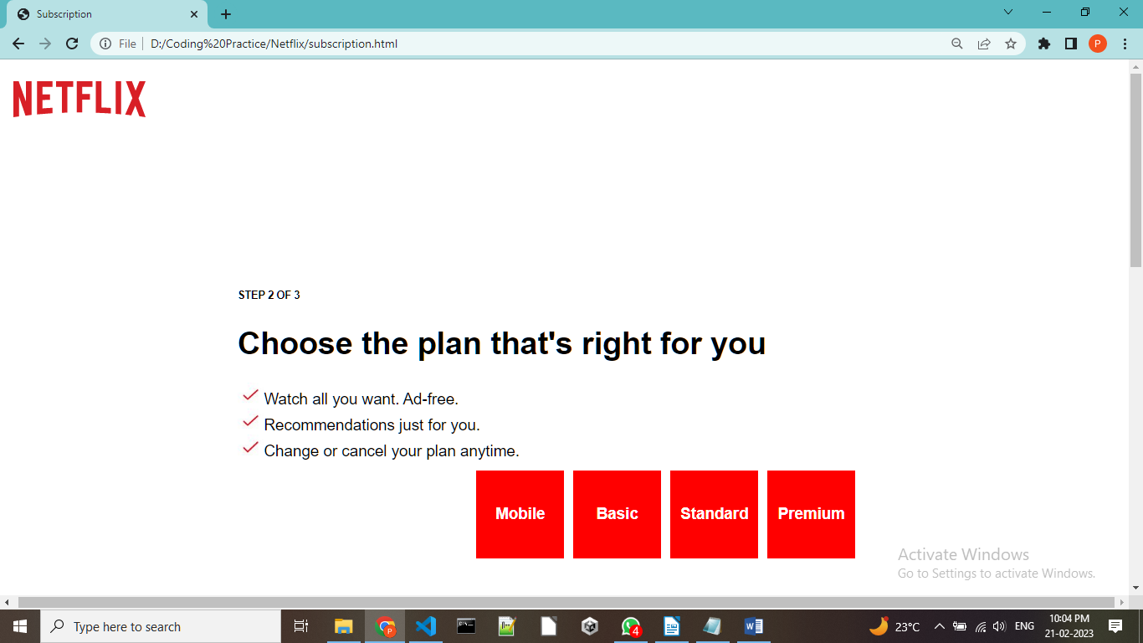

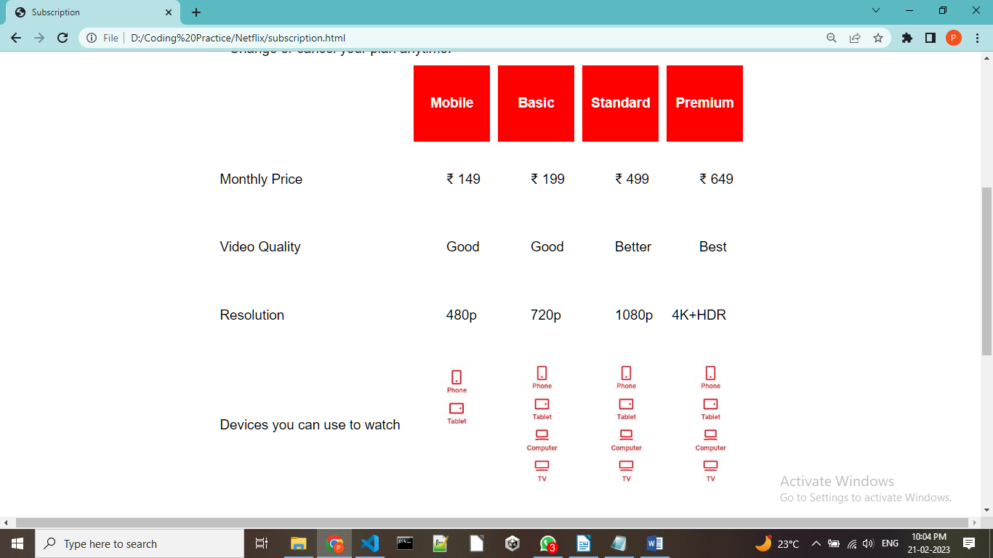

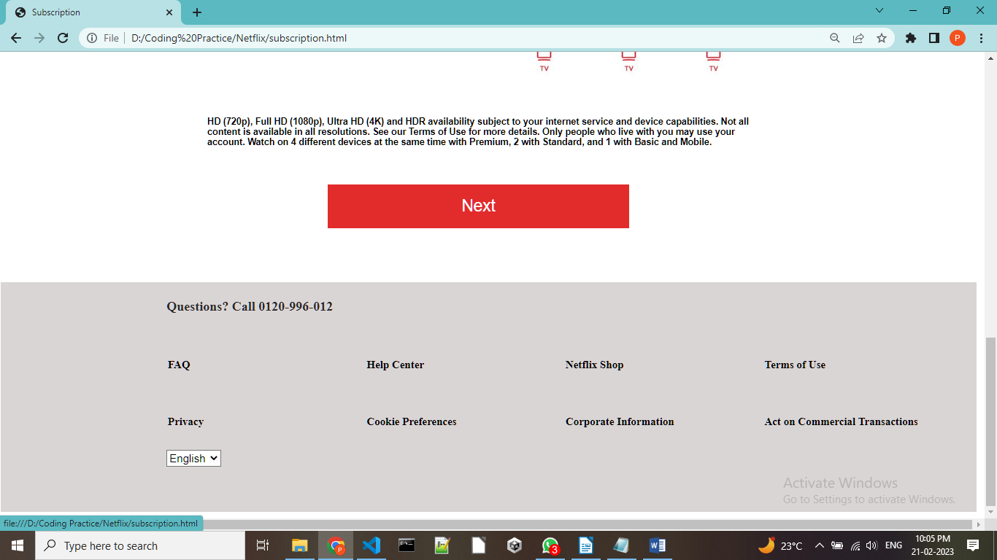

5.Payment.html

CODE:
<!DOCTYPE html>
<html lang="en">
<head>
<title>Payment</title>
</head>
<style>

.pay-footer{
height: 400px;
background-color: rgb(218, 213, 213);
color: white;
bottom: 0;
display: flex;
align-items: left;
flex-direction: column;
border: auto;
margin: 12px 0;
width: 100%;
padding-bottom: 20px;
position: relative;
}
.footer-items{
color: rgb(41, 39, 39);
padding-left: 17%;
padding-top: 12px;
justify-content: center;
}

#pay-container{
font-size: 25px;
padding-right: 15%;
justify-content: center;
align-items: center;
}
.pay-box{
min-height: 70vh;
background-color: white;
color: black;
font-family: 'Varela Round', sans-serif;
display: flex;
margin: 100px auto;
width: 700px;
height:750px;
justify-content: center;
padding-left: 90px;
text-align: center;
}
.logo{
padding-left: 20px;
padding-top: 20px;
}

a:link, a:visited {

color: black;
background-color: transparent;
text-decoration: none;
}
#button{
background-color: white;
color: black;
width: 500px;
height: 70px;
font-size: large;
text-align: left;
display:inline;
}
.selection{
height: 40px;
width: 170px;
float:left;
text-align: center;

margin: auto;
padding: 20px;
}
.logo-contianer{
float: right;
height: 30px;
width: 200px;
}

#form{
height: 30px;
width: 100px;
font-size: 20px;
}
#data-box{
text-align: left;
width: 360px;
height: 100px;
font-size: 20px;
}
</style>

<body>
<div class="logo">
<img src="LOGO.svg" width="190" height="60">
</div>
<div class="pay-box">
<div id="pay-container">
<h6>STEP 3 OF 3</h6>
<h1>Select Payment method</h1>
Your payment is encrypted and you can change the payment method at any time.
<br><br><b>Security for peace of mind.<br>Cancel easily online.</b><br><br>
<button id="button"><div class="selection"><a href="credit_form.html">Credit or Debit Card</a></div>
<div class="logo-container"><img src="cards.JPG" width="220px" height="60px"></div>
</button><br><br>
<button id="button"><div class="selection"><a href="upi_form.html">UPI Auto-Pay</a></div>
<div class="logo-container"><img src="upi.JPG"></div> </button>
</div>
</div>
<div class="pay-footer">
<div class="footer-items">
<h2>Questions? Call 0120-996-012</h2><br>
<table>
<tr>
<th id="data-box"><a href="">FAQ</a></th>
<th id="data-box"><a href="">Help Center</a></th>
<th id="data-box"><a href="">Netflix Shop</a></th>
<th id="data-box"><a href="">Terms of Use</a></th>
</tr>
<tr>
<th id="data-box"><a href="">Privacy</a></th>
<th id="data-box"><a href="">Cookie Preferences</a></th>
<th id="data-box"><a href="">Corporate Information</a></th>
<th id="data-box"><a href="">Act on Commercial Transactions</a></th>
</tr>
</table>
<form>
<select name="dropdown" id="form">
<option value="English">English</option>
<option value="Hindi">हिंदी</option>
<option value="Tamil">தமிழ்</option>
<option value="Telegu">తెలుగు</option>
</form>
</div>
</div>
</body>
</html>

Screenshots:

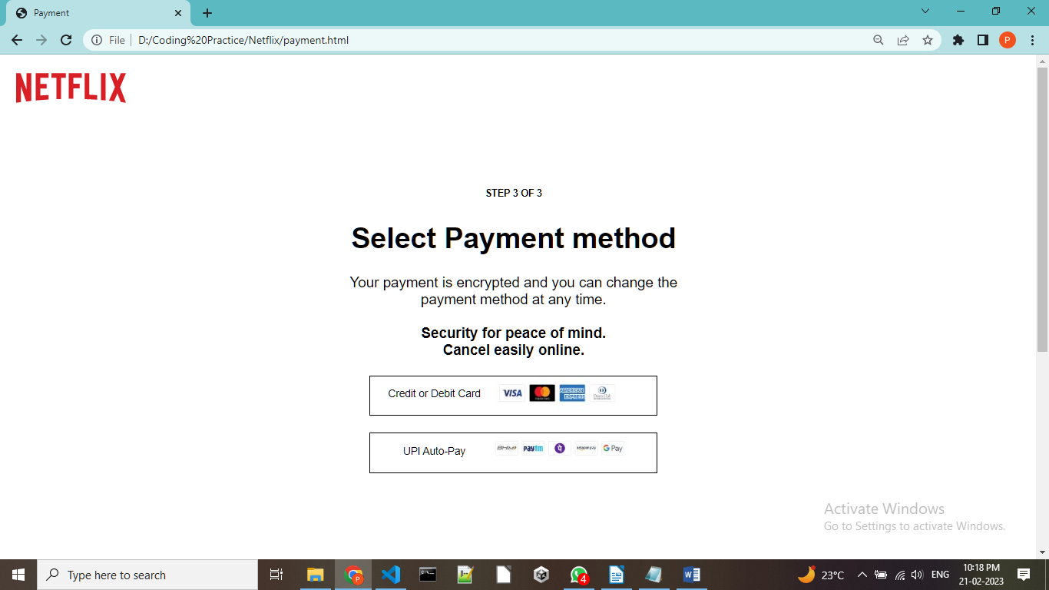
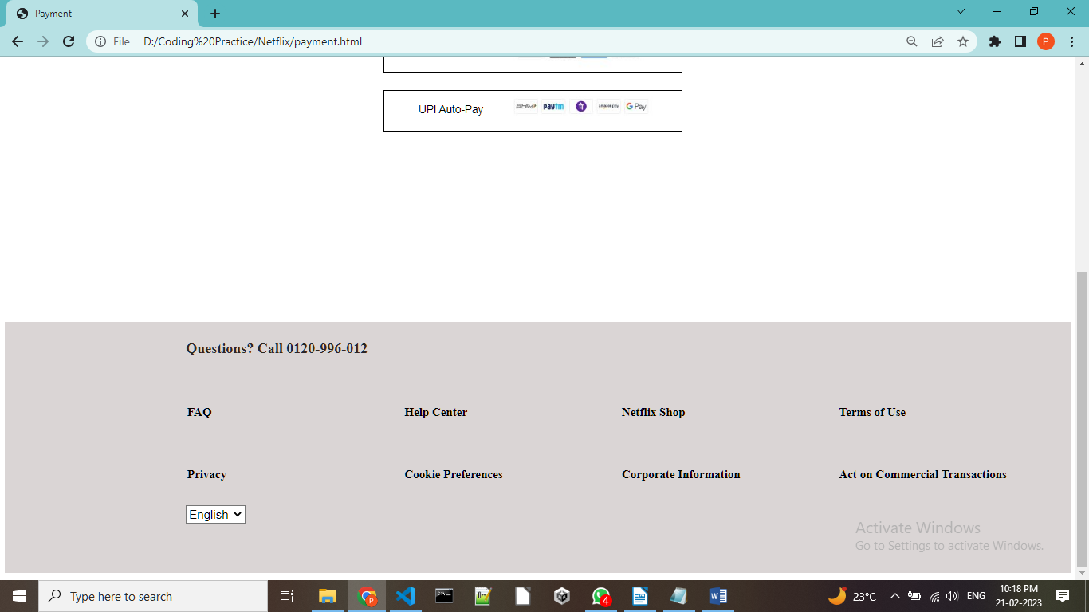

6.Credit_form.html:

CODE:
<!DOCTYPE html>
<html lang="en">
<head>
<title>Credit Card</title>
</head>
<style>

.card-footer{
height: 400px;
background-color: rgb(218, 213, 213);
color: white;
bottom: 0;
display: flex;
align-items: left;
flex-direction: column;
border: auto;
margin: 12px 0;
width: 100%;
padding-bottom: 20px;
position: relative;
}
.footer-items{
color: rgb(41, 39, 39);
padding-left: 17%;
padding-top: 12px;
justify-content: center;
}

#card-container{
font-size: 25px;
padding-right: 15%;
justify-content: center;
align-items: left;
text-align: left;
padding-bottom: 20%;
}
.card-box{
min-height: 70vh;
background-color: white;
color: black;
font-family: 'Varela Round', sans-serif;
display: flex;
margin: 100px auto;
width: 40%;
height: 50%;
border-radius: 12px;
justify-content: center;
padding-left: 90px;
text-align: center;
}
#button{
background-color: rgb(226, 43, 43);
color:white;
font-size: larger;
height: 80px;
width: 100%;
border: 0px;
}
.logo{
padding-left: 20px;
padding-top: 20px;
}
#input{
height: 75px;
width: 98%;
background-color: white;
border-radius: 5px;
font-size: 25px;
color: black;
}
::placeholder {
padding: 24px;
font-size: 25px;
}
a:link , a:visited {
color: black;
background-color: transparent;
text-decoration: none;
}
.price{
width: 720px;
height: 100px;
background-color: rgb(168, 167, 167);
text-align: center;
align-items: center;
padding-top: 20px;
}
#form{
height: 30px;
width: 100px;
font-size: 20px;
}
#data-box{
text-align: left;
width: 360px;
height: 100px;
font-size: 20px;
}
#membership{
color: white;
}
</style>

<body>
<div class="logo">
<img src="LOGO.svg" width="190" height="60">
</div>
<div class="card-box">
<div id="card-container">
<h6>STEP 3/3</h6>
<div id="des1"><h1>Setup your credit or debit card</h1></div>
<img src="cards.JPG" width="220" height="60">
<form>
<input id="input" type="text" name="Name" placeholder="Name"/><br><br>
<input id="input" type="text" name="Surname" placeholder="Surname"/><br><br>
<input id="input" type="number" name="Card Number" placeholder="Card Number"/><br><br>
<input id="input" input type="text" placeholder="MM/YYYY" onfocus="(this.type='month')" name="Expiry Date" placeholder="Expiry Date (MM/YY)"/><br><br>
<input id="input" type="number" name="CVV" placeholder="Security Code (CVV)"/><br><br>
<br>
<div class="price">
₹649/month<br>
premium plan
</div>
</form>
<h5> All payments above ₹ 2000 will require an additional authentication.
<br><br>By clicking the checkbox below, you agree to our Terms of Use , Privacy Statement and that you are over 18. Netflix will automatically continue your membership and charge your membership fee (currently ₹649/month) to your payment method until you cancel it. You can cancel your membership at any time to avoid future charges.</h5>
<button id="button"><a id="membership" href=" ">Start Membership</a></button><br>
</div>
</div>
<div class="card-footer">
<div class="footer-items">
<h2>Questions? Call 0120-996-012</h2><br>
<table>
<tr>
<th id="data-box"><a href="">FAQ</a></th>
<th id="data-box"><a href="">Help Center</a></th>
<th id="data-box"><a href="">Netflix Shop</a></th>
<th id="data-box"><a href="">Terms of Use</a></th>
</tr>
<tr>
<th id="data-box"><a href="">Privacy</a></th>
<th id="data-box"><a href="">Cookie Preferences</a></th>
<th id="data-box"><a href="">Corporate Information</a></th>
<th id="data-box"><a href="">Act on Commercial Transactions</a></th>
</tr>
</table>
<form>
<select name="dropdown" id="form">
<option value="English">English</option>
<option value="Hindi">हिंदी</option>
<option value="Tamil">தமிழ்</option>
<option value="Telegu">తెలుగు</option>
</form>
</div>
</div>
</body>
</html>

Screenshots:

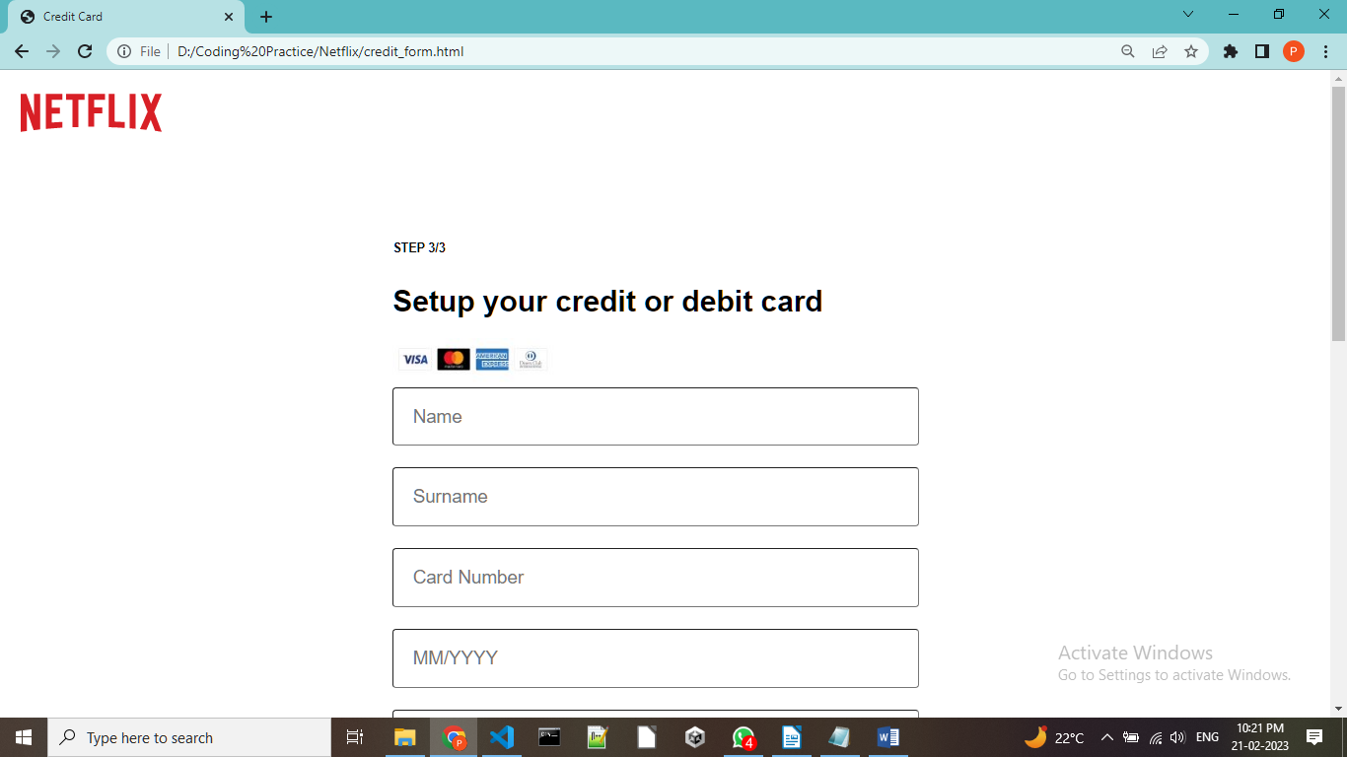

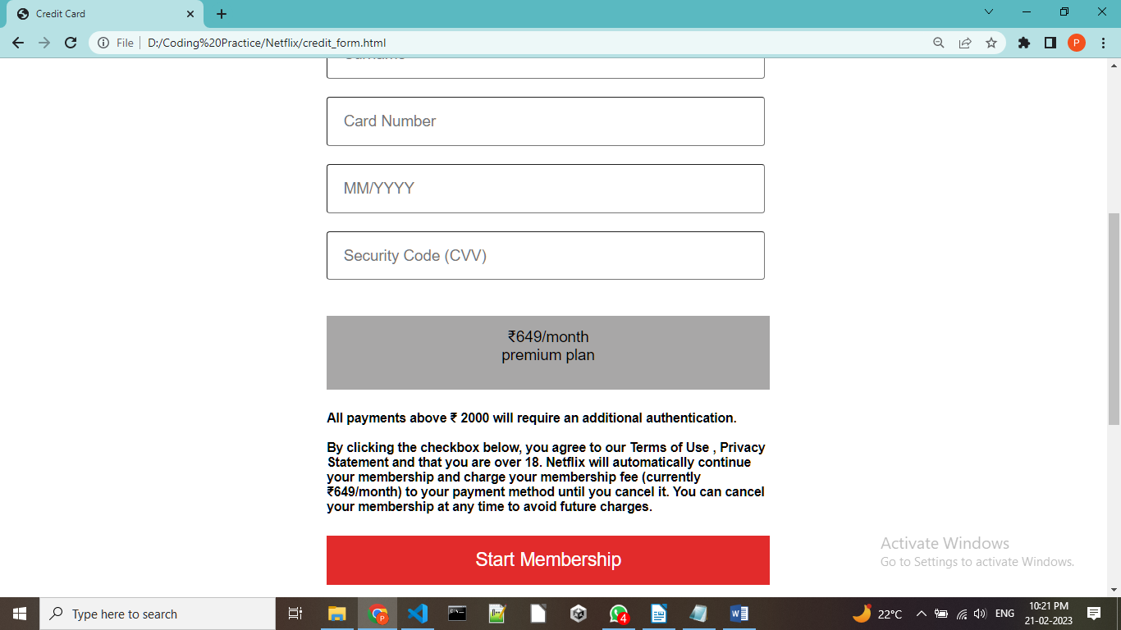

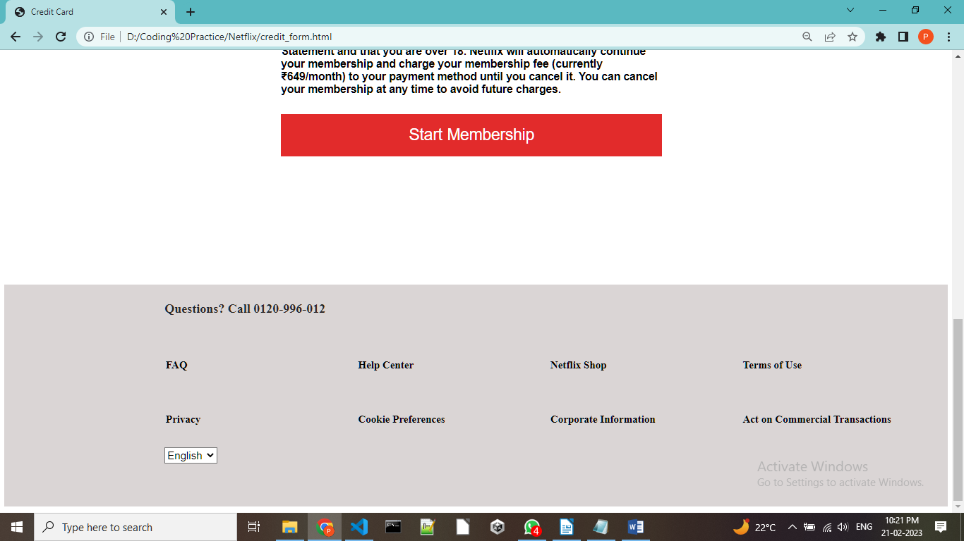

7.UPI_From.html:

CODE:
<!DOCTYPE html>
<html lang="en">
<head>
<title>UPI</title>
</head>
<style>

.upi-footer{
height: 400px;
background-color: rgb(218, 213, 213);
color: white;
bottom: 0;
display: flex;
align-items: left;
flex-direction: column;
border: auto;
margin: 12px 0;
width: 100%;
padding-bottom: 20px;
position: relative;
}
.footer-items{
color: rgb(41, 39, 39);
padding-left: 17%;
padding-top: 12px;
justify-content: center;
}

#upi-container{
font-size: 25px;
padding-right: 15%;
justify-content: center;
align-items: left;
text-align: left;
padding-bottom: 20%;
}
.upi-box{
min-height: 70vh;
background-color: white;
color: black;
font-family: 'Varela Round', sans-serif;
display: flex;
margin: 100px auto;
width: 35%;
height: 50%;
border-radius: 12px;
justify-content: center;
padding-left: 90px;
text-align: center;
}
#button{
background-color: rgb(226, 43, 43);
color:white;
font-size: larger;
height: 80px;
width: 100%;
border: 0px;
}
.logo{
padding-left: 20px;
padding-top: 20px;
}

#input{
height: 75px;
width: 98%;
background-color: white;
border-radius: 5px;
font-size: 25px;
color: black;
}
::placeholder {
padding: 24px;
font-size: 25px;
}
a:link , a:visited {
color: black;
background-color: transparent;
text-decoration: none;
}

#form{
height: 80px;
width: 527px;
font-size: 20px;
}
#form1{
height: 30px;
width: 100px;
font-size: 20px;
}
#data-box{
text-align: left;
width: 360px;
height: 100px;
font-size: 20px;
}
#goahead{
color: white;
}
</style>

<body>
<div class="logo">
<img src="LOGO.svg" width="190" height="60">
</div>
<div class="upi-box">
<div id="upi-container">
<h6>STEP 3/3</h6>
<div id="des1"><h1>Setup UPI AutoPay.</h1></div>
<div id="des2">You can update your periodic payments at any time in your settings.</div>
<form>
<select name="dropdown" id="form">
<option value="select" >Select your UPI app</option>
<option value="paytmstyle="background-image:url(paytm.png)">Paytm</option>
<option value="Gpay">Google Pay</option>
<option value="PhonePe">PhonePe</option>
<option value="Amazon Pay">Amazon Pay</option>
</select><br><br>

<input id="input" type="password" name="Pass" placeholder="Add a Password"/><br><br><br>
</form>
<button id="button"><a id="goahead"href=" ">Go Ahead</a></button><br>
</div>
</div>
<div class="upi-footer">
<div class="footer-items">
<h2>Questions? Call 0120-996-012</h2><br><table>
<tr>
<th id="data-box"><a href="">FAQ</a></th>
<th id="data-box"><a href="">Help Center</a></th>
<th id="data-box"><a href="">Netflix Shop</a></th>
<th id="data-box"><a href="">Terms of Use</a></th>
</tr>
<tr>
<th id="data-box"><a href="">Privacy</a></th>
<th id="data-box"><a href="">Cookie Preferences</a></th>
<th id="data-box"><a href="">Corporate Information</a></th>
<th id="data-box"><a href="">Act on Commercial Transactions</a></th>
</tr>
</table>
<form>
<select name="dropdown" id="form1">
<option value="English">English</option>
<option value="Hindi">हिंदी</option>
<option value="Tamil">தமிழ்</option>
<option value="Telegu">తెలుగు</option>
</form>
</div>
</div>
</body>
</html>

Screenshots:

