AIM:
To write a Flex program to identify and display HTML tags from a given HTML input file.

PSEUDOCODE:
- Start the program.
- Define a pattern to recognize HTML tags.
- Open the HTML input file.
- Read the file using the Flex scanner.
- Identify and display the HTML tags.
- Continue until the end of the file.
- Close the input file.
- Stop the program.

PROGRAM:
%{
#include <stdio.h>
%}

%%
\<\/?[A-Za-z][A-Za-z0-9]*[^<>]*\> {
printf("HTML Tag: %s\n", yytext);
}

.|\n ;
%%

int main(int argc, char *argv[])
{
if (argc > 1)
{
yyin = fopen(argv[1], "r");

if (yyin == NULL)
{
printf("Cannot open input file!\n");
return 1;
}
}

printf("HTML Tags:\n");
yylex();

if (argc > 1)
fclose(yyin);

return 0;
}

int yywrap(void)
{
return 1;
}

SAMPLE INPUT:

<html>

<head>

<title>My Page</title>

</head>

<body>

<h1>Hello World</h1>

<p>Welcome to HTML</p>

</body>

</html>

SAMPLE OUTPUT:

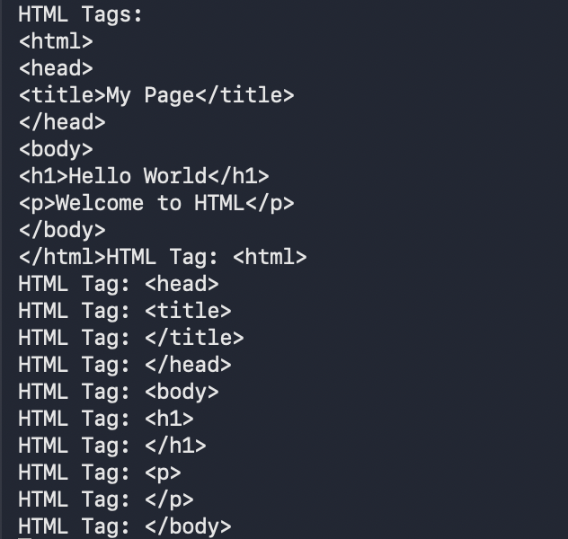

RESULT:
Thus, the Flex program was successfully implemented to identify and display HTML tags from the given input file.

