AIM:
To write a Lex program to replace the word “hello” with “hi” in the given input text.

PSEUDOCODE:
- Start the program.
- Read the input text.
- Search for the word “hello”.
- Replace each occurrence of “hello” with “hi”.
- Print the modified text.
- Stop the program.

PROGRAM:
%{
#include <stdio.h>
%}

%%
hello { printf("hi"); }
. { ECHO; }
\n { ECHO; }
%%

int yywrap()
{
return 1;
}

int main()
{
yylex();
return 0;
}

SAMPLE INPUT:

hello everyone

welcome to hello world

SAMPLE OUTPUT:

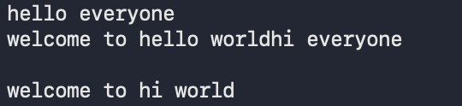

RESULT:
Thus, the Lex program was successfully implemented to replace the word “hello” with “hi” in the given input text.

