**Background:**

The Application is created using **Visual Studio 2019**.

An EmployeeInfo table is created under the MyEmployeeDB database. I utilized **Entity Framework** code first approach to store and access data in the **SQL Server Database.** I utilized SQL Server Management studio as well for proper data management.

The Datagridview is connected the database and records can be added, updated and deleted using the required buttons.Double Click of a record will populate the Name and Job Title field with the selected record and a thus row can be updated. Deletion can also be done directly from the datagrid and a warning message is prompted to confirm the delete.There will be notification after each button action.

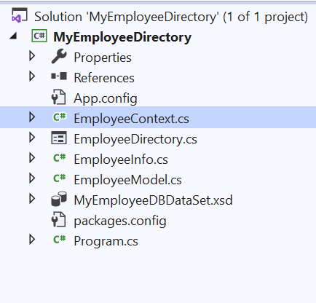EmployeeInfo.cs is the database context class.

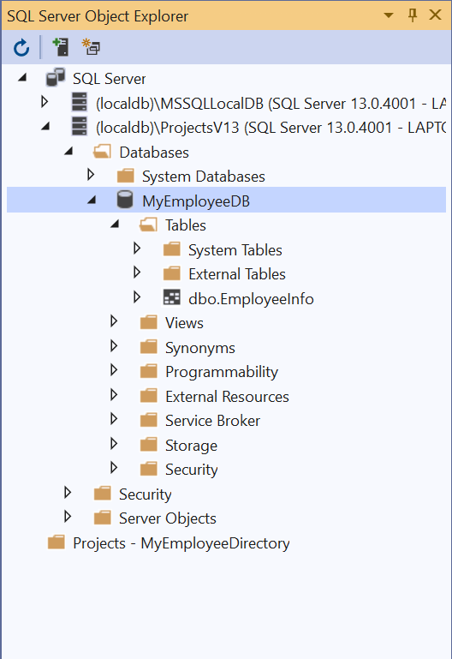 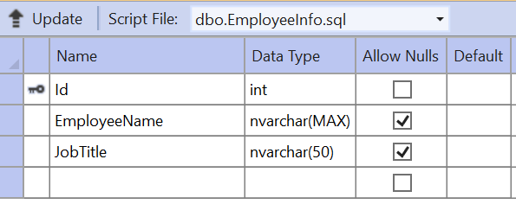

**Insert a record**

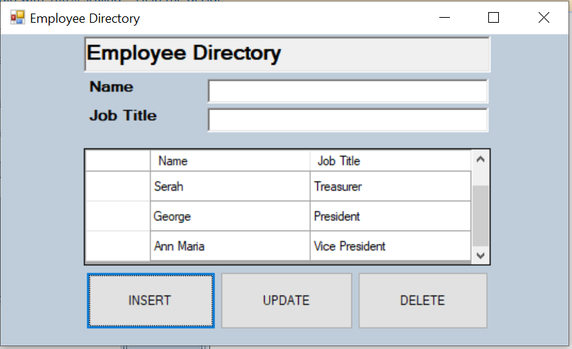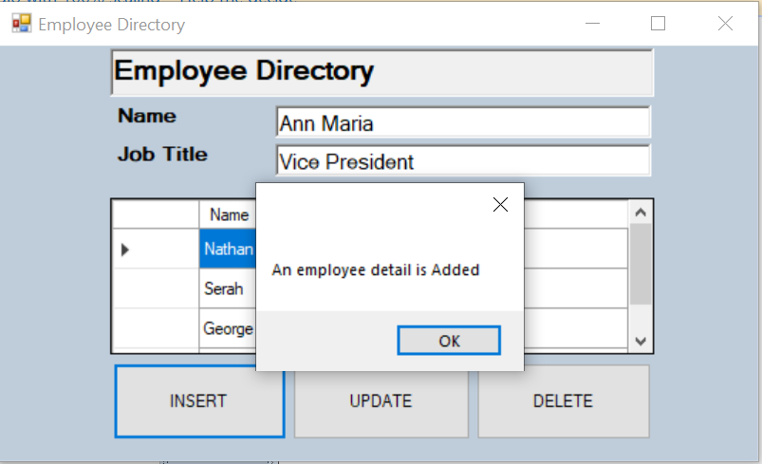

**Update a record**

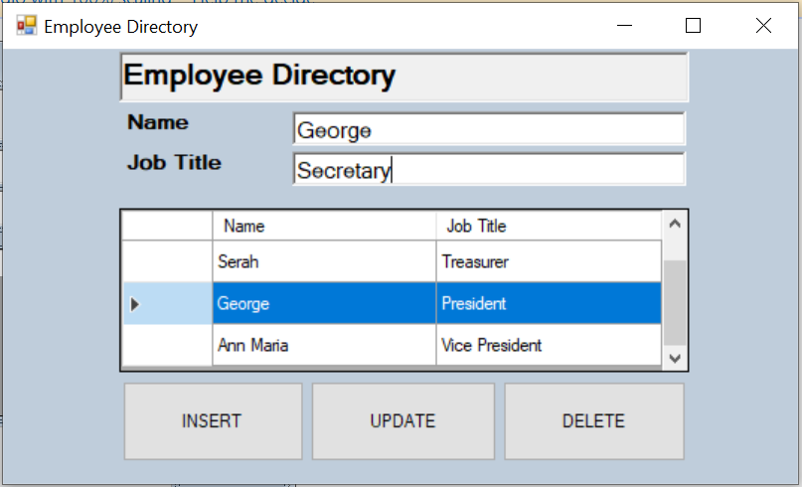

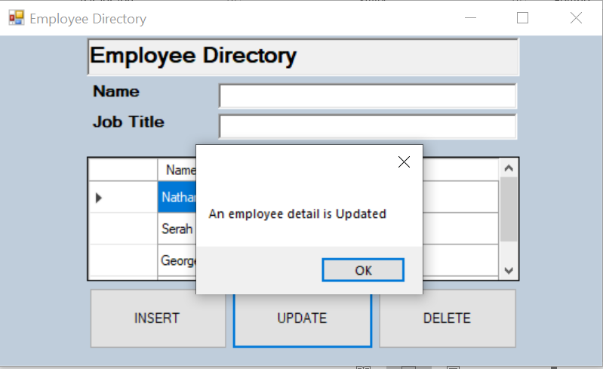

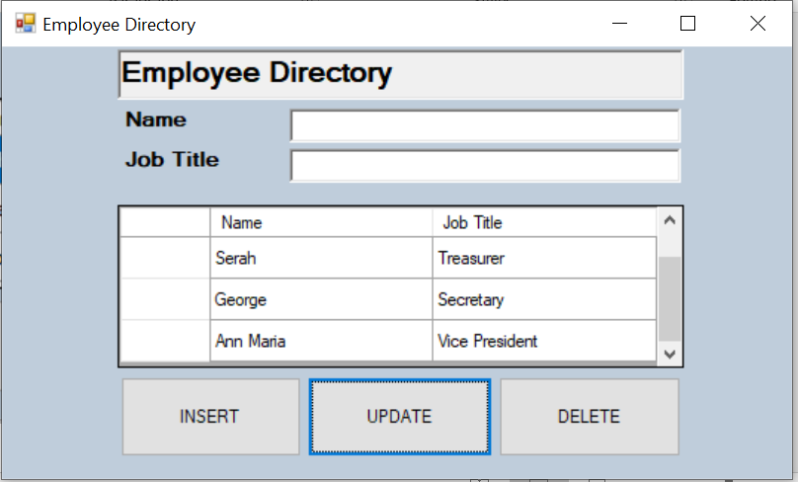

**Delete a record**

