ПРИЛОЖЕНИЕ А
Схема архитектуры приложения
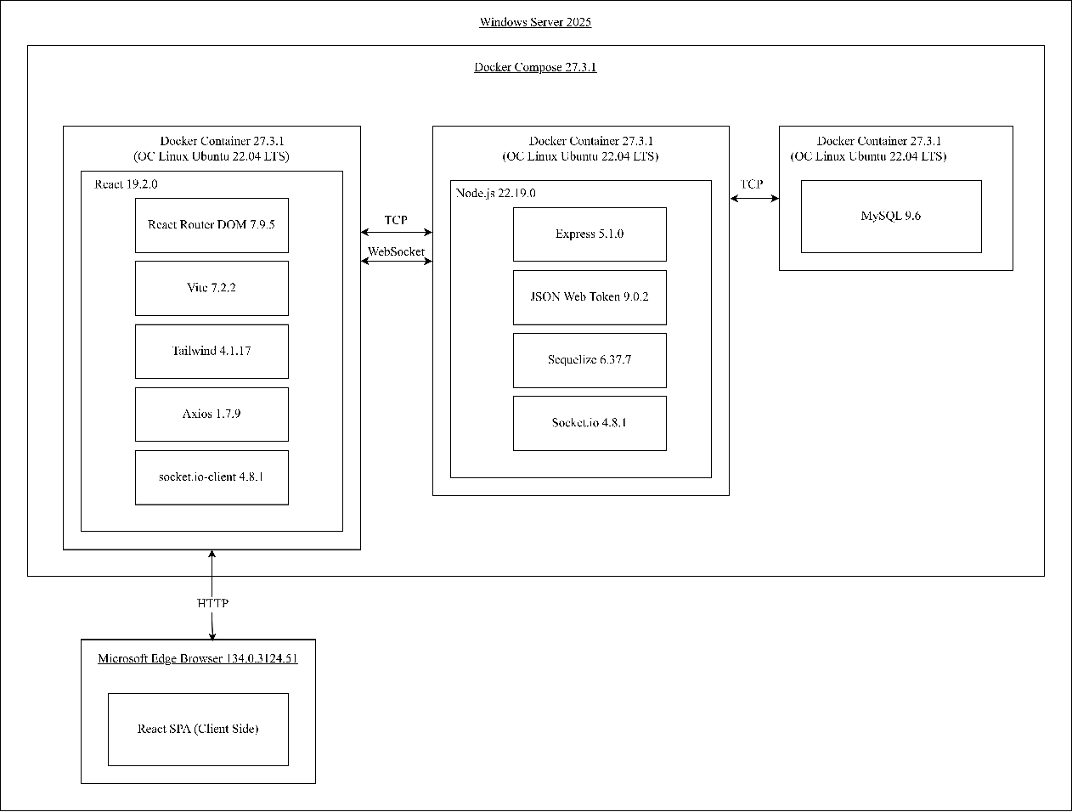

ПРИЛОЖЕНИЕ Б
Реализация создания отклика на заказ или услугу
exports.createApplication = async (req, res) => {
try {
const currentUser = req.user;
const { orderId, serviceId, message, proposedPrice } = req.body;
if (!orderId && !serviceId) {
return res.status(400).send({ message: "Необходимо указать orderId или serviceId" });
}
if (orderId && serviceId) {
return res.status(400).send({ message: "Укажите только orderId или serviceId" });
}
if (orderId) {
const order = await Order.findByPk(orderId);
if (!order) {
return res.status(404).send({ message: "Заказ не найден" });
}
if (order.customerId === currentUser.id) {
return res.status(403).send({ message: "Вы не можете откликнуться на свой заказ" });
}
}
if (serviceId) {
const service = await Service.findByPk(serviceId);
if (!service) {
return res.status(404).send({ message: "Услуга не найдена" });
}
if (service.executerId === currentUser.id) {
return res.status(403).send({ message: "Вы не можете откликнуться на свою услугу" });
}
}
const existing = await Application.findOne({
where: {
userId: currentUser.id,
[Op.or]: [
{ orderId: orderId || null },
{ serviceId: serviceId || null }
]
}
});

if (existing) {
return res.status(400).send({ message: "Вы уже откликнулись на этот заказ/услугу" });
}
const application = await Application.create({
userId: currentUser.id,
orderId: orderId || null,
serviceId: serviceId || null,
message: message || null,
proposedPrice: proposedPrice || null
});
const applicationWithRelations = await Application.findByPk(application.id, {
include: [
{ model: User, as: "user", attributes: ["id", "username", "email"] },
{ model: Order, as: "order" },
{ model: Service, as: "service" }
]
});
if (orderId) {
const order = await Order.findByPk(orderId);
if (order) {
await createNotification(
order.customerId,
'new_application',
'Новый отклик на ваш заказ',
`Пользователь ${currentUser.username} откликнулся на ваш заказ "${order.title}"`,
application.id,
'application'
);
}
} else if (serviceId) {
const service = await Service.findByPk(serviceId);
if (service) {
await createNotification(
service.executerId,
'new_application',
'Новый отклик на вашу услугу',
`Пользователь ${currentUser.username} откликнулся на вашу услугу "${service.title}"`,
application.id,
'application'
);
}
}
res.status(201).send(applicationWithRelations);
} catch (error) {
console.error(error);
res.status(500).send({ message: error.message });
}
};

ПРИЛОЖЕНИЕ В
Модели серверной части
const { PASSWORD } = require("../../config/db.config");
module.exports = (sequelize, Sequelize) => {
const User = sequelize.define("users", {
username: {
type: Sequelize.STRING
},
email: {
type: Sequelize.STRING
},
password: {
type: Sequelize.STRING
},
isBlocked: {
type: Sequelize.BOOLEAN,
defaultValue: false
},
lastSeen: {
type: Sequelize.DATE,
allowNull: true
}
});
return User;}
Листинг 1 – Модель пользователя
module.exports = (sequilize, Sequelize) => {
const Role = sequilize.define("roles", {
id: {
type: Sequelize.INTEGER,
primaryKey: true
},
name: {
type: Sequelize.STRING
}
});
return Role;
}
Листинг 2 – Модель пользователя

ПРИЛОЖЕНИЕ Г
Система маршрутизации клиентской части
return (
<Router>
<Navbar />
<Routes>
<Route path="/login" element={<Login />} />
<Route path="/register" element={<Register />} />
<Route path="/verify/:token" element={<Verify />} />
<Route path="/verify" element={<Verify />} />
<Route
path="/catalog"
element={
<ProtectedRoute allowPublic={true}>
<Catalog />
</ProtectedRoute>
}
/>
<Route
path="/orders/:id"
element={
<ProtectedRoute allowPublic={true}>
<OrderDetail />
</ProtectedRoute>
}
/>
<Route
path="/services/:id"
element={
<ProtectedRoute allowPublic={true}>
<ServiceDetail />
</ProtectedRoute>
}
/>
<Route
path="/profile/:id"
element={
<ProtectedRoute allowPublic={true}>
<WorkProfile />
</ProtectedRoute>
}
/>

<Route
path="/"
element={
<ProtectedRoute>
<Home />
</ProtectedRoute>
}
/>

ПРИЛОЖЕНИЕ Д
Сервис администратора
import axios from "axios";
const API_URL = "http://localhost:8080/";
const getAuthHeaders = () => {
const user = localStorage.getItem("user");
if (user) {
const userData = JSON.parse(user);
return {
Authorization: `Bearer ${userData.accessToken}`,
};
}
return {};
};
const blockUser = (userId: number) => {
return axios.put(API_URL + `admin/users/${userId}/block`, {}, {
headers: getAuthHeaders(),
withCredentials: true,
});
};
const unblockUser = (userId: number) => {
return axios.put(API_URL + `admin/users/${userId}/unblock`, {}, {
headers: getAuthHeaders(),
withCredentials: true,
});
};
const getAllUsers = () => {
return axios.get(API_URL + "admin/users", {
headers: getAuthHeaders(),
withCredentials: true,
});
};
const AdminService = {
blockUser,
unblockUser,
getAllUsers,
};
export default AdminService;

ПРИЛОЖЕНИЕ Е
WebSocket-коммуникация и управление состоянием
import { io, Manager, Socket } from "socket.io-client";
import AuthService from "./auth.service";
class WebSocketService {
private socket: Socket | null = null;
private reconnectAttempts = 0;
private maxReconnectAttempts = 5;
private isConnecting = false;
connect() {
const currentUser = AuthService.getCurrentUser();
if (!currentUser) {
return;
}
if (this.socket?.connected || this.isConnecting) {
return;
}
if (this.socket && !this.socket.connected) {
this.socket.disconnect();
this.socket = null;
}
this.isConnecting = true;
const token = currentUser.accessToken;
this.socket = io("http://localhost:8080", {
auth: {
token: token,
},
transports: ["websocket", "polling"],
reconnection: true,
reconnectionDelay: 1000,
reconnectionDelayMax: 5000,
reconnectionAttempts: this.maxReconnectAttempts,
timeout: 10000,
forceNew: false,
});
this.socket.on("connect", () => {
console.log("WebSocket connected");
this.reconnectAttempts = 0;
this.isConnecting = false;
});
this.socket.on("disconnect", (reason) => {
console.log("WebSocket disconnected:", reason);
this.isConnecting = false;
if (
reason === "io client disconnect" ||
reason === "io server disconnect"
) {
this.socket = null;
}
});
this.socket.on("connect_error", (error) => {
if (this.reconnectAttempts === 0) {
console.warn("WebSocket connection error:", error.message);
}
this.isConnecting = false;
this.reconnectAttempts++;
if (this.reconnectAttempts >= this.maxReconnectAttempts) {
console.warn(
"Max reconnection attempts reached. WebSocket will not reconnect automatically."
);
if (this.socket) {
}
}
});
}
disconnect() {
if (this.socket) {
this.socket.disconnect();
this.socket.removeAllListeners();
this.socket = null;
}
this.isConnecting = false;
this.reconnectAttempts = 0;
}
getSocket(): Socket | null {
return this.socket;
}
isConnected(): boolean {
return this.socket?.connected || false;
}
subscribeToChat(chatId: number) {
if (this.socket) {
this.socket.emit("subscribe_chat", chatId);
}
}
unsubscribeFromChat(chatId: number) {
if (this.socket) {
this.socket.emit("unsubscribe_chat", chatId);
}
}
onNewMessage(callback: (message: any) => void) {
if (this.socket) {
this.socket.on("new_message", callback);
}
}
offNewMessage(callback?: (message: any) => void) {
if (this.socket) {
if (callback) {
this.socket.off("new_message", callback);
} else {
this.socket.off("new_message");
}
}
}
onChatsUpdated(callback: () => void) {
if (this.socket) {
this.socket.on("chats_list_updated", callback);
}
}
offChatsUpdated(callback?: () => void) {
if (this.socket) {
if (callback) {
this.socket.off("chats_list_updated", callback);
} else {
this.socket.off("chats_list_updated");
}
}
}
onChatUpdated(callback: (data: { chatId: number }) => void) {
if (this.socket) {
this.socket.on("chat_updated", callback);
}
}
offChatUpdated(callback?: (data: { chatId: number }) => void) {
if (this.socket) {
if (callback) {
this.socket.off("chat_updated", callback);
} else {
this.socket.off("chat_updated");
}
}
}
onNotification(callback: (notification: any) => void) {
if (this.socket) {
this.socket.on("new_notification", callback);
}
}
offNotification(callback?: (notification: any) => void) {
if (this.socket) {
if (callback) {
this.socket.off("new_notification", callback);
} else {
this.socket.off("new_notification");
}
}
}
onNotificationsUpdated(callback: () => void) {
if (this.socket) {
this.socket.on("notifications_updated", callback);
}
}
offNotificationsUpdated(callback?: () => void) {
if (this.socket) {
if (callback) {
this.socket.off("notifications_updated", callback);
} else {
this.socket.off("notifications_updated");
}
}
}
on(event: string, callback: (...args: any[]) => void) {
if (this.socket) {
this.socket.on(event, callback);
}
}
off(event: string, callback?: (...args: any[]) => void) {
if (this.socket) {
if (callback) {
this.socket.off(event, callback);
} else {
this.socket.off(event);
}
}
}
}
const websocketService = new WebSocketService();
export default websocketService;

ПРИЛОЖЕНИЕ Ж
Docker-файлы для сборки проекта
FROM node:20-alpine
WORKDIR /app
COPY package*.json ./
RUN npm install
COPY backend/ ./backend/
COPY config/ ./config/
WORKDIR /app/backend
EXPOSE 8080
CMD ["node", "server.js"]
Листинг 1 – Docker-файл для backend части
FROM node:20-alpine
WORKDIR /app
COPY package*.json ./
RUN npm install
COPY . .
EXPOSE 3000
CMD ["npm", "run", "dev", "--", "--host"]
Листинг 2 – Docker-файл для frontend части

