T1
Windows:
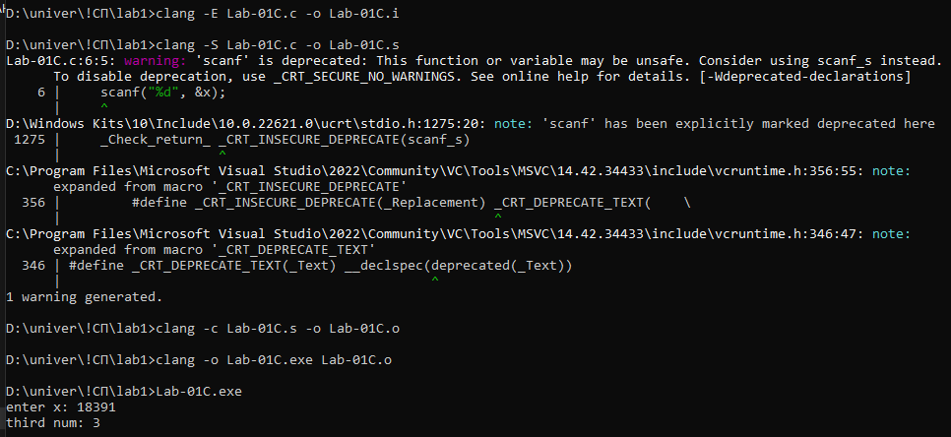
Linux:
daria@DESKTOP-2DSGURS:~$ cd t1
daria@DESKTOP-2DSGURS:~/t1$ sudo clang -E Lab-01C.c -o Lab-01C.i
[sudo] password for daria: 1111
daria@DESKTOP-2DSGURS:~/t1$ sudo clang -E Lab-01C.c -o Lab-01C.i
daria@DESKTOP-2DSGURS:~/t1$ sudo clang -S Lab-01C.i -o Lab-01C.s
daria@DESKTOP-2DSGURS:~/t1$ sudo clang -c Lab-01C.s -o Lab-01C.o
daria@DESKTOP-2DSGURS:~/t1$ sudo clang Lab-01C.o -o Lab-01C.out

T2
Windows:
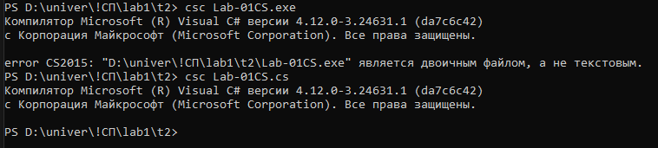
Linux:
daria@DESKTOP-2DSGURS:~/t1$ cd ..
daria@DESKTOP-2DSGURS:~$ cd t2
daria@DESKTOP-2DSGURS:~/t2$ sudo apt install -y dotnet-sdk-8.0
daria@DESKTOP-2DSGURS:~/t2$ dotnet --version
8.0.112
daria@DESKTOP-2DSGURS:~/t2$ sudo dotnet new console -n Lab-01CS
daria@DESKTOP-2DSGURS:~/t2$ cd Lab-01CS
daria@DESKTOP-2DSGURS:~/t2/Lab-01CS$ sudo dotnet run
daria@DESKTOP-2DSGURS:~/t2/Lab-01CS$ sudo dotnet run
enter x: 9147
third num: 1
daria@DESKTOP-2DSGURS:~/t2/Lab-01CS$ cd bin
daria@DESKTOP-2DSGURS:~/t2/Lab-01CS/bin$ cd Debug
daria@DESKTOP-2DSGURS:~/t2/Lab-01CS/bin/Debug$ cd net8.0
daria@DESKTOP-2DSGURS:~/t2/Lab-01CS/bin/Debug/net8.0$ ./Lab-01CS
enter x: 1371
third num: 3

T3
Windows:
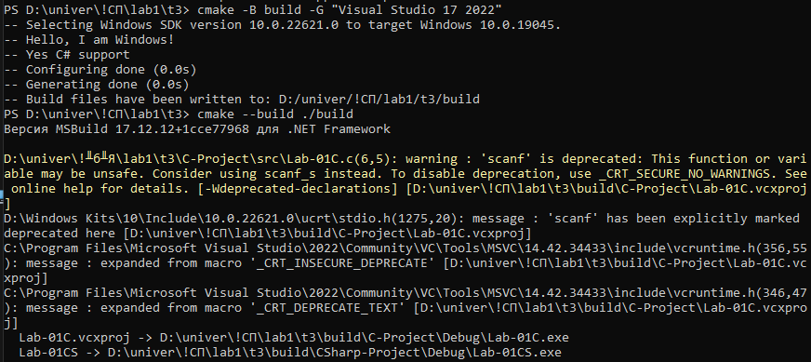
Linux:
daria@DESKTOP-2DSGURS:~$ cd t3
daria@DESKTOP-2DSGURS:~/t3$ sudo cmake -B out/linuxBuild -G "Unix Makefiles" DCMAKE_C_COMPILER=clang
daria@DESKTOP-2DSGURS:~/t3$ sudo cmake --build ./out/linuxBuild
daria@DESKTOP-2DSGURS:~/t3$ cmake --version
cmake version 3.28.3
daria@DESKTOP-2DSGURS:~/t3$ cd out/ linuxBuild
daria@DESKTOP-2DSGURS:~/t3/out/linuxBuild$ sudo cmake --build .
daria@DESKTOP-2DSGURS:~/t3/out/linuxBuild$ cd C-Project
daria@DESKTOP-2DSGURS:~/t3/out/linuxBuild/C-Project$ ./Lab-01C
enter x: 137113131
third num: 1
daria@DESKTOP-2DSGURS:~/t3/out/linuxBuild/C-Project$

