T1

**Windows:**

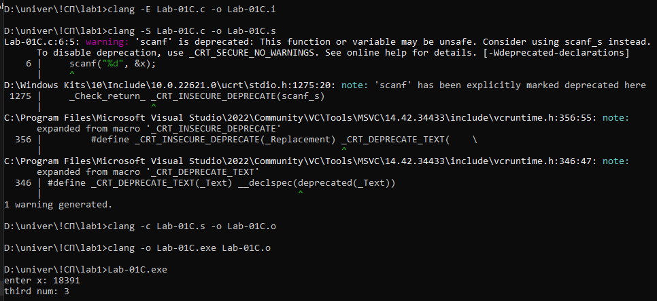

**Linux:**

daria@DESKTOP-2DSGURS:~$ cd t1

daria@DESKTOP-2DSGURS:~/t1$ sudo clang -E Lab-01C.c -o Lab-01C.i

[sudo] password for daria: 1111

daria@DESKTOP-2DSGURS:~/t1$ sudo clang -E Lab-01C.c -o Lab-01C.i

daria@DESKTOP-2DSGURS:~/t1$ sudo clang -S Lab-01C.i -o Lab-01C.s

daria@DESKTOP-2DSGURS:~/t1$ sudo clang -c Lab-01C.s -o Lab-01C.o

daria@DESKTOP-2DSGURS:~/t1$ sudo clang Lab-01C.o -o Lab-01C.out

T2

**Windows:**

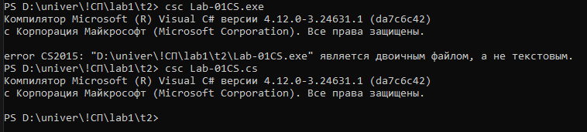

**Linux:**

daria@DESKTOP-2DSGURS:~/t1$ cd ..

daria@DESKTOP-2DSGURS:~$ cd t2

daria@DESKTOP-2DSGURS:~/t2$ sudo apt install -y dotnet-sdk-8.0

daria@DESKTOP-2DSGURS:~/t2$ dotnet --version

8.0.112

daria@DESKTOP-2DSGURS:~/t2$ sudo dotnet new console -n Lab-01CS

daria@DESKTOP-2DSGURS:~/t2$ cd Lab-01CS

daria@DESKTOP-2DSGURS:~/t2/Lab-01CS$ sudo dotnet run

daria@DESKTOP-2DSGURS:~/t2/Lab-01CS$ sudo dotnet run

enter x: 9147

third num: 1

daria@DESKTOP-2DSGURS:~/t2/Lab-01CS$ cd bin

daria@DESKTOP-2DSGURS:~/t2/Lab-01CS/bin$ cd Debug

daria@DESKTOP-2DSGURS:~/t2/Lab-01CS/bin/Debug$ cd net8.0

daria@DESKTOP-2DSGURS:~/t2/Lab-01CS/bin/Debug/net8.0$ ./Lab-01CS

enter x: 1371

third num: 3

T3

**Windows:**

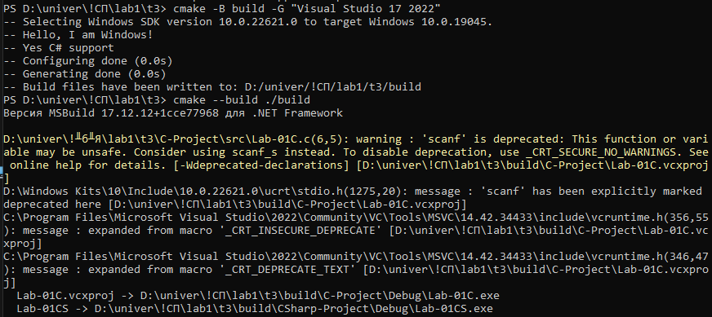

**Linux:**

daria@DESKTOP-2DSGURS:~$ cd t3

daria@DESKTOP-2DSGURS:~/t3$ sudo cmake -B out/linuxBuild -G "Unix Makefiles" DCMAKE_C_COMPILER=clang

daria@DESKTOP-2DSGURS:~/t3$ sudo cmake --build ./out/linuxBuild

daria@DESKTOP-2DSGURS:~/t3$ cmake --version

cmake version 3.28.3

daria@DESKTOP-2DSGURS:~/t3$ cd out/ linuxBuild

daria@DESKTOP-2DSGURS:~/t3/out/linuxBuild$ sudo cmake --build .

daria@DESKTOP-2DSGURS:~/t3/out/linuxBuild$ cd C-Project

daria@DESKTOP-2DSGURS:~/t3/out/linuxBuild/C-Project$ ./Lab-01C

enter x: 137113131

third num: 1

daria@DESKTOP-2DSGURS:~/t3/out/linuxBuild/C-Project$