Mobile Assignment Two – Math Game v1.0
<SamOLeary/DNET4/somhairle.olaoire@mycit.ie>
Design and implement an Android App that is a Maths game for children. The app ‘thinks’ of two numbers to add/subtract etc and the child must enter the answer. The app should include the following:

  - Basic functionality that addresses App’s purpose: at least 3 Activities and navigation between them. Simple UI components e.g. TextView, EditText & Button.

  - Use of 3 different layout managers on the 3 activities e.g. LinearLayout, TableLayout, RelativeLayout, FrameLayout etc.

  - Use a scoring system so the child sees how many right/wrong answers they got.

  - Include 3 different types of UI widgets e.g. Spinner, togglebutton, radiobutton, progressbar, imagebutton etc. but excluding TextView, Button & EditText. Process the events for 2 of the UI widgets.

  - 4 Menus items invoked by menu button. Process the events from the menu items e.g. launch another activity or web page, reset score etc.
(10 marks ea, 50 marks total)

2. Three Advanced features or innovation/creativity; here are some examples but you can do different ones if you want:

  - Extra app functionality not covered in 1(a)

  - Use of the notification manager and a pending intent that does something e.g. launches a web page.

  - API functionality not covered in lectures.
(10 marks ea, 30 marks total)

3. Documentation includes the following:
- Commented code & the use a coding standard. Use extra classes where appropriate.
- This document stating what done including screen shots of code snippets & the running app code (on pages 3+). App Specification (~½ page). List of classes and what each is for. Evaluation (~½ page in 3 bullet points): how has it worked out, what could be done differently & future outlook.
(10 marks ea, 20 marks total)

Assignment Procedure guide (includes a coding standard)

Demo in the lab (mandatory for on site courses):
- Demonstrate the running program in the 1st lab after the due date. You may be asked to make changes to the code after the demo. The purpose of the demo is to show what you have done and that you understand what you have done. There are no marks for the demo but failure to do one may impact your overall mark.

- Submission
Submit to Blackboard (ONLY): This edited document & Eclipse/Netbeans Project folder. All goes in 1 archive file. Please name the archive file with:
    - Course/Yr e.g. DCOM3, COM3, CLCO, BBIS4
    - yourName
    - subject e.g. MOB, GUI, AUI
    - Assignment number e.g. 1 or 2.

Examples:
    - COM3mickeyMouseAUI-Asn1.7z
    - CLCOfredFlintstoneMOB-Asn1.zip

“By submitting this electronically, using an account & password only I have access to, I hereby certify that this material which I now submit for assessment is entirely my own work and has not been taken from the work of others, save and to the extent, that such work has been cited and acknowledged within the text of my work.”

NB – CIT has access to plagiarism tools and these may be used on submitted assignments. The use of ‘rent a coder’ type services in preparing your assignment is forbidden.
Place each item of the assignment on a separate page stating if completed or not and showing screen shot(s) of code snippets and application screen(s). The code should be just a small screen shot snippet(s) showing where e.g. a component is created, listener assigned etc.
1 (a) Basic functionality that addresses App’s purpose: at least 3 Activities and navigation between them. Simple UI components e.g. TextView, EditText & Button.
Completed? Yes
Main Screen
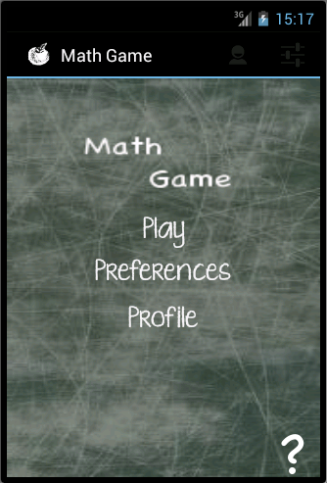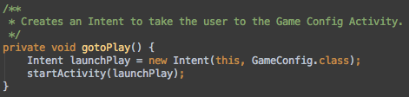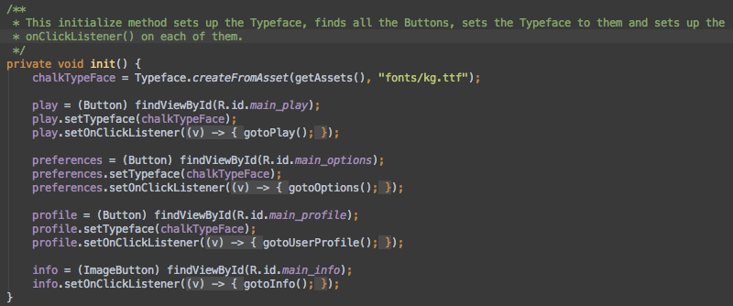
Game Screen
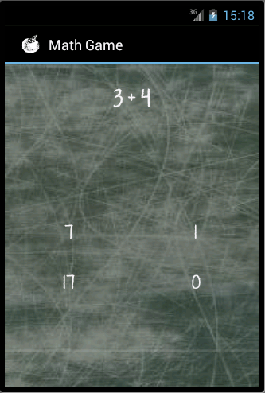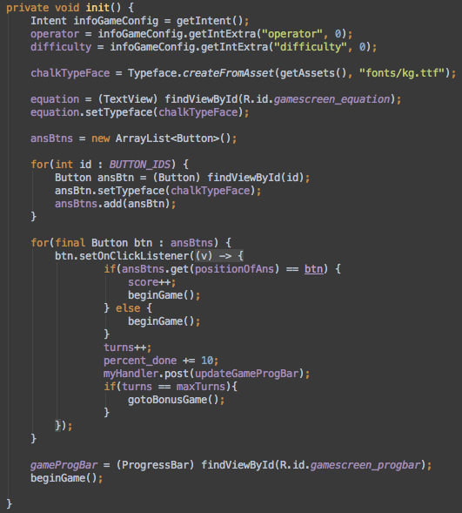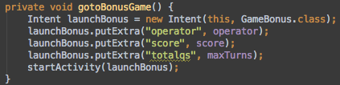

Game Bonus
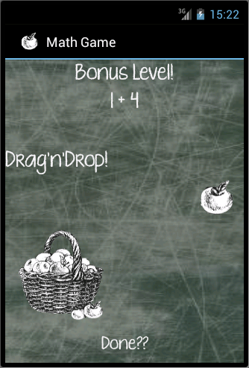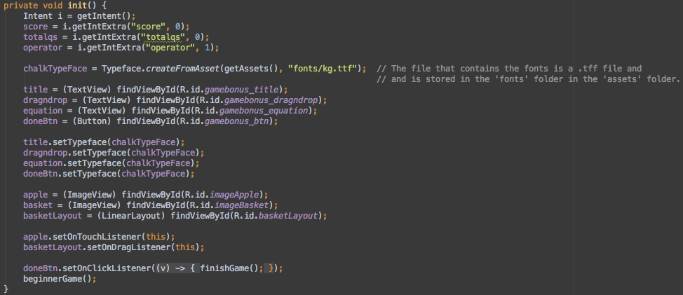
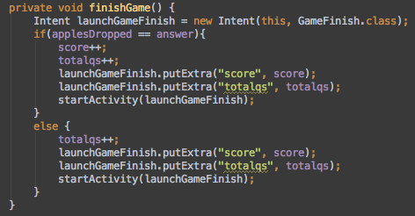

Game Finish
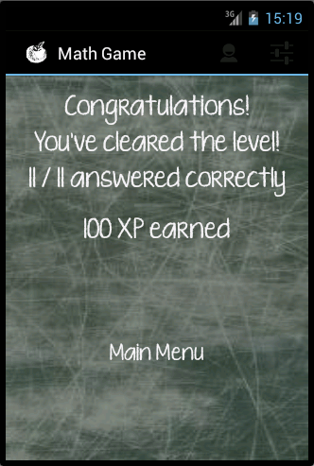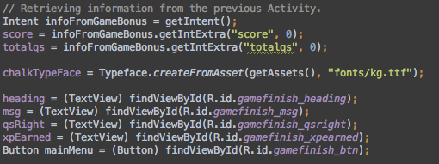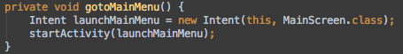

1 (b) Use of 3 different layout managers on the 3 activities e.g. LinearLayout, TableLayout, RelativeLayout, FrameLayout etc.
Completed? Yes
Info Screen
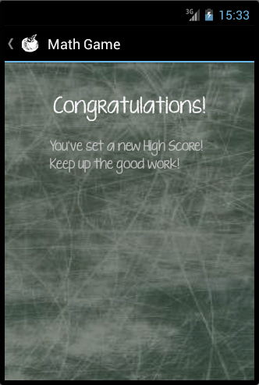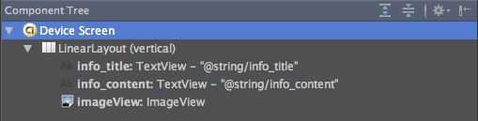

Config Screen
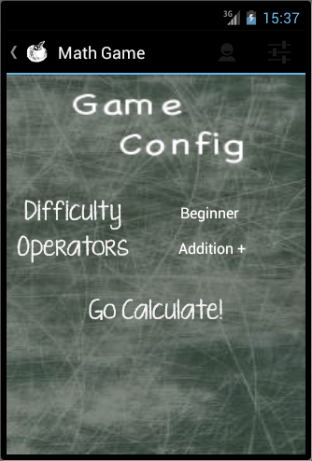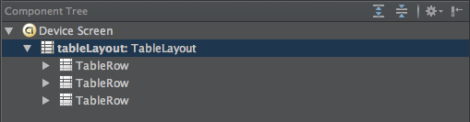

Highscore Screen
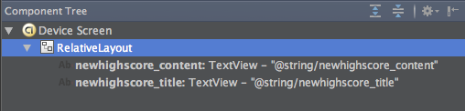

1 (c) Use a scoring system so the child sees how many right/wrong answers they got.
Completed? Yes
Info Screen
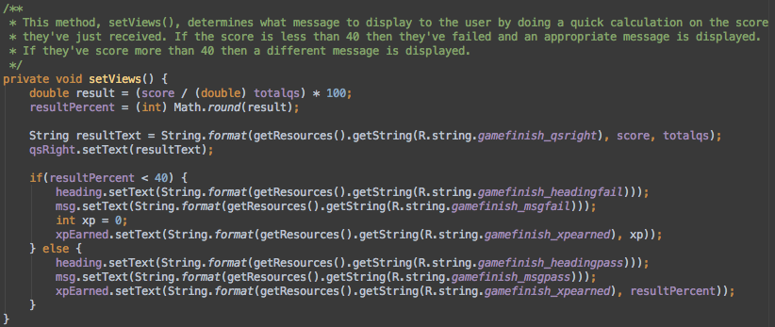

Profile Screen
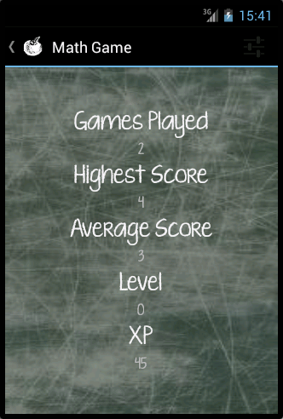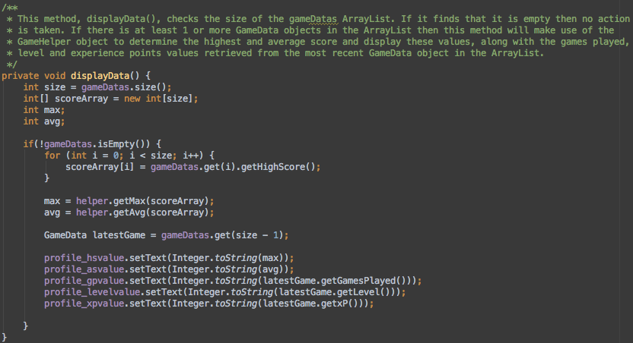

1 (d) Include 3 different types of UI widgets e.g. Spinner, togglebutton, radiobutton, progressbar, imagebutton etc. but excluding TextView, Button & EditText. Process the events for 2 of the UI widgets. Completed? Yes

Main Screen – Image Button
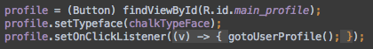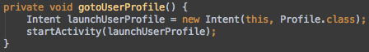

Config Screen – Spinner
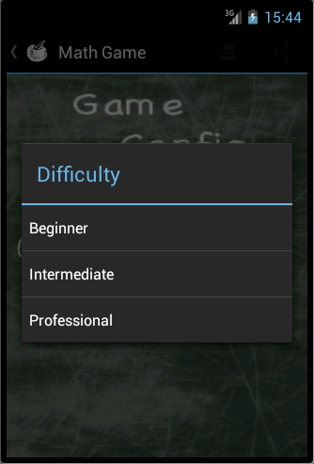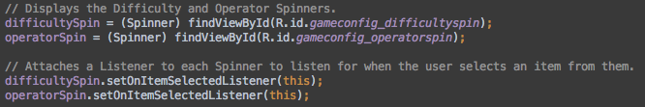

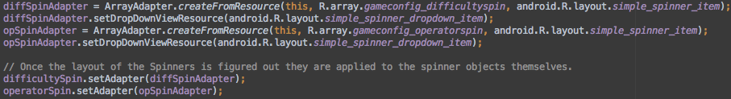

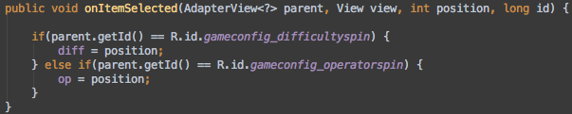

Game Screen – Progress Bar
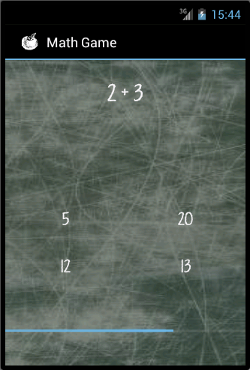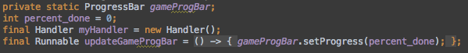

1 (e) 4 Menus items invoked by menu button. Process the events from the menu items e.g. launch another activity or web page, reset score etc.
Completed? Yes
Game Screen
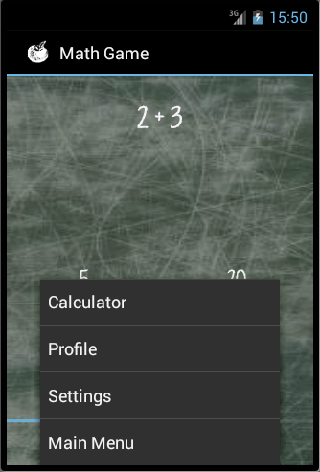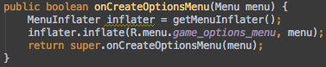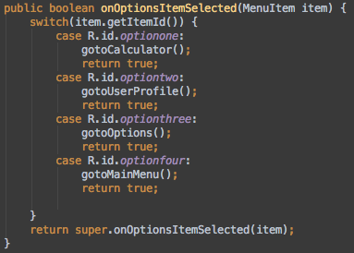
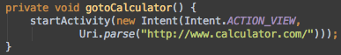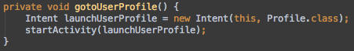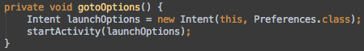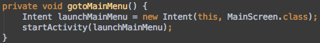

2 (f) Extra app functionality not covered in 1(a)
Completed? Yes
Game Bonus Screen
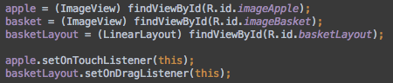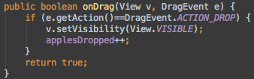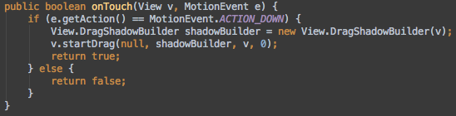

2 (g) Use of the notification manager and a pending intent that does something e.g. launches a web page.
Completed? Yes
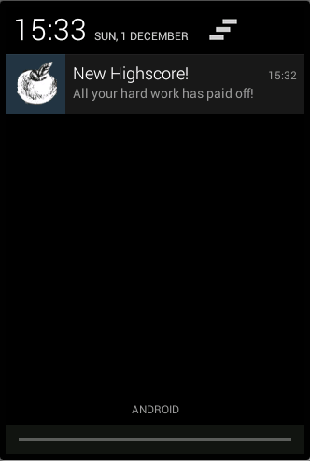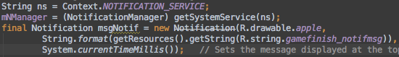

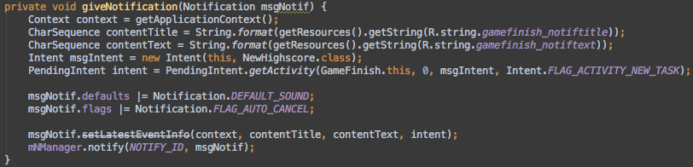

2 (h) API functionality not covered in lectures.
Completed? Yes

Main Screen

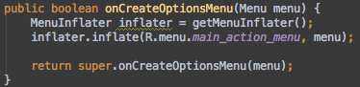

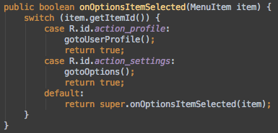

Profile Screen

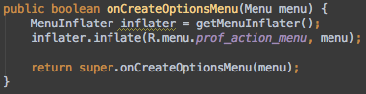

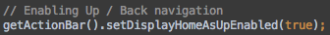
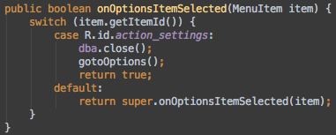

Preferences Screen

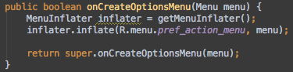

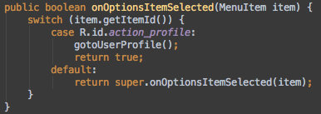

Specification

This app is a simple maths game aimed at providing enjoyment and learning to children. The app contains 3 difficulty modes: Beginner, Intermediate and Professional and 2 operators: Addition and Subtraction. With each increment in difficulty the range of numbers involved in the equations increases.
Each difficulty contains 10 equations and concludes with a bonus level. This bonus level requires user to work out the answer to one last equation and then drag that number of apples into a basket. There is no visible counter displaying how many apples are in the basket so the user must also keep track of how many apples they’ve dropped in so far.
Upon completing each game the user is be rewarded with Experience Points. These points are added up and contribute towards the users overall skill level. Every 100 points the user increases in level so the more answers the user gets correct the faster they level up!

List of Classes

- Constants
This class contains the commonly used values used by the Database classes. They're specified here to allow for ease of management and reuse.

- GameBonus
This class is the 'Bonus' Activity that starts once the user has answered 10 equations. An image of an apple and a basket is displayed on the screen, as well as one more equation. The user is required to drag the apple and drop it into the basket. Once the user is finished they must tap on the button at the end of the screen. The number of apples dropped into the basket should equal the answer to the equation. The 'Bonus' Activity is configured to run on the 'Beginner Game' settings so as to not allow the answer to become too big.

- GameConfig
This Activity gives the user two options they can change to modify their game, the difficulty and the operator used. The Difficulty Spinner has three options, Beginner, Intermediate and Professional. The Operators Spinner has two options, Addition and Subtraction. As the difficulty increases the range of numbers in which the answers and values for the equations are generated gets larger.

- GameData
This class is used to store the information that is retrieved from the SQLite Database. This data can then be used and manipulated through the 'getter' methods within this class.

- GameDB
This class handles the opening, closing, inserting and retrieving of data and information from the SQLite Database.

- GameFinish
This Activity is called once the user completes the bonus game and finishes their overall game. If the user manages to answer over 40% of the questions correctly they will have passed the game and a congratulations message is displayed, along with the number of questions they got right and the experience points they have earned. If they get less than 40% then a condolences message is displayed, along with the number of questions they got right but no experience points will have been earned. The user can navigate away from this Activity via the Action Bar or the Main Menu button. The results of their game are stored in the database once this activity starts. If the user gets a score that is higher than any score they've previously gotten then they will receive a notification congratulating them.

- GameHelper
More than one class makes use of the methods below. This class is intended to reduce the repetition of code and encourage reusability.

- GameScreen
This Activity randomly generates equations and answers according to the difficulty and operator selected and presents them to the user. The user then taps the correct answer among a list of four buttons. Once ten questions have been answered the user is directed to the Bonus Game Activity. A Progress Bar at the bottom of the screen shows the user how far into this current game the user has progressed so far.

- Info
This Activity simply displays some basic info about the application. It was created to demonstrate the use of an ImageButton

- MainScreen
This is the main Activity and is the first Activity to be presented to the user when they start the app. From here the user can navigate to their profile, preferences, app info or they can start a game.

- MyDBHelper
This Class is a helper class for the GameDB class. Its methods deal with the creation of tables and handling of upgrades to the Database.

- NewHighscore
This Activity simply displays a message to the user congratulating them on achieving a new high score. This Activity can only be accessed when the user taps on the notification they received from the app in the Notification Manager.

- Preferences
Preferences shows the user the settings, or preferences, for the app. If the app were to be expanded or updated this is where the user could modify the newly added settings. At the moment users can access the Preferences menu to reset their profile and delete their details and progress to date. From here users can navigate back to the main menu via the left-facing caret on the left hand side of the Action Bar at the top of the screen, or navigate to their profile via the Profile Icon on the right side of the Action Bar.

- Profile
This class is used to display information such as,
Games Played,
Highest Score,
Average Score,
Level and
Experience Points achieved by the user.

Evaluation

How it has worked out

For the most part I think the app worked out pretty well. It was a challenge and a great opportunity to be creative and incorporate your own ideas into the app and steer the app in the direction you wanted to go in while keeping the goals of the assignment in mind. It is a big step up from the first assignment, both technically and visually. I wanted a part of this assignment to involve some effort in the areas of design and user experience. I tried to achieve this through the incorporation of the Action Bar, a background for all activities, custom font and buttons and involving the user through a ‘Drag’n’Drop’ mechanism.

What could be done differently

Towards the end of the assignment I had learned about the idea of Styles. Instead of defining the properties of each View in each Activity you can create a Style XML file to contain the most commonly used Style properties, such as background, font size and color, transparency etc. This will save the developer and lot of time in long run if changes need to be made.
Adding in more operators, such as division and multiplication, and allowing equations to be formed including multiple operators. However this requires complex maths and is beyond the scope of the assignment but it make the app a more complete Math Game.

Future Outlook

I feel my skill in developing Android apps has improved immensely. One area I feel I need to look at is the area of refactoring code and reusability. Between the two assignments there were moments where I had the same idea for a method or layout file but had it implemented differently in both assignments. With experience I believe I will be better able to spot this and carve out my own particular style of coding where writing reusable code and methods etc. will come naturally.

