Mobile Assignment One- “Speed” v1.0
<MyName/Com3|FC|BBIS4/MyEmail> ← fill in please & then pages 3+
- Design and implement an Android App that will give the user an idea of what it’s like to hit a solid object in a car by comparing it to a distance a person would free-fall. For example driving into wall at 50km/h is equivalent to free-falling 9 meters onto a hard surface. See last page for more details. Your App must include the following:

  - TextView, EditText and button components in the main activity page. Use two layout managers e.g. LinearLayout inside another. Any text relevant to the components should be stored in the strings.xml file.

  - Create your own App icon in 3 different resolutions (doesn’t need to be beautiful!)

  - A trigger on the first screen (Activity) launches a second screen and passes data to it for display. A trigger on the first screen to launch a third activity which passes data back.

  - Localise your App for a second language of your choice. Include the App name. Change the language in your AVD to see your App correctly & automatically switch to and from the second language.

  - Create a Second layout file for horizontal orientation – preserve at least 1 app variable.
(10 marks ea, 50 marks total)

2. Three Advanced features or innovation/creativity; here are some examples but you can do different ones of equivalent difficulty:

  - Show the user a list of choices. Show the user an Alert using AlertDialog class.

  - Save the App state when quitting. Restore on re-launch.

  - Draw a graphic to display some app related info.
(10 marks ea, 30 marks total)

3. Documentation includes the following:
- Commented code & the use a coding standard. Use extra classes where appropriate.
- This document stating what was done including screen shots of code snippets & the running app code (on pages 3+). Include list of classes, class or block diagram, what each is for. Also include an evaluation – how has it worked out & future outlook – what could be done differently.
(10 marks ea, 20 marks total)

Assignment Procedure guide (includes a coding standard)

Demo in the lab (mandatory for on site courses):
- Demonstrate the running program in the 1st lab following the due date. You may be asked to make changes to the code after your demo. The purpose of the demo is to show what you have done and that you understand what you have done.

- Submission
Submit to Blackboard: This edited document & Project code.. All goes in 1 archive file. Please name the file as in this example: YourClass-YourName-MOB-Asn1.7z

“By submitting this electronically, using an account & password only I have access to, I hereby certify that this material which I now submit for assessment is entirely my own work and has not been taken from the work of others, save and to the extent, that such work has been cited and acknowledged within the text of my work.”

NB – CIT has access to plagiarism tools and these may be used on submitted assignments. The use of ‘rent a coder’ type services in preparing your assignment is forbidden.
Place each item of the assignment on a separate page stating if completed or not and showing screen shot(s) of code and application screen(s)
1 (a)
TextView, EditText and button components in the main activity page. Use one LinearLayout inside another. Any text relevant to the components should be stored in the strings.xml file.
Completed? Yes/ No

Code screen shot(s) (an example, replace with your own)
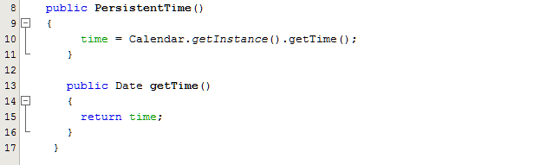

Application screen shot(s)
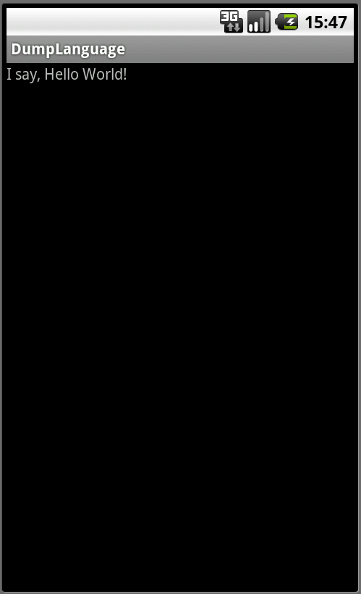

--- New page for (b) etc
1 (b)
Create your own App icon in 3 different resolutions (doesn’t need to be beautiful!)
Completed? Yes/ No <Paste screen shot of code extract here >

Etc
Etc.
New page for each item…
1 (a)
TextView, EditText and button components in the main activity page. Use one LinearLayout inside another. Any text relevant to the components should be stored in the strings.xml file.
Completed? Yes

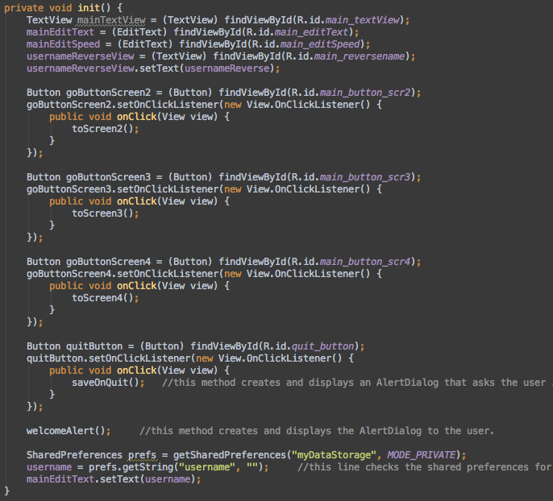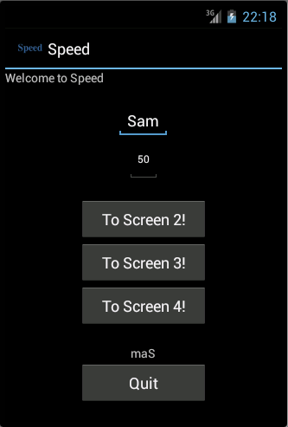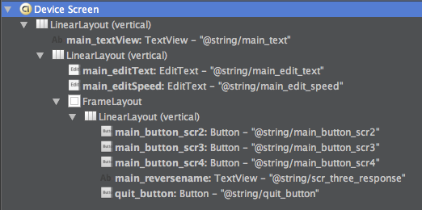
1 (b)
Create your own App icon in 3 different resolutions (doesn’t need to be beautiful!)
Completed? Yes
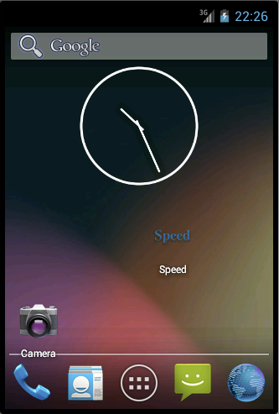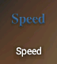
1 (c)
A trigger on the first screen (Activity) launches a second screen and passes data to it for display. A trigger on the first screen to launch a third activity which passes data back.
Completed? Yes

HomeScreen Activity
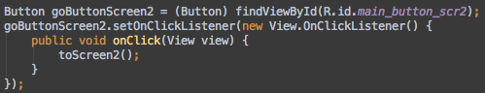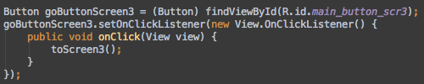

ScreenTwo Activity
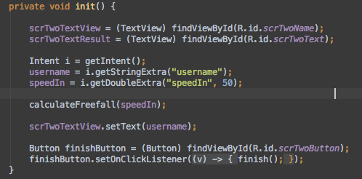
ScreenThree Activity
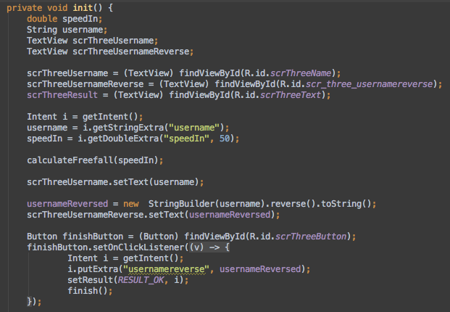
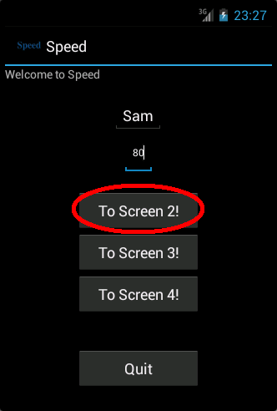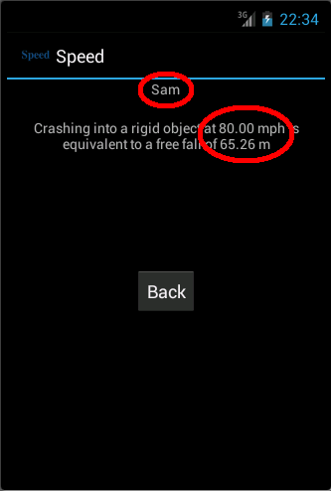
HomeScreen ScreenTwo
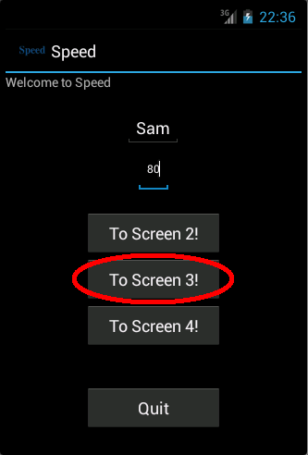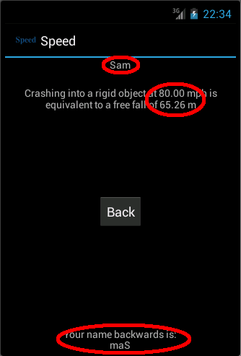
HomeScreen ScreenThree
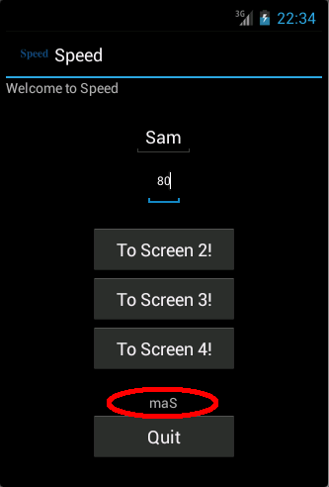
HomeScreen
1 (d)
Localise your App for a second language of your choice. Include the App name. Change the language in your AVD to see your App correctly & automatically switch to and from the second language.
Completed? Yes
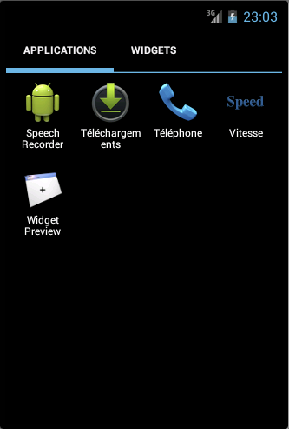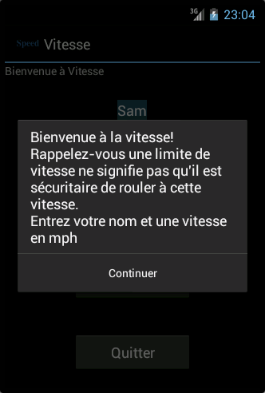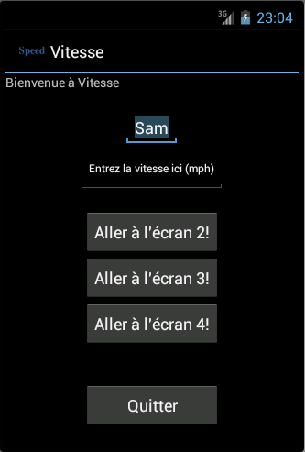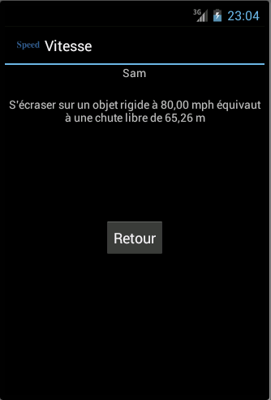
1 (e)
Create a Second layout file for horizontal orientation – preserve at least 1 app variable.
Completed? Yes

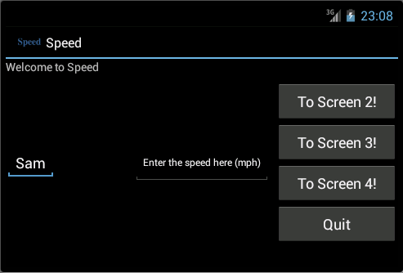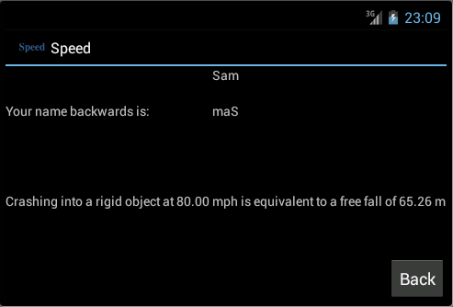
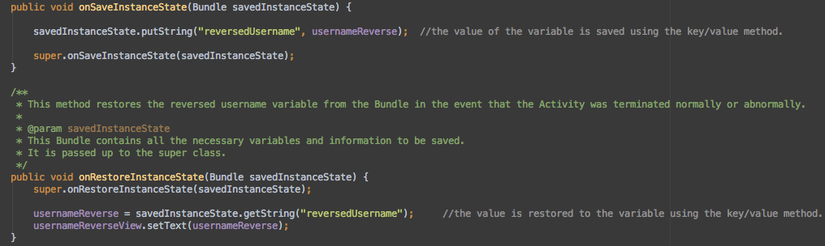

2 (f)
Show the user a list of choices. Show the user an Alert using AlertDialog class.
Completed? Yes
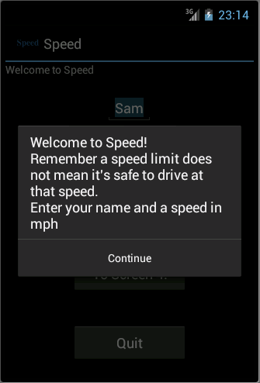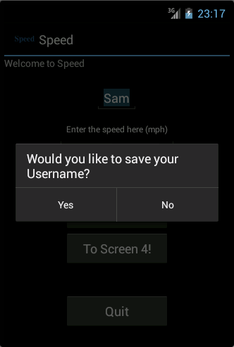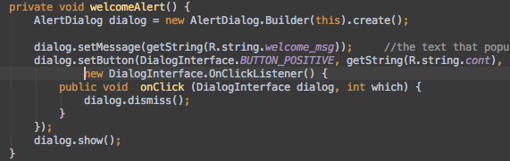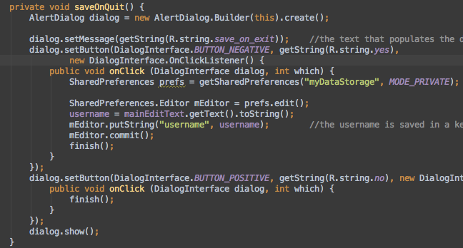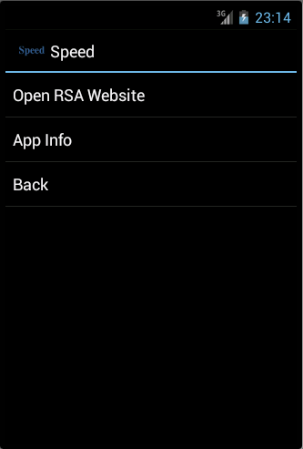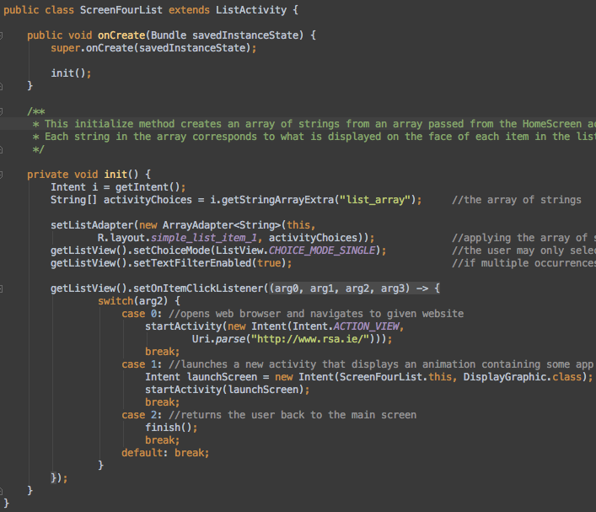
2 (g)
Save the App state when quitting. Restore on re-launch.
Completed? Yes
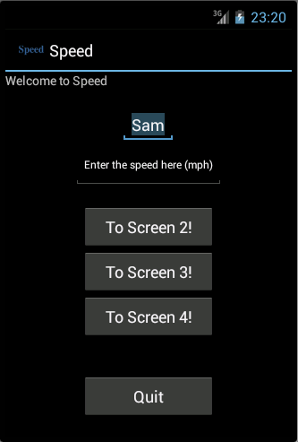

Saving
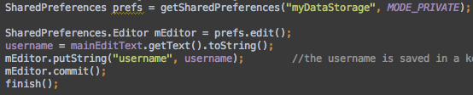

Restoring
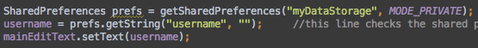
2 (h)
Draw a graphic to display some app related info.
Completed? Yes
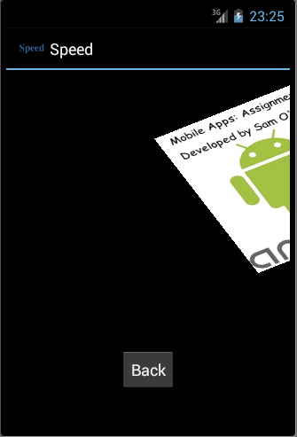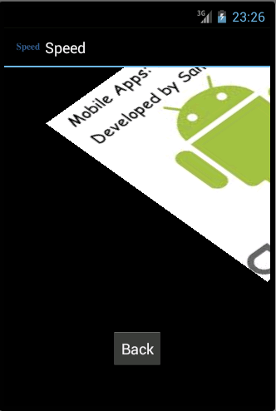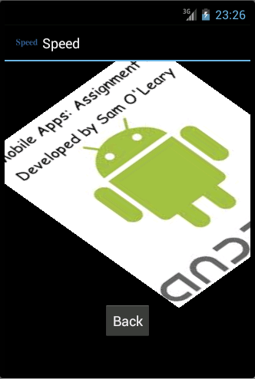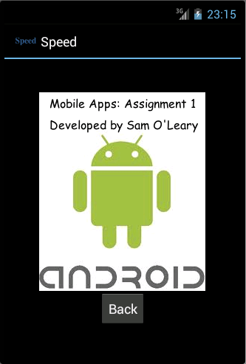
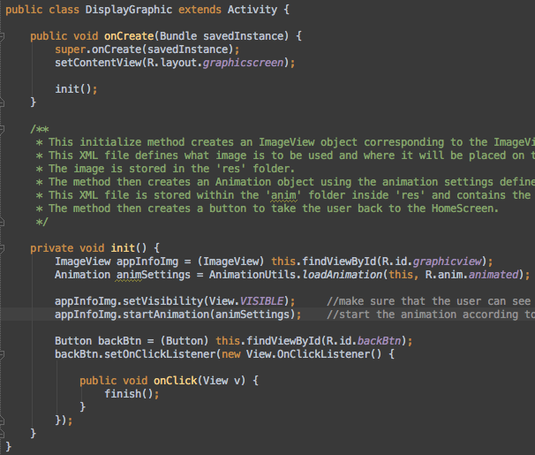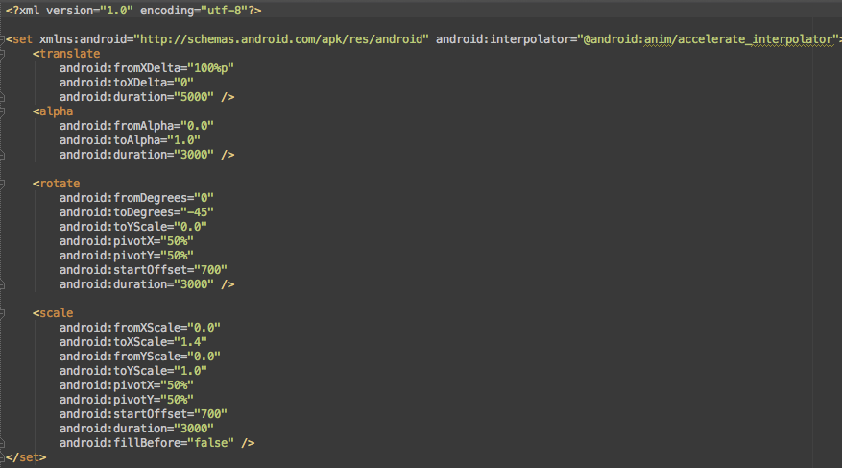

List of Classes

HomeScreen – The main class and activity. Displays 4 buttons, 2 EditViews and 2 TextViews.
An AlertDialog is displayed here when the user starts the app and a different AlertDialog is displayed when the user quits the app.
This is the navigation menu, all other activities can only reached from this activity.

ScreenTwo - This class displays the users name, passed from the HomeScreen, as well as the speed they’ve entered and the calculated value for the equivalent distance of free-fall. There is also a button to take the user back to the HomeScreen.

ScreenThree - This class provides the same functionality as that of ScreenTwo but also has the added feature of being able to reverse the users name, display the reversed name on the screen and also send the reversed name back to the HomeScreen for the HomeScreen to display.

ScreenFourList - This class provides the user with a list of 3 items, Go to the RSA Website, App Info and Back. The first item opens up the web browser and goes to www.rsa.ie, the second item displays a short animation that presents some of the apps info to the user and the final item takes the user back to the HomeScreen.

DisplayGraphic - This class controls the animation that takes place before the app info is displayed. It is in control of preparing the ImageView and the Animation for the image.

Evaluation

I found this assignment very interesting, but also challenging. I enjoyed the element of freedom to implement what we wanted and how we wanted it. I am also very happy with the end result of this assignment, a functional but somewhat limited app!

Towards the end I’ve realized that I can implement the ‘Saving State of the App’ a bit better, this was due to rooting around in the Google Android Documentation whilst trying to solve a different problem. From what I can tell, use the onPause() method to save your app state is a lot safer and more reliable than just using onSaveInstanceState(). For whatever reason it isn’t fully implemented the way it is described in the documentation, or so the Google Android Documentation says!

For future projects I will also do a better job of laying out the different activities. I discovered that each View or Widget could be assigned a different ‘weight’ and that this makes laying out a screen a lot easier and tidier, as opposed to my method of burying different Layouts within each other and then specifying the size of each Widget or View in device-independent pixels.

