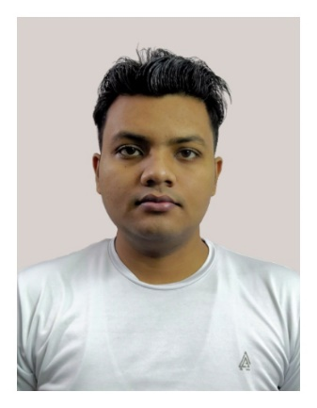

|  |
| --- |
| CONTACT ME |

 Faridabad, Haryana, India

ssjshivam2777@gmail.com



 +91 7703903587

 https://ssjshivam.github.io

https://www.linkedin.com/in/ssjshivam



|  |
| --- |
| EDUCATION |

* **Under graduation**

Bachelor of Commerce with  
University of Delhi, **7.47 CGPA**, 2021

* **High School**

Central Board of Secondary Education, New Delhi, **81%**, 2018

|  |
| --- |
| SOFT SKILLS |

MS OFFICE

PYTHON

COOPERATIVE

ATTENTIVE

INQUISITIVE

SURYA PRATAP SINGH

|  |
| --- |
| OBJECTIVE |

To prove my flexible and compassionate characteristic towards the job. With the willingness to serve with dedication and commitment to the assigned work. To possess good work ethics and versatility in the working environment.

|  |
| --- |
| BASIC INFORMATION |

**Date of Birth:** 1st March 1999

**Marital Status:** Single

**Mother’s Name:** Munni Devi

**Father’s Name:** Shri Shiv Prasad

**Language:** Hindi, English (intermediate)

|  |
| --- |
| CERTIFICATIONS |

**Udemy:** 100 Days of Code: The Complete Python Pro Bootcamp for 2023

**Typing.com:** Advance Assessment (44 WPM)

|  |
| --- |
| HARD SKILLS |

* **Programming Languages**
  + Python, HTML, CSS
* **Libraries & Frameworks**
  + Flask, Bootstrap, SQLalchemy
* **Design**
  + Canva, Photoshop, Gimp
* **Other Tools**
  + Git, GitHub, Render