LockedMe:

Contents of document:

1. Sprint Planning
2. Flow Chart
3. Core concepts and algorithms used
4. USP
5. Conclusion
6. Spring Planning:

This particular project has been completed in two sprints:

1. Sprint 1 includes below steps:

* Creating the flow of application
* Java concepts/algorithms to be used
* Writing the basic details that are required for coding
* Starting with basic steps in the code
* Writing the code for whole application

1. Sprint 2 includes:

* Testing the code
* And reframing the code on need basis
* Retesting the code
* Pushing the final code to github
* Documentation

1. Flow chart:

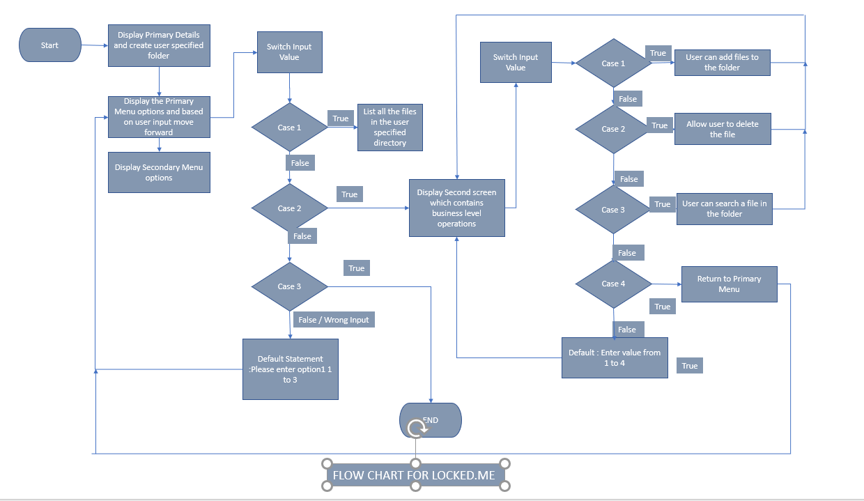

1. Core Concepts used:

File Handling, Exception Handling, Flow Control, Sorting, Loops and conditional statements

1. USP:

* User is allowed to enter/create the folder of their own and can perform the basic operations designed in the program within that folder.
* Exception handling has been used. So that the program doesn’t termination if any exceptions occur
* The user can switch between the primary menu and the secondary menu based on the requirement.

1. Conclusion:

* User to be allowed to have nested folder structure
* Allowing user to add/edit/append the data in to the file.