“CODE TRACE: Linux Process & System Call Explorer”
A Project Report Submitted in the partial fulfillment of the requirements for the award of the degree of

BACHELOR OF TECHNOLOGY
In

DEPARTMENT OF COMPUTER SCIENCE ENGINEERING

By

MIRIYALA THARAVARSHINI 2520030052

PRATHYUSHA REDDY 2520030612

HARSHITH 2520030572

SAI KRISHNA 2520030XXX

Under the Esteemed Guidance of

Dr. Hema
Assistant Professor
Department of Computer Science and Engineering




K L (Deemed to be) University DEPARTMENT OF COMPUTER SCIENCE ENGINEERING
&

DEPARTMENT OF COMPUTER SCIENCE AND INFORMATION TECHNOLOGY

Declaration

The Project Report entitled “CODE TRACE: Linux Process & System Call Explorer” is a record of Bonafide work of MIRIYALA THARAVARSHINI - 2520030052, PRATHYUSHA REDDY - 2520030612, HARSHITH - 2520030572, SAI KRISHNA - 2520030XXX submitted in
partial fulfillment for the award of B. Tech in Computer Science and Engineering to the K L (Deemed to be) University, for the course Operating Systems and Systems Programming (25CS2104E). The results embodied in this report have not been copied from any other departments/University/Institute.

MIRIYALA THARAVARSHINI 2520030052

PRATHYUSHA REDDY 2520030612

HARSHITH 2520030572

SAI KRISHNA 2520030XXX

K L (Deemed to be) University

DEPARTMENT OF COMPUTER SCIENCE ENGINEERING

CERTIFICATE

This is to certify that the project-based report entitled “CODE TRACE: Linux Process & System Call Explorer” is a bonafide work done and submitted by MIRIYALA THARAVARSHINI - 2520030052, PRATHYUSHA REDDY - 2520030612, HARSHITH - 2520030572, SAI KRISHNA - 2520030XXX
in partial fulfillment of the requirements for the award of the degree of BACHELOR OF TECHNOLOGY in Department of Computer Science Engineering, K L (Deemed to be University), for the course Operating Systems and Systems Programming (25CS2104E), during the academic year 2026-2027.

Signature of the Guide

Signature of the Course Coordinator Signature of the HOD

ACKNOWLEDGEMENT
The success in this project would not have been possible but for the timely help and guidance rendered by many people. We wish to express our sincere thanks to all those who have assisted us in one way or the other for the completion of our project.

Our greatest appreciation goes to our guide Dr. Hema, Department of Computer Science and Engineering, whose tremendous support, encouragement and guidance cannot be expressed in words and made this project possible.

We express our gratitude to Dr. P Venkateshwara Roa (CSE), Head of the Department for Computer Science Engineering for providing us with adequate facilities, ways and means by which we are able to complete this project-based Lab.

We thank all the members of teaching and non-teaching staff members, and also those who have assisted us directly or indirectly for the successful completion of this project. Finally, we sincerely thank our parents, friends and classmates for their kind help and cooperation during our work.

MIRIYALA THARAVARSHINI 2520030052

PRATHYUSHA REDDY 2520030612

HARSHITH 2520030572

SAI KRISHNA 2520030XXX
Abstract

The Linux operating system runs every program as a process that interacts with the kernel through system calls, signals, memory, files and other resources. When such a program fails, finding the exact location and cause of the error is difficult without proper debugging and system-level analysis tools. Our project, CODE TRACE: Linux Process & System Call Explorer, addresses this difficulty by providing a systematic Linux-based approach for debugging programs and processes, identifying programming errors, runtime failures, abnormal behaviour and system-level issues.

The solution combines the GNU Debugger (GDB) and the strace utility. GDB is used for source-level debugging: setting breakpoints, stepping through execution, inspecting variables, viewing the call stack and locating errors. strace is used to trace the system calls made by a process and to observe its interaction with the Linux kernel. Process states and signals are studied to understand how processes behave during abnormal execution. In addition, a small explorer tool written in C with the ptrace() interface and the /proc filesystem lists the system calls of a running program, shows its process status and reports how it terminated.

The implementation is carried out with C programs in a Linux/Ubuntu environment. Programs containing controlled errors (a NULL-pointer crash, a failing file access, a signal handler, a parent–child process pair and a zombie process) are compiled with debugging information and executed to reproduce the failures. The debugging workflow runs the program, identifies the failure, examines the execution using GDB, traces system calls using strace and CODE TRACE, analyses the collected information and determines the cause of the problem. The final outcome demonstrates how Linux debugging tools help locate and understand programming and process-level problems.

Index

S. No. | Chapter | Topics / Subtopics | Page No.
 | Acknowledgement |  | i
 | Abstract |  | ii
1 | Introduction |  | 1–3
 |  | 1.1 Background of the Project | 1
 |  | 1.2 Problem Statement | 1
 |  | 1.3 Scope of the Project | 2
 |  | 1.4 Objectives of the Project | 2
 |  | 1.5 Importance of the Application | 2
 |  | 1.6 Target Users / Audience | 3
2 | OS Concepts and Background Study |  | 4–7
 |  | 2.1 Operating System Concepts Related to the Project | 4
 |  | 2.2 Existing Methods / Algorithms | 6
 |  | 2.3 Proposed Approach | 6
 |  | 2.4 Advantages of the Proposed Approach | 7
3 | System Requirements |  | 8–9
 |  | 3.1 Hardware Requirements | 8
 |  | 3.2 Software Requirements | 8
 |  | 3.3 Operating System Environment – Ubuntu / WSL | 8
 |  | 3.4 Development Tools and Compilers | 9
4 | Technology and Tools Used |  | 10–11
 |  | 4.1 C / C++ Programming | 10
 |  | 4.2 GCC Compiler | 10
 |  | 4.3 Linux System Calls | 10
 |  | 4.4 POSIX Threads / Synchronization | 10
 |  | 4.5 Linux Commands and Utilities | 11
 |  | 4.6 Other Tools / Libraries Used | 11
5 | System Architecture and Design |  | 12–14
 |  | 5.1 Overall System Architecture | 12
 |  | 5.2 System Workflow
 |  | 5.3 Flowchart / Data Flow | 13
 |  | 5.4 Module Description | 14
 |  | 5.5 Input and Output Design | 14
6 | Implementation |  | 15–21
 |  | 6.1 Module-wise Implementation | 15
 |  | 6.2 Algorithm / Pseudocode | 15
 |  | 6.3 Core C / C++ Implementation | 16
 |  | 6.4 Linux System Calls / APIs Used | 19
 |  | 6.5 Process / Thread Implementation | 19
 |  | 6.6 IPC / Synchronization Implementation | 20
 |  | 6.7 Memory Management Implementation | 20
 |  | 6.8 Optional User Interface Implementation | 21
7 | Execution and Demonstration |  | 22–27
 |  | 7.1 Compilation in Ubuntu | 22
 |  | 7.2 Execution Commands | 22
 |  | 7.3 Sample Inputs and Outputs | 22
 |  | 7.4 Screenshots of Execution | 25
 |  | 7.5 Demonstration of OS Concepts | 27
8 | Conclusion |  | 28–29
 |  | 8.1 Summary of the Project | 28
 |  | 8.2 Objectives Achieved | 28
 |  | 8.3 Results Achieved | 28
 |  | 8.4 Skills and Learning Outcomes | 29
9 | References |  | 30
 |  | 9.1 Books | 30
 |  | 9.2 Research Papers | 30
 |  | 9.3 Linux / GNU Documentation | 30
 |  | 9.4 Online Resources | 30

CHAPTER -1 INTRODUCTION

1.1 Background of the Project
An operating system (OS) is the layer of software that manages hardware resources and provides services to application programs. Every program that runs on Linux does so as a process, an executing instance of a program that owns a virtual address space, a set of open files, a process identifier (PID) and a scheduling state. A process cannot touch hardware directly. Whenever it needs to read a file, allocate memory, create another process or print on the screen, it asks the kernel through a system call, and the kernel may also interrupt the process by delivering a signal.
Because so much of a program’s behaviour is expressed through these interactions, errors in Linux programs rarely stay inside the source code. A wrong pointer ends in a segmentation fault (signal SIGSEGV), a missing file shows up as a failed openat() call with the error code ENOENT, and a parent that forgets to call wait() leaves a zombie process behind. To understand and fix such problems a programmer needs two views at once: the source-level view, provided by the GNU Debugger (GDB), and the operating-system view, provided by system-call tracing with strace and by the /proc filesystem.
CODE TRACE: Linux Process & System Call Explorer is a mini project for the course Operating Systems and Systems Programming (25CS2104E) that brings these two views together. It defines a repeatable Linux workflow for reproducing a failure, inspecting it with GDB, tracing its system calls with strace, observing process states and signals, and finally documenting the root cause. To make the workflow concrete and to show how such tools work internally, the project also includes a small C tool, codetrace, that uses the ptrace() system call and the /proc filesystem to launch a program, print every system call it makes and report how the process ends.

1.2 Problem Statement
Debugging Linux programs and processes is difficult when errors appear only at run time and produce unexpected results, crashes or abnormal process behaviour. Finding the exact location and cause of a failure is hard without proper debugging and system-level analysis tools, and the problem grows when the program interacts with the operating system through system calls, signals, files, memory and child processes.
The problem addressed by this project is therefore: how can a programmer systematically reproduce, observe and explain program-level and process-level errors on Linux, using source-level debugging together with system-call and process tracing?

1.3 Scope of the Project
Within scope
- Compiling C programs with debugging information (gcc -g -O0) and running them in a controlled Ubuntu/Linux environment.
- Source-level debugging with GDB: breakpoints, stepping, variable inspection, call-stack (backtrace) analysis and post-mortem investigation of a crash.
- System-call tracing with strace, and with the project’s own codetrace explorer built on ptrace().
- Observation of process creation (fork, exec), process states (R, S, T, Z), signals and the /proc/<pid> interface.
- Five demonstration programs that reproduce typical faults: NULL-pointer dereference, failing file access, signal handling, parent–child synchronisation and a zombie process.
Outside scope
- Kernel-level debugging (kgdb, crash dumps of the kernel) and kernel module development.
- Graphical debugger front-ends; the project works from the terminal.
- Tracing of multi-threaded programs by codetrace itself (GDB and strace do support threads; see Section 4.4).
- Non-Linux operating systems. The tracer targets Linux on the x86-64 architecture.

1.4 Objectives of the Project
1. Develop a Linux-based workflow for debugging C/C++ programs using GDB.
2. Trace and analyse Linux system calls and process activity using strace.
3. Identify runtime errors, crashes, incorrect execution and abnormal process behaviour.
4. Demonstrate the relationship between debugging, processes, signals and operating-system resources.
5. Design and implement CODE TRACE, a small ptrace-based explorer that lists the system calls of a process, shows its /proc status and reports how it terminated.

1.5 Importance of the Application
Debugging is a core skill of systems programming. Most course exercises in processes, signals and file handling fail in ways that the compiler cannot report, so students and developers need a dependable method to find the cause. The project is important for the following reasons.
- It links theory with practice: concepts such as process states, system calls and signals taught in the OS course are observed on a live system rather than only drawn on paper.
- It reduces debugging time by giving a fixed order of investigation: reproduce, locate with GDB, confirm with strace, record.
- Tracing explains why a program failed at the OS boundary (for example, which file could not be opened and with which error code), which source-level debugging alone does not show.
- The same tools (gdb, strace, /proc) are used in industry for diagnosing production incidents, so the skills transfer directly.

1.6 Target Users / Audience
User group | How they benefit
Undergraduate students of OS / Systems Programming | Learn how processes, signals and system calls behave by watching them live.
Faculty and lab instructors | A ready set of reproducible faulty programs and a step-by-step debugging procedure for demonstrations.
Beginner Linux / C developers | A practical checklist for diagnosing crashes and failing system calls.
Support and DevOps engineers | Introduction to strace and /proc based triage of misbehaving processes.

CHAPTER -2 OS CONCEPTS AND BACKGROUND STUDY

2.1 Operating System Concepts Related to the Project
Process and Process Control Block
A process is a program in execution. The kernel keeps one process control block for every process (in Linux, the task_struct), which stores the PID, parent PID, state, scheduling information, memory map, open file table and signal handlers. Much of this information is exported to user space through /proc/<pid>/, for example status, maps, fd/ and stat. CODE TRACE reads /proc/<pid>/status to display the name, state, PID, parent PID, virtual size and resident size of the traced process.
Process states
During its life a process moves between states. Linux reports them with a single letter in ps and in /proc/<pid>/status: R (running or runnable), S (interruptible sleep), D (uninterruptible sleep, usually disk I/O), T (stopped by a job-control signal) , t (stopped by a tracer or debugger) and Z (zombie, terminated but not yet reaped by its parent). While codetrace or GDB controls a program, the program is shown in state t (tracing stop), which is exactly what the project output displays.
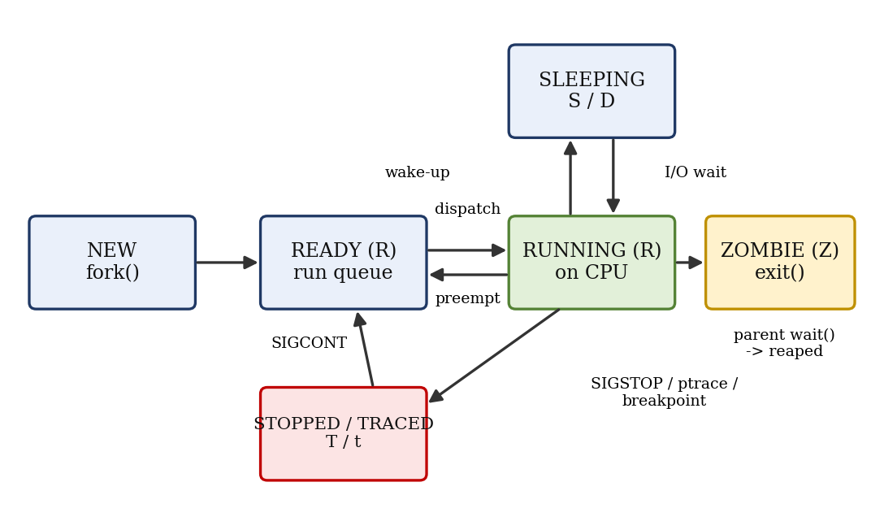
Figure 2.1 : Linux process states and the transitions observed in this project
Process creation and termination: fork(), exec(), wait()
fork() creates a child that is a copy of the parent. On current glibc it is implemented with the clone system call, which is visible in the trace as clone(0x1200011, ...) (flags CLONE_CHILD_CLEARTID | CLONE_CHILD_SETTID | SIGCHLD). The exec family replaces the program image inside the same process, which appears as the first call, execve, in every trace. A parent synchronises with its child using wait() or waitpid(); if it never does, the terminated child stays in the zombie state until the parent exits.
System calls and the user/kernel boundary
Programs run in unprivileged user mode. A system call executes a special instruction (syscall on x86-64) that switches to kernel mode, where the kernel validates the arguments and performs the service. The call number is placed in rax, the arguments in rdi, rsi, rdx, r10, r8, r9, and the result is returned in rax; a negative value between -1 and -4095 means an error whose absolute value is errno. These register conventions are what codetrace reads with PTRACE_GETREGS.
Signals
A signal is an asynchronous notification sent to a process. Some are raised by the hardware through the kernel (SIGSEGV for an invalid memory access, SIGFPE for an arithmetic fault), some by other processes (kill), and some by the kernel on events (SIGCHLD when a child terminates). A process can ignore, handle or accept the default action of most signals. A debugger or tracer sees every signal before the program does and can decide whether to pass it on, which is how GDB reports "Program received signal SIGSEGV".
Virtual memory
Each process has a private virtual address space made of text, data, heap and stack regions plus memory-mapped libraries. The heap grows with brk() and large allocations or shared libraries are placed with mmap(). A reference to an address that is not mapped makes the CPU raise a page fault; the kernel finds no valid mapping and sends SIGSEGV with the code SEGV_MAPERR. This is the mechanism behind the NULL-pointer fault demonstrated in Chapter 7.
Files and the /proc filesystem
Files are accessed through file descriptors (0 = stdin, 1 = stdout, 2 = stderr). /proc is a virtual filesystem generated by the kernel on demand; it needs no disk and always reflects the live state of the system.
Mapping of OS concepts to the project
OS concept | Where it appears in CODE TRACE
Process / PCB | codetrace reads /proc/<pid>/status; GDB info proc
fork / exec / wait | codetrace forks the target and calls execvp; hello_fork.c and bug_zombie.c show wait semantics
System calls | Entry and exit of each call captured through PTRACE_SYSCALL; strace output
Signals | SIGSEGV (bug_segv), SIGUSR1 handler (bug_signal), SIGCHLD (hello_fork), SIGSTOP at start-up
Virtual memory | brk/mmap calls in the trace; segmentation fault analysis; /proc/<pid>/maps
File I/O and errno | openat returning ENOENT in bug_file.c

2.2 Existing Methods / Algorithms
Several techniques are used today to find faults in Linux programs. None of them alone gives a complete picture.
Method / tool | What it does | Limitation
printf / logging | Prints variable values at chosen points | Needs source change and recompilation; changes timing; shows nothing about kernel interaction
GDB | Breakpoints, stepping, variable and stack inspection, core-file analysis | Shows program state, not the system calls made unless catchpoints are set manually
strace | Lists every system call, arguments, return value and signal | Does not show source lines or local variables
ltrace | Traces calls to shared-library functions | Does not cover direct system calls or crashes in user code
Valgrind / AddressSanitizer | Detects memory errors such as invalid reads and leaks | Slower execution; focused on memory errors only
ps, top, /proc | Shows process state and resource usage | Snapshot only; gives no cause for a failure
Core dumps | Saves memory image at a crash for post-mortem analysis | Must be enabled (ulimit -c); needs GDB to interpret

2.3 Proposed Approach
CODE TRACE combines the strengths of the methods above into one staged workflow and adds an educational tracer of its own.
1. Reproduce – compile a program that contains a controlled error with debugging information and run it to trigger the failure.
2. Locate – run it under GDB, set breakpoints, step to the failing statement, print variables and read the backtrace.
3. Observe – run the same program under strace and under codetrace to see which system calls and signals precede the failure and which return errors.
4. Inspect the process – read /proc/<pid>/status and related files to see the state, parent and memory use of the process.
5. Correlate and conclude – match the GDB location with the system-call evidence, determine the root cause, apply a fix and re-test.
The explorer codetrace implements step 3 and 4 in about one hundred lines of C. It uses ptrace(PTRACE_TRACEME) in the child, execvp() to start the target, PTRACE_SYSCALL to stop the target at every system-call entry and exit, PTRACE_GETREGS to read the arguments and return values, and waitpid() to learn whether the target stopped, received a signal or terminated.

2.4 Advantages of the Proposed Approach
- Complete diagnosis: source-level, system-call level and process level evidence are collected for the same run.
- No source modification: apart from compiling with -g, the programs under test are not changed.
- Educational transparency: the custom tracer shows how strace and debuggers work internally (ptrace, registers, wait status).
- Repeatable: every demonstration program is small and deterministic, so results can be reproduced on any Ubuntu machine.
- Low cost: only standard GNU/Linux tools are used; no licence or special hardware is needed.

CHAPTER -3 SYSTEM REQUIREMENTS

3.1 Hardware Requirements
Component | Minimum | Recommended
Processor | x86-64 dual-core, 1.6 GHz | Intel Core i5 / AMD Ryzen 5 or better
Memory (RAM) | 2 GB | 8 GB
Storage | 2 GB free disk space | 10 GB free (Ubuntu + tools + logs)
Display | 1366 x 768 | 1920 x 1080
Input | Keyboard and mouse | Keyboard and mouse

The tracer reads x86-64 register names (rax, rdi, rsi, rdx), so the processor must be x86-64. Other architectures need a different register mapping and system-call table.

3.2 Software Requirements
Software | Version used / needed | Purpose
Operating system | Ubuntu 22.04 / 24.04 LTS (native, VM or WSL2) | Execution environment
GCC | 11 or later (13.3 used) | Compiling C programs with debug information
GDB | 12 or later | Source-level debugging
strace | 5.x or later | System-call tracing
GNU Make | 4.x | Build automation
Git | 2.x | Version control, GitHub repository
VS Code / Terminal | Any recent version | Editing source and running commands

3.3 Operating System Environment – Ubuntu / WSL
The project was developed and tested on Ubuntu (Linux kernel 6.x, x86-64). Ubuntu may be installed natively, in a virtual machine, or on Windows through WSL2. The required tools are installed with the following commands:
sudo apt update
sudo apt install -y build-essential gdb strace git make

# verify
gcc --version
gdb --version
strace -V

Points to note
- ptrace permissions. Tracing a process that is not your own child needs privileges. Ubuntu’s Yama security module (/proc/sys/kernel/yama/ptrace_scope) restricts attaching to unrelated processes; strace prog and codetrace prog are unaffected because the tracer starts the target itself.
- WSL. Use WSL2; WSL1 does not implement ptrace completely. Containers (Docker) may block ptrace unless --cap-add=SYS_PTRACE is given.
- Core dumps. To analyse a crash after it happened, enable core files with ulimit -c unlimited.

3.4 Development Tools and Compilers
All programs are written in C and compiled with GCC. The options below are used for every demonstration program:
Option | Meaning
-g | Include DWARF debugging information so GDB can show source lines and variable names
-O0 | Disable optimisation so that execution follows the source order
-Wall -Wextra | Enable common compiler warnings
-o name | Name of the output executable

gcc -g -O0 -Wall -Wextra -o bug_segv bug_segv.c

CHAPTER -4 TECHNOLOGY AND TOOLS USED

4.1 C / C++ Programming
C is the natural language for systems programming on Linux because the kernel interface (system calls, signals, /proc) is defined in C terms and the language gives direct control over pointers and memory. The demonstration programs and the CODE TRACE explorer are written in C99/GNU C. C++ programs can be debugged with exactly the same workflow, because GDB and strace work on compiled machine code irrespective of the source language.

4.2 GCC Compiler
The GNU Compiler Collection translates the C source to an executable ELF file. With -g it stores a line table and variable descriptions in the DWARF format; GDB uses these tables to map a machine address back to a source line (for example bug_segv.c:7). Using -O0 avoids variables being optimised into registers or removed, which would make stepping confusing. The _GNU_SOURCE macro is defined in codetrace.c to expose Linux-specific declarations.

4.3 Linux System Calls
The table lists the x86-64 system calls that appear in the traces and in the source code of the project.
No. | System call | Purpose | Seen in
0 | read | Read from a file descriptor | library loading
1 | write | Write to a file descriptor (stdout, stderr) | all programs
3 | close | Close a file descriptor | library loading
9 / 11 | mmap / munmap | Map or unmap memory | dynamic loader, malloc
12 | brk | Change the heap size | start-up, stdio buffers
13 / 15 | rt_sigaction / rt_sigreturn | Install a handler / return from it | bug_signal
39 | getpid | Return process ID | hello_fork, bug_signal
56 | clone | Create a child (used by fork()) | hello_fork
59 | execve | Replace the process image | every trace
61 | wait4 | Wait for child state change | hello_fork
62 | kill | Send a signal to a process | bug_signal
231 | exit_group | Terminate the process | every trace
257 | openat | Open a file relative to a directory fd | bug_file

4.4 POSIX Threads / Synchronization
POSIX threads (pthread_create, pthread_mutex_lock, semaphores) are the standard way to create concurrent flows inside a process. The programs of this project are deliberately single-threaded so that the traces stay short and deterministic; the only concurrency is between a parent and its child process. Threads still matter for the debugging workflow in two ways: GDB can list and switch threads (info threads, thread N) and strace can follow them with the -f flag. The ptrace interface supports the same through the options PTRACE_O_TRACECLONE and PTRACE_O_TRACEFORK, and extending codetrace with these options is listed as future work in Chapter 8. Synchronisation between the tracer and the tracee (the stop/resume handshake of ptrace and waitpid) is described in Section 6.6.

4.5 Linux Commands and Utilities
Command | Use in the project
gdb ./prog | Start the debugger on a program
strace -o log.txt ./prog | Trace system calls to a log file
strace -c ./prog | Summary: count and time per system call
strace -e trace=openat,write ./prog | Filter to selected calls
ps -o pid,ppid,stat,cmd | Show process state letters
cat /proc/<pid>/status | Detailed state, memory and signal information
cat /proc/<pid>/maps | Memory regions of a process
kill -SIGUSR1 <pid> | Send a signal to a running process
ulimit -c unlimited | Allow core dump on crash
echo $? | Show exit status; 139 means killed by SIGSEGV (128 + 11)

4.6 Other Tools / Libraries Used
Tool / library | Purpose
<sys/ptrace.h>, <sys/wait.h>, <sys/user.h> | Declarations for ptrace, waitpid and the register structure user_regs_struct
<signal.h>, <unistd.h> | Signal handling, fork, getpid, execvp
Git and GitHub | Version control; repository: https://github.com/taravarshini31/Debugging_OSSP
VS Code | Source editing and integrated terminal
Make | Compiles all programs with one command

CHAPTER -5 SYSTEM ARCHITECTURE AND DESIGN

5.1 Overall System Architecture
CODE TRACE is organised in four layers. The user works in a terminal on Ubuntu. The tool layer contains three ways of observing a program: GDB (source level), strace (system-call level) and the CODE TRACE explorer (system-call and process level, written for this project). Below them is the target process, a C program with a deliberate fault. Everything is finally served by the Linux kernel through the ptrace() interface, the /proc filesystem, signals and the system-call interface.
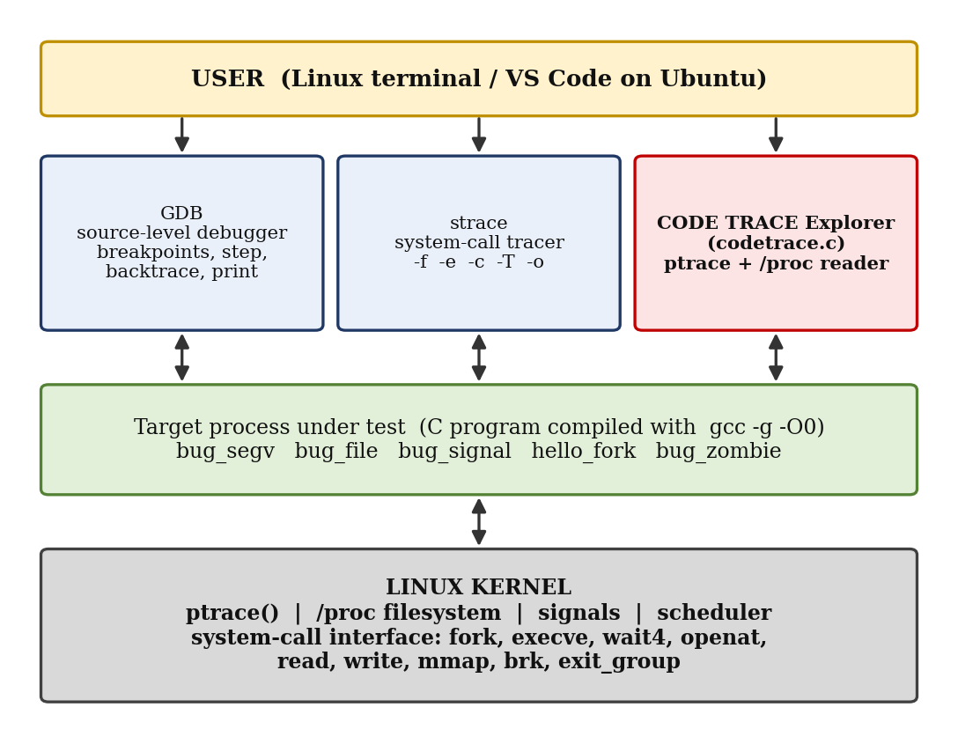
Figure 5.1 : Overall architecture of CODE TRACE
Layer | Components | Responsibility
User layer | Terminal, VS Code | Compile programs, run tools, read output
Tool layer | GDB, strace, codetrace | Control and observe the target; present results
Target layer | bug_segv, bug_file, bug_signal, hello_fork, bug_zombie | Programs that reproduce typical errors
Kernel layer | ptrace, /proc, signals, scheduler, system-call interface | Provide the services the tools rely on

5.2 System Workflow
The investigation of every program follows the same ten steps (Figure 5.2). Steps 4, 5 and 6 are the core of the project and are highlighted.
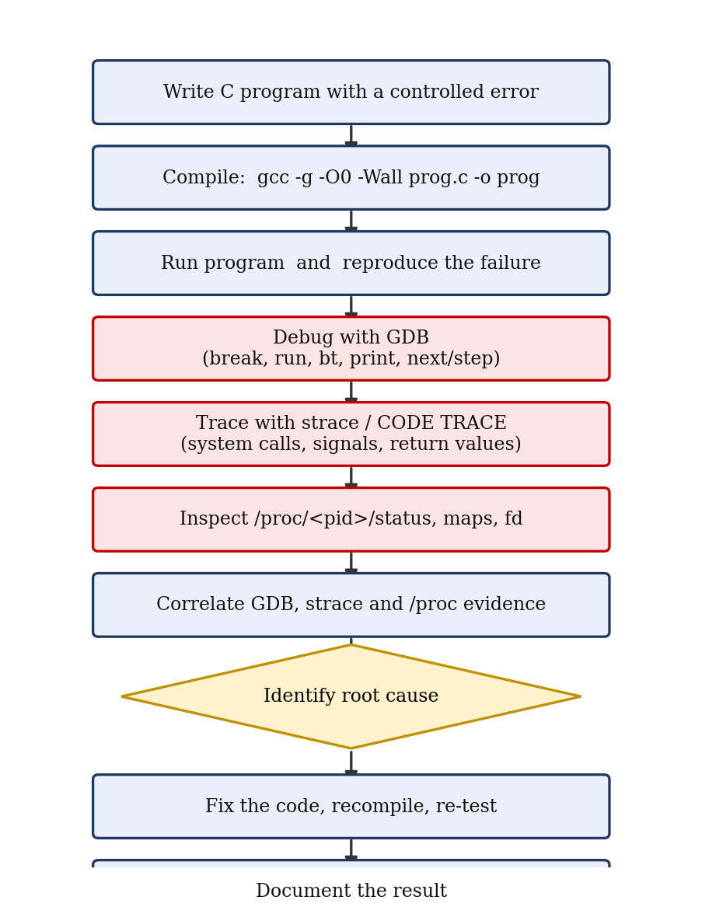
Figure 5.2 : Debugging and tracing workflow

5.3 Flowchart / Data Flow
The internal control flow of the codetrace explorer is shown below as a numbered flow. The process is split into a child part (which becomes the target) and a parent part (the tracer).
Step | Process | Action
1 | Parent | Read the program name from argv; call fork().
2 | Child | Call ptrace(PTRACE_TRACEME), stop itself with raise(SIGSTOP), then execvp() the target program.
3 | Parent | waitpid() for the first stop; set PTRACE_O_EXITKILL and PTRACE_O_TRACESYSGOOD; print /proc/<pid>/status.
4 | Parent | Resume the child with PTRACE_SYSCALL (run until the next system-call entry or exit) and waitpid().
5 | Parent | If the child exited or was killed, print the termination reason and go to step 8.
6 | Parent | If the stop is a system-call stop: read registers; on entry print name and arguments, on exit print the return value or error text.
7 | Parent | If the stop is another signal: print it and pass it to the child on the next resume; go to step 4.
8 | Parent | Print the total number of system calls observed and end.

Data flow. Input data (the program name and its arguments) flows from the command line to the tracer; the tracer receives registers and wait-status values from the kernel and reads text from /proc; the output data is the formatted trace on the terminal, which can be redirected to a file for the documentation.

5.4 Module Description
Module | Description | Files | Team member
M1 Test programs | Five small C programs that reproduce faults | bug_segv.c, bug_file.c, bug_signal.c, hello_fork.c, bug_zombie.c | Prathyusha Reddy
M2 GDB debugging | Breakpoints, stepping, variable inspection, backtrace on the test programs | gdb command scripts, session notes | Prathyusha Reddy
M3 System-call tracing | strace runs with filters and summary; analysis of the call sequences | strace logs | Miriyala Tharavarshini
M4 CODE TRACE explorer | ptrace-based tracer with /proc status viewer | codetrace.c, Makefile | Sai Krishna
M5 Process analysis & documentation | Process states, signals, results, report and GitHub repository | Report, README, repository | Harshith

5.5 Input and Output Design
Item | Input | Output
codetrace | ./codetrace <program> [arguments] | Header with PID and /proc status; one line per system call (name, three arguments, result); signal and termination messages; total call count
strace | strace [options] ./program | System calls with decoded arguments; --- SIGSEGV --- and +++ killed by ... +++ lines
GDB | Commands typed at the (gdb) prompt | Source line, variable values, backtrace, signal location
/proc | cat /proc/<pid>/status | State, PPid, VmSize, VmRSS, Threads and more

Output conventions. All messages from the explorer itself start with [CODE TRACE], so that they can be distinguished from the output of the traced program. Arguments are printed in hexadecimal; a failed call prints = -1 followed by the strerror() text.

CHAPTER -6 IMPLEMENTATION

6.1 Module-wise Implementation
M1 – Test programs
Each program isolates one kind of failure so that the effect of every tool can be seen clearly.
Program | Deliberate behaviour | OS concept shown
bug_segv.c | Passes a NULL pointer to sum() which dereferences it | Virtual memory, SIGSEGV
bug_file.c | Opens /tmp/missing_input.txt, which does not exist | System call error, errno (ENOENT)
bug_signal.c | Installs a SIGUSR1 handler and sends the signal to itself | Signals, handlers, rt_sigreturn
hello_fork.c | Parent creates a child that exits with code 3 and waits for it | fork, wait4, SIGCHLD
bug_zombie.c | Child exits but parent does not call wait() | Zombie process state (Z)

M2 – GDB debugging
GDB is used with the programs compiled with -g. The standard command set is listed in Section 7.2. For the crash in bug_segv the investigation is: run (GDB stops at the SIGSEGV), bt (shows sum called from main), frame 0, print a (shows the pointer value 0x0) and list (shows the failing line s += a[i];).
M3 – System-call tracing with strace
strace is run in three modes: full trace (strace ./prog), filtered trace (-e trace=openat,write), and statistics (-c). The trace of bug_file identifies the failed openat call and its ENOENT result without looking at the source code.
M4 – CODE TRACE explorer
The explorer is the project’s own implementation of the strace idea. Its complete source is given in Section 6.3 and its algorithm in Section 6.2.
M5 – Process analysis
Process states are recorded with ps and /proc/<pid>/status while the programs run; signals are observed through GDB, strace and codetrace; all results are saved in log files and entered in this report.

6.2 Algorithm / Pseudocode
ALGORITHM CodeTrace(program, args)
child <- fork()
IF child = 0 THEN // tracee
ptrace(TRACEME); raise(SIGSTOP); execvp(program, args)
exit(127) // only if exec fails
ENDIF
waitpid(child); // first stop (SIGSTOP)
set options EXITKILL, TRACESYSGOOD
print header; print /proc/child/status
in_call <- false; count <- 0; pending <- 0
LOOP
ptrace(SYSCALL, child, pending); pending <- 0
waitpid(child, status)
IF exited(status) THEN print exit code; BREAK
IF signaled(status) THEN print killing signal; BREAK
sig <- stop signal of status
IF sig = SIGTRAP|0x80 THEN // syscall stop
regs <- GETREGS(child)
IF NOT in_call THEN
print name(regs.orig_rax), regs.rdi, regs.rsi, regs.rdx
in_call <- true; count <- count + 1
ELSE
print regs.rax (or "-1 " + strerror(-rax) if error)
in_call <- false
ENDIF
ELSE IF sig <> SIGTRAP THEN // ordinary signal
print "signal delivered"; pending <- sig
ENDIF
ENDLOOP
print count

The variable pending is important: a signal that arrives is first reported to the tracer, and it reaches the program only if the tracer passes it back with the next PTRACE_SYSCALL request. An earlier version of the tool resumed the child in a separate call and lost the entry/exit pairing after SIGCHLD; carrying the signal in pending fixed this and made the trace of hello_fork consistent.

6.3 Core C / C++ Implementation
codetrace.c – the CODE TRACE explorer
/* CODE TRACE - Linux Process & System Call Explorer (x86_64) */
#define _GNU_SOURCE
#include <stdio.h>
#include <stdlib.h>
#include <string.h>
#include <unistd.h>
#include <signal.h>
#include <errno.h>
#include <sys/ptrace.h>
#include <sys/wait.h>
#include <sys/user.h>
#include <sys/types.h>

static const char *sysname(long n) {
switch (n) {
case 0: return "read"; case 1: return "write";
case 2: return "open"; case 3: return "close";
case 5: return "fstat"; case 9: return "mmap";
case 10: return "mprotect"; case 11: return "munmap";
case 12: return "brk"; case 39: return "getpid";
case 57: return "fork"; case 59: return "execve";
case 60: return "exit"; case 61: return "wait4";
case 62: return "kill"; case 231: return "exit_group";
case 257: return "openat"; case 262: return "newfstatat";
case 318: return "getrandom"; case 4: return "stat";
case 8: return "lseek"; case 13: return "rt_sigaction";
case 14: return "rt_sigprocmask"; case 21: return "access";
case 17: return "pread64"; case 56: return "clone";
case 158: return "arch_prctl"; case 202: return "futex";
case 218: return "set_tid_address"; case 273: return "set_robust_list";
case 302: return "prlimit64"; case 334: return "rseq";
case 435: return "clone3"; case 15: return "rt_sigreturn";
case 35: return "nanosleep";
case 230: return "clock_nanosleep";
default: return NULL;
}
}

static void show_proc(pid_t pid) {
char path[64], line[256];
snprintf(path, sizeof path, "/proc/%d/status", pid);
FILE *f = fopen(path, "r");
if (!f) return;
printf("---- /proc/%d/status ----\n", pid);
while (fgets(line, sizeof line, f))
if (!strncmp(line, "Name:", 5) || !strncmp(line, "State:", 6) ||
!strncmp(line, "Pid:", 4) || !strncmp(line, "PPid:", 5) ||
!strncmp(line, "VmSize:", 7) || !strncmp(line, "VmRSS:", 6) ||
!strncmp(line, "Threads:", 8))
fputs(line, stdout);
fclose(f);
}

int main(int argc, char **argv) {
if (argc < 2) { fprintf(stderr, "usage: %s prog [args]\n", argv[0]); return 1; }
pid_t child = fork();
if (child == 0) {
ptrace(PTRACE_TRACEME, 0, NULL, NULL);
raise(SIGSTOP);
execvp(argv[1], argv + 1);
perror("execvp"); _exit(127);
}
int status, in_call = 0, count = 0, pending = 0;
waitpid(child, &status, 0);
ptrace(PTRACE_SETOPTIONS, child, 0, PTRACE_O_EXITKILL | PTRACE_O_TRACESYSGOOD);
printf("[CODE TRACE] tracing PID %d : %s\n", child, argv[1]);
show_proc(child);
printf("---- system call trace ----\n");
for (;;) {
ptrace(PTRACE_SYSCALL, child, 0, pending);
pending = 0;
waitpid(child, &status, 0);
if (WIFEXITED(status)) {
if (in_call) printf(" = ?\n");
printf("[CODE TRACE] +++ exited with %d +++\n", WEXITSTATUS(status));
break;
}
if (WIFSIGNALED(status)) {
printf("[CODE TRACE] +++ killed by signal %d (%s) +++\n",
WTERMSIG(status), strsignal(WTERMSIG(status)));
break;
}
if (!WIFSTOPPED(status)) continue;
int sig = WSTOPSIG(status);
if (sig == (SIGTRAP | 0x80)) {
struct user_regs_struct r;
ptrace(PTRACE_GETREGS, child, 0, &r);
if (!in_call) {
const char *n = sysname(r.orig_rax);
if (n) printf("%-16s(0x%llx, 0x%llx, 0x%llx)", n, r.rdi, r.rsi, r.rdx);
else printf("syscall_%-8lld(0x%llx, 0x%llx, 0x%llx)",
r.orig_rax, r.rdi, r.rsi, r.rdx);
in_call = 1; count++;
} else {
long rv = (long)r.rax;
if (rv < 0 && rv > -4096) printf(" = -1 %s\n", strerror(-rv));
else printf(" = %ld\n", rv);
in_call = 0;
}
} else if (sig != SIGTRAP) {
printf("[CODE TRACE] --- signal %d (%s) delivered ---\n",
sig, strsignal(sig));
pending = sig;
}
}
printf("[CODE TRACE] total system calls observed: %d\n", count);
return 0;
}

bug_segv.c – NULL-pointer dereference
#include <stdio.h>

int sum(int *a, int n)
{
int s = 0;
for (int i = 0; i < n; i++)
s += a[i];
return s;
}

int main(void)
{
int *data = NULL; /* BUG: array never allocated */
printf("start\n");
fflush(stdout);
printf("sum = %d\n", sum(data, 5));
return 0;
}

bug_file.c – failing file access
#include <stdio.h>
#include <string.h>
#include <errno.h>
int main(void) {
FILE *f = fopen("/tmp/missing_input.txt", "r");
if (!f) { fprintf(stderr, "open failed: %s\n", strerror(errno)); return 1; }
fclose(f); return 0;
}

bug_signal.c – signal handler
#include <stdio.h>
#include <signal.h>
#include <unistd.h>

static void handler(int sig)
{
const char msg[] = "handler: caught SIGUSR1\n";
(void)sig;
write(1, msg, sizeof msg - 1);
}

int main(void)
{
signal(SIGUSR1, handler);
printf("pid=%d, sending SIGUSR1 to self\n", getpid());
fflush(stdout);
kill(getpid(), SIGUSR1);
printf("back in main after handler\n");
return 0;
}

hello_fork.c – fork and wait
#include <stdio.h>
#include <unistd.h>
#include <sys/wait.h>
int main(void) {
pid_t p = fork();
if (p == 0) { printf("child pid=%d ppid=%d\n", getpid(), getppid()); return 3; }
int st; waitpid(p, &st, 0);
printf("parent pid=%d child exit=%d\n", getpid(), WEXITSTATUS(st));
return 0;
}

bug_zombie.c – zombie process
#include <stdio.h>
#include <stdlib.h>
#include <unistd.h>
int main(void) {
pid_t p = fork();
if (p == 0) exit(0);
sleep(1);
char cmd[64]; snprintf(cmd, sizeof cmd, "grep State /proc/%d/status", p);
printf("child %d state after exit (parent has not called wait):\n", p);
fflush(stdout); system(cmd);
return 0;
}

6.4 Linux System Calls / APIs Used
API | Header | Purpose in the project
fork() | unistd.h | Create the tracee (and the child in hello_fork, bug_zombie)
execvp() | unistd.h | Replace the child with the program under test
ptrace(PTRACE_TRACEME) | sys/ptrace.h | Child asks to be traced by its parent
ptrace(PTRACE_SETOPTIONS) | sys/ptrace.h | EXITKILL: kill tracee if tracer dies; TRACESYSGOOD: mark syscall stops as SIGTRAP|0x80
ptrace(PTRACE_SYSCALL) | sys/ptrace.h | Resume tracee until next system-call entry/exit
ptrace(PTRACE_GETREGS) | sys/ptrace.h | Read the registers into struct user_regs_struct
waitpid(), WIFEXITED, WIFSIGNALED, WIFSTOPPED | sys/wait.h | Receive and decode state changes of the tracee
raise(SIGSTOP) | signal.h | Let the tracer take control before exec
signal(), kill(), getpid() | signal.h, unistd.h | Signal handler demonstration
fopen() / fgets() on /proc/<pid>/status | stdio.h | Read process information from the kernel
strsignal(), strerror() | string.h | Human-readable signal and error names

6.5 Process / Thread Implementation
The tool uses a two-process design. After fork() the child marks itself as traced with PTRACE_TRACEME and stops with SIGSTOP. The parent, which is now the tracer, waits for this stop and takes control. When the child calls execvp(), the kernel replaces its program image but not its PID, and because it is traced it receives a SIGTRAP stop at the exec; the first system call seen in each trace is therefore execve. From this moment the parent decides when the child may run: it is allowed to run only until the next system-call boundary.
While stopped, the child appears in /proc/<pid>/status as State: t (tracing stop), which is printed in the header of each run. The test program hello_fork.c additionally creates a child through clone; this process is not traced because PTRACE_O_TRACEFORK is not enabled, which keeps the output readable. No threads are created by the tool.

6.6 IPC / Synchronization Implementation
The project does not use shared memory, message queues or semaphores. The communication and synchronisation mechanisms that appear are the following:
Mechanism | Where | Role
ptrace stop/resume protocol | codetrace | The tracee blocks at every system-call boundary until the tracer sends PTRACE_SYSCALL; this is strict lock-step synchronisation.
waitpid() | codetrace, hello_fork | The parent sleeps until the child changes state and receives the status word (exit code, signal number, stop reason).
Signals | bug_signal, hello_fork | SIGUSR1 is sent with kill() and handled asynchronously; SIGCHLD informs the parent that the child terminated.
Exit status | hello_fork | The child returns 3 and the parent reads it with WEXITSTATUS; this is a one-value IPC channel.
/proc filesystem | codetrace, bug_zombie | One-way information channel from the kernel to user space.

Since the tracer and tracee never run at the same time on a ptrace stop, no race conditions can occur on the data they exchange and no explicit locks are required.

6.7 Memory Management Implementation
The project does not implement a memory manager; it observes the kernel’s memory management through the system calls and /proc fields that every process produces.
- Heap growth. Each trace contains two brk calls near the end of the start-up phase: brk(0x0) returns the current end of the heap and the second call extends it so that printf can allocate its buffer.
- Memory mapping. mmap calls create the regions for the C library; mprotect then makes parts of them read-only; munmap releases the temporary mapping of the library cache.
- Memory counters. The header printed by codetrace shows VmSize (total virtual memory) and VmRSS (resident pages in RAM) from /proc/<pid>/status. Their different values show that most of the virtual address space is not resident.
- Invalid access. In bug_segv, address 0 is not mapped. The CPU raises a page fault, the kernel finds no mapping and delivers SIGSEGV; the trace ends with killed by signal 11 (Segmentation fault) and the shell reports exit status 139.
The complete memory layout of a process can be viewed during a debugging session with cat /proc/<pid>/maps or info proc mappings in GDB.

6.8 Optional User Interface Implementation
The project uses a command-line interface, which is the natural interface for Linux system tools. The following features improve usability:
- A fixed-width, column-aligned trace format (%-16s), so that call names, arguments and results line up.
- The [CODE TRACE] prefix for tool messages, which separates them from the program’s own output.
- GDB’s text user interface (gdb -tui ./bug_segv, then layout src) shows the source code and the current line next to the command prompt.
- Output redirection (./codetrace ./prog > trace.txt) so that logs can be stored with the report.

CHAPTER -7 EXECUTION AND DEMONSTRATION

7.1 Compilation in Ubuntu
# build everything with Make
make

# Makefile
CC = gcc
CFLAGS = -g -O0 -Wall -Wextra
PROGS = codetrace bug_segv bug_file bug_signal hello_fork bug_zombie

all: $(PROGS)
%: %.c
$(CC) $(CFLAGS) -o $@ $<
clean:
rm -f $(PROGS)

The explorer compiles without warnings. The command make produces six executables in the project folder. (In a real Makefile the recipe lines must begin with a TAB character, not spaces.)

7.2 Execution Commands
Task | Command
Run a faulty program normally | ./bug_segv ; echo $?
Trace with CODE TRACE | ./codetrace ./bug_segv
Full strace | strace -o segv.log ./bug_segv
strace of selected calls | strace -e trace=openat,write ./bug_file
strace statistics | strace -c ./hello_fork
Follow child processes | strace -f ./hello_fork
Start GDB | gdb ./bug_segv
GDB: run / backtrace | (gdb) run (gdb) bt
GDB: breakpoint and stepping | (gdb) break sum (gdb) next (gdb) step (gdb) continue
GDB: inspect | (gdb) print a (gdb) print i (gdb) info locals (gdb) list
GDB: catch system calls | (gdb) catch syscall openat
Process state | ps -o pid,ppid,stat,cmd cat /proc/<pid>/status

7.3 Sample Inputs and Outputs
The listings below are real output produced on Ubuntu 24.04 (x86-64) with the CODE TRACE explorer. Process IDs and addresses change from run to run; long start-up sections are abbreviated with “...”.
Test 1 – Normal run of bug_segv (shell view)
$ ./bug_segv
start
Segmentation fault
$ echo $?
139

The program prints start, then crashes. Exit status 139 equals 128 + 11, i.e. termination by signal 11 (SIGSEGV).
Test 2 – bug_segv under CODE TRACE
[CODE TRACE] tracing PID 264 : ./bug_segv
---- /proc/264/status ----
Name: codetrace
State: t (tracing stop)
Pid: 264
PPid: 263
VmSize: 2556 kB
VmRSS: 524 kB
Threads: 1
---- system call trace ----
execve (0x7ffc9a75ccd9, 0x7ffc9a75c430, 0x7ffc9a75c440) = 0
brk (0x0, 0x7f660e271a18, 0x0) = 94512484904960
mmap (0x0, 0x2000, 0x3) = 140076300570624
...
getrandom (0x7f660e20a178, 0x8, 0x1) = 8
brk (0x0, 0x7f660e203b20, 0x7f660e203b20) = 94512484904960
brk (0x55f567190000, 0x7f660e203b20, 0x7f660e20ad70) = 94512485040128
start
write (0x1, 0x55f56716f2a0, 0x6) = 6
[CODE TRACE] --- signal 11 (Segmentation fault) delivered ---
[CODE TRACE] +++ killed by signal 11 (Segmentation fault) +++
[CODE TRACE] total system calls observed: 34

The last system call is the write of the string start (6 bytes). The next event is SIGSEGV, delivered while the program was running user code, followed by termination. The trace shows when the crash happened but not where; the location is found with GDB (Test 6).
Test 3 – bug_file under CODE TRACE
brk (0x55b0d0287000, 0x7f454d803b20, 0x7f454d80ad70) = 94217894916096
openat (0xffffff9c, 0x55b090303006, 0x0) = -1 No such file or directory
open failed: No such file or directory
write (0x2, 0x7fff3605e320, 0x27) = 39
exit_group (0x1, 0xffffffffffffff88, 0xe7) = ?
[CODE TRACE] +++ exited with 1 +++
[CODE TRACE] total system calls observed: 35

The openat call at the end of the start-up sequence returns -1 No such file or directory, i.e. ENOENT. The program then writes 39 bytes (the message open failed: No such file or directory plus newline) to file descriptor 2 (stderr) and exits with status 1. The root cause is visible without reading any source code.
Test 4 – hello_fork under CODE TRACE
clone (0x1200011, 0x0, 0x0) = 260
child pid=260 ppid=259
[CODE TRACE] --- signal 17 (Child exited) delivered ---
wait4 (0x104, 0x7fff53b2a1e0, 0x0) = 260
getpid (0x104, 0x7fff53b2a1e0, 0x0) = 259
fstat (0x1, 0x7fff53b29e10, 0x7f08dce01ee0) = 0
getrandom (0x7f08dce0a178, 0x8, 0x1) = 8
brk (0x0, 0x7f08dce03b20, 0x7f08dce03b20) = 94841733795840
brk (0x56420fdc6000, 0x7f08dce03b20, 0x7f08dce0ad70) = 94841733931008
parent pid=259 child exit=3
write (0x1, 0x56420fda52a0, 0x1c) = 28
exit_group (0x0, 0xffffffffffffff88, 0xe7) = ?
[CODE TRACE] +++ exited with 0 +++
[CODE TRACE] total system calls observed: 38

clone returns 260, the PID of the child, to the parent. The child’s own output (child pid=260 ppid=259) appears right after the clone call, because the child runs independently of the traced parent. When the child ends, SIGCHLD (signal 17) is delivered to the parent and wait4 returns the same PID 260. The child exit code 3 is shown by the parent’s message child exit=3.
Test 5 – bug_signal under CODE TRACE
brk (0x55ffdecb5000, 0x7f67e2c03b20, 0x7f67e2c0ad70) = 94557442887680
pid=864, sending SIGUSR1 to self
write (0x1, 0x55ffdec942a0, 0x21) = 33
getpid (0x7f67e2c05710, 0x0, 0x55ffdec942a0) = 864
kill (0x360, 0xa, 0x55ffdec942a0) = 0
[CODE TRACE] --- signal 10 (User defined signal 1) delivered ---
handler: caught SIGUSR1
write (0x1, 0x7ffe548a1840, 0x18) = 24
rt_sigreturn (0x1, 0x7ffe548a1840, 0x18) = 0
back in main after handler
write (0x1, 0x55ffdec942a0, 0x1b) = 27
exit_group (0x0, 0xffffffffffffff88, 0xe7) = ?
[CODE TRACE] +++ exited with 0 +++
[CODE TRACE] total system calls observed: 42

The kill(pid, 10) call sends SIGUSR1 (signal 10) to the process itself. The signal is reported to the tracer first and then delivered; the handler runs and writes its message, and rt_sigreturn returns control to main, which prints the final line.
Test 6 – bug_zombie and process state
child 276 state after exit (parent has not called wait):
State: Z (zombie)

After the child has exited, /proc/<pid>/status of the child still exists and shows State: Z (zombie), because the parent has not yet called wait(). The entry disappears once the parent collects the exit status or terminates.
Test 7 – Representative strace output (expected format)
The following is the format produced by strace for the same faults. It is given here for comparison; the team’s own run should be pasted in Section 7.4.
$ strace -e trace=openat,write ./bug_file
openat(AT_FDCWD, "/tmp/missing_input.txt", O_RDONLY) = -1 ENOENT (No such file or directory)
write(2, "open failed: No such file or dir"..., 39) = 39
+++ exited with 1 +++

$ strace ./bug_segv
...
write(1, "start\n", 6) = 6
--- SIGSEGV {si_signo=SIGSEGV, si_code=SEGV_MAPERR, si_addr=NULL} ---
+++ killed by SIGSEGV (core dumped) +++

strace decodes arguments (AT_FDCWD, O_RDONLY, ENOENT) and prints the fault address of the signal (si_addr=NULL), which confirms the NULL-pointer cause.
Test 8 – Representative GDB session (expected format)
$ gdb ./bug_segv
(gdb) run
start
Program received signal SIGSEGV, Segmentation fault.
0x... in sum (a=0x0, n=5) at bug_segv.c:7
7 s += a[i];
(gdb) bt
#0 0x... in sum (a=0x0, n=5) at bug_segv.c:7
#1 0x... in main () at bug_segv.c:16
(gdb) print a
$1 = (int *) 0x0
(gdb) print i
$2 = 0
(gdb) frame 1
(gdb) print data
$3 = (int *) 0x0

GDB stops at the faulting instruction, shows that the parameter a of sum() is the NULL pointer 0x0, and the backtrace shows that it was passed from main at line 16, where data was never allocated. The fix is to allocate or initialise the array before calling sum().

7.4 Screenshots of Execution
The team should paste screenshots taken on its own Ubuntu machine in the frames below.
[ Paste screenshot here: Compilation of all programs with make ]
Figure 7.1 : Compilation of all programs with make
[ Paste screenshot here: Normal run of bug_segv and exit status 139 ]
Figure 7.2 : Normal run of bug_segv and exit status 139
[ Paste screenshot here: Output of ./codetrace ./bug_segv ]
Figure 7.3 : Output of ./codetrace ./bug_segv
[ Paste screenshot here: strace -e trace=openat,write ./bug_file ]
Figure 7.4 : strace -e trace=openat,write ./bug_file
[ Paste screenshot here: GDB session: run, bt, print a on bug_segv ]
Figure 7.5 : GDB session: run, bt, print a on bug_segv
[ Paste screenshot here: bug_zombie: State Z (zombie) in /proc/<pid>/status ]
Figure 7.6 : bug_zombie: State Z (zombie) in /proc/<pid>/status

7.5 Demonstration of OS Concepts
OS concept | Demonstration | Evidence
Process creation | hello_fork | clone(...) = 260 in the parent; child PID 260 with PPid 259
Program execution (exec) | Any trace | First call is execve
Parent–child synchronisation | hello_fork | wait4(...) = 260, exit code 3 read by parent
System-call error handling | bug_file | openat ... = -1 No such file or directory
Signals and handlers | bug_signal | SIGUSR1 delivered; rt_sigaction before and rt_sigreturn after the handler
Fatal signal / memory protection | bug_segv | SIGSEGV, exit status 139
Process states | codetrace header, bug_zombie | State: t (tracing stop) and State: Z (zombie)
Virtual memory | All traces | brk, mmap, mprotect, munmap; VmSize larger than VmRSS

CHAPTER -8 CONCLUSION

8.1 Summary of the Project
CODE TRACE: Linux Process & System Call Explorer demonstrates a systematic way to debug Linux programs by combining source-level debugging (GDB), system-call tracing (strace) and process analysis (/proc, signals). Five small programs reproduce typical faults, and a custom explorer written in about 100 lines of C with ptrace() shows how system-call tracing works internally. The investigation of each fault followed the same chain of reproduction, location, observation, correlation and documentation, and in every case the root cause could be identified from the collected evidence.

8.2 Objectives Achieved
Objective | Status | How it was achieved
1. GDB-based debugging workflow | Achieved | Compile with -g, run, break, step, print, bt; demonstrated on bug_segv (Section 7.3, Test 8)
2. System-call and process tracing with strace | Achieved | Full, filtered and summary traces; failed openat identified in bug_file (Test 3, Test 7)
3. Identify runtime errors, crashes and abnormal behaviour | Achieved | NULL-pointer crash, failed file open, zombie process, signal delivery
4. Relate debugging, processes, signals and OS resources | Achieved | Section 7.5 maps each concept to observed evidence
5. Implement the CODE TRACE explorer | Achieved | codetrace.c compiled without warnings and tested on four programs

8.3 Results Achieved
Program | Observed behaviour | Revealed by | Root cause
bug_segv | Crash after printing start; exit status 139 | codetrace (SIGSEGV), GDB (a=0x0) | NULL pointer passed to sum()
bug_file | Message open failed, exit status 1 | strace / codetrace (openat = ENOENT) | Input file does not exist
bug_signal | Handler message printed, program continues | codetrace (kill, signal 10, rt_sigreturn) | Normal signal delivery
hello_fork | Child exit code 3 collected by parent | codetrace (clone, SIGCHLD, wait4) | Normal fork/wait behaviour
bug_zombie | Child shown as Z (zombie) | /proc status | Parent did not call wait()

Measured on the test machine, the traces contained 34 system calls for bug_segv, 35 for bug_file, 38 for hello_fork and 42 for bug_signal. About thirty of these belong to the start-up of every dynamically linked C program (loader, library mapping, heap set-up), which is why filtering with strace -e is useful for large programs.

8.4 Skills and Learning Outcomes
- Using GDB and strace for diagnosis of real faults.
- Understanding the user/kernel boundary, the x86-64 system-call convention and how ptrace stops and resumes a process.
- Reading process states and memory information from /proc.
- Writing C programs that use fork, exec, wait, signals and file I/O correctly.
- Team work: tool development, debugging, tracing and documentation were shared among four members and managed through a GitHub repository.
Limitations and future scope
- codetrace prints only raw argument values; decoding strings and flags (as strace does) would improve readability.
- The system-call table covers about 30 common calls; the complete x86-64 table can be generated from the kernel headers.
- Following children and threads with PTRACE_O_TRACEFORK and PTRACE_O_TRACECLONE.
- Time-stamps and per-call statistics, a -e style call filter, and a simple text user interface.
- Support for the ARM64 architecture.

CHAPTER -9 REFERENCES

9.1 Books
1. A. Silberschatz, P. B. Galvin and G. Gagne, Operating System Concepts, 10th ed., Wiley, 2018.
2. M. Kerrisk, The Linux Programming Interface, No Starch Press, 2010.
3. W. R. Stevens and S. A. Rago, Advanced Programming in the UNIX Environment, 3rd ed., Addison-Wesley, 2013.
4. R. Love, Linux Kernel Development, 3rd ed., Addison-Wesley, 2010.
5. A. S. Tanenbaum and H. Bos, Modern Operating Systems, 4th ed., Pearson, 2014.
6. R. E. Bryant and D. R. O’Hallaron, Computer Systems: A Programmer’s Perspective, 3rd ed., Pearson, 2016.
7. A. Zeller, Why Programs Fail: A Guide to Systematic Debugging, 2nd ed., Morgan Kaufmann, 2009.

9.2 Research Papers
1. N. Nethercote and J. Seward, “Valgrind: A Framework for Heavyweight Dynamic Binary Instrumentation,” in Proc. ACM SIGPLAN Conference on Programming Language Design and Implementation (PLDI), 2007.
2. K. Serebryany, D. Bruening, A. Potapenko and D. Vyukov, “AddressSanitizer: A Fast Address Sanity Checker,” in Proc. USENIX Annual Technical Conference, 2012.

9.3 Linux / GNU Documentation
1. Linux manual pages: ptrace(2), wait(2), fork(2), execve(2), kill(2), signal(7), proc(5), syscalls(2), strace(1). https://man7.org/linux/man-pages/
2. GNU Project, Debugging with GDB. https://sourceware.org/gdb/current/onlinedocs/gdb/
3. GNU Compiler Collection online documentation. https://gcc.gnu.org/onlinedocs/
4. The Linux Kernel documentation. https://www.kernel.org/doc/html/latest/

9.4 Online Resources
1. strace project page. https://strace.io/
2. Ubuntu documentation and package information. https://help.ubuntu.com/
3. Project repository (OSSP, Team 17). https://github.com/taravarshini31/Debugging_OSSP

