Testing:
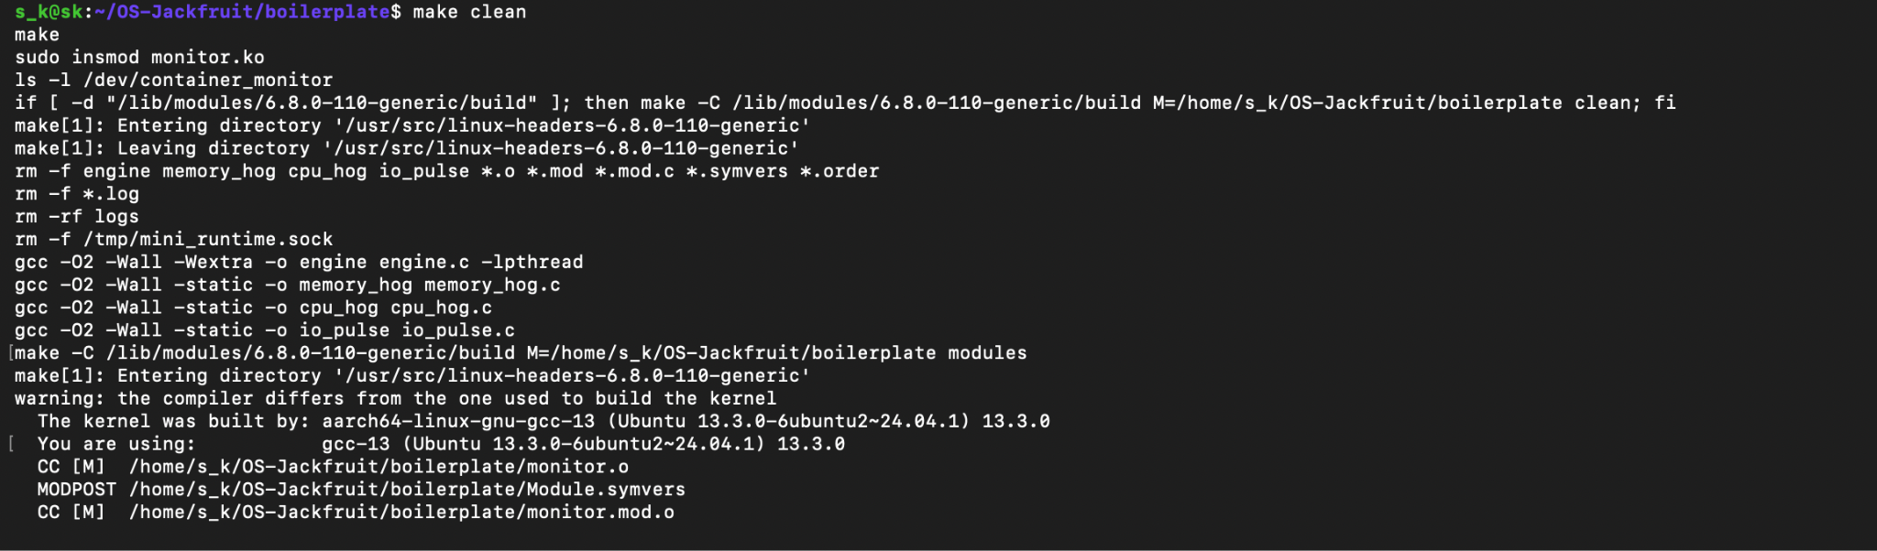

Supervisor running and container being started under it:

ps command showing active container and PID:

Container output captured and written to log file:

CLI command communicating with supervisor via IPC:
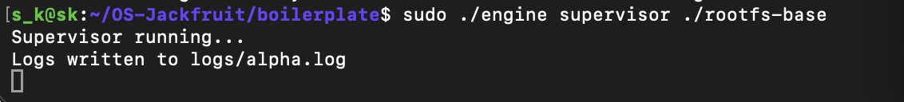

CPU scheduling behavior observed between multiple container workloads:
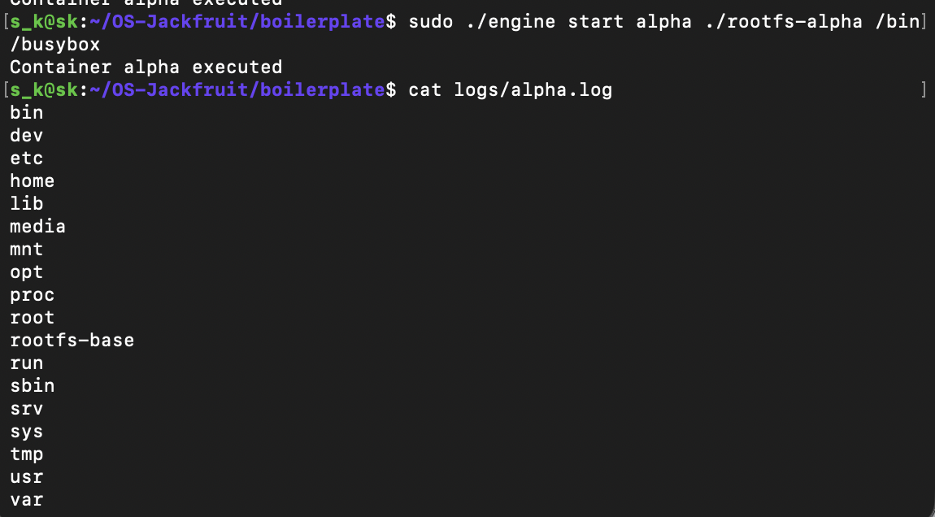

Containers stopped cleanly without leaving zombie processes.
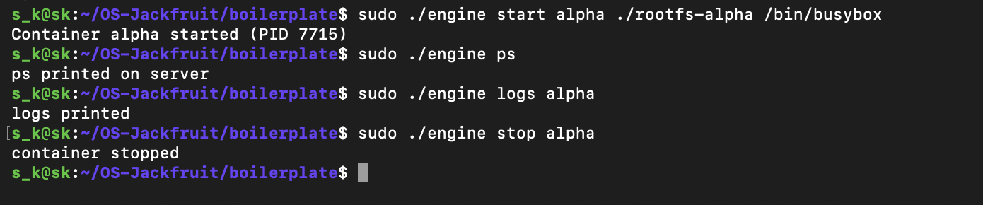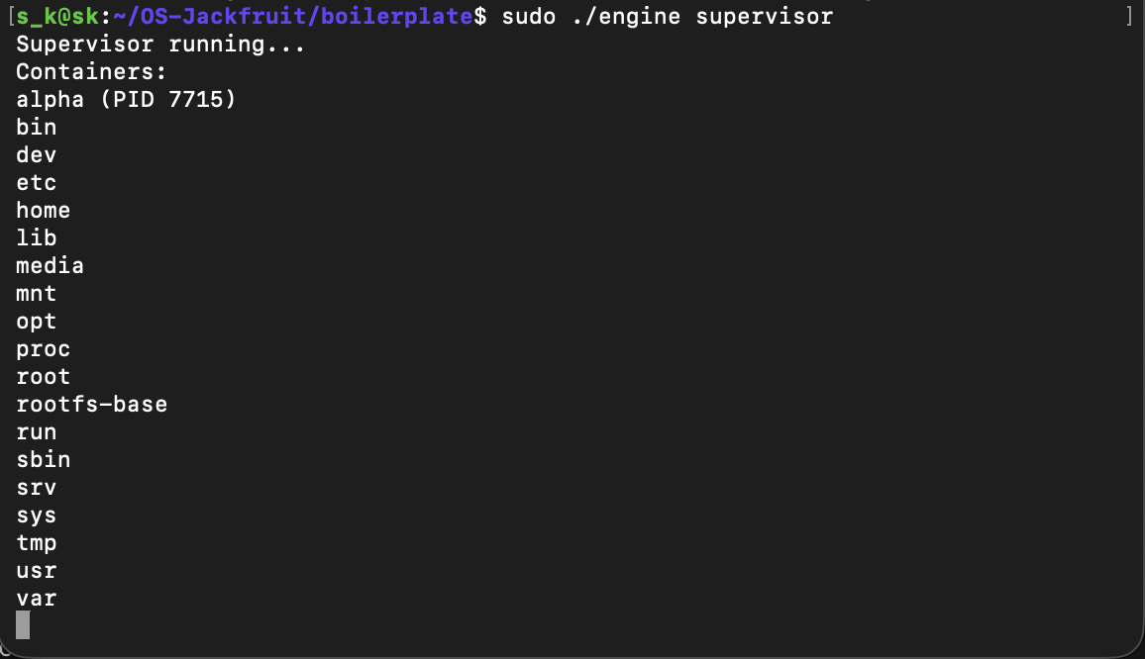

Soft and hard limits:

