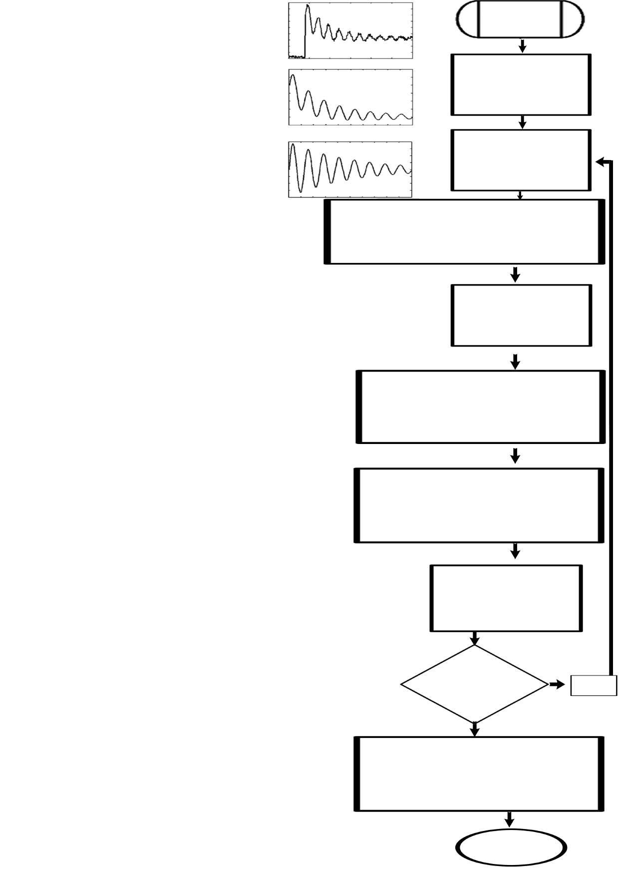Image result for square brackets pngImage result for square brackets pngImage result for square brackets pngImage result for square brackets pngImage result for square brackets pngImage result for square brackets pngImage result for square brackets pngImage result for square brackets pngImage result for square brackets pngImage result for square brackets pngImage result for square brackets pngImage result for square brackets pngImage result for square brackets pngImage result for square brackets png

P

P

**A(z)=∏(z-z1)=∑a(m)zp-m**

NO

Extend with another set of PMU data.

If the result is undesirable ?

END

Plot the desired output result in MATLAB

based Graphical User Interface

(GUI).

Update C

αi=Re(log(zk)1/T)

ωi=Im(log(zk)1/T)

Using a we calculate the other parameters

**LPSVD**

**Y=USV**H

Sr 0

Ŝ= 0 0 **â= -Y+ y**

y(P) y(P-1) ... y(1) a(1) y(P+1) **a=(YδY)-1 Yδy**

y(P+1) y(P) ...y(2) a(2) y(P+2) **Ya=-y**

... ... = - ...

y(N-1) y(N-2)...y(N-P) a(P) y(N)

y(P) y(P-1) ... y(1) a(1) y(P+1)

y(P+1) y(P) ... y(2) a(2) y(P+2)

... ... ... ... = - ...

Y(2P-1) y(2P-2)..y(P) a(P) y(2P)

m=0

k=1

P

k=1

**ŷ= ∑ Ak e(ak+iωk)(n-1)T+iφk**

Starting

Mechanism

Set c=1 and r=1