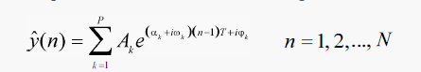

Starting Mechanism

Set c=1,r=1

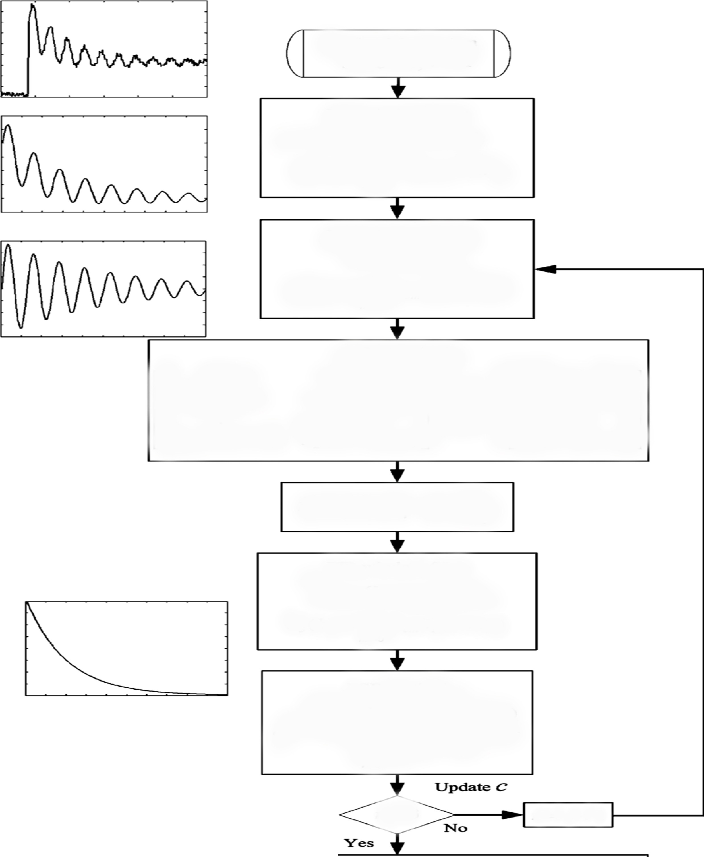

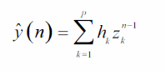

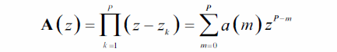

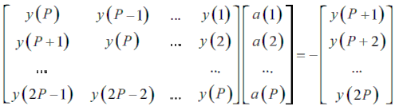

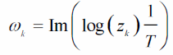

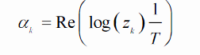

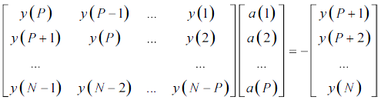

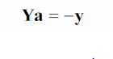 ;

 **LPSVD**

Using a we calculate

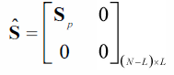 the other parameters.



If λ +ve Stable system

The system is unstable and for that the a

useful insight into the system operation can be unreliable .