Part 1 Data Analytics Execution Evidence
This document records the requirements, calculations, screenshots and interpretations for the four Part 1 tasks.

Task 1: SQL-Based Traffic Analysis
Using the Metro Interstate Traffic Volume dataset:

1.1 Load the dataset
- Load the comma-delimited traffic CSV file into SQLite.
- Verify that the data has been loaded correctly.
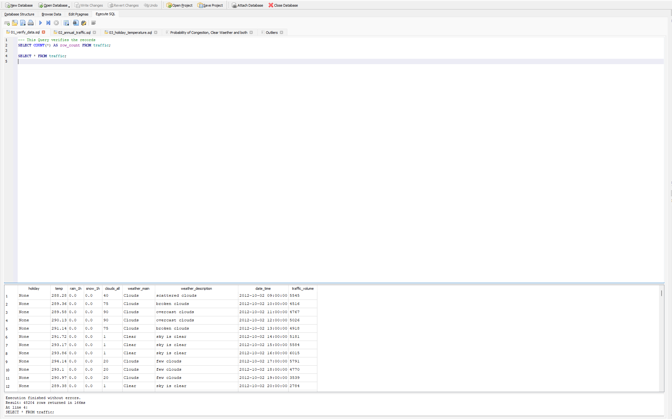
Figure 1 1.1 Load the dataset

1.2 Analyse annual traffic trends
Compare the total yearly traffic volume for:
- 2012
- 2013
- 2014
- 2015
- 2016
- 2017
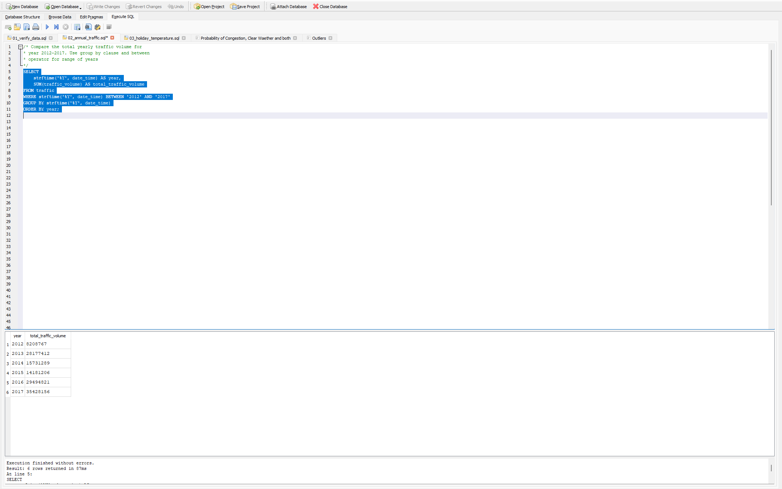
Figure 2 1.2 Analyse annual traffic trends
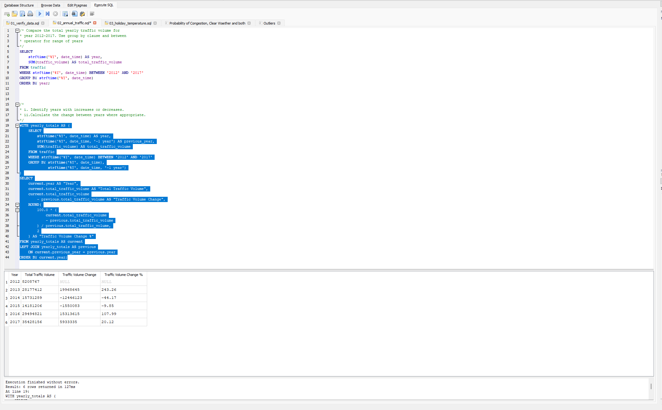
Figure 3 1.2 Analyse annual traffic trends

Observations:
- Recorded traffic volume fell in 2014 and 2015, then rose in 2016 and 2017. The highest decrease was between 2013 and 2014, when the total fell by 44.17%.
- Year 2017 had the highest recorded total traffic volume. It was about 35.43 M, which was 5.93 M more than 2016 with an increase of 20.12%.
- Missing hours and repeated timestamps also affect the other totals. In 2012, the data includes only records from October, hence, it cannot be proved that the large increase in 2013 mean traffic grew that much.

1.3 Analyse temperature around holidays
Compare temperature patterns for 2015, 2016 and 2017 during:
- New Year's Day
- Labor Day
Identify notable year-on-year changes and discuss whether these changes appear relevant to traffic conditions.
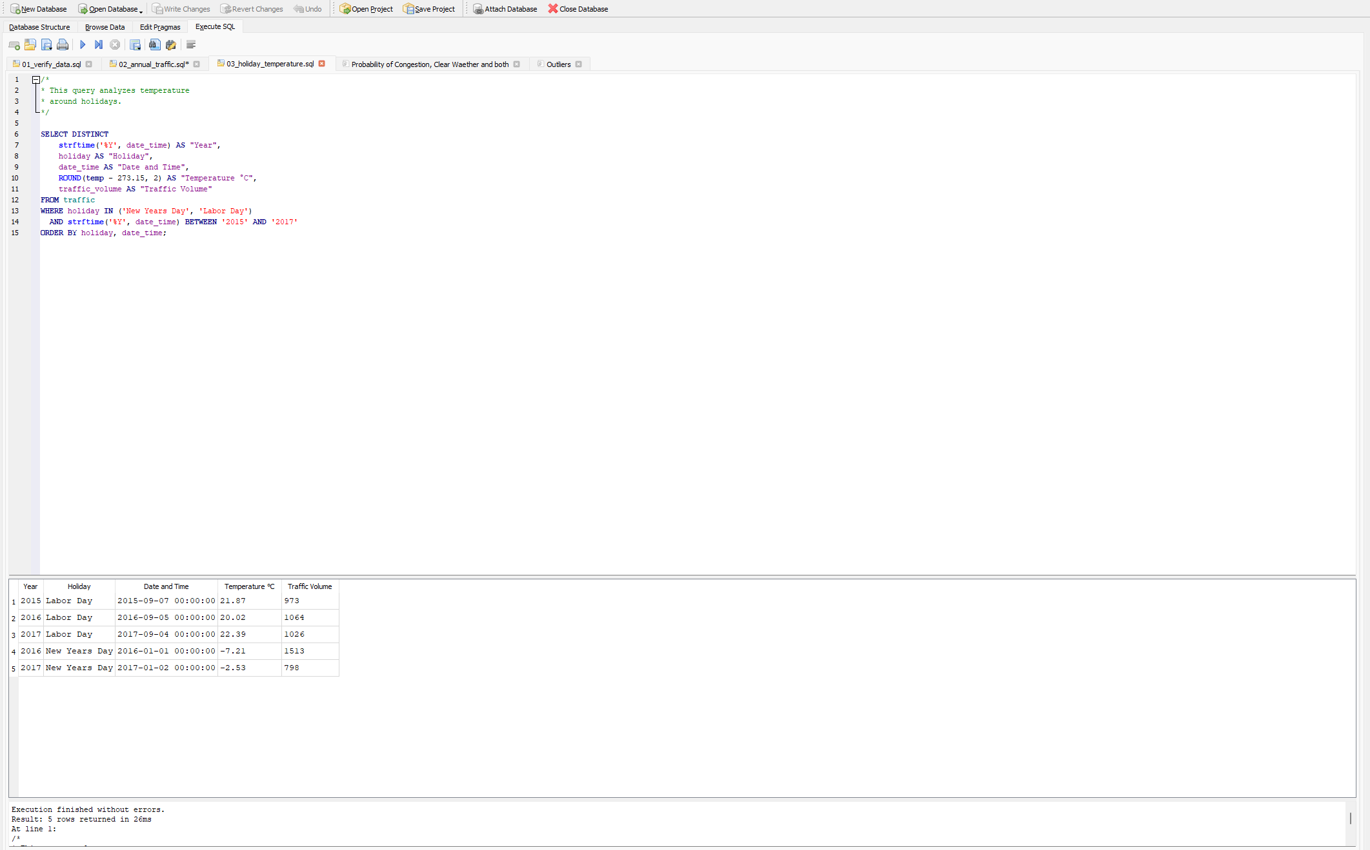
Figure 4 1.3 Analyse temperature around holidays

Observations:
- The record labelled New Year’s Day was 4.68°C warmer in 2017 than in 2016. The 2017 record is dated 2 January, while the 2016 record is dated 1 January. Recorded traffic volume decreased from 1513 to 798. These are midnight observations, not whole-day averages.
- Labor Day was cooler in 2016 and warmer again in 2017. Traffic rose from 973 in 2015 to 1064 in 2016, then fell to 1026 in 2017. There does not seem to be a clear pattern linking temperature to traffic volume.
- New Year's Day 2015 has no data available. Also, each result shows only the midnight hour, not the whole day.

Task 2: Descriptive Statistics and Correlation
Using the traffic dataset, calculate:

2.1 Traffic volume statistics
- Mean
- Median
- Standard deviation
- Variance
- Range
Interpret what these statistics tell you about traffic volume and its variability.
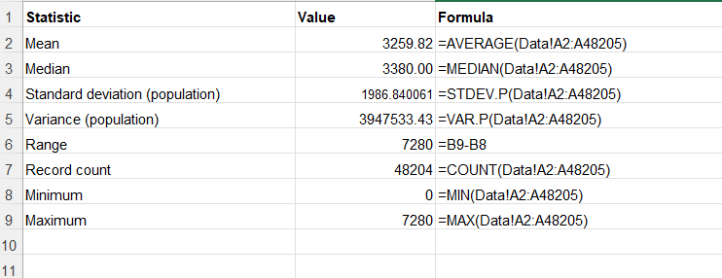
Figure 5 2.1 Traffic volume statistics
Statistic Parameter | Value
Mean | 3259.82
Median | 3380
Standard deviation | 1986.840061
Variance | 3947533.43
Range | 7280

Observations:
- Mean: The average recorded traffic volume was about 3260 vehicles per hour.
- Median: The Median value was 3380 vehicles per hour. This indicates that half the records had traffic volume at or below this value, and half had volume at or above it.
- Standard deviation: Standard deviation is roughly 1987 vehicles, which indicates that traffic volume varies considerably around the average.
- Variance: This indicates how spread out traffic volume is.
- Range: Recorded traffic volume went from 0 to 7280 vehicles per hour, which indicates a wide difference between the lowest and highest values of a dataset.

2.2 Correlation analysis
Calculate the correlation coefficient between:
- Temperature
- Traffic volume
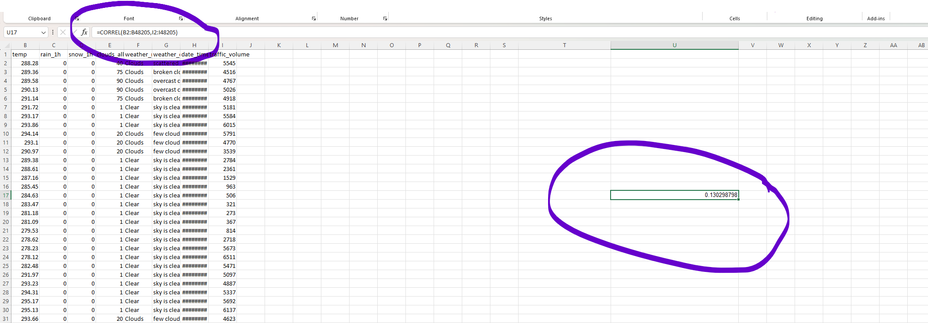
Figure 6 2.2 Correlation analysis
Correlation coefficient: ~ 0.1303

Observations:
- Direction: The correlation is 0.1303, which is positive. This means warmer temperatures, slightly more traffic.
- Strength: The number is close to zero, so the link is weak. Warmer weather does not always necessarily mean more traffic.
- Cause: This does not prove that warmer weather causes more traffic. There are other things could explain the link. For example, daytime is often warmer than nighttime, more people also travel during the day etc.

Task 3: Probability and Congestion Analysis
Define congestion as: traffic volume > 5,500 vehicles.
Calculate:

3.1 Basic probability
- P(Congestion)
- P(Clear Weather)
- P(Congestion AND Clear Weather)
- P(Congestion)
= Number of congestion records ÷ Total records
= 7100 ÷ 48204
= 0.1473
- P(Clear Weather)
= Number of clear weather records ÷ Total records
= 13391 ÷ 48204
= 0.2778
- P(Congestion AND Clear Weather)
= Number of records with both congestion and clear weather ÷ Total records
= 1763 ÷ 48204
= 0.0366
Verification by running SQL queries:
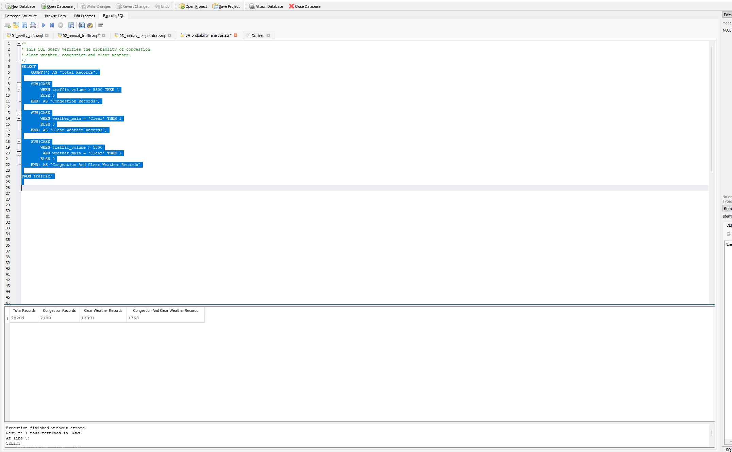
Figure 7 3.1 Basic probability

3.2 Conditional probability
Calculate:
- P(Clear Weather | Congestion)
- P(High Temperature | Congestion), where high temperature > 292K
- Determine whether weather conditions and congestion can be considered independent using P(A ∩ B) = P(A) × P(B)
- Calculate the odds ratio of congestion in clear versus cloudy weather.
Conclude with a short explanation of what the probability analysis suggests about the relationship between weather and congestion.
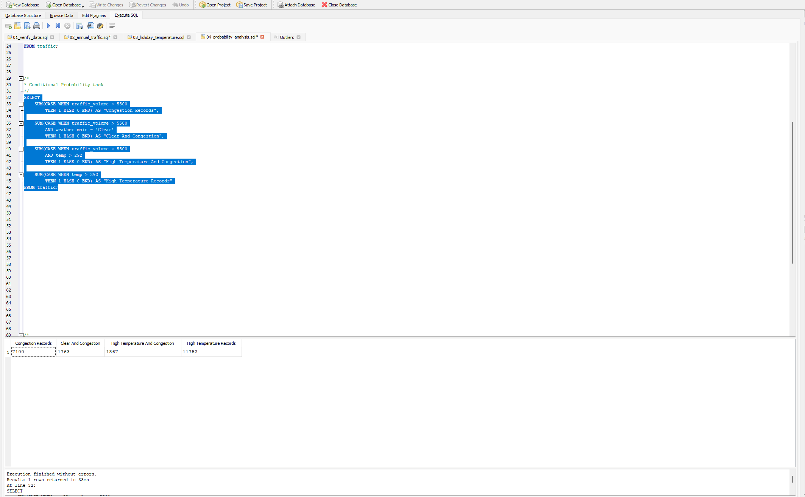
Figure 8 3.2 Conditional probability
- P(Clear Weather | Congestion)
= Clear weather and congestion records ÷ Congestion records
= 1763 ÷ 7100
= 0.2483
- P(High Temperature | Congestion), where high temperature > 292K
= High temperature and congestion records ÷ Congestion records
= 1867 ÷ 7100
= 0.2630
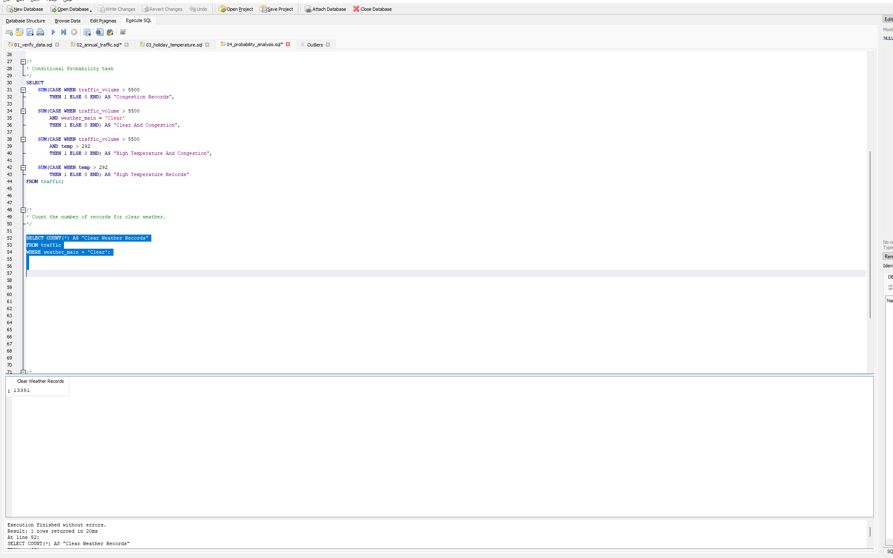
Figure 9 3.2 Conditional probability

Weathre conditions related calculations:
P(Clear Weather)
= 13391 ÷ 48204
= 0.2778
P(Congestion)
= 7100 ÷ 48204
= 0.1473
P(Clear Weather AND Congestion)
= 1763 ÷ 48204
= 0.0366
P(Clear Weather) × P(Congestion)
= 0.2778 × 0.1473
= 0.0409

Temperature related calculations :
P(High Temperature)
= 11752 ÷ 48204
= 0.2438
P(Congestion)
= 7100 ÷ 48204
= 0.1473
P(High Temperature AND Congestion)
= 1867 ÷ 48204
= 0.0387
P(High Temperature) × P(Congestion)
= 0.2438 * 0.1473
= 0.03591
Looking at both the calculations, P(Clear Weather AND Congestion) and P(Clear Weather) × P(Congestion) slightly differ. The same is observed for P(High Temperature AND Congestion) and P(High Temperature) × P(Congestion). This indicates that weather and congestion are not exactly independent. They have slight connection, but clearly we cannot say that good weather induces the congestion.

odds ratio of congestion in clear versus cloudy weather:
Odds = Congestion records ÷ No congestion records
- Clear weather odds = 1763 ÷ 11628 = 0.1516
- Cloudy weather odds = 2592 ÷ 12572 = 0.2062
Odds ratio = Clear weather odds ÷ Cloudy weather odds
= (1763 ÷ 11628) ÷ (2592 ÷ 12572)
= 0.7354
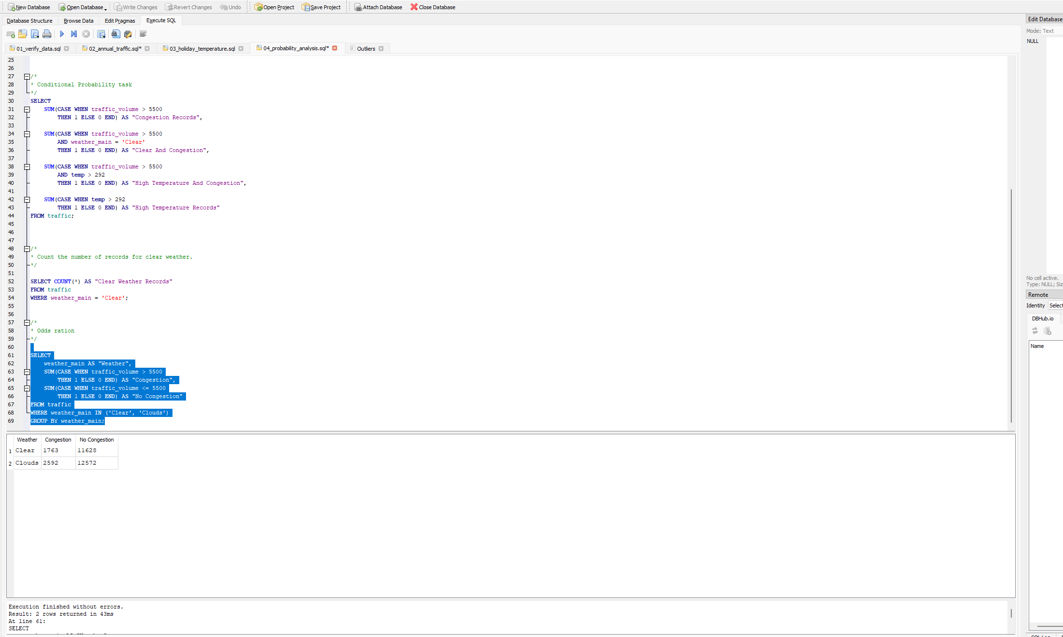
Figure 10 3.2 Conditional probability
The odds ratio is 0.74. Because it is below 1, it shows that congestion had lower odds in clear weather than in cloudy weather.
Conclusion: Overall, 14.73% of records had congestion. Of these congestion records, 24.83% had clear weather and 26.30% had hih temperatures. Congestion had lower odds in clear weather than in cloudy wether. This indicates some link between weather and congestion, but does not necessarily indicate that weather causes congestion.

Task 4: Power BI Traffic Intelligence Dashboard
Import the traffic CSV file into Power BI Desktop and use Power Query Editor to prepare the data.
4.1 Data quality and preparation
Perform the following:
- Determine the number of rows and columns.
- Identify null/missing values and the columns affected.
- Check whether the data types are appropriate.
- Extract Hour from DateTime.
- Create Temperature in Celsius.
- Create a Traffic Category:
Traffic Volume | Category
< 4,500 | Low
4,500–5,500 | Medium
> 5,500 | High

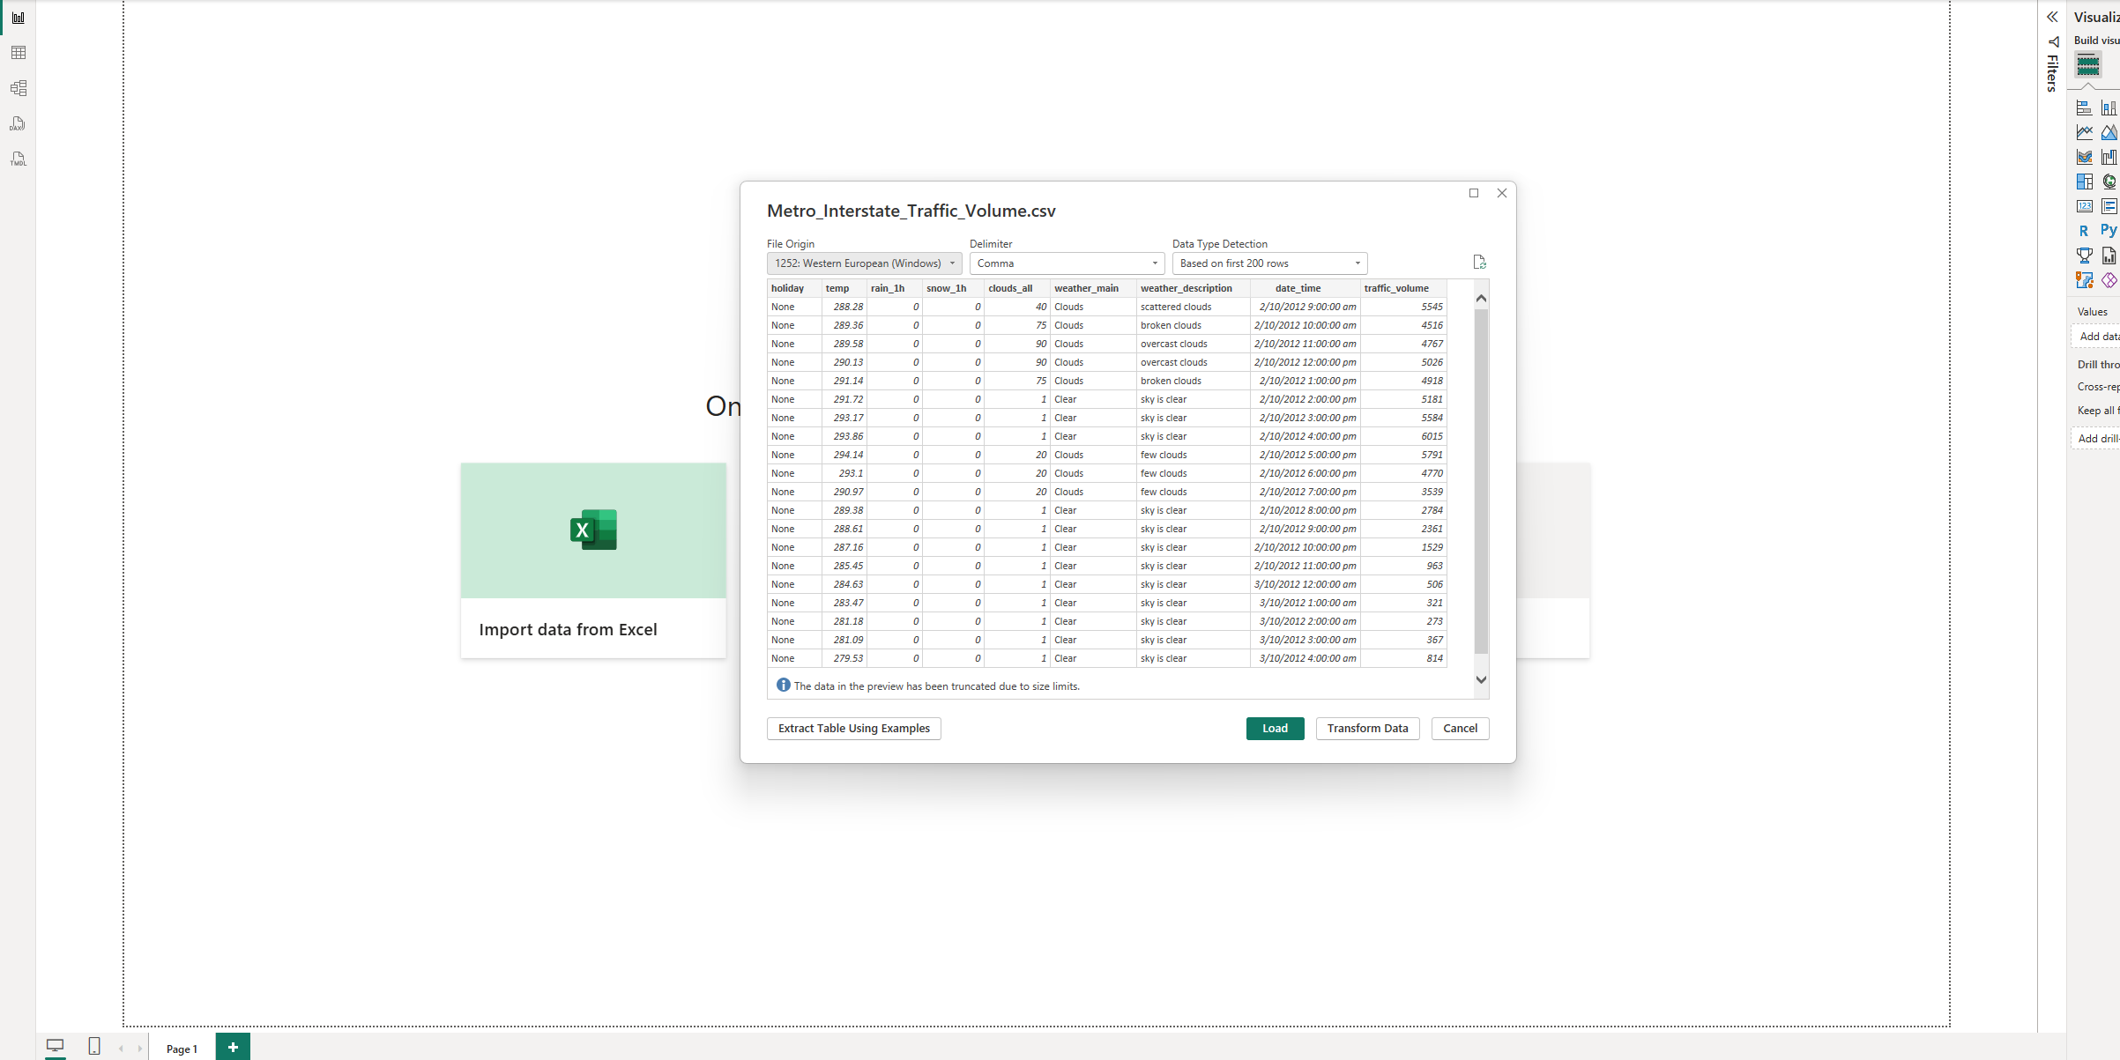
Figure 11 4.1 Data quality and preparation
- Number of rows and columns:
Number of Rows: 48204
Number of Columns: 9
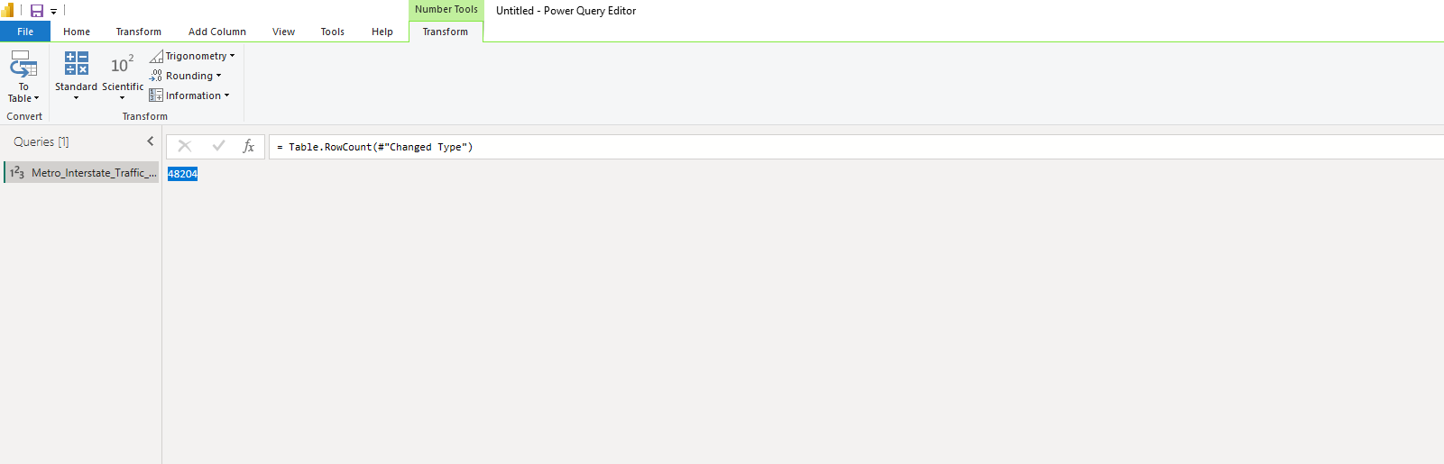
Figure 12 4.1 Data quality and preparation
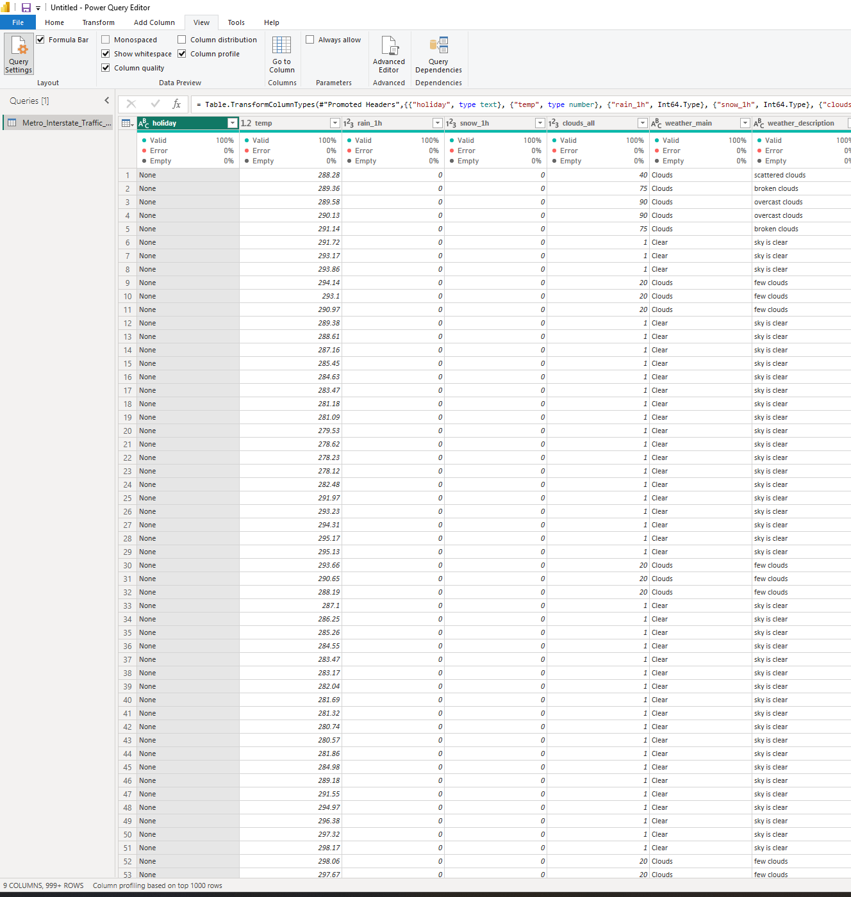
Figure 13 4.1 Data quality and preparation
NOTE: Number of columns are changed to 13 after adding Hour, Temperature in Celsius, Traffic Category and Date.
- Identify null/missing values and the columns affected.
Every column showed 0% Empty and 0% Error, so no null or missing values were found.
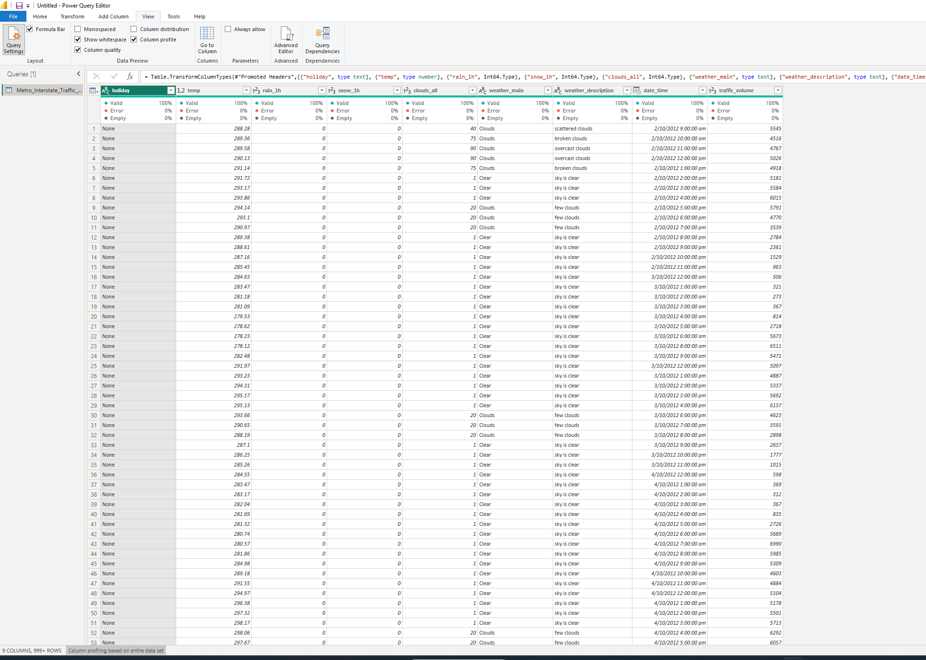
Figure 14 4.1 Data quality and preparation
- Check whether the data types are appropriate.
The data types were checked and corrected. Temperature, rain and snow were set to Decimal Number. Clouds_all and traffic volume were set to Whole Number. The date and time column was set to Date/Time. Remaining columns kept as it is in Text.
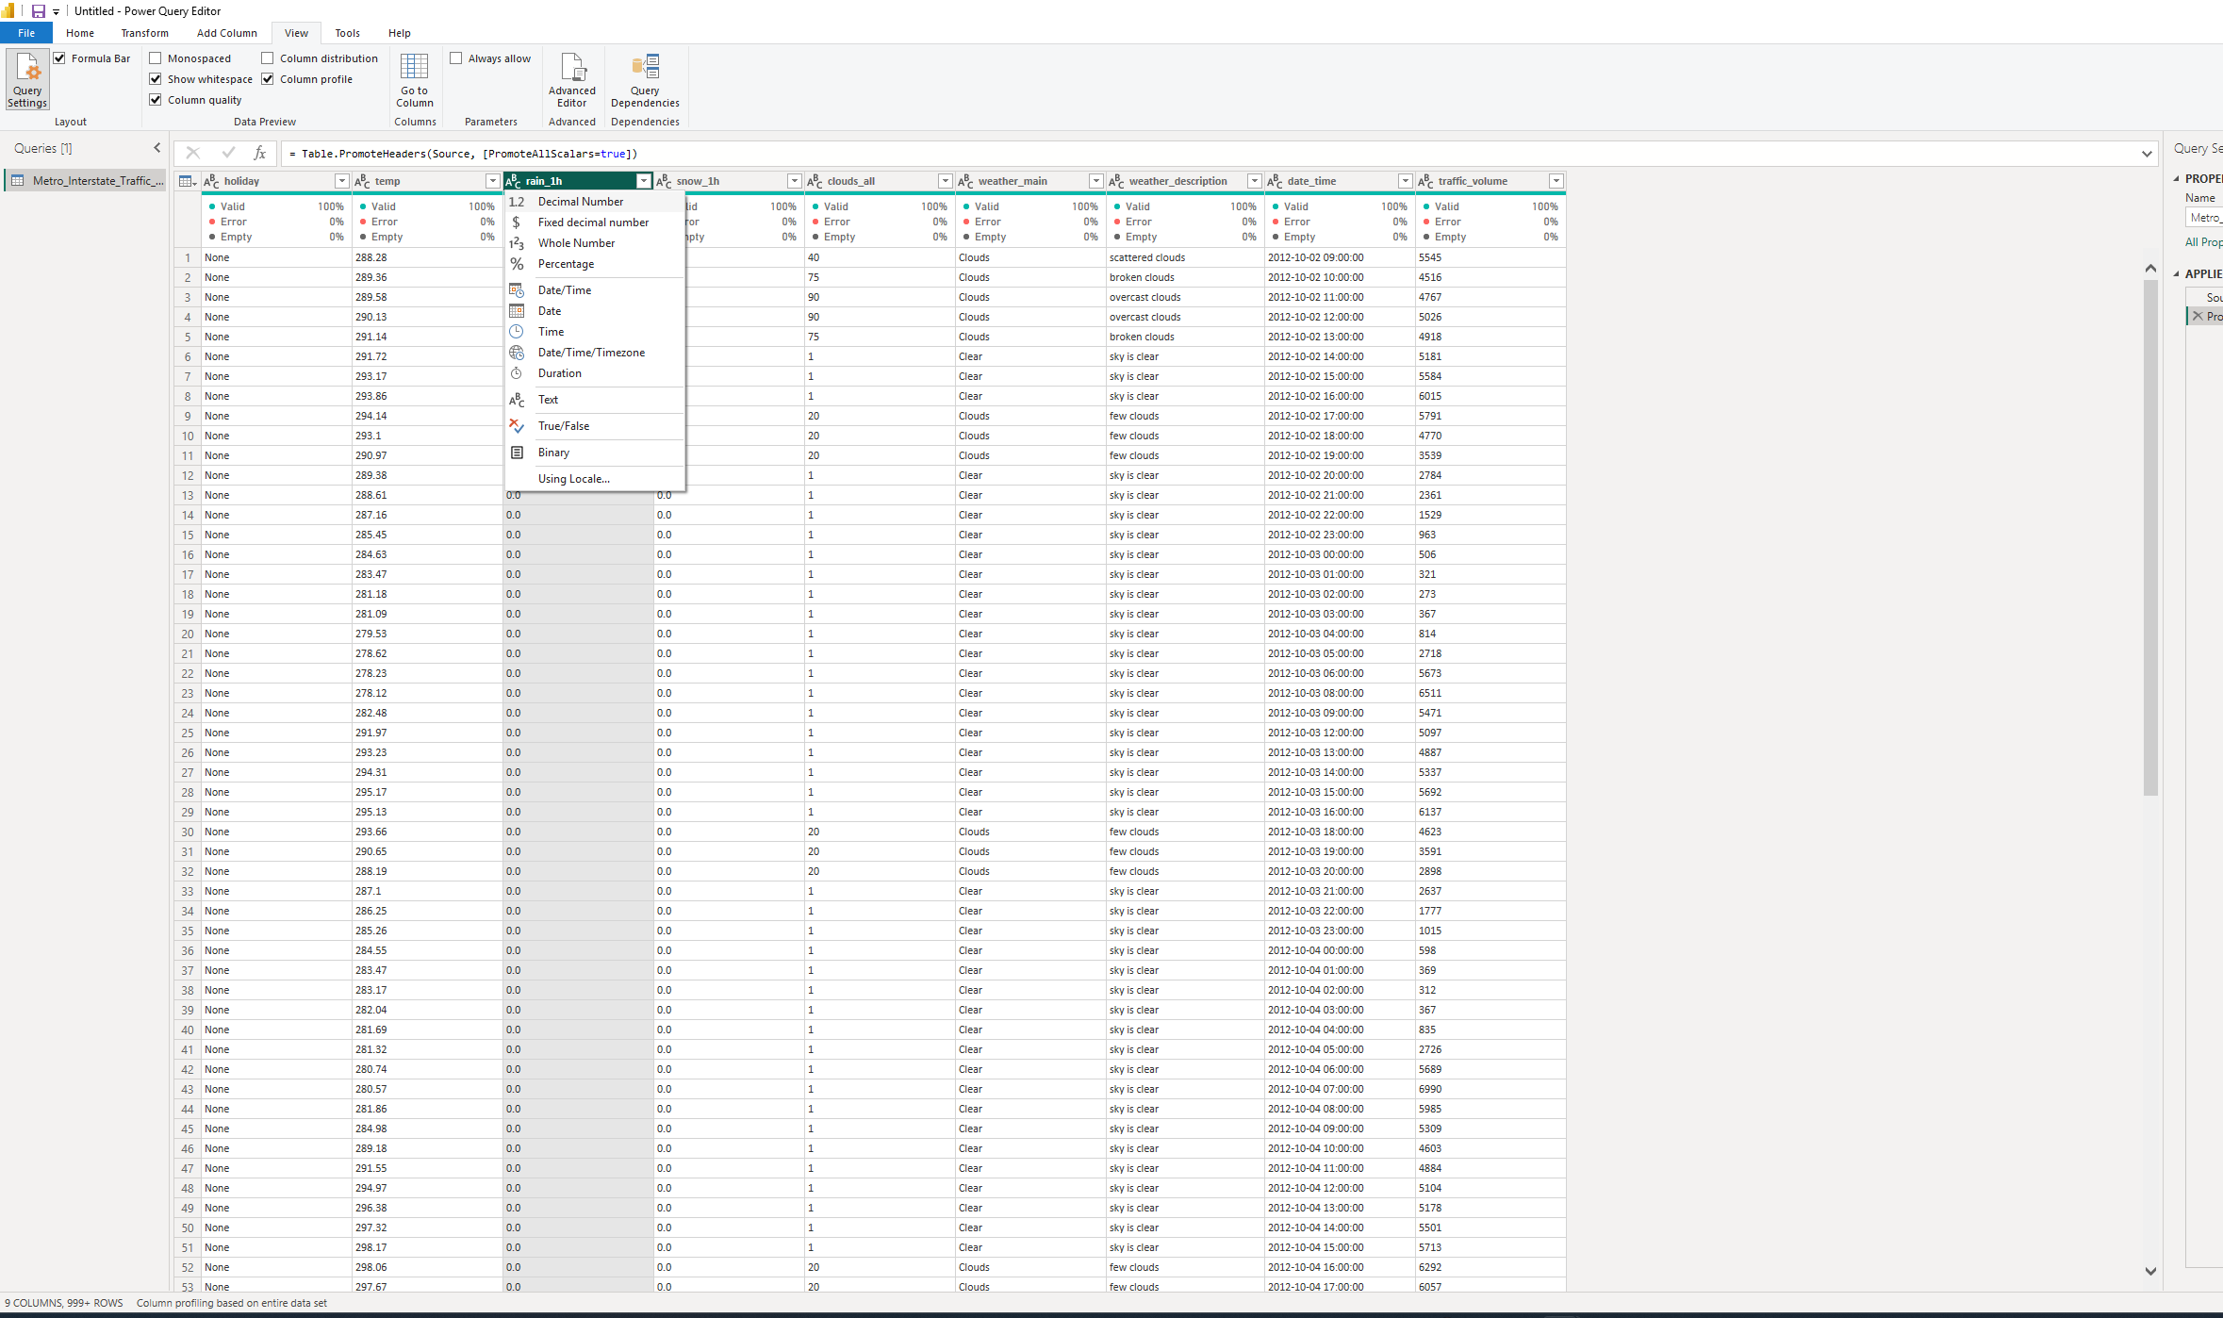
Figure 15 4.1 Data quality and preparation
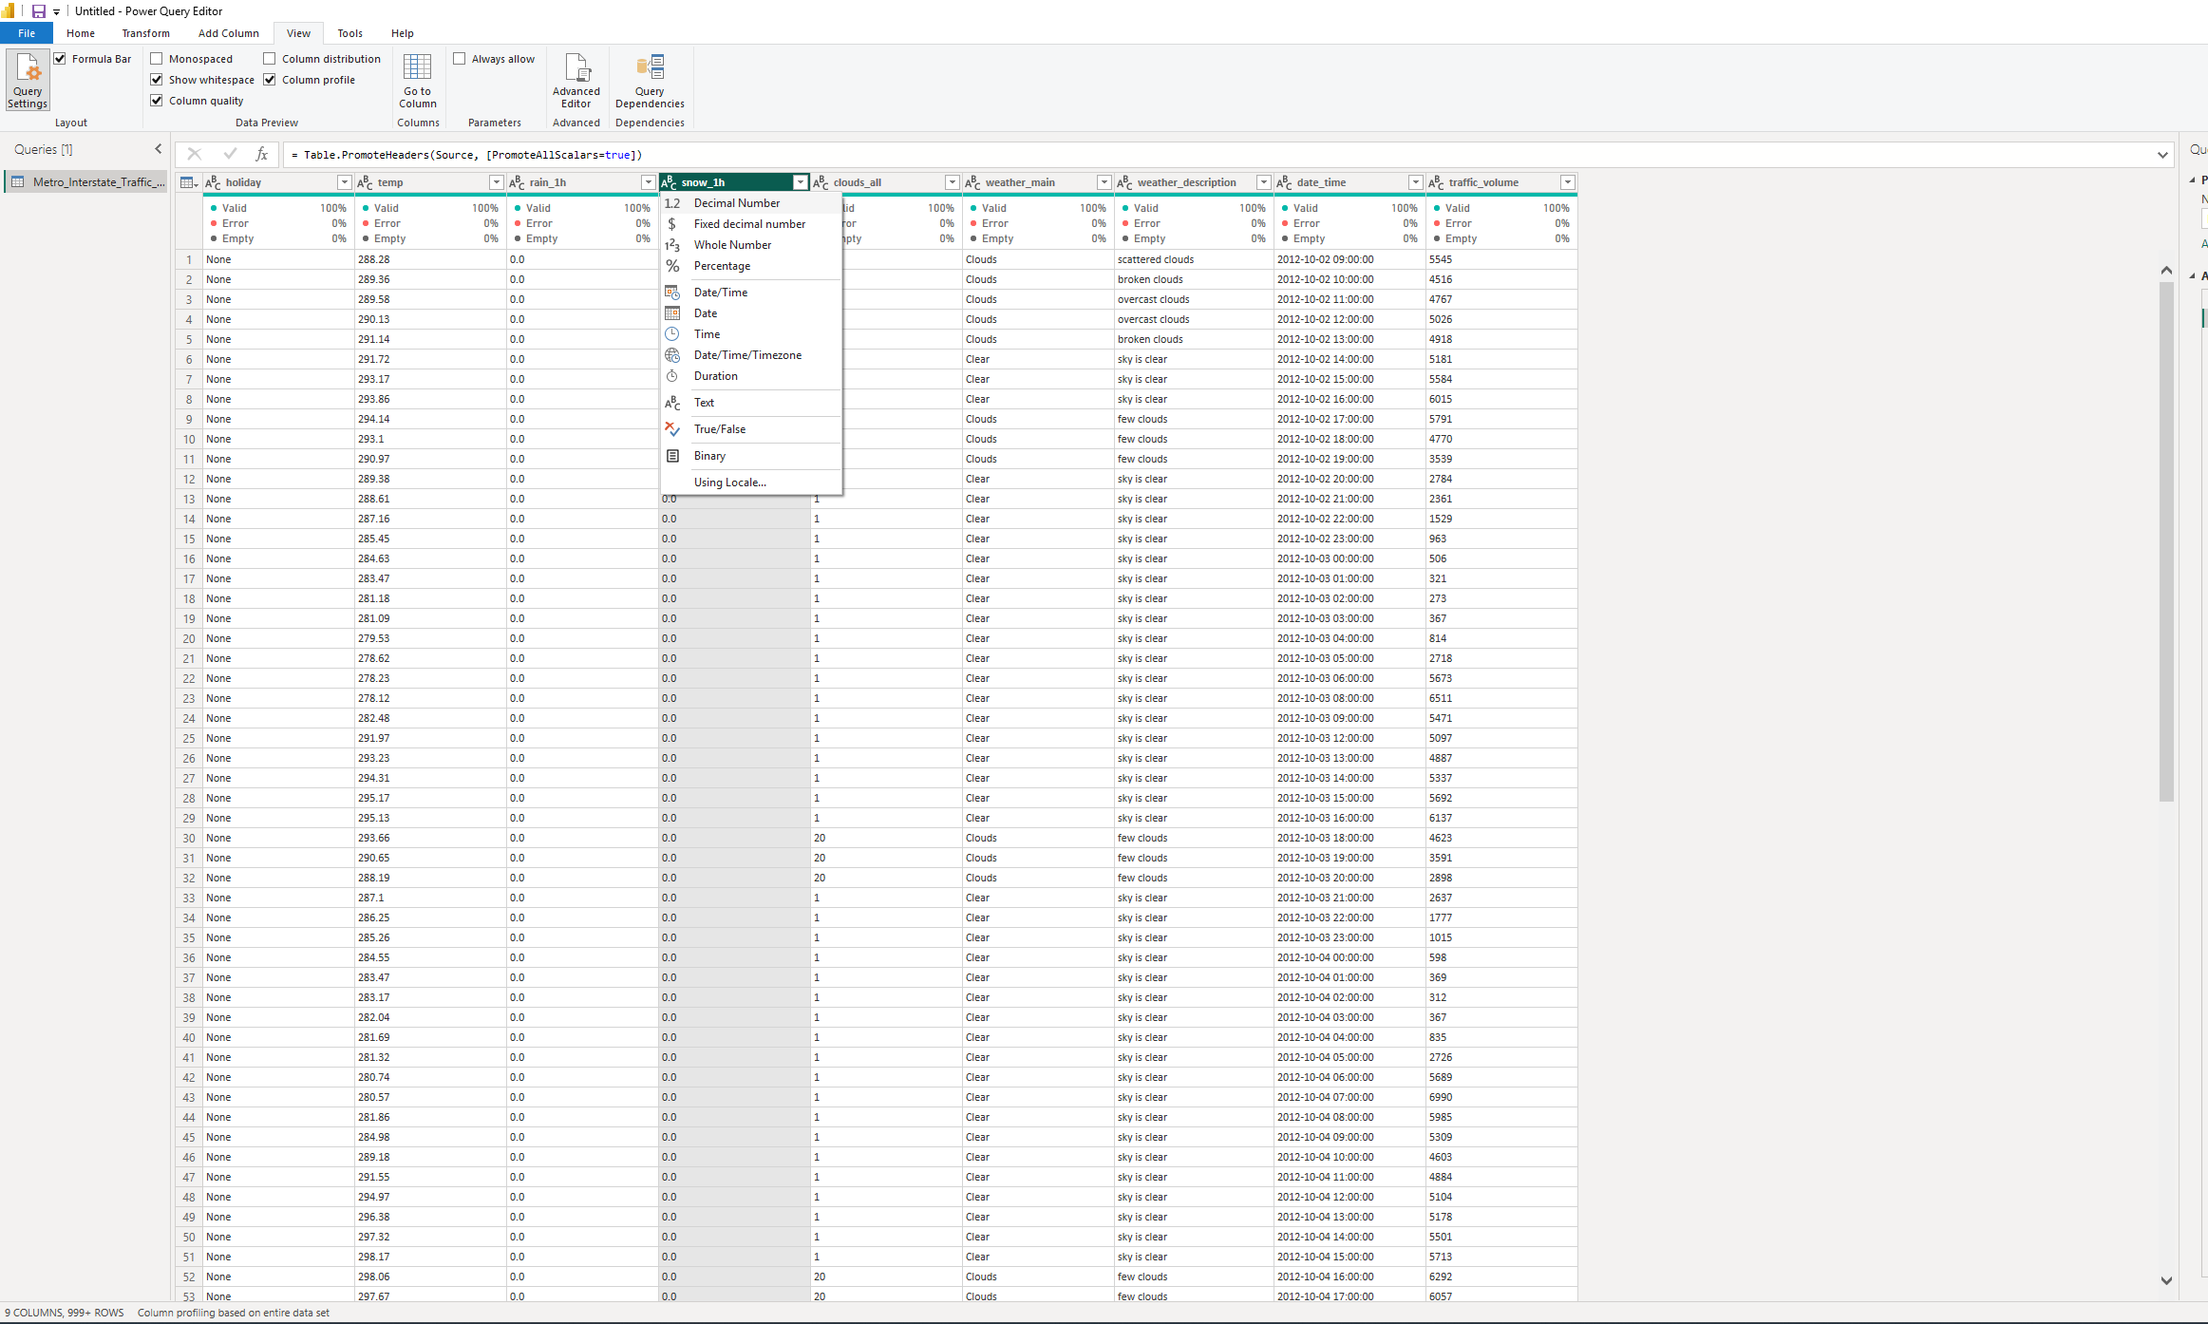
Figure 16 4.1 Data quality and preparation
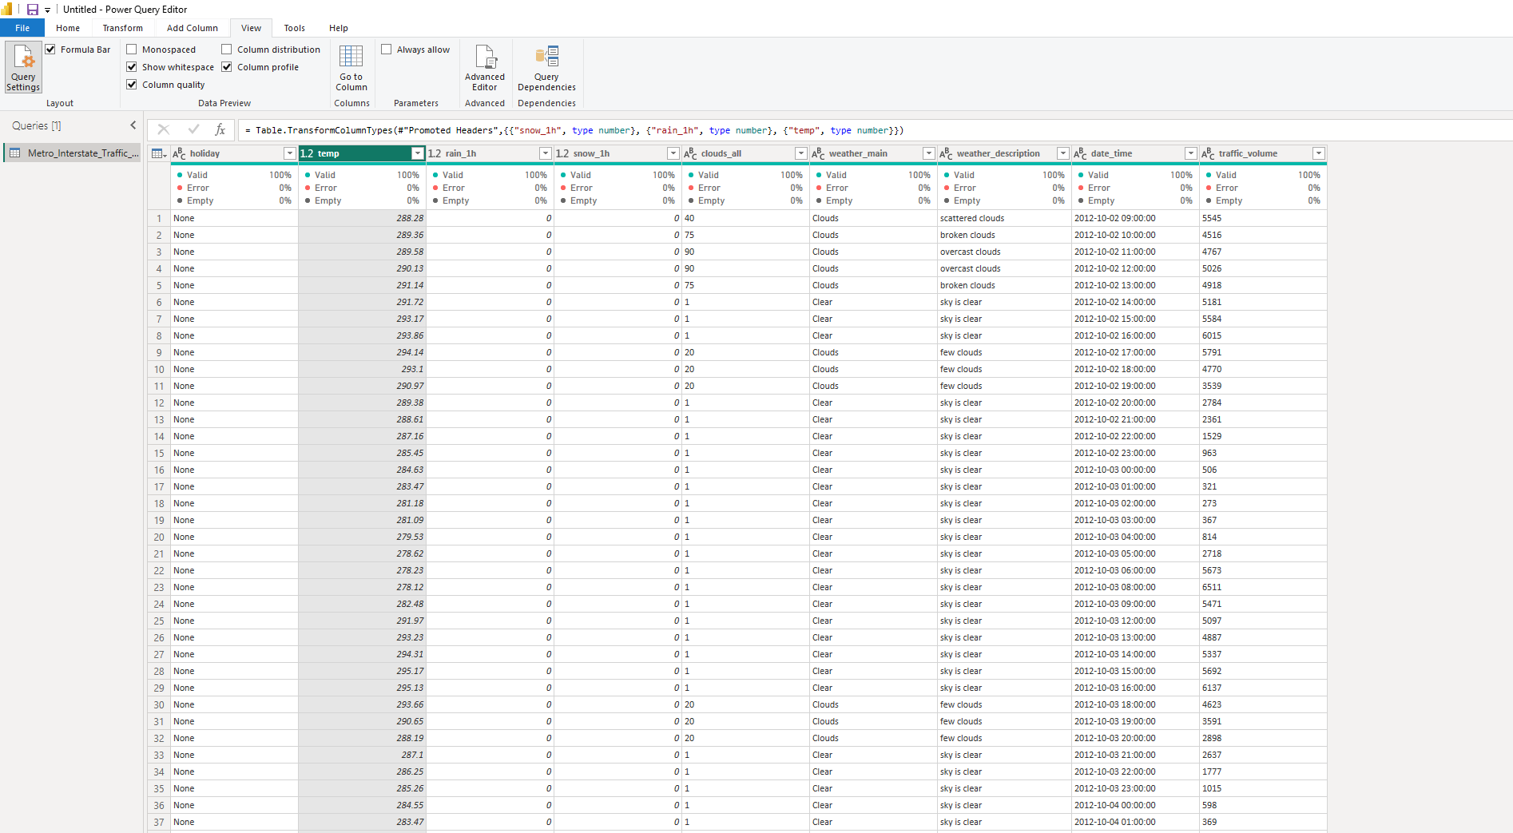
Figure 17 4.1 Data quality and preparation
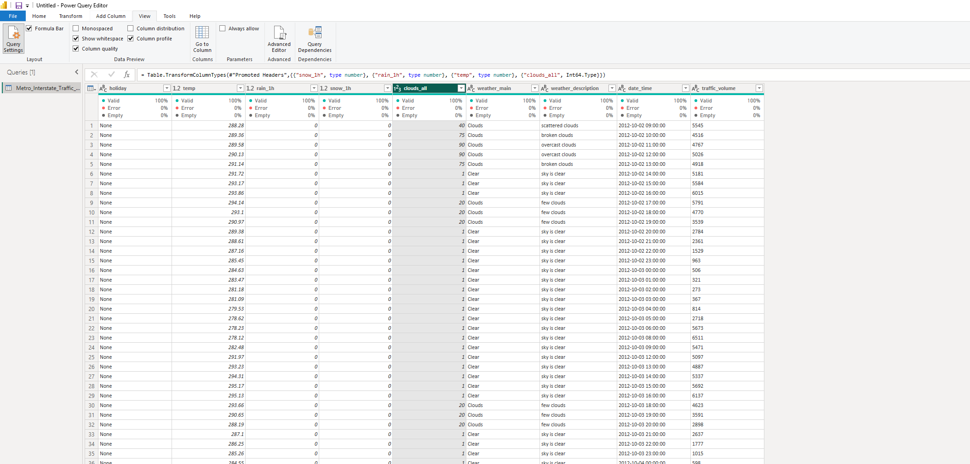
Figure 18 4.1 Data quality and preparation
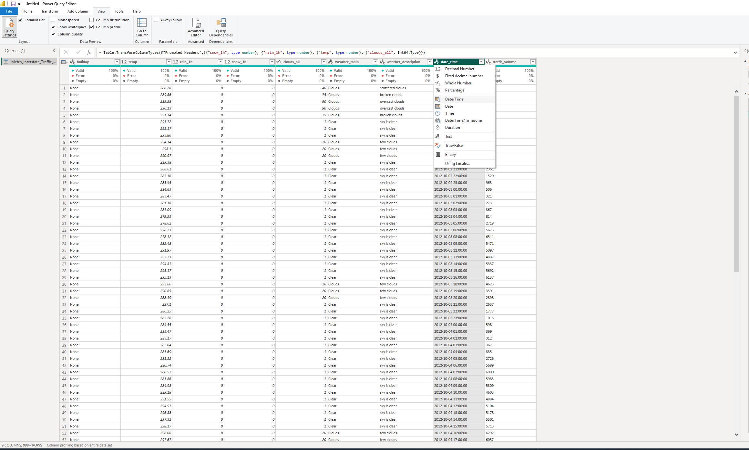
Figure 19 4.1 Data quality and preparation
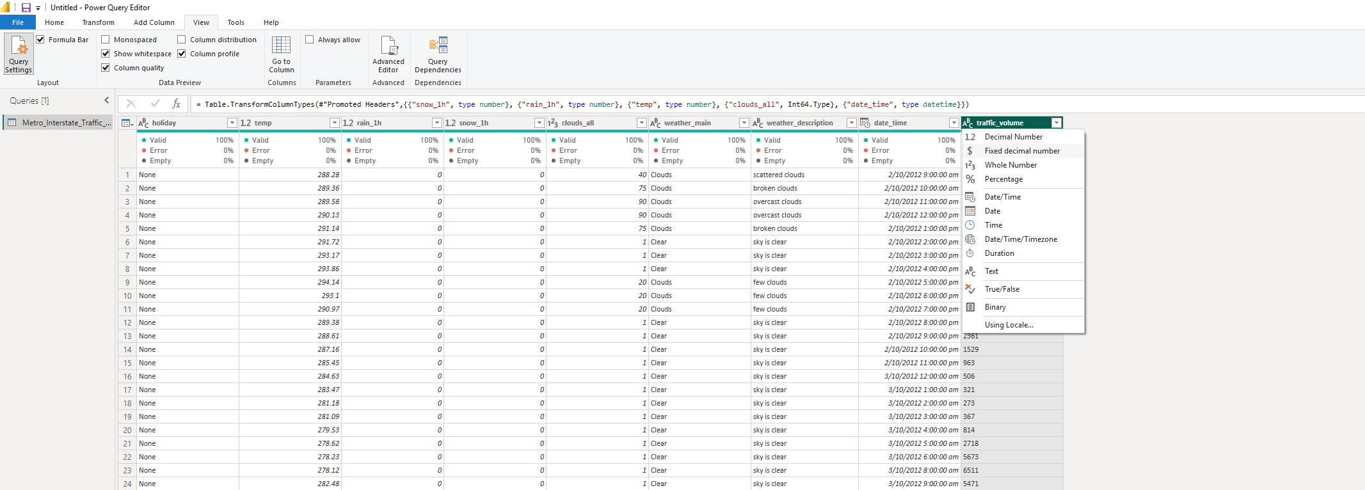
Figure 20 4.1 Data quality and preparation
- Extract Hour from DateTime:
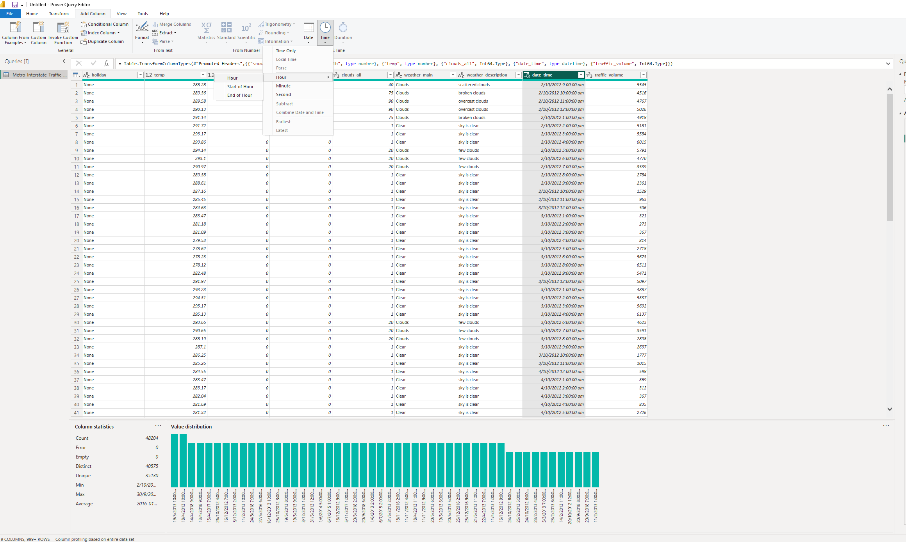
Figure 21 4.1 Data quality and preparation
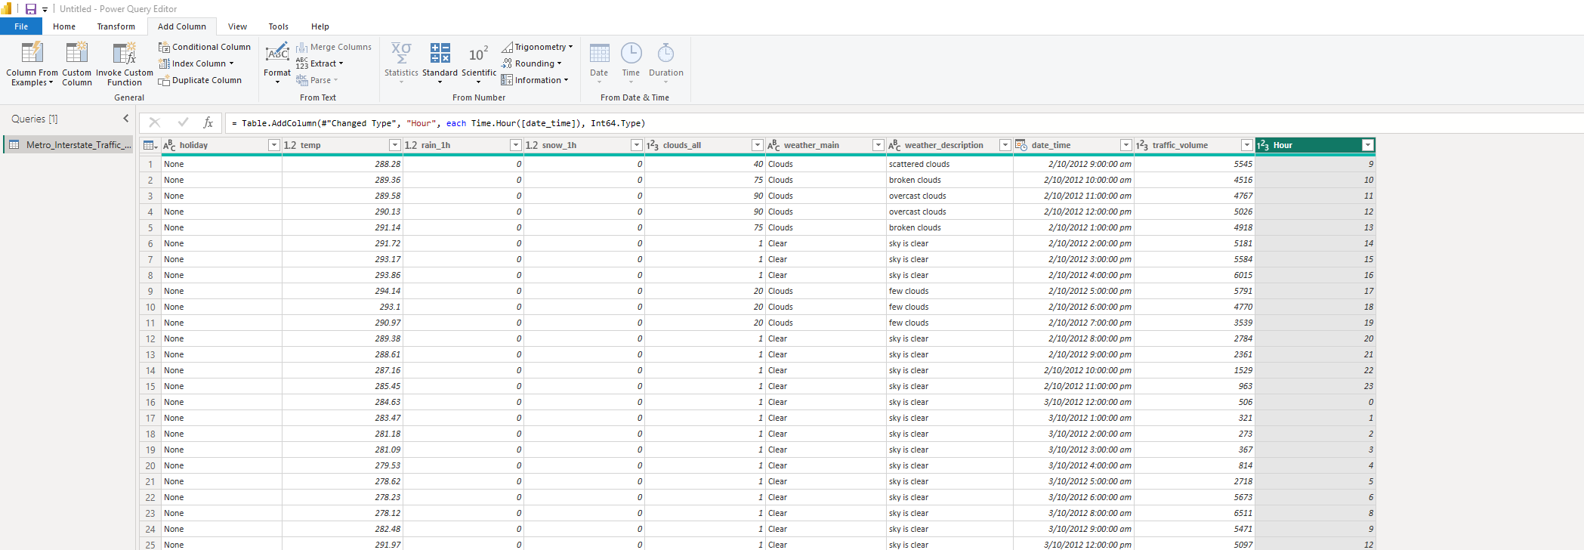
Figure 22 4.1 Data quality and preparation
- Create Temperature in Celsius.
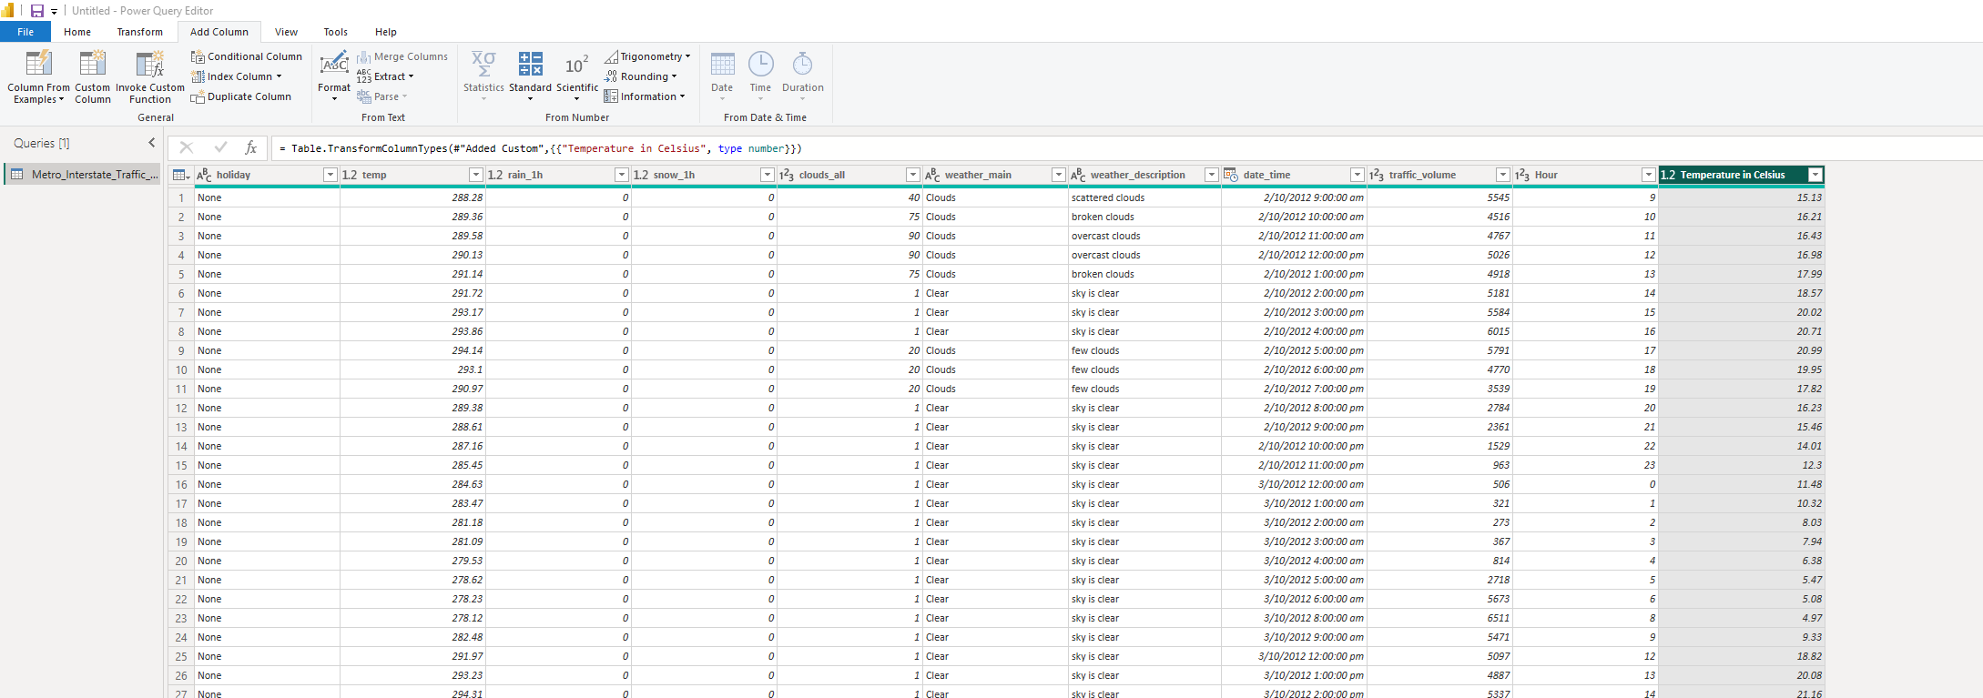
Figure 23 4.1 Data quality and preparation
- Create a Traffic Category:
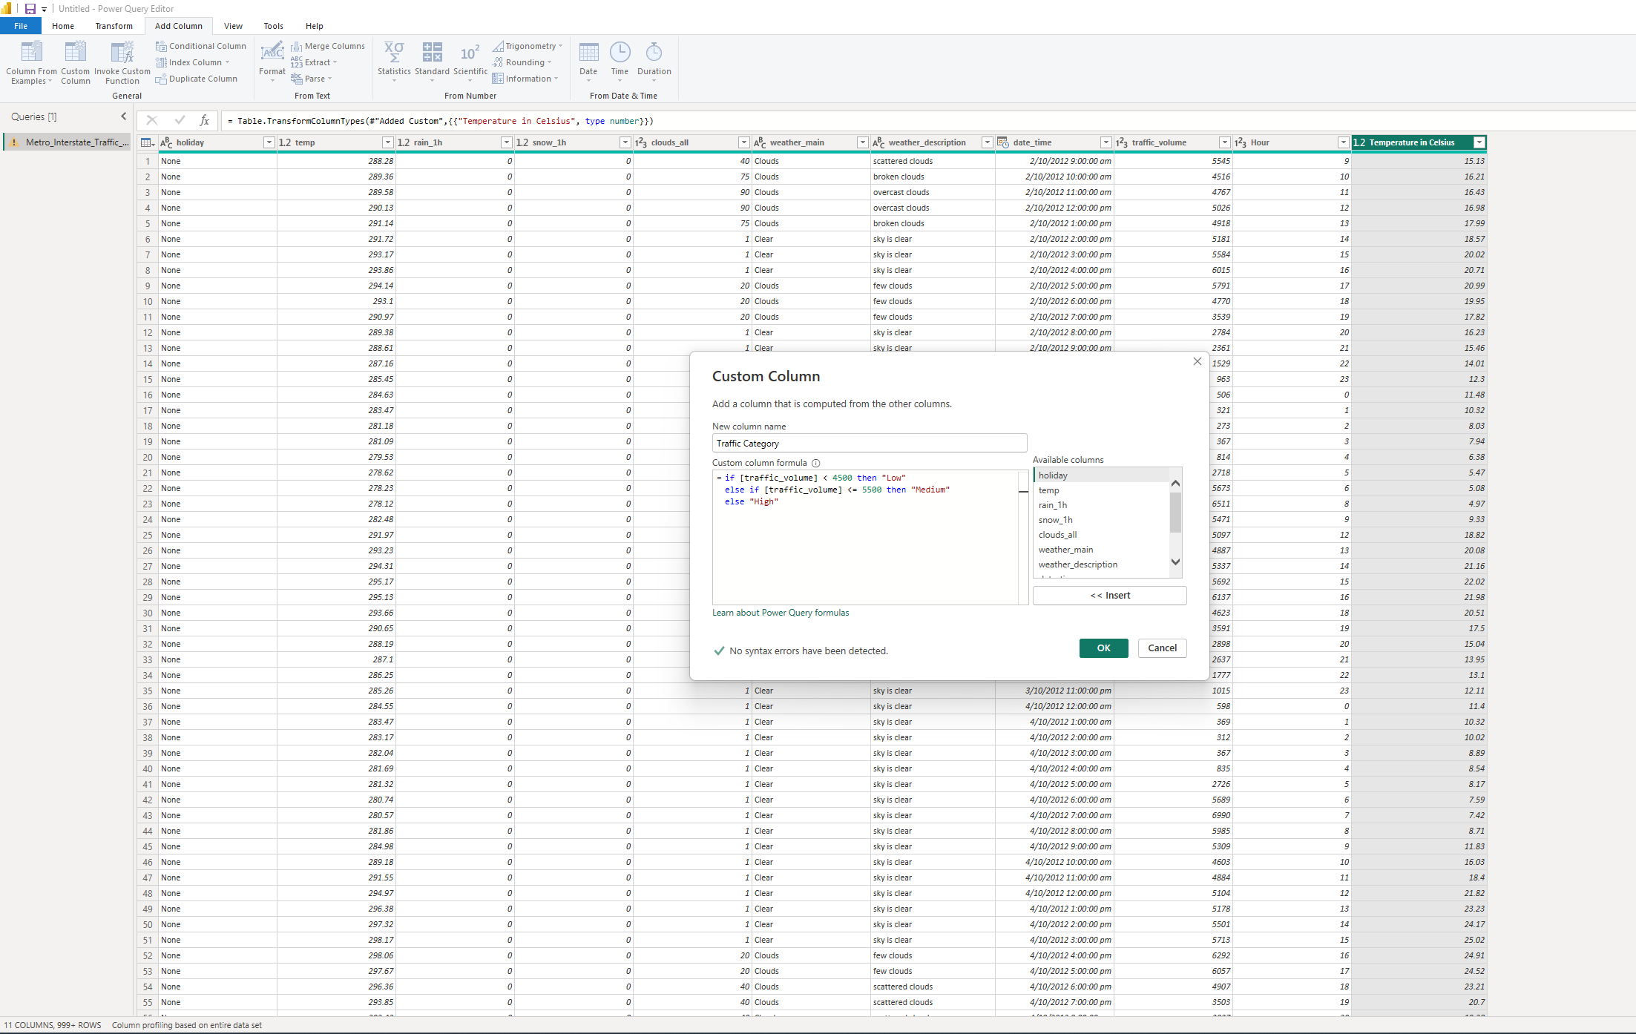
Figure 24 4.1 Data quality and preparation
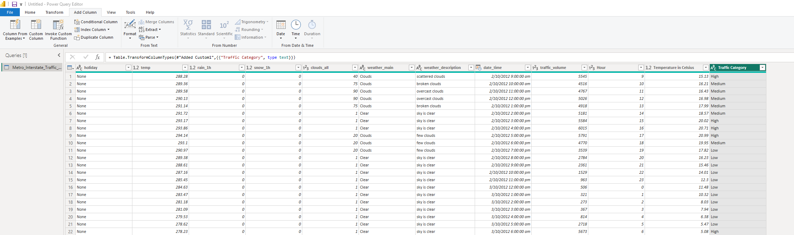
Figure 25 4.1 Data quality and preparation
Load the data in Power BI:
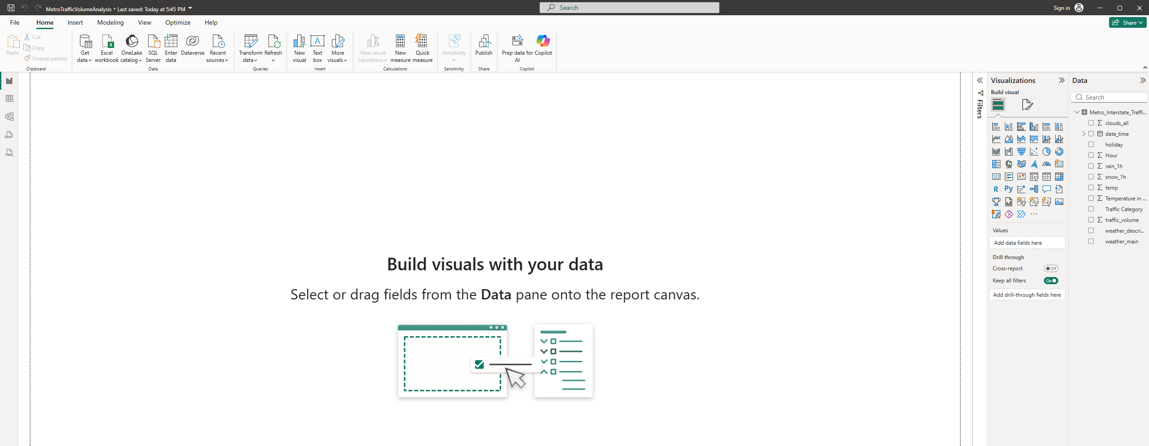
Figure 26 4.1 Data quality and preparation

4.2 Dashboard analysis

A. Daily traffic trends
- Show daily average traffic trends for 2015, 2016 and 2017.
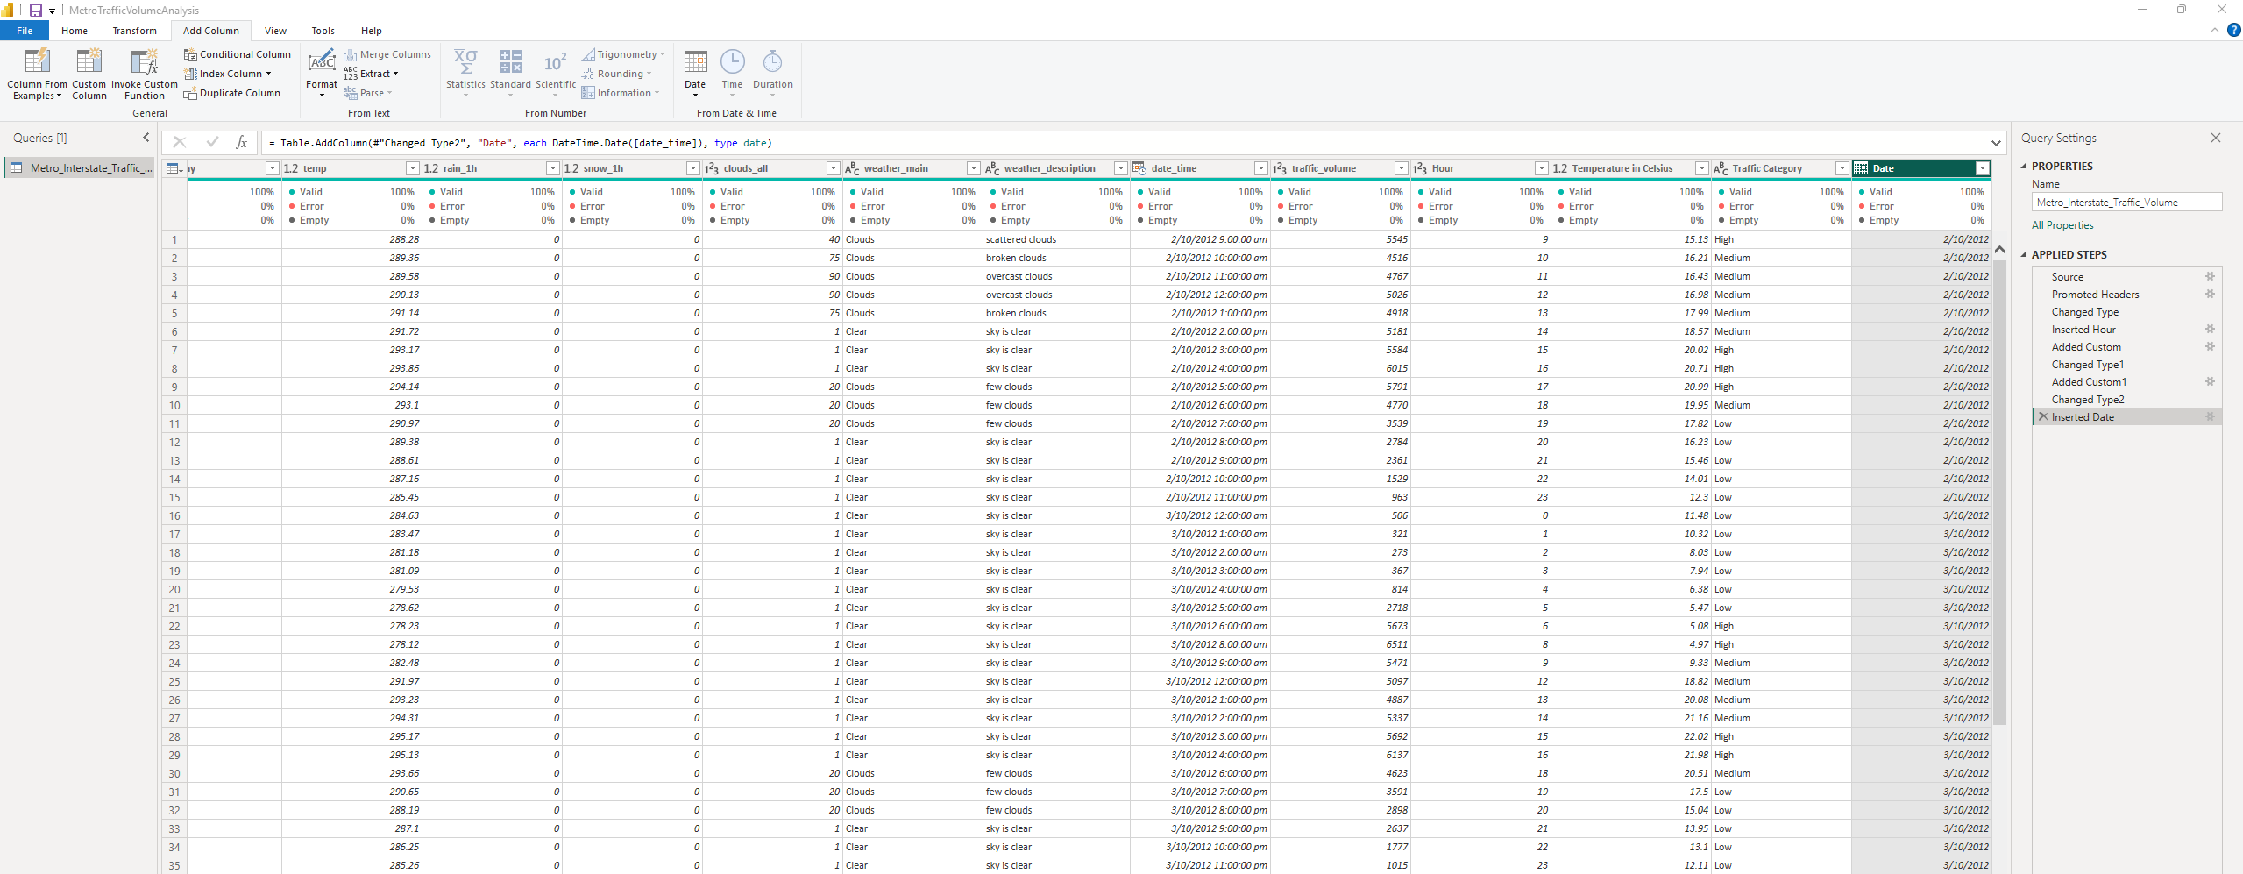
Figure 27 A. Daily traffic trends
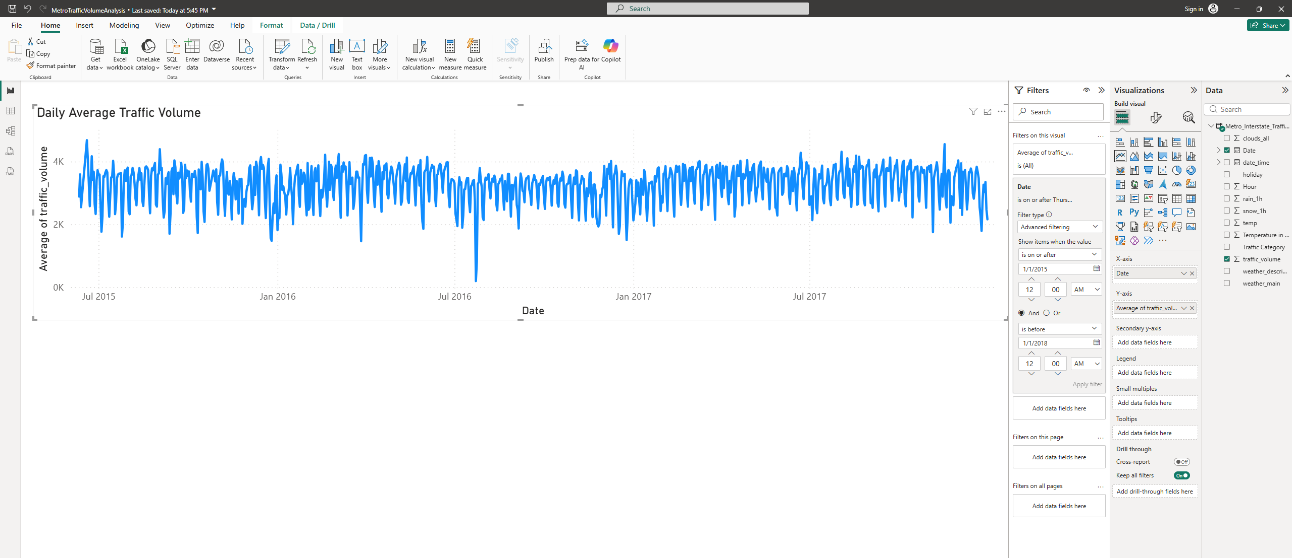
Figure 28 A. Daily traffic trends

B. Hourly traffic patterns
- Create a column chart showing average traffic by hour for 2017.
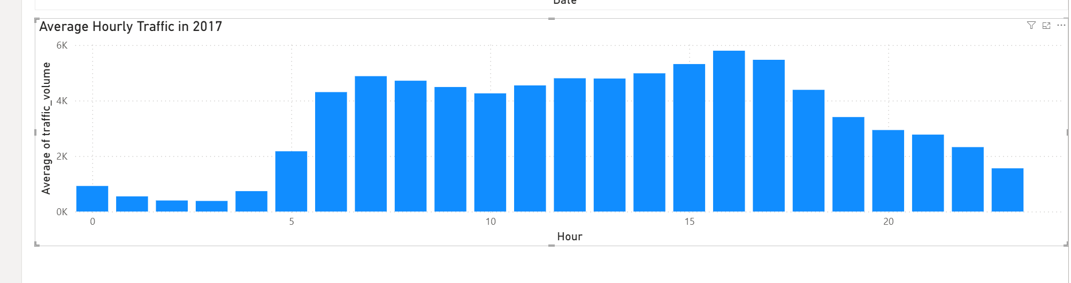
Figure 29 B. Hourly traffic patterns
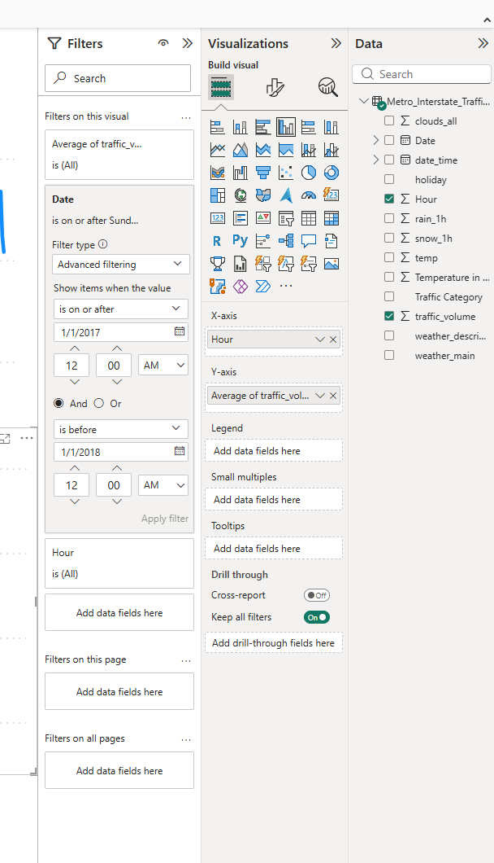
Figure 30 B. Hourly traffic patterns

C. Weather impact
Analyse average traffic by weather condition and answer:
- Which weather condition has the highest average traffic?
- Which has the lowest?
- What is the difference between the highest and lowest average traffic?
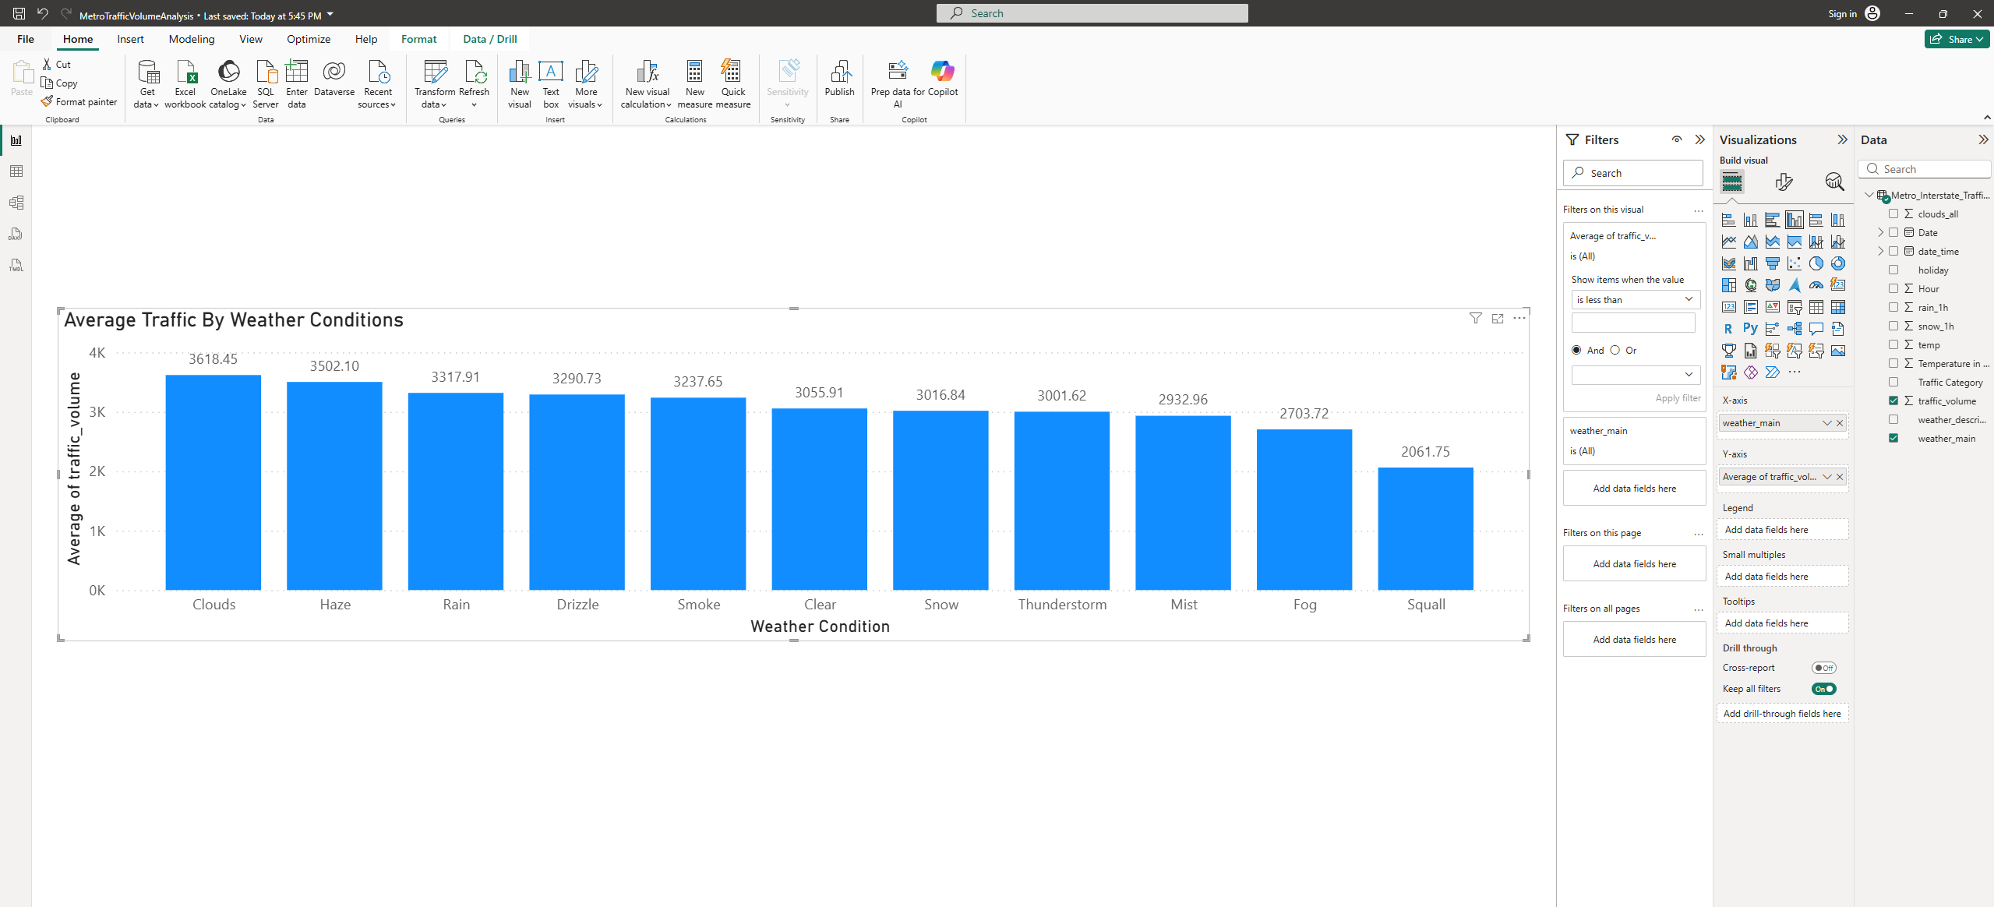
Figure 31 C. Weather impact
- Clouds has the highest average traffic with 3618.45 vehicles.
- Squall has the lowest average traffic with 2061.75 vehicles.
- The difference between the highest and lowest average traffic is 3618.45 − 2061.75 = 1556.70.

D. Temperature and traffic
Create a scatter plot of:
- Temperature vs. traffic volume.
Discuss:
- Whether a visible relationship exists.
- The temperature range associated with higher traffic.
- Any notable outliers.
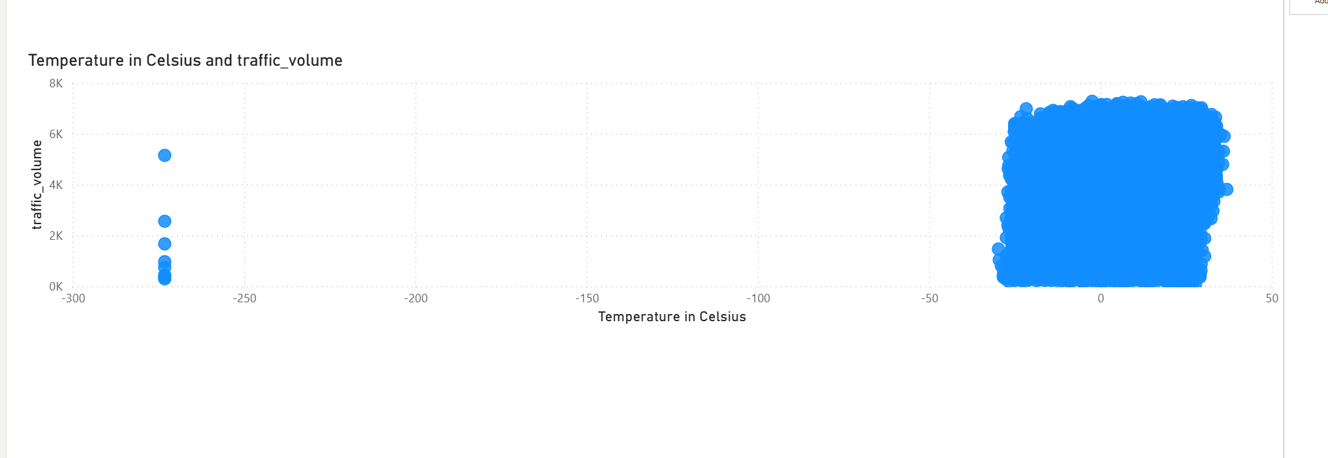
Figure 32 D. Temperature and traffic
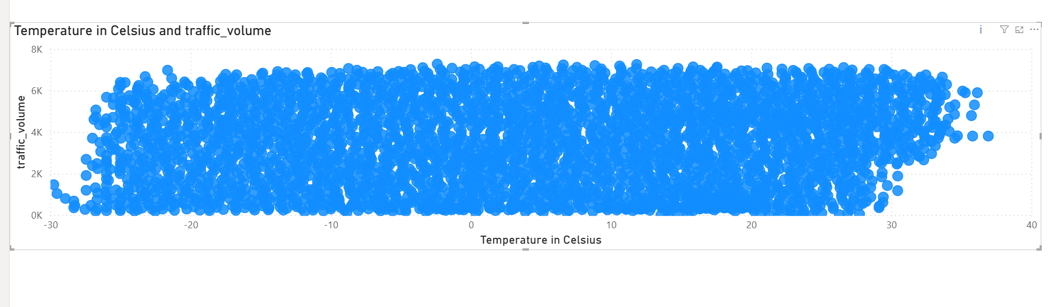
Figure 33 D. Temperature and traffic
- Relationship: The chart does not show a clear link between temperature and traffic. Both low and high traffic occur at many temperatures.
- Temperature range: Excluding the invalid zero-kelvin readings, recorded temperatures range from approximately −29.76C to 36.92C. Higher traffic volumes occur across a broad range of temperatures, so the scatter plot does not show one narrow temperature range consistently associated with higher traffic.

Outliers:
There are 10 incorrect temperature readings at −273.15°C. I hid them in the second chart. Some traffic values are also close to zero and need checking.
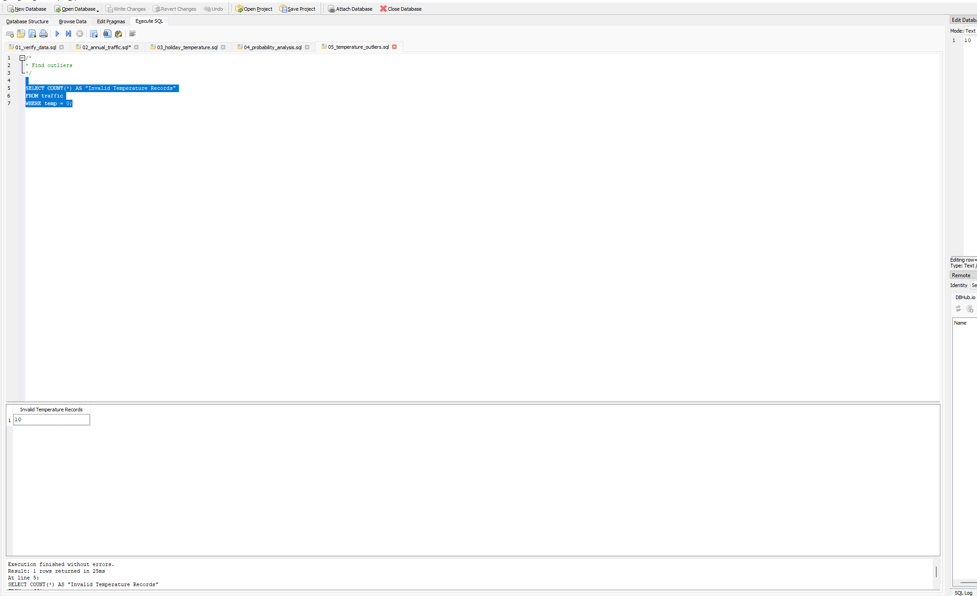
Figure 34 D. Temperature and traffic
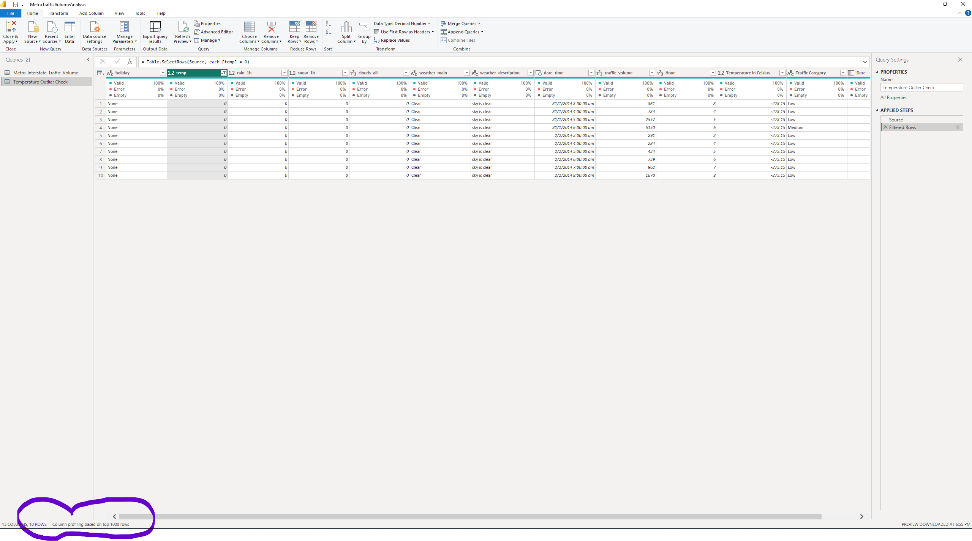
Figure 35 D. Temperature and traffic

4.3 KPI cards and filters
Create KPI cards showing:
- Total hours analysed
- Average traffic volume
- Average temperature
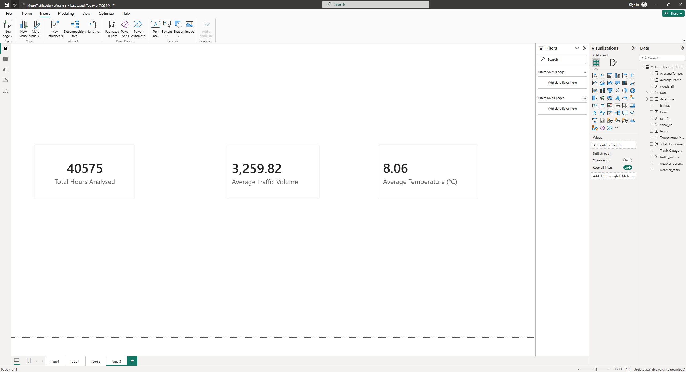
Figure 36 4.3 KPI cards and filters
Add slicers for:
- Hour range
- Weather condition
- Traffic category
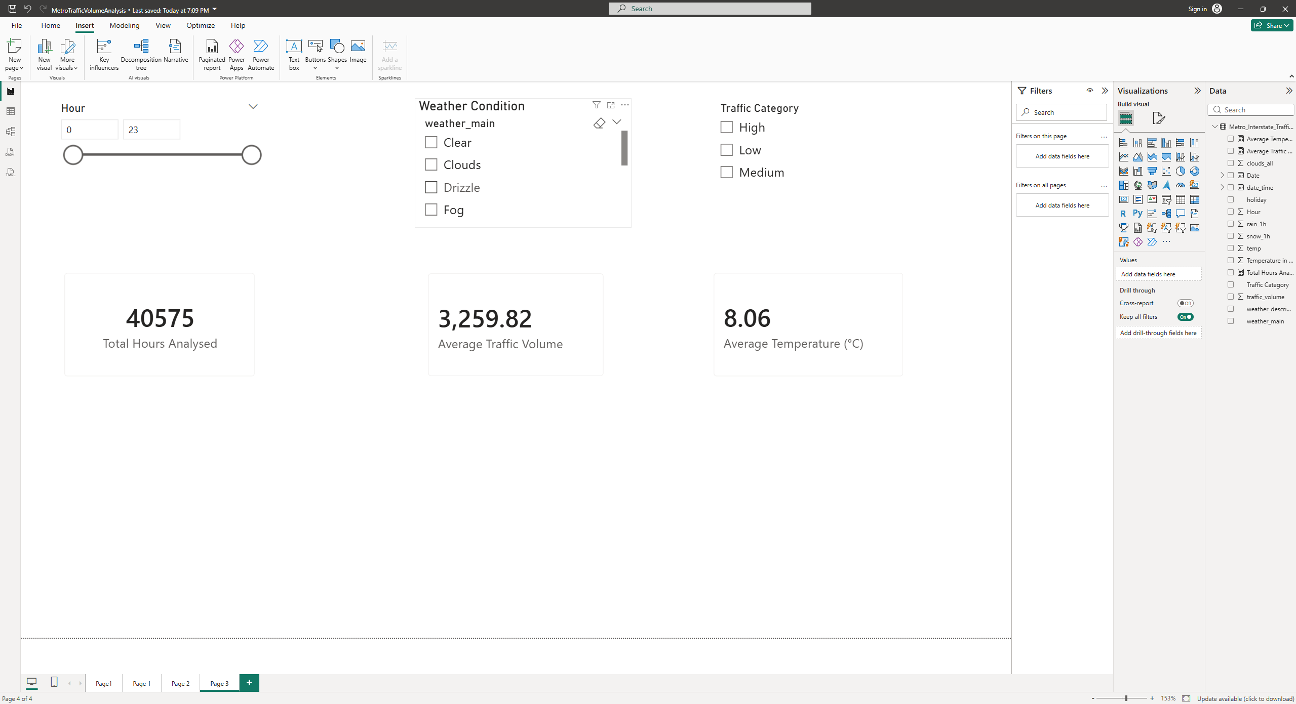
Figure 37 4.3 KPI cards and filters
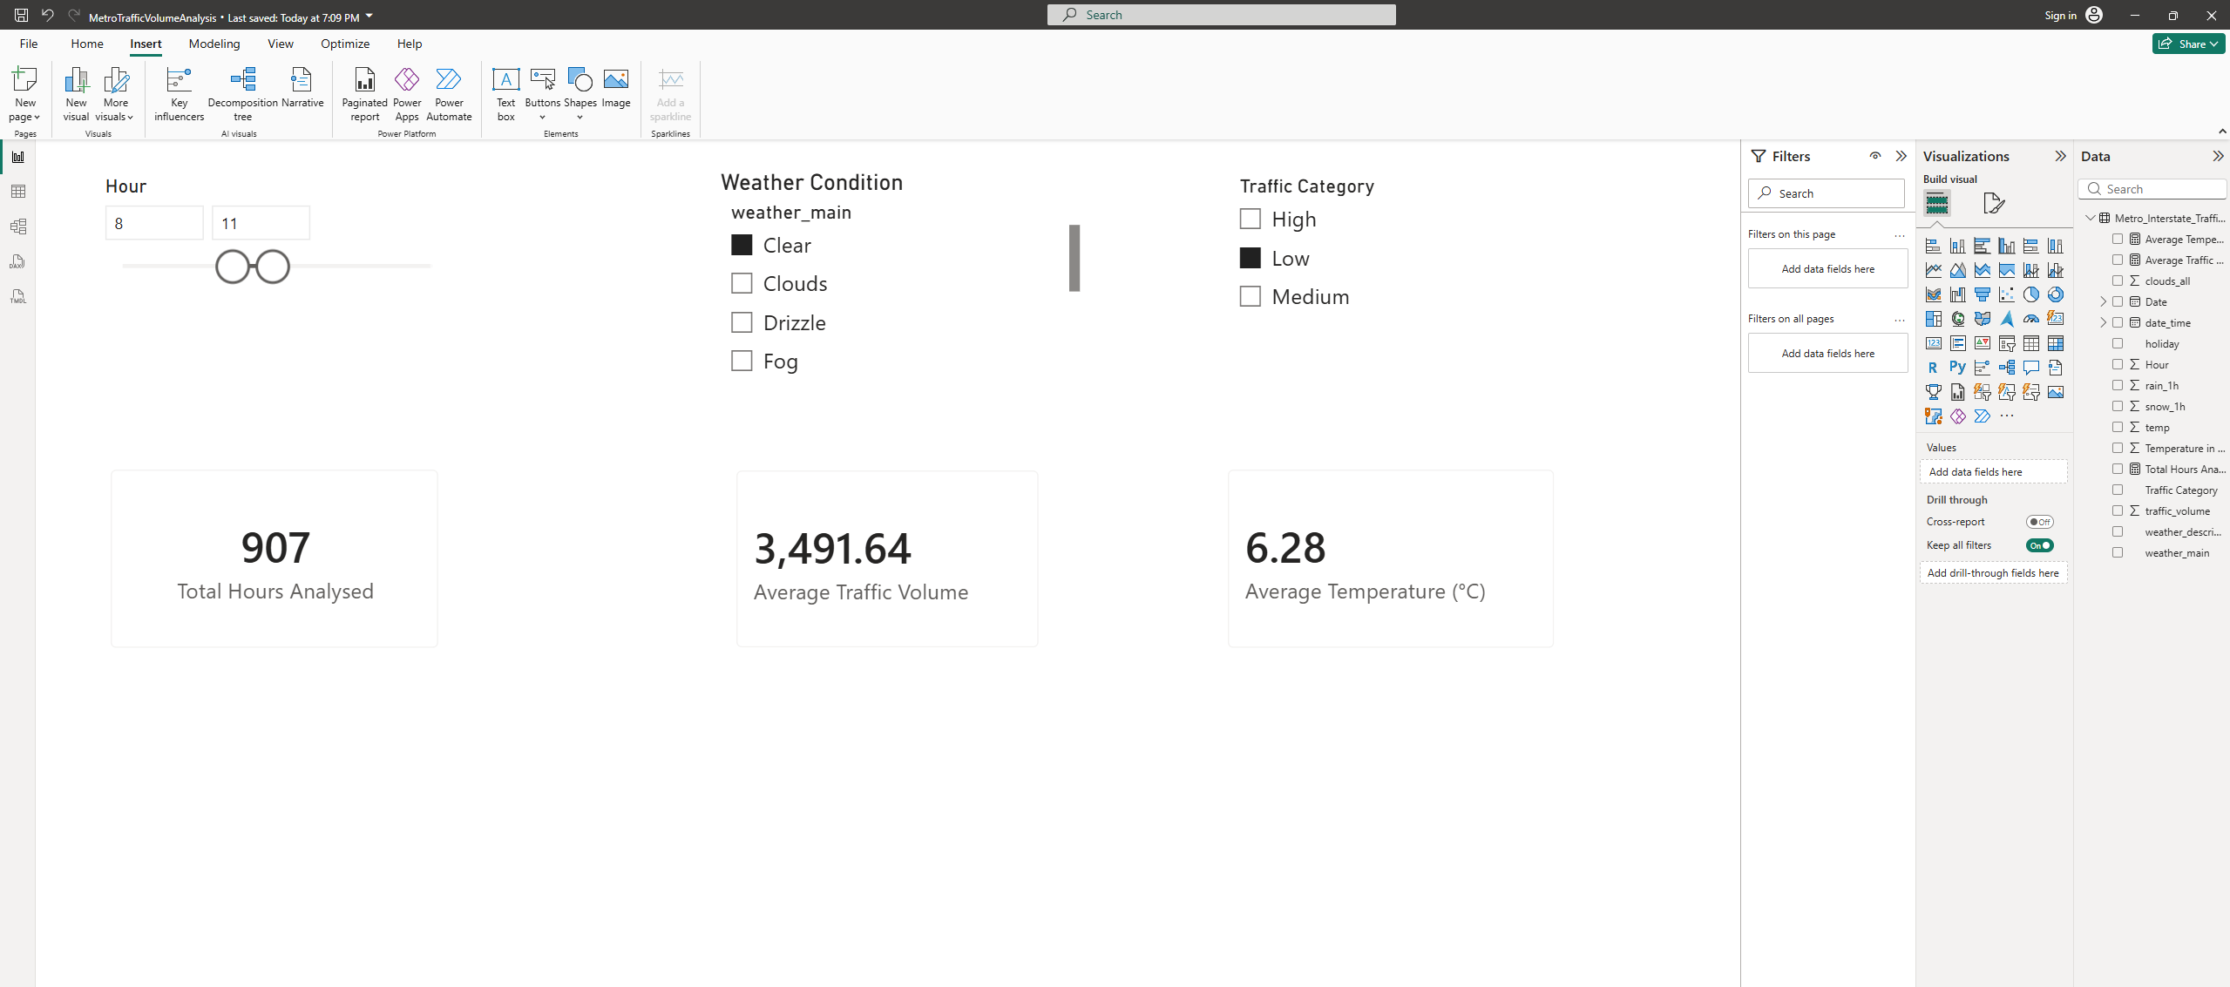
Figure 38 4.3 KPI cards and filters

