Task 1: Data Pipeline Construction

1.1 Load the dataset and check the columns

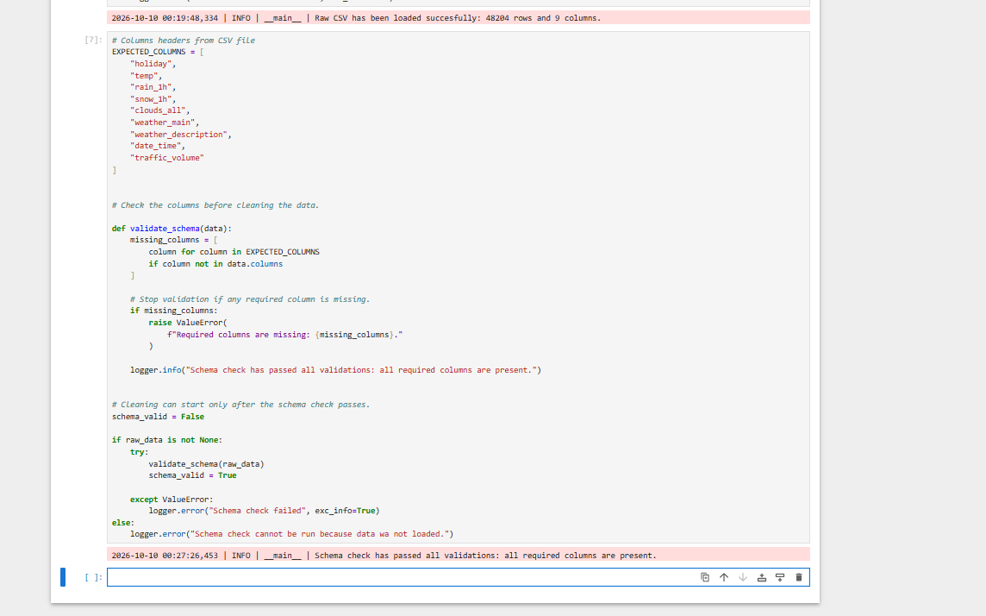
1.2 Make category text consistent and convert dates

The notebook reports 1730 changes in weather_description.
The date_time column was converted to datetime using the expected format. T he actual dataset had no missing o r invalid dates.
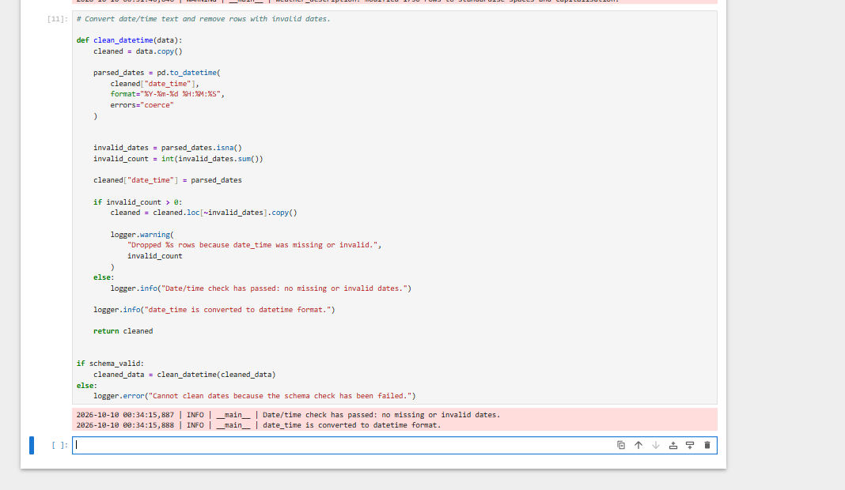

1.3 Remove exact duplicates and fix invalid readings
There were 17 rows that repeated exactly across all columns
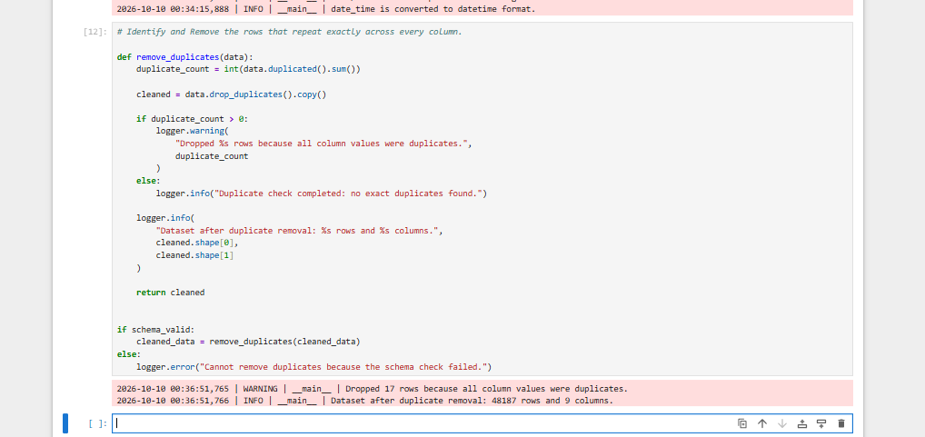

1.4 Validate and save the cleaned dataset
Checks found no missing cells or blank text.
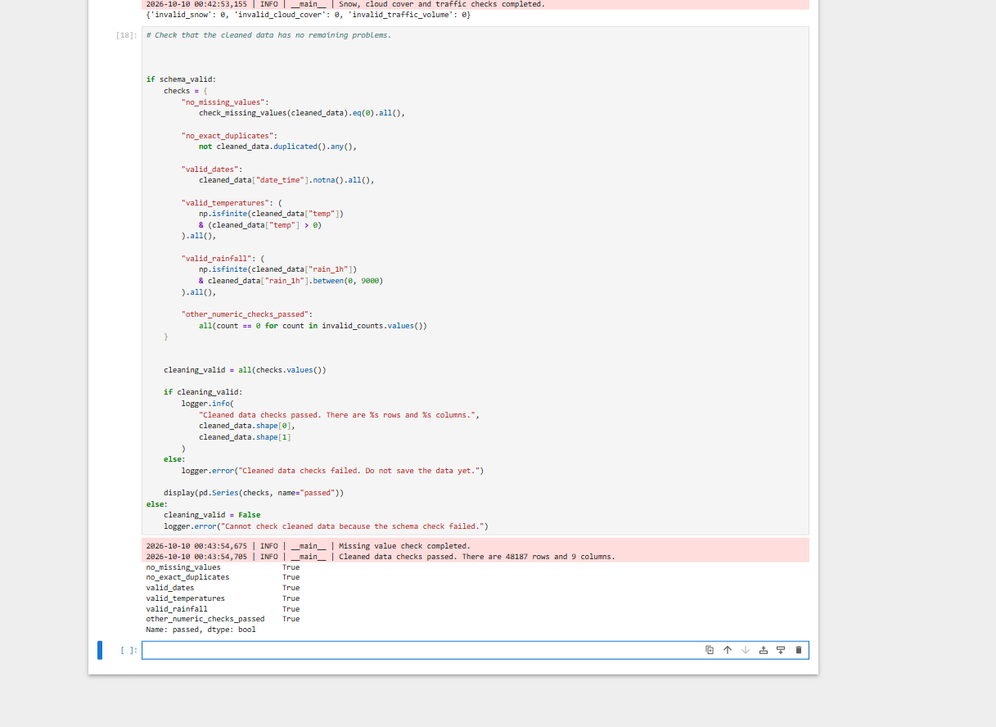

1.5 Run the standalone pipeline
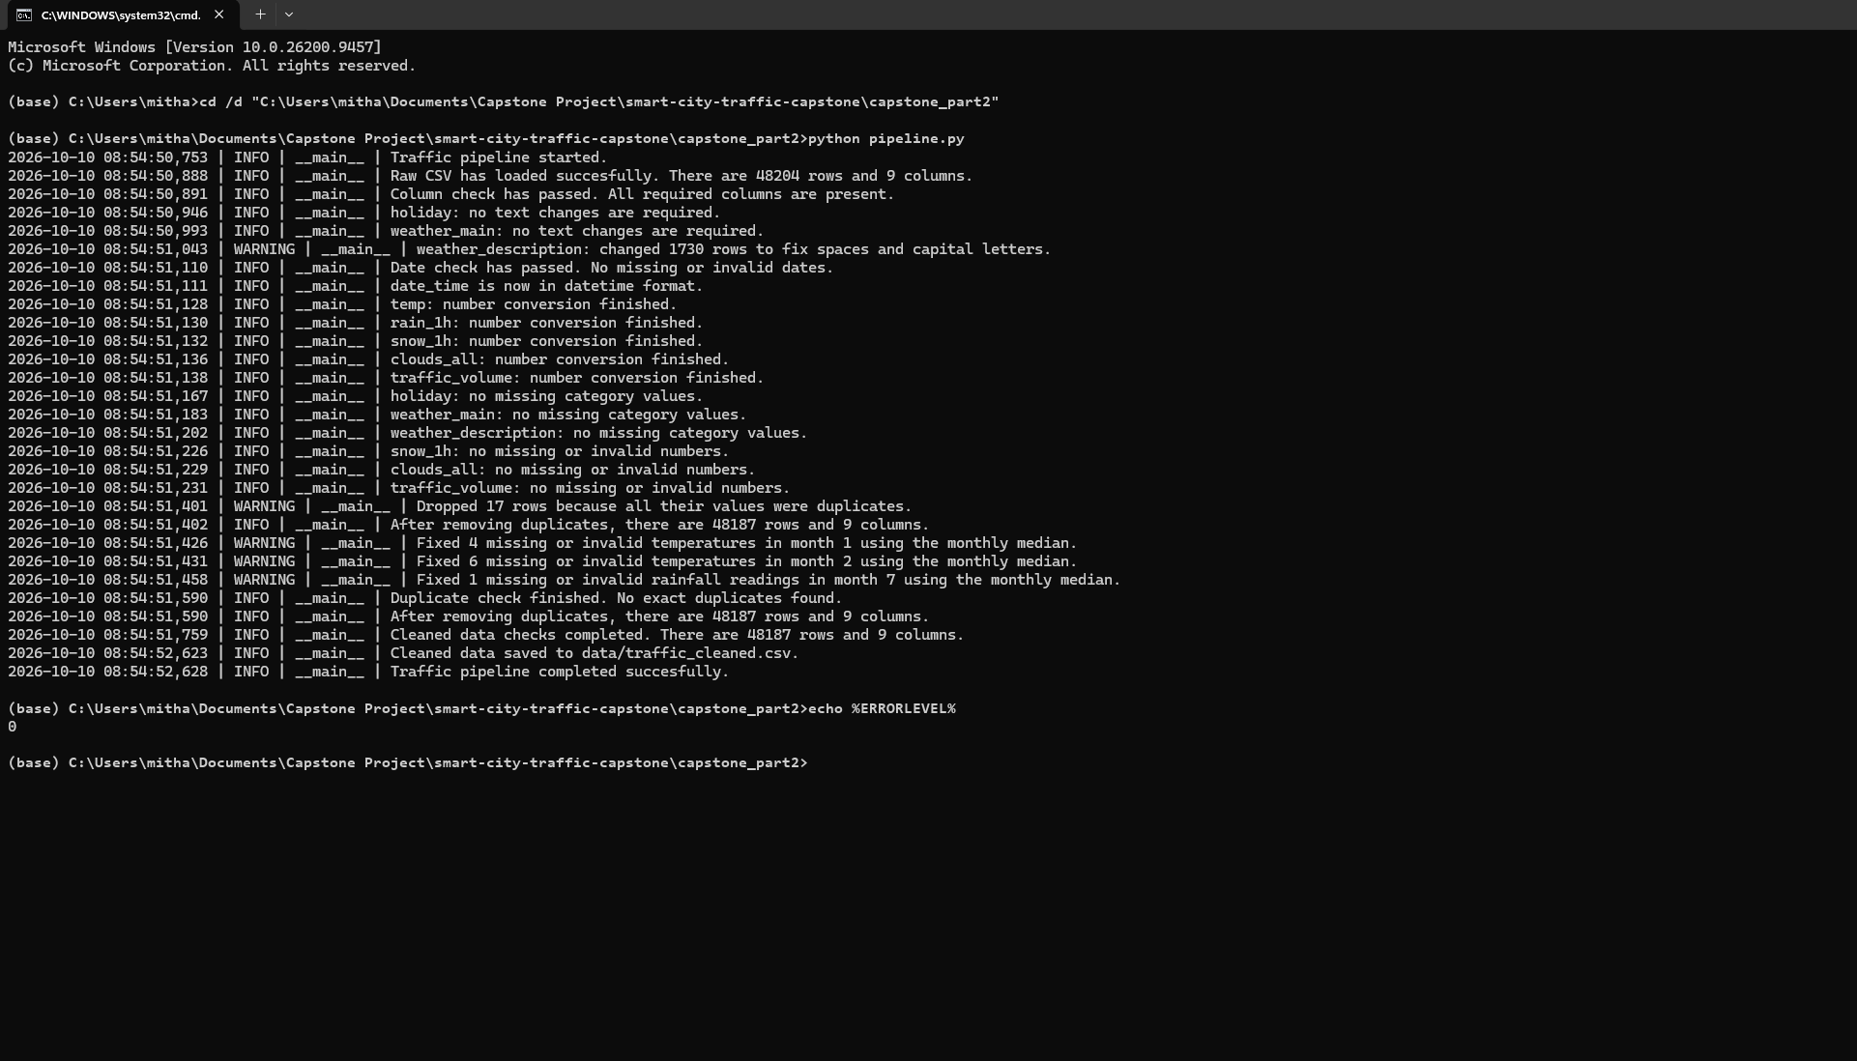

1.6 Check logging in debug mode
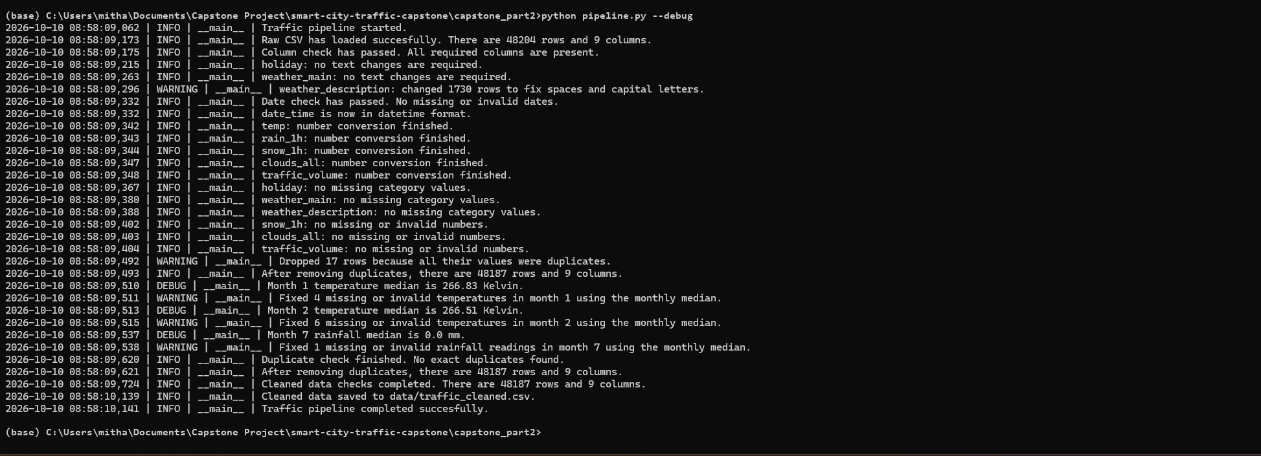

Task 2: Feature Engineering

2.1 Time features
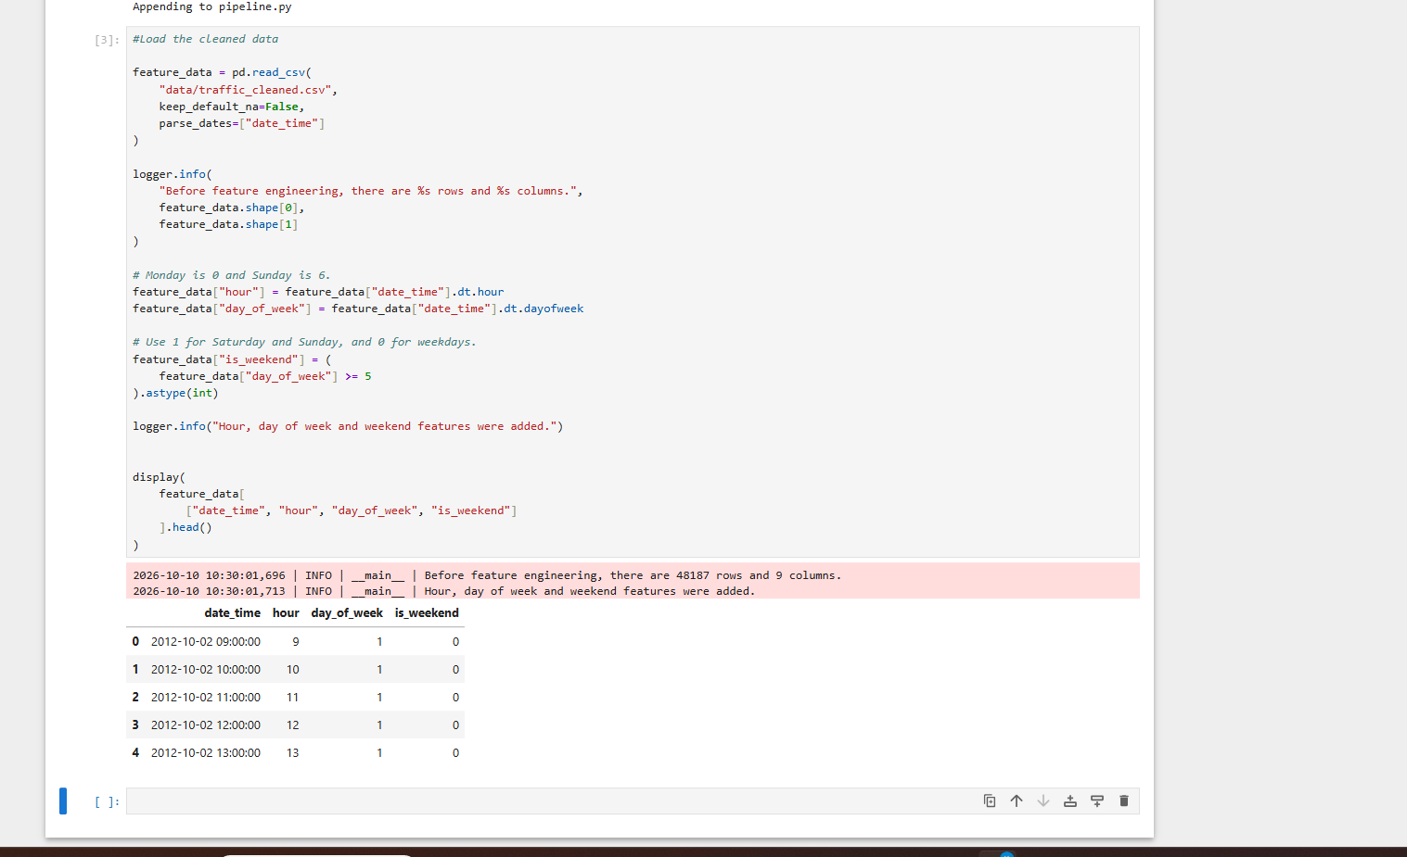
Hour encoded with sine and cosine using a 24-hour cycle. This keeps nearby hours close across midnight, including 23:00 and 00:00.

2.2 Cyclical encoding and weather features
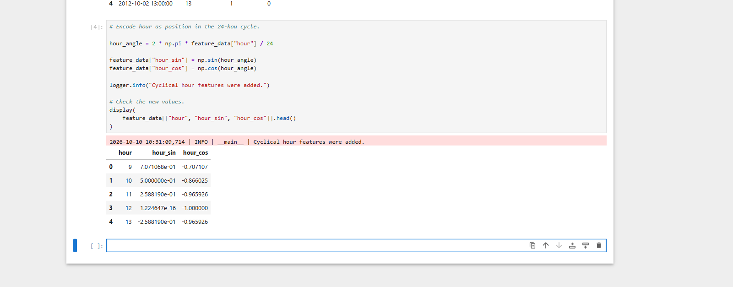
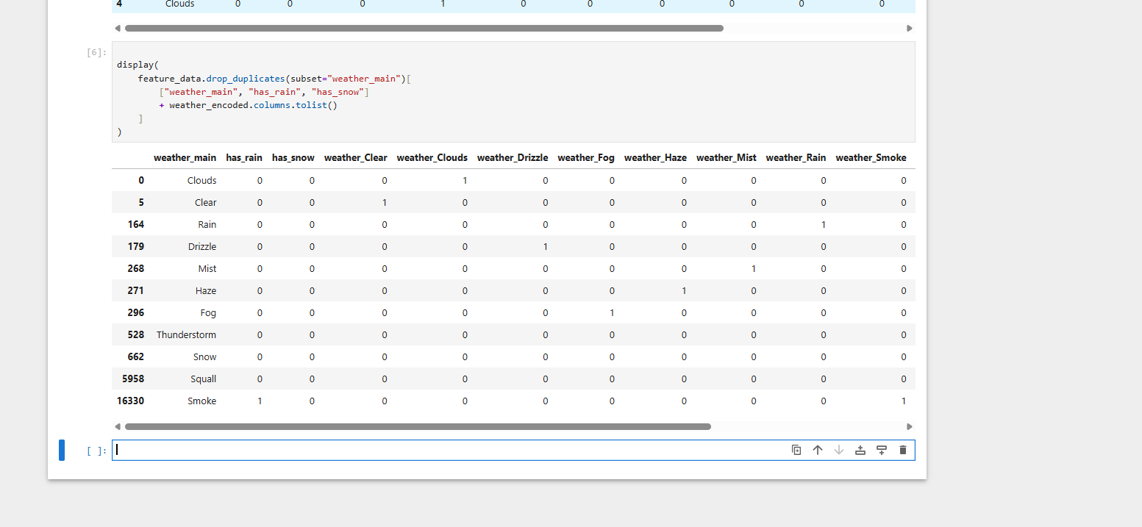
I tried to verify that each category is shown.

2.3 Numerical features
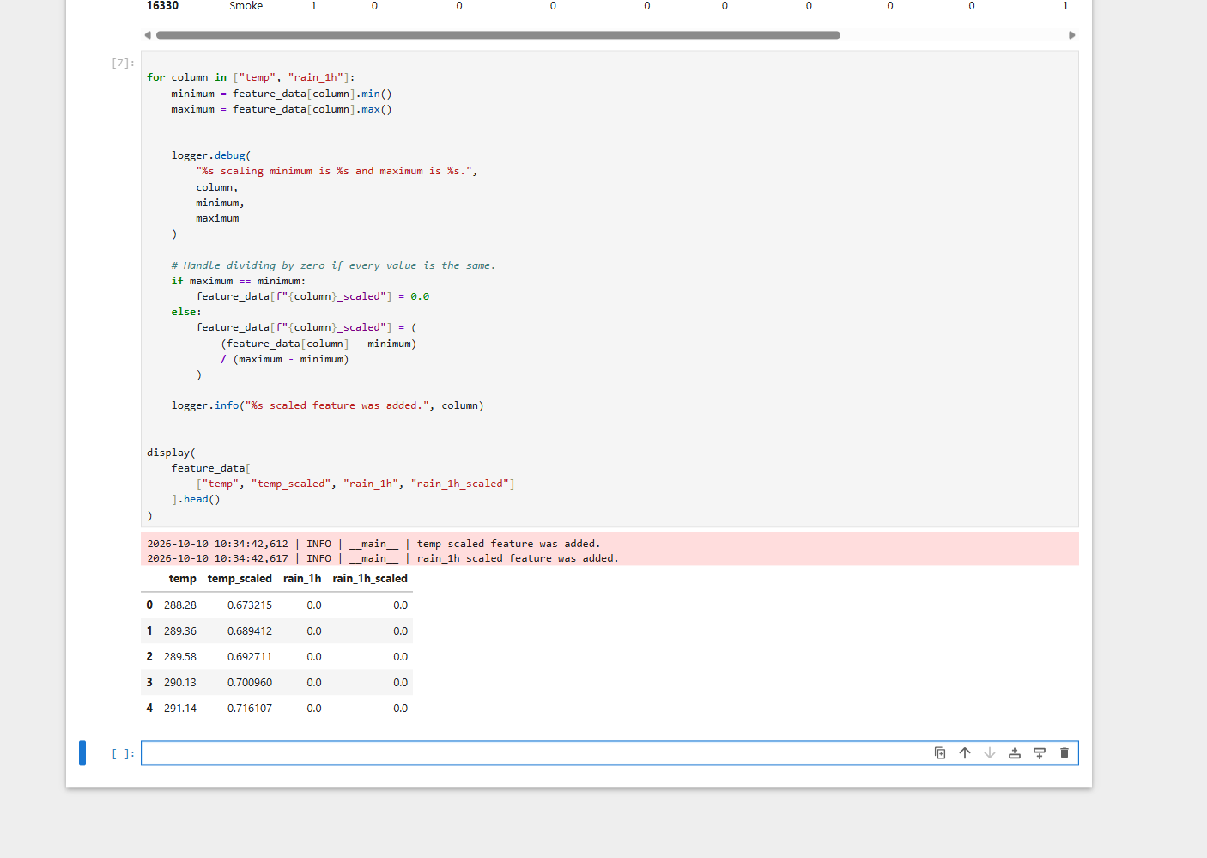
The temperature range was 243.39 to 310.07 Kelvin. The rainfall range was 0.0 to 55.63 mm.

2.4 Traffic target
I chose the 25th and 75th percentiles so the thresholds come from the cleaned traffic data. This separates lower and higher traffic records while keeping the middle range as Medium. Unlike the fixed 5500 threshold used in Part 1, these thresholds depend on the dataset. Equal values at a boundary can make the group sizes differ slightly from 25 percent, 50 percent and 25 percent.
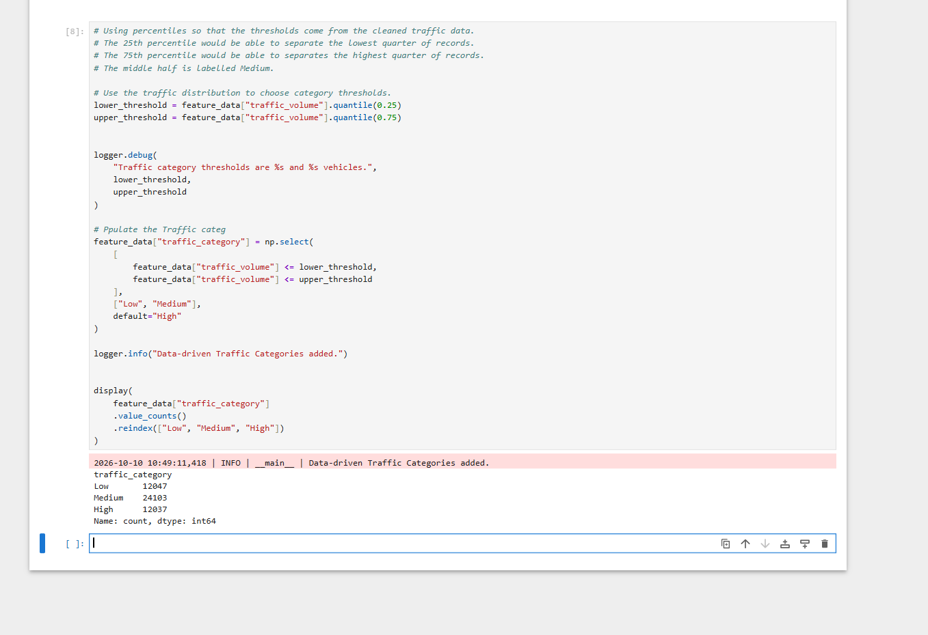
Low has 12047 records, Medium has 24103 records and High has 12037 records.

2.5 Validate and save the features
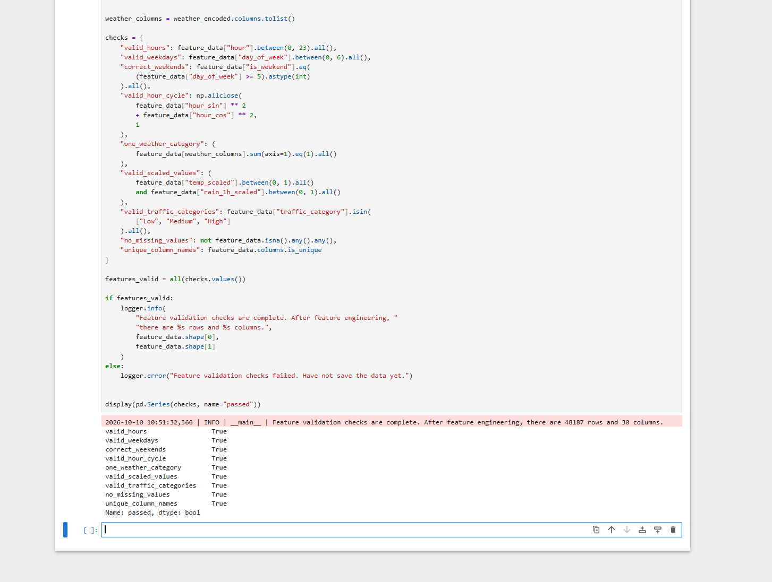

2.6 Run the standalone script and check logging
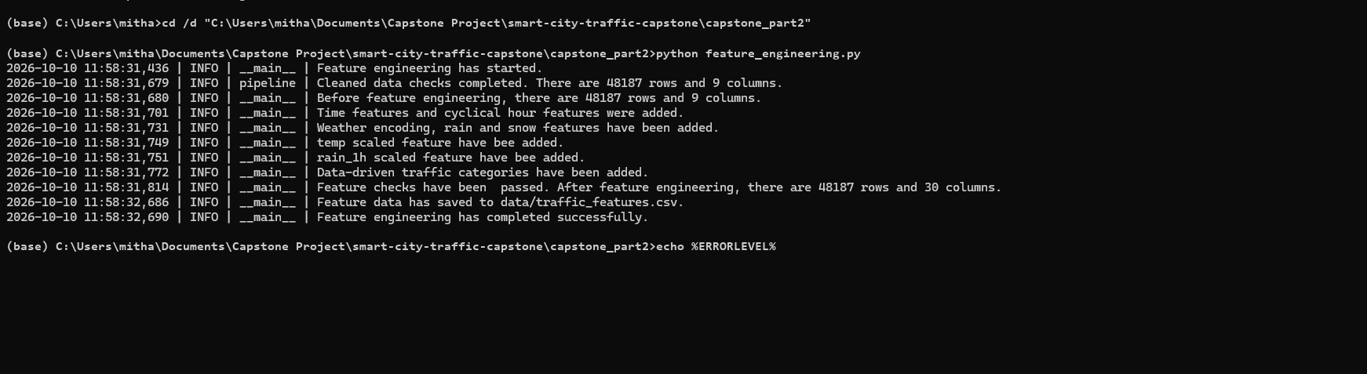
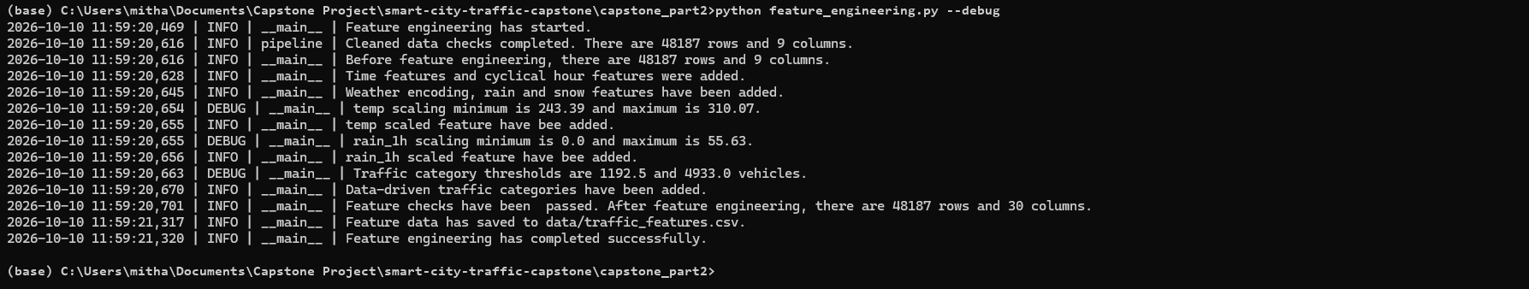
DEBUG s hows the scaling values and the thresholds 1192.5 and 4933.0.

Task 3: Visualise Traffic Patterns
Three Matplotlib charts have beensaved..

3.1 Traffic demand by hour
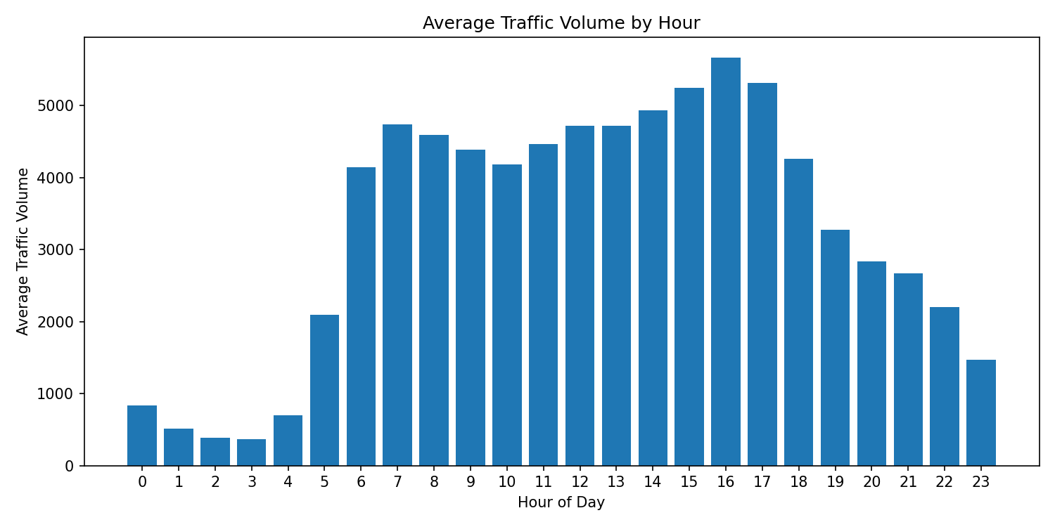
Average recorded traffic volume was lowest at 03:00 with 371.09 vehicles, and highest at 16:00 with 5663.76 vehicles. Traffic rises sharply between 05:00 and 07:00 and stays relatively high during the daytime before declining into the evening.

3.2 Weekday vs. weekend traffic
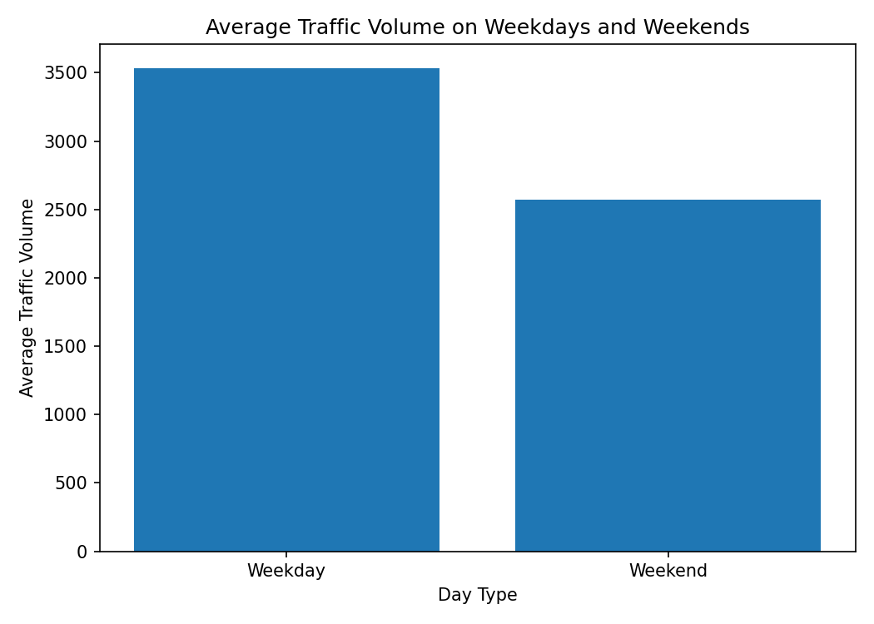
Average recorded traffic volume was 3533.29 on weekdays and 2570.70 on weekends. Weekdays had about 962.59 more vehicles per recorded hour. This is consistent with regular work and school travel, but the chart does not prove the reason for the difference.

3.3 Traffic and weather relationships
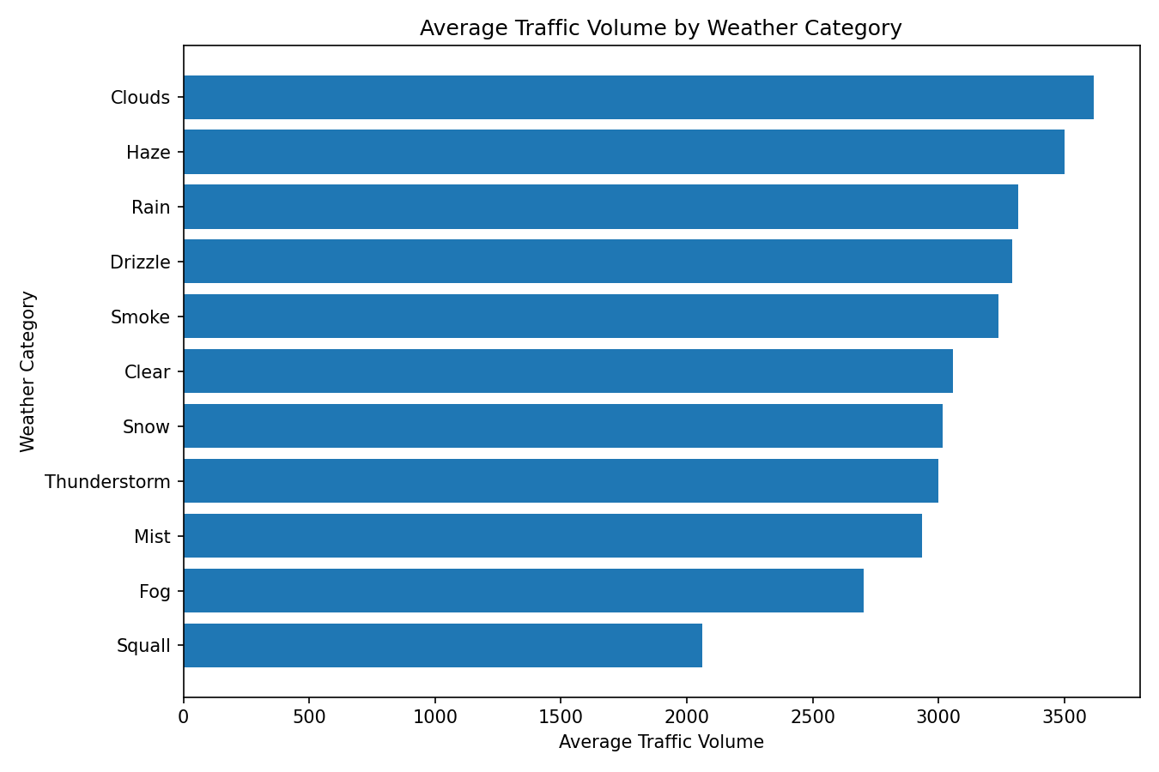
Clouds had the hig hest average recorded traffic volume at 3617.99, from 15158 records. Squall had the lowest average at 2061.75, from ony 4 records. Smoke also had few records, with 20 observations. The weather summary includes both averages and record counts.

3.4 Script execution and logging requirement
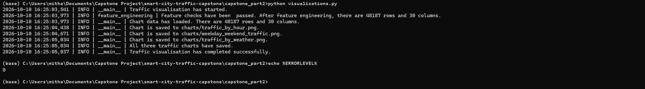

Task 4: Build a Mini Traffic Analytics Application

4.1 Compare weekday and weekend traffic
Command: python cli_app/traffic_app.py compare-days
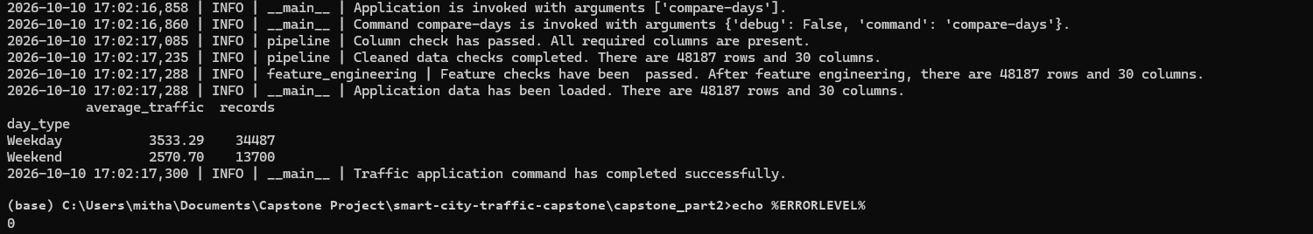
The weekday average is 3533.29 from 34487 records. The weekend average is 2570.70 from 13700 records. These values match the chart

4.2 Query a specific date and time
Command: python cli_app/traffic_app.py query --datetime "2012-10-02 09:00:00"
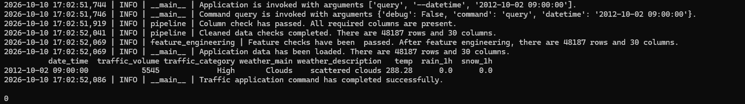
The query returned one record with traffic volume 5545 and category High. The weather was Clouds with scattered clouds. Temperature was 288.28 Kelvin, and rainfall and snowfall were both 0.0.

4.3 Find traffic above a chosen threshold
Command: python cli_app/traffic_app.py high-traffic --threshold 7000
The results show records above 7000, sorted from highest to lowest traffic volume. The highest value shown is 7280.
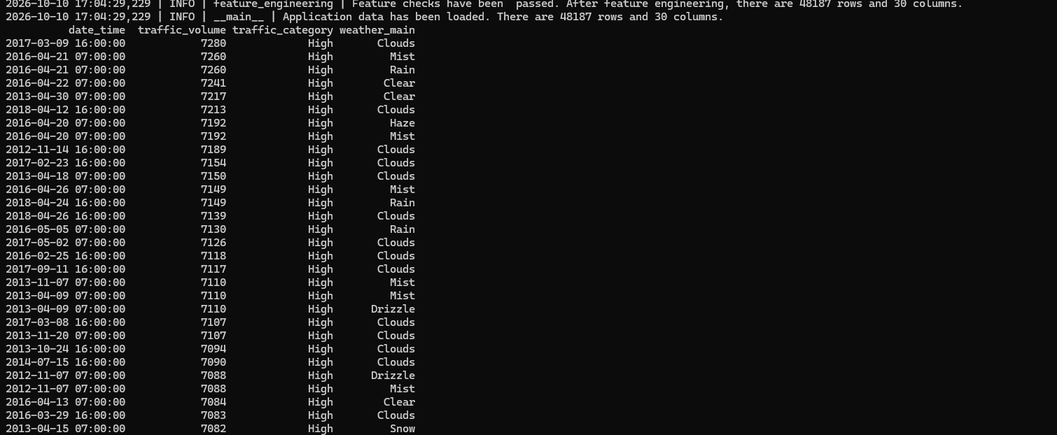

4.3 High-traffic results continued
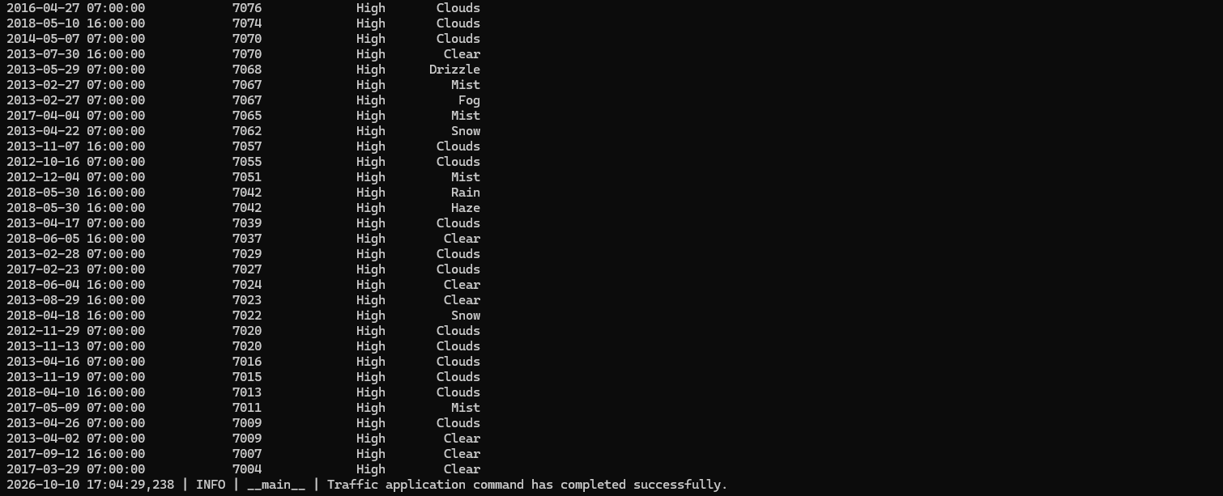

4.4 Handle an invalid date
Command: python cli_app/traffic_app.py query --datetime "invalid-date"
The application showed a clear ERROR explaining how the date and time sjhoupd look like.

4.5 Handle an invalid threshold argument
Command: python cli_app/traffic_app.py high-traffic --threshold abc
The application showed a clear ERROR because the threshold must be an integer.

Task 5 GitHub and Reproducibility

5.1 Incremental version control
The work was saved in separate, descriptive Git commits. The recorded task commits were 548c9ec for pipeline construction, b7942c4 for feature engineering, c09dc97 for visualisations, bc53926 for the mini traffic analytics application and dafe1bd for GitHub and reproducibility. These changes were pushed to the project repository. A later commit, e39f05c, corrected the README commands and Markdown formatting.
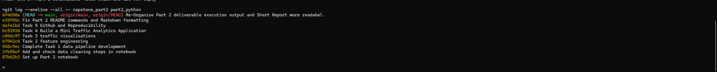

5.2 Project documentation and run instructions
The part2_python/README.md documents the project structure, required Python packages, raw data location and script order. From the Part 2 folder, the workflow runs pipeline.py, feature_engineering.py and visualizations.py. The README also gives examples for the query, high-traffic and compare-days application commands, along with invalid-input handling and exit codes.

5.3 Logging and reproducibility evidence
The README explains logging to the console and pipeline.log using a timestamp, log level, module name and message. INFO records normal milestones, WARNING records recoverable data issues, ERROR records failures and DEBUG records internal calculations when debug mode is enabled. Each module uses logging.getLogger(__name__). The sample pipeline.log, saved data and charts, script execution screenshots and command checks in Tasks 1 to 4 provide supporting evidence.

5.4 Repository location
The project repository is https://github.com/sskomal91/smart-city-traffic-capstone. Part 2 files are under part2_python. Keep the Part 1 raw dataset with the repository because the pipeline reads part1_data_analytics/Metro_Interstate_Traffic_Volume.csv. Rerunning the processing scripts replaces the generated data and charts.

Folder organisation update
Part 2 files are stored in part2_python. The CLI entry point is cli_app/traffic_app.py, and generated charts are stored in figures. Run commands and dependencies are documented in the Part 2 README.

Verification of the updated folder structure
The Part 2 file list shows cli_app, figures, data, scripts and documentation.
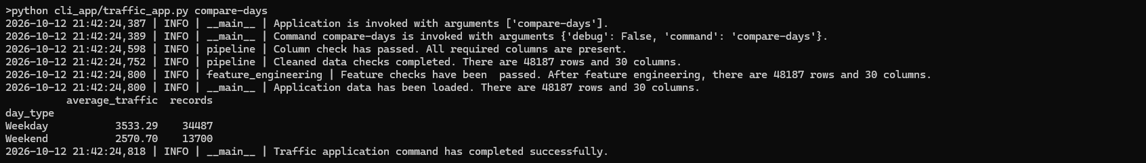
The updated command python cli_app/traffic_app.py compare-days returned weekday average 3533.29 from 34487 records and weekend average 2570.70 from 13700 records.

Pipeline and feature verification
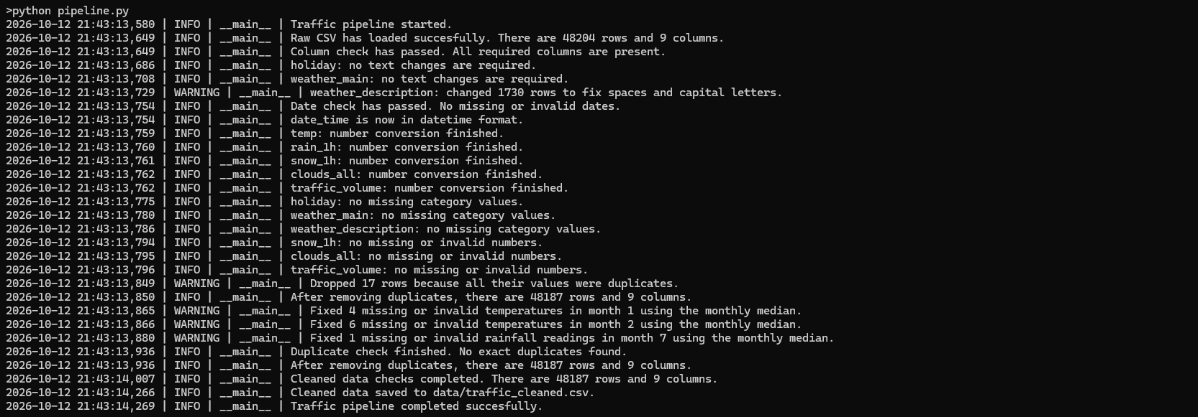
The pipeline completed successfully and saved 48187 cleaned rows and 9 columns, after duplicate removal and monthly-median corrections.
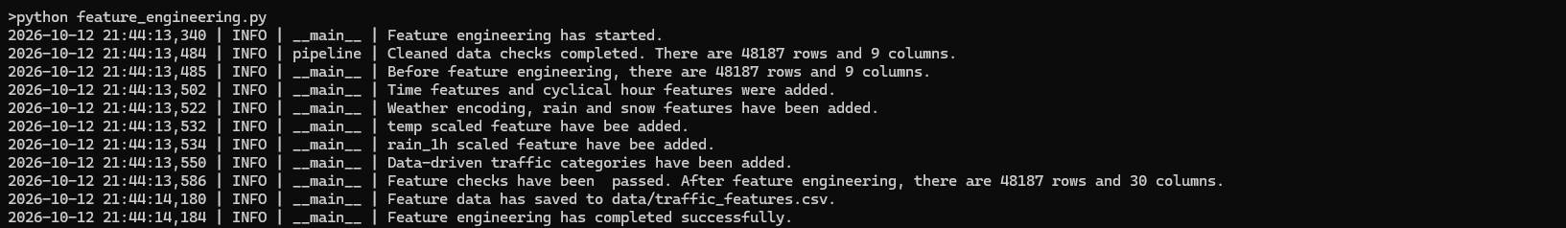
Feature engineering completed successfully and saved 48187 rows and 30 columns.

Figure output verification
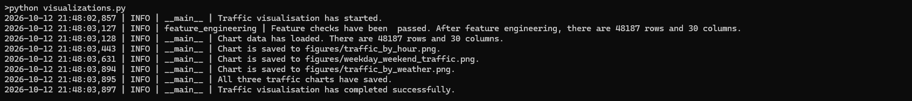
The visualisation script successfully saved traffic_by_hour.png, weekday_weekend_traffic.png and traffic_by_weather.png under figures.

