Task 1 Supervised Machine Learning Models

Data preparation
The raw dataset contained 48204 rows and 9 columns. Reusable Part 2 cleaning functions removed 17 exact duplicates. 10 invalid temperature readings and on e invalid rainfall reading wre marked as missing.
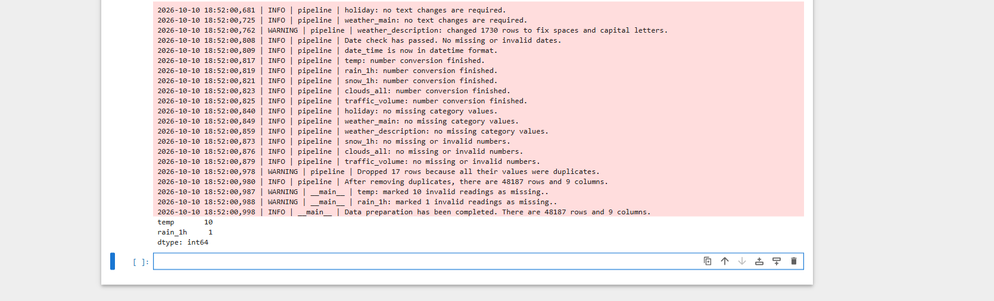

Chronological split and imputation
The split used 75 percent of unique timestamps for training, 15 percent for validation and 10 percent for testing. All records with the same timestamp stayed in one set. Training contained 35873 rows, validation 7370 and testing 4944. Missing temperature and rainfall values were filled using monthly medians calculatd from training data only, with training-wide medians as a fallback.


Training only preparation
The training period ended on 2 August 2017. Validation ran from 3 August 2017 to 14 April 2018, followed by the test period through 30 September 2018.

Features and proxy accident risk
Model inputs included time features, cyclic hour and weekday encodings, holiday flags, weather indicators and encoded weather categories. There were 16 numeric features and one categorical feature

Proxy label construction
Training traffic-volume quartiles were 1175, 3349 and 4923. Values were categorised as Low, Medium, High or Severe. High risk required High or Severe trafic volume together with Snow, Thunderstorm or Squall, or low-visibility weather defined as Fog, Mist, Haze or Smoke. There were 3852 positive training labels, 1138 validation labels and 476 test labels. This proxy demonstrates classification and does not predict actual accidents. Weather is used in both the label definition and model inputs, which helps explain the strong classification scores.
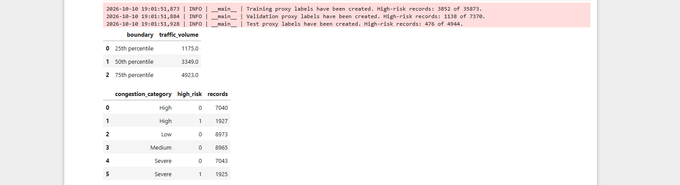

Regression model comparison
Linear Regression and Random Forest were trained to estimate recorded traffic volume. Random Forest achieved validation MAE 317.5692 and R squared 0.9256, compared with MAE 826.1898 and R squared 0.7158 for Linear Regression. Random Forest was selected using the lower validation MAE.
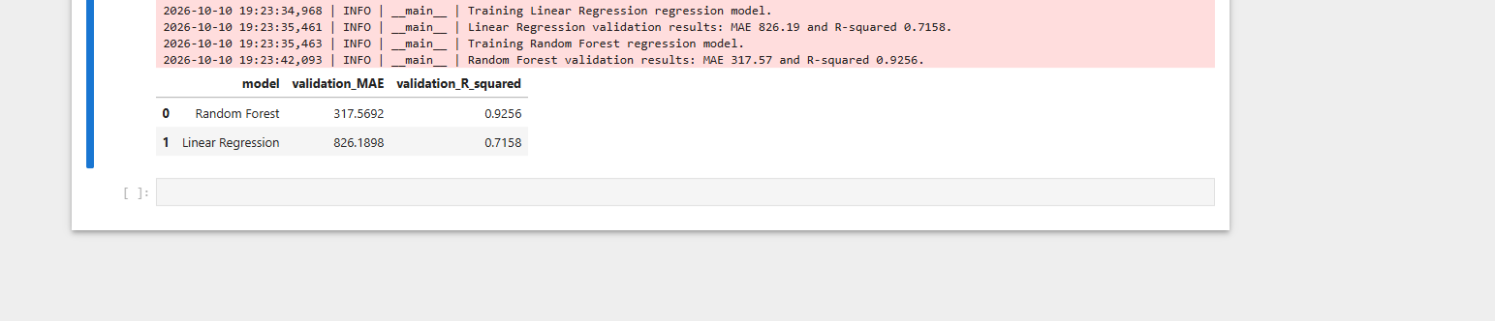

lassification model comparison
Logistic Regression and Random Forest were compared for the proxy high-risk label. Random Forest achieved validation accuracy 0.9769, precision 0.9047, recall 0.9508, F1 0.9272 and ROC AUC 0.9932. Logistic Regression achieved accuracy 0.9507, precision 0.7645, recall 0.9842, F1 0.8605 and ROC AUC 0.9895. Random Forest was selected using the higher validation F1.


Held out test evaluation
The selected models were evaluated without changing their settings. Random Forest regression achieved test MAE 250.8358 and R squared 0.9448. Random Forest classification achieved accuracy 0.9875, precision 0.9091, recall 0.9664, F1 0.9369 and ROC AUC 0.9982. Classification results measure agreement with the constructed proxy label.


Saved models and reload verification
Four model pipelines were saved as version 1 joblib files, together with preparation_config_v1.joblib. Four CSV fies record regresion and classification validation and test results. Reloaded models reproduced predictions and classifier probablities on 20 validation examples.


Task 2 Unsupervised Machine Learning

Clustering inputs and model selection
The cleaned Part 2 dataset contained 48187 records. Clustering used standardised hour sine, hour cosine, weather severity and traffic volume. Weather severity was a project-defined score: Clear and Clouds 0; Rain, Drizzle, Fog, Mist, Haze and Smoke 1; Snow, Thunderstorm and Squall 2. K-means models with 2 to 6 clusters were compared using the same random sample of 3000 records for silhouette scoring.
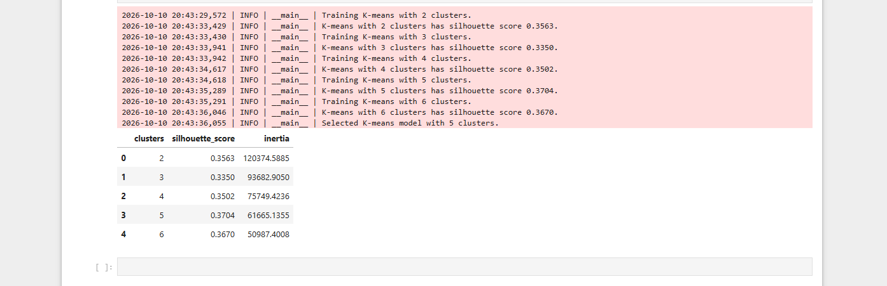

Cluster interpretation
Cluster 0 had average traffic volume 1079.69, with Mist most common and 04:00 the most common hour. Cluster 1 had average volume 5080.17, severity 0, Clouds most common and 14:00 the most common hour. Cluster 2 had average volume 3189.59, average severity 0.27 and 18:00 the most common hour. Cluster 3 had average volume 4924.87, average severity 1.22, Rain most common and 09:00 the most common hour. Cluster 4 had average volume 944.87, severity 0, Clear most common and midnight the most common hour.
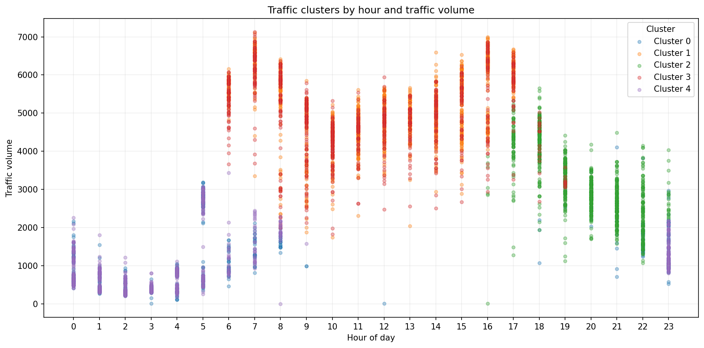

Association rule preparation
Time periods were Night 00:00 to 05:59, Morning 06:00 to 11:59, Afternoon 12:00 to 17:59 and Evening 18:00 to 23:59. Day type distinguished weekdays and weekends. Full historical traffic-volume quartiles were 1192.5, 3379 and 4933. They defined Low, Medium, High and Severe categories for this exploratory analysis. These full-dataset thresholds differ from the training-only thresholds used in Task 1.

Association rule results
Rules were calculated directly with pandas by counting every one-, two- and three-attribute combination of time period, day type and weather, with a congestion category as the consequent. Rules required support of at least 1 percent, confidence of at least 60 percent and lift greater than 1.
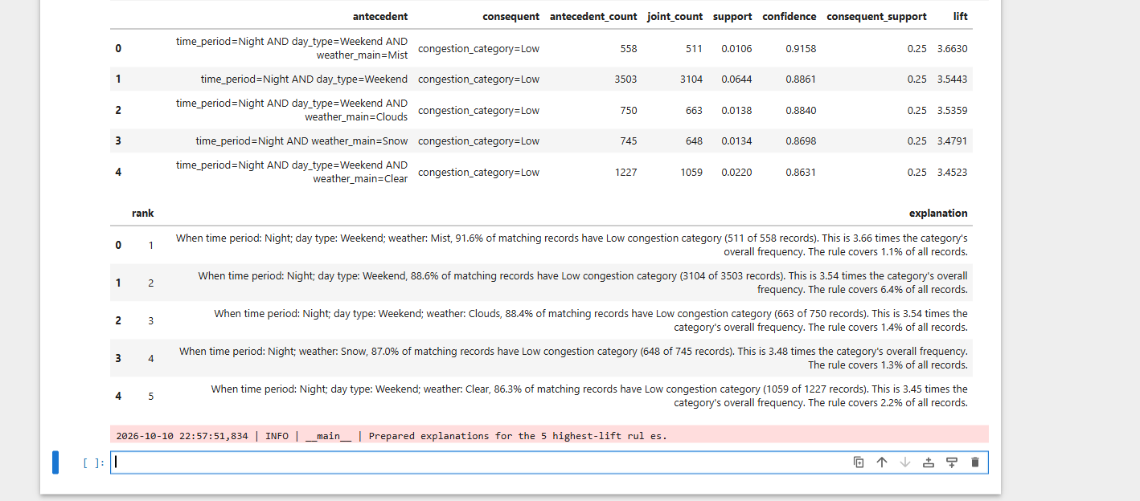

Meaning of the strongest rules
Weekend nights with Mist had Low trafic volume in 511 of 558 matching records, giving confidence 91.6 percent, support 1.06 percent and lift 3.6630. Weekend nights overall had Low trffic volume in 3104 of 3503 records, conidence 88.6 percent and lift 3.5443. The nex rules were weekend nights with Clouds, nights with Snow, and weekend nights with Clear weather.

Saved outputs and reload verification


Task 3 Deep Learning with Explainability

Packages and data preparation
TensorFlow 2.21.0 and SHAP 0.53.0 imported successfully. The original dataset and reusable cleaning functions reproduced the Task 1 data preparation and chronological split: 35873 training records, 7370 validation records and 4944 test records. Records sharing a timestamp remained together. Invalid readings were imputed using the training-only medians saved in Task 1.
The same 16 numeric inputs and weather category were prepared. The saved Random Forest preprocessor, fitted only on training data, produced 27 transformed features for both models. Traffic volume was the target and was excluded from the predictors. Task 3 estimates recorded traffic volume from time and weather features; it does not forecast a sequence of future observations.


Neural network training
The feedforward network used two hidden layers with 64 and 32 ReLU neurons and a single linear output. Training used Adam with learning ratte 0.001, mean squared error loss and batch size 256. The trget was standardised using the training mean and standard deviation. Earl y stopping monitored validation loss with patience 10 and restored the best weights. Training completed on the CPU after 37 epochs; the best validation loss occurred at epoch 27.

Training curve and validation comparison
Training and validation loss decreased sharply during the early epochs. Validation loss then levelled off while training loss continued to decrease. Early stopping retained epoch 27. The chart shows loss on the standardised target; prediction metrics below use original traffic-volume units.
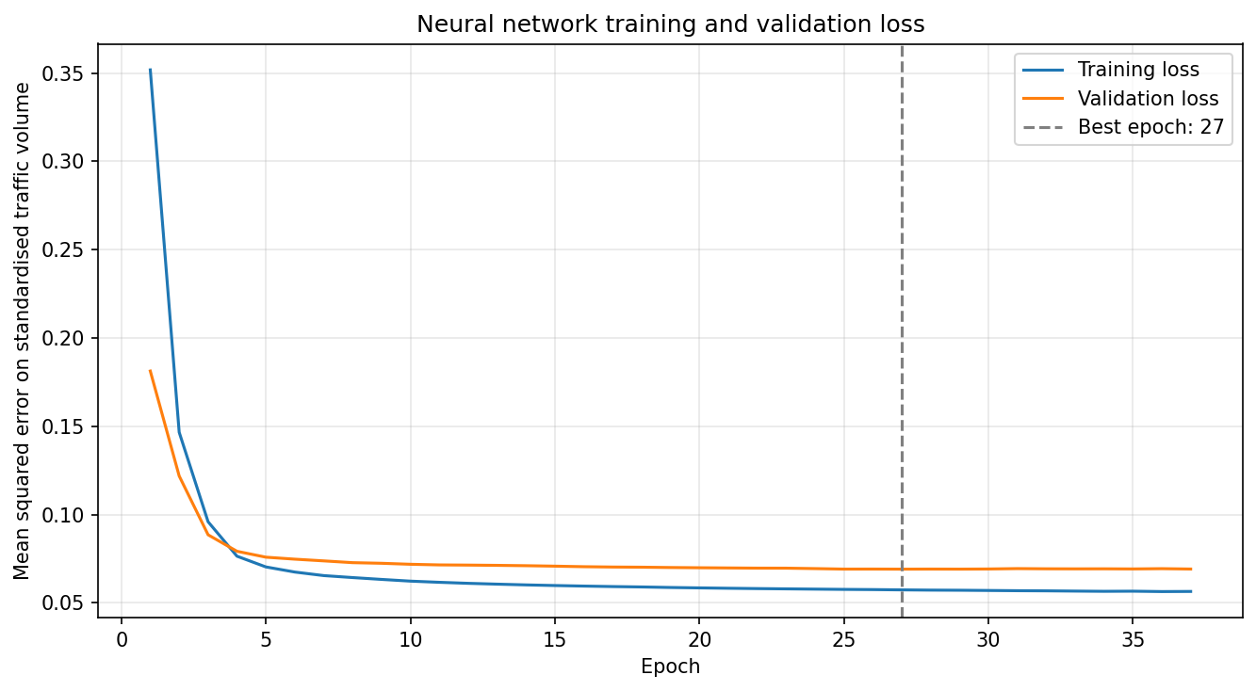
The neural network achieved validation MAE 316.4414 and R squared 0.9307. The comparable Random Forest achieved MAE 317.5692 and R squared 0.9256. Their validation MAE values were close, with the neural network slightly lower
Held out test evaluation
Both fixed models were evaluated on the same chronological test records without further tuning. The neural network achieved test MAE 256.9366 and R squared 0.9455. Random Forest achieved MAE 250.8358 and R squared 0.9448. Random Forest had slightly lower MAE, while the neural network had slightly higher R squared. These metrics do not establish that one model is universally better.


Explainability approach
SHAP explained the Task 1 Random Forest regression model, which used the same features and prediction target as the neural network. These explanations apply to Random Forest rather than the neural network. Tree SHAP used training sample counts stored in the fitted trees as its reference distribution. A reproducible random sample of 200 test records was explained. The baseline plus feature contributions reconstructed the corresponding Random Forest predictions, and the numerical verification passed.

Global feature contributions
Time-of-day features had the largest mean absolute SHAP values in the sample. Hour cosine contributed 1438.3837 traffic-volume units on average in absolute magnitude, followed by hour at 447.4004 and hour sine at 204.0781. Day of week, weekday sine and the weekend flag also ranked highly. Individual weather features had smaller average contributions in this sample.
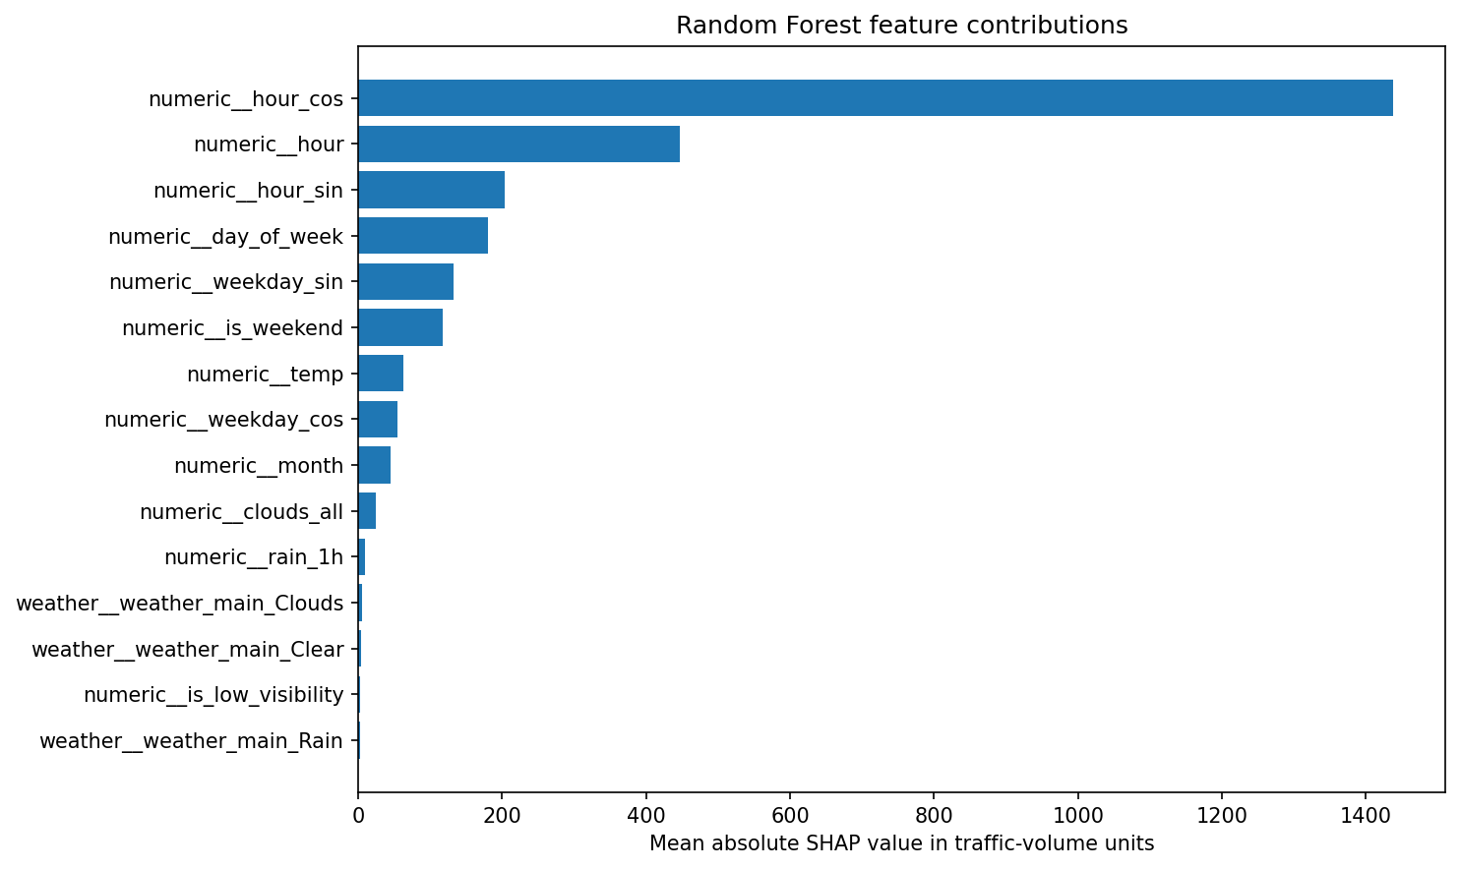

Local prediction explanation
For the sampled record at 18 April 2018 at 15:00, actual traffic volume was 5835 and Random Forest predicted 5801.5944. The SHAP baseline was 3244.9937 and the sum of contributions was 2556.6007. Their sum reconstructed the prediction. Hour cosine, hour and hour sine were the largest positive contributions.
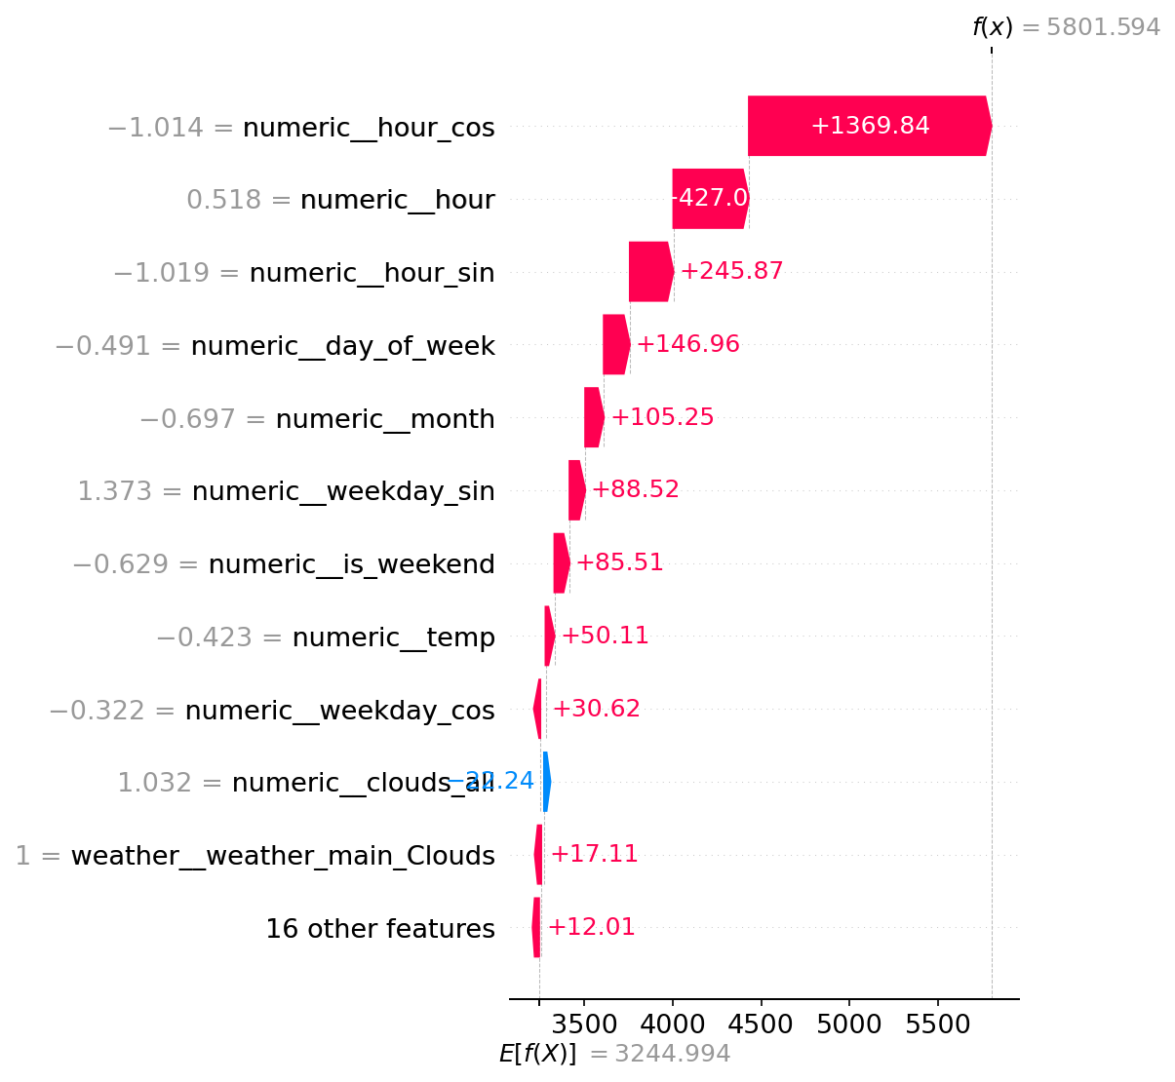

Saved artifacts and reload verification
The network was saved as neural_network_traffic_v1.keras. The fitted preprocessor and configuration were saved as neural_network_preprocessor_v1.joblib and neural_network_config_v1.joblib. Configuration included the target scaling, feature list, imputation values, architecture, training settings, completed epochs and package versions.


Task 4 Apply an Advanced AI Technique

MLflow experiment tracking
MLflow 3.17.0 imported successfully. Experiment tracking was used to record the existing Random Forest and neural network regression evaluations from Tasks 1 and 3. Each run retained model settings, version identifiers, validation and test metrics, and supporting artifacts.

Local tracking configuration


Inputs and model settings
The Task 3 validation and test comparison CSV files loaded and joined by model name. Actual Random Forest settings read from the saved pipeline, and neural network settings read from its saved configuration.

Recorded regression runs


Metrics and artifacts
Random Forest validation MAE was 317.5692 and R squared 0.9256; test MAE was 250.8358 and R squared 0.9448. Neural Nettwork validation MAE was 316.4414 and R squared 0.9307; test MAE was 256.9366 and R squared 0.9455. Saved model files were logged as artifacts together with preparation settings, figures and readable evaluation JSON files. The neural network run also retained training history.

Read back verification
Both runs retrieved through MlflowClient and had FINISHED status. Stored metrics matched the original results within numerical tolerance, and the model_version parameter was v1.
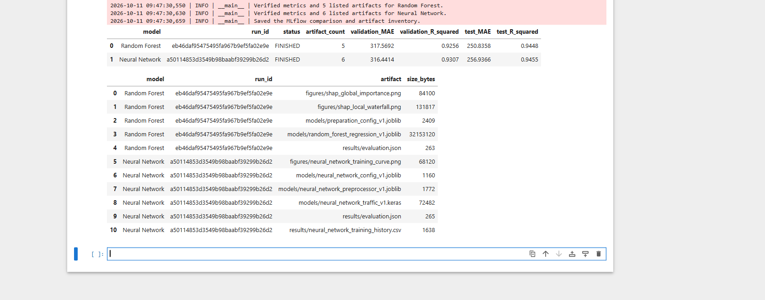

Value and limitations
MLflow brings the model settings, evaluation metrics and supporting artifacts together under identifiable runs. This makes the existing models easier to compare and supports later deployment and monitoring work.
Random Forest had slightly lower test MAE, while the neural network had slightly higher test R squared. Their results were close.
These runs record existing evaluations rather than new training experiments. Tracking does not improve model accuracy by itself. The artifact locations use local filesystem paths, so another computer may need tracking configuration changes.

Task 5 Build a Traffic Recommendation System

Travel hour comparison
The saved Random Forest regression v1 model ranked supplied travel hours on one corridor by predicted hourly traffic volume. The system reused the saved preparation settings and 17 input features. The historical demonstration compared five hours on 07 May 2018 from 06:00 to 10:00, assuming clear weather, temperature 288.15 K, no rain or snow, zero cloud cover and no holiday.
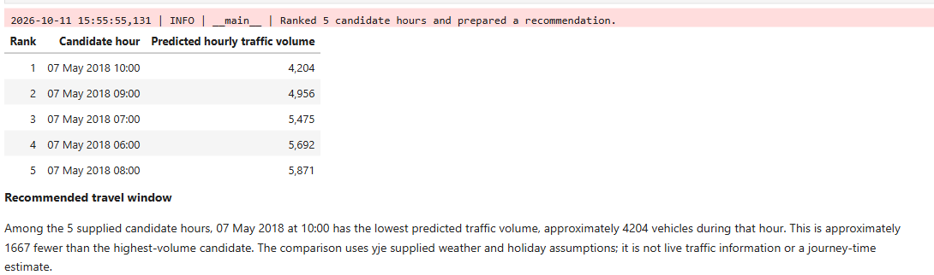

Input and ranking validation
The ranking retained every supplied candidate and sorted predicted volumes in ascending order. Shuffling input rows produced the same ranking. Validation rejected an unknown weather category, duplicate timestamps and cloud cover above 100. All three rejection checks passed, with full messages displayed.
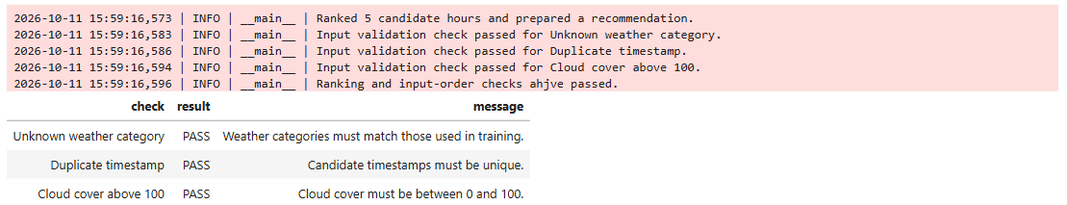
Reusable recommendation module
The input preparation and travel window recommendation functions saved in recommendation_system/recommender.py.
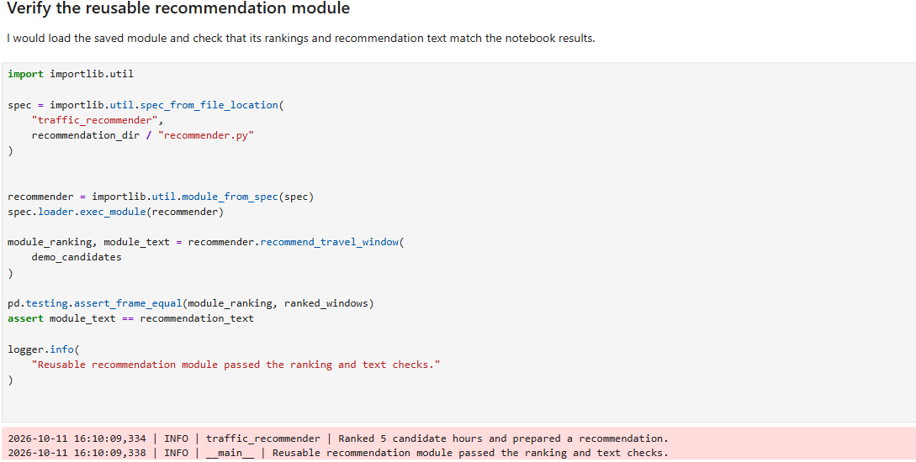

Scope and limitations
The system compares only the supplied candidate hours on one corridor using stated weather and holiday assumptions. It does not compare routes, estimate journey time or provide live traffic information.

Task 6 MLOps and Deployment Simulation

Model version and deployment manifest
Deployment manifest recorded model v1 and its evaluation metrics.

Model version comparison
The two saved traffic-volume models are compared using their existing validation and held-out test results. Each model family has its own version v1, these are distinct artifacts, not successive releases of one model. Random Forest v1 remains deployed in the local API and Neural Network v1 is retained as a comparison candidate.
Random Forest test MAE was 250.84 and R-squared 0.9448. Neural Network test MAE was 256.94 and R-squared 0.9455. The comparison is saved to results/deployment_model_version_comparison.csv.
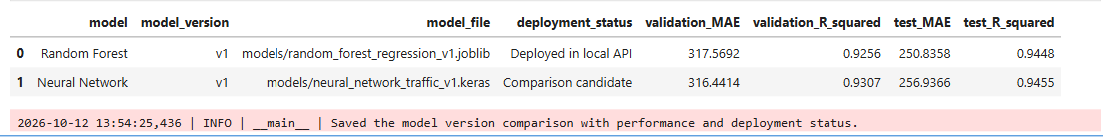

API behavior and validation
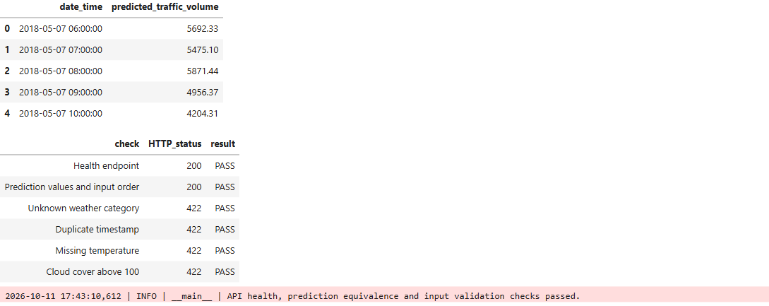

Training reference and monitoring outcomes
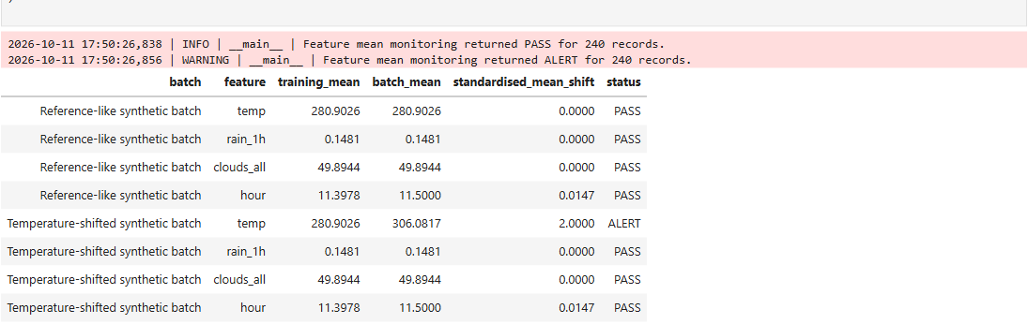
Synthetic batches produced the expected PASS and ALERT outcomes.
The five-record example batch was rejected with the message Monitoring requires at least 100 records. This prevented an insufficient batch from receiving PASS or ALERT.

Local server startup
The startup command launched Uvicorn successfully on 127.0.0.1 port 8000.

Reusable application and running server
The verified API and monitoring functions are saved in deployment/app.py. It loads deployment_manifest.json and monitoring_reference.json, verifies artifact hashes and locates the Task 5 feature preparation module relative to its oown location. Import checks reproduced API metadata and timestamps exactly, prediction values within tight tolerance, and both monitoring outcomes.
Uvicorn served the application on 127.0.0.1 port 8000. Actual HTTP requests confirmed health and prediction responses with HTTP 200, preserved input order and matched direct inference. Invalid cloud cover returned HTTP 422. Verification tables and a live prediction response were saved.
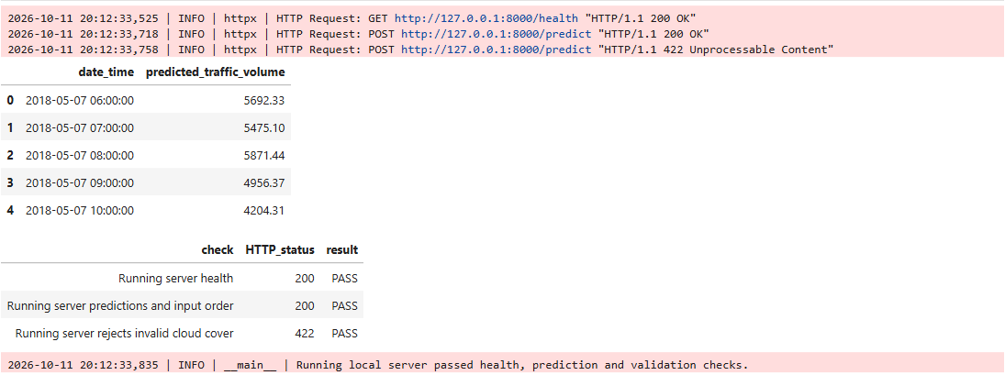
The running local server passed health, prediction and validation checks.

Interactive browser tests
The interactive API documentation was used to submit one clear-weather record for 07 May 2018 at 10:00. The browser received HTTP 200, model version v1 and a prediction of approximately 4204.31 vehicles per hour. A second request set cloud cover to 150 and received HTTP 422 with a validation message requiring a value less than or equal to 100.
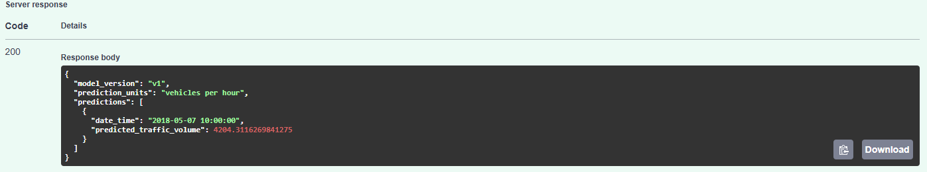
Browser request returned HTTP 200 and the expected traffic prediction.
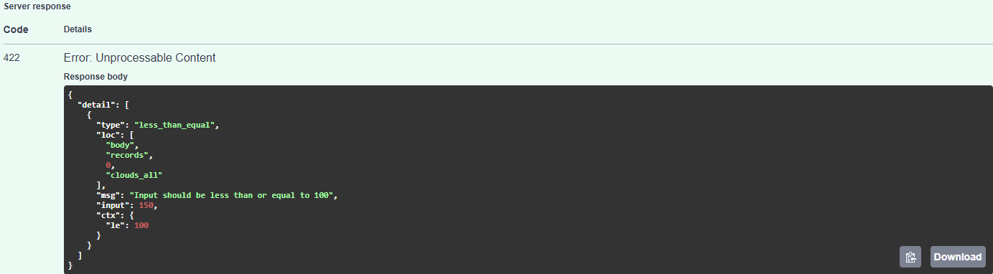
Browser validation rejected cloud cover 150 with HTTP 422.

Scope and limitations
This is a local deployment simulation using historical model artifacts. The monitoring threshold requires operational calibration. Mean checks do not detect every distribution change and PASS does not establish unchanged prediction accuracy. Accuracy monitoring requires observed traffic volumes. Feature monitoring is a Python function rather than an HTTP endpoint. The system does not provide live traffic information or journey times.

Task 7 Responsible and Sustainable AI

Held out analysis and time groups
The analysis used 4944 saved held-out predictions from 14 April 2018 at 16:00 to 30 September 2018 at 23:00. Models remained fixed. Time group results included record counts, mean actual volume, mean absolute error and mean signed error, defined as prediction minus actual volume.
Random Forest MAE ranged from 97.14 at night to 330.02 in the morning. Neural Network MAE ranged from 116.40 at night to 324.96 in the morning. Each group had 1187 to 1298 records. Different traffic volumes affect interpretation of absolute errors; these differences alone do not establish unfairness.
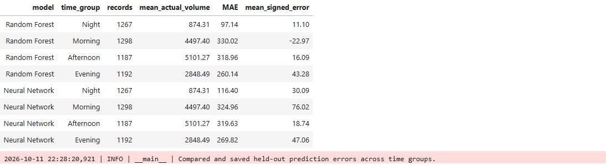

Weekday and weekend errors
Weekdays had 3517 records and weekends 1427. Random Forest MAE was 222.63 on weekdays and 320.35 on weekends. Neural Network MAE was 234.90 and 311.25 respectively. Average weekend volume was lower, yet both models had higher weekend absolute error.
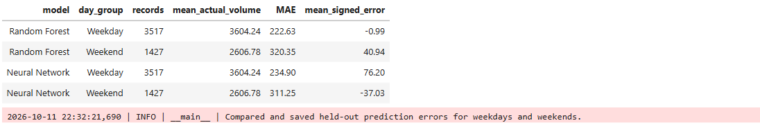
Weather alignment and performance
The original cleaning and chronological split were repeated. Test timestamps and actual traffic volumes matched the saved prediction rows before weather labels were attached.
Snow had the highest observed MAE: 1125.13 for Random Forest and 1164.69 for the neural network, with average overprediction of approximately 1053 vehicles. Only 47 snow records supported these estimates. Fog had 112 records and MAE 444.55 and 435.23 respectively. Results are descriptive and do not show that weather alone caused the errors.
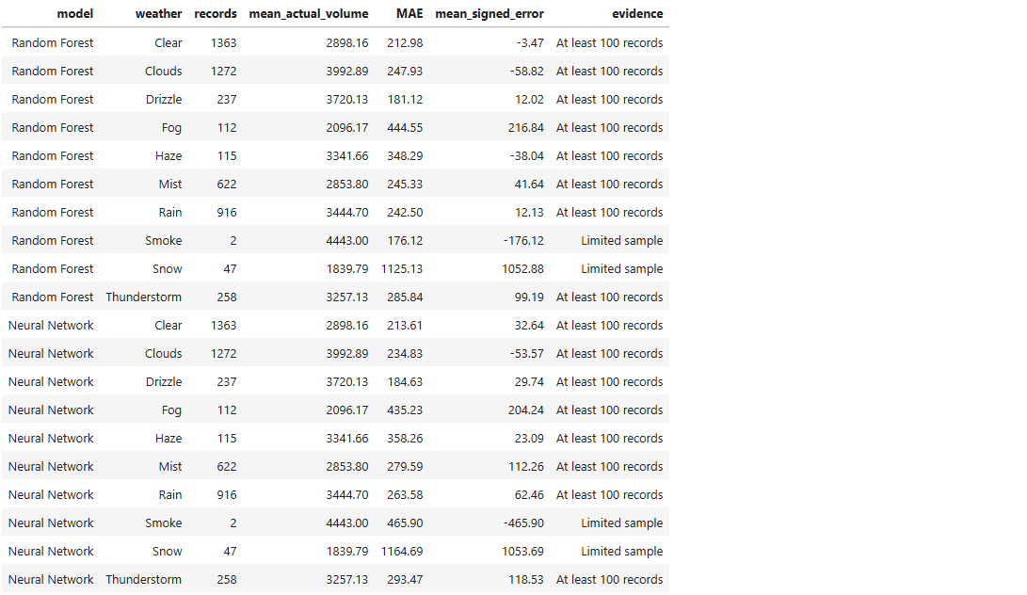

Coverage and fairness limitations
Groups below 100 records were flagged as limited evidence, a reporting rule rather than a statistical guarantee. The April to September test period did not cover a complete annual weather cycle. Records sharing an hourly timestamp are not independent observations.
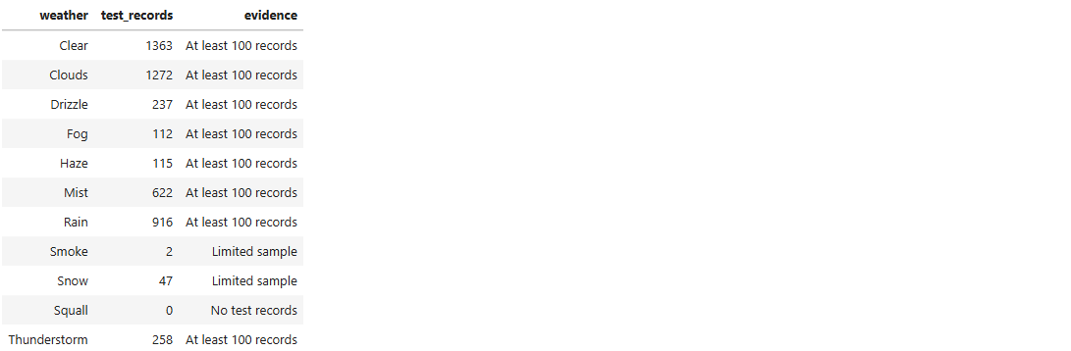
The dataset has no demographic attributes. Time, day and weather comparisons identify uneven errors and coverage limitations but canot establish demographic fairness.

Classification proxy and human oversight
HighRisk was constructed from traffic volume thresholds and selected weather conditions, not observed accidents or injuries. Weather features also helped define the label. Strong classification scores reflect reproduction of this rule rather than validated accident prediction. The proxy must not be used to declare journeys safe, issue penalties or make emergency decisions.
Recommendations should support human judgement alongside current incidents, road conditions and official information. Model versions, preparation settings, evaluation results and artifact hashes should be retained. Replacement models require validation and group performance review. Monitoring ALERT results require investigation rather than automatic retraining; PASS does not guarantee accuracy.

Sustainability and saved report
Saved models arereused for recommendation and deployment. Early stopping completed neural network training after 37 epochs instead of the maximum 100. Energy and emissions were not measured, so environmental savings cannot be quantified and neither model is claimed to be greener. MLflow artifact copies support reproducibility but increase storage use. Retention policies and measured training time, latency, memory and energy use are recommended for future operational work.

