Task 1: Data Pipeline Construction
1.1 Load the dataset and check the columns
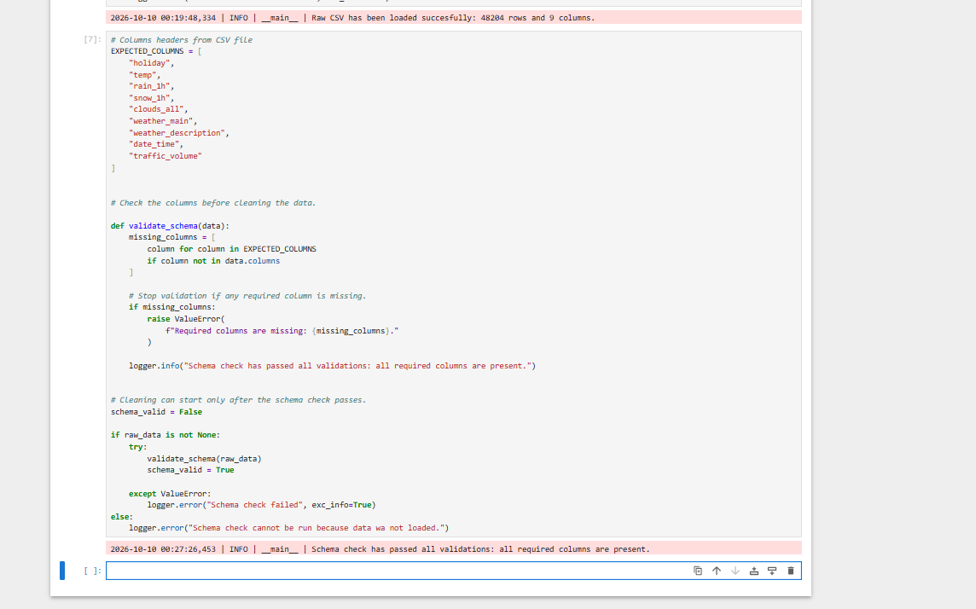
Column check passed. All required columns were present.
1.2 Make category text consistent and convert dates

The notebook reports 1730 changes in weather_description.
The date_time column was converted to datetime using the expected format. T he actual dataset had no missing o r invalid dates.
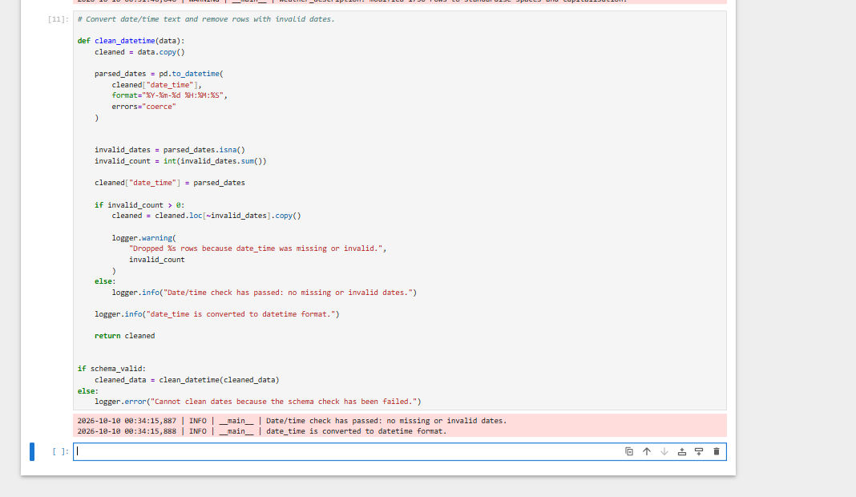
1.3 Remove exact duplicates and fix invalid readings
There were 17 rows that repeated exactly across all columns
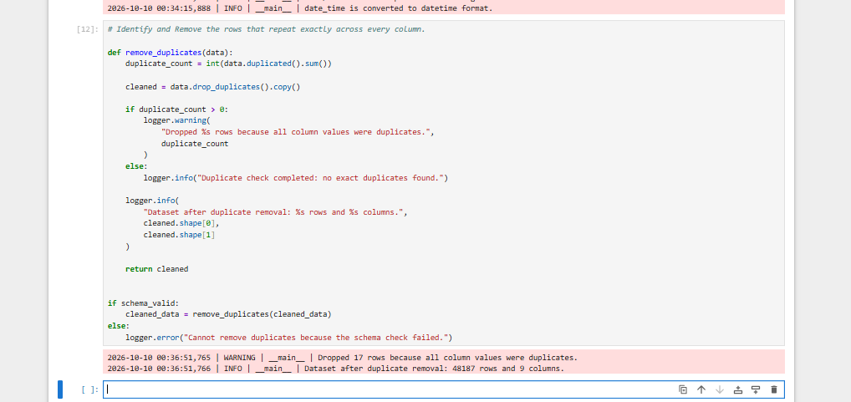
1.4 Validate and save the cleaned dataset
Checks found no missing cells or blank text.
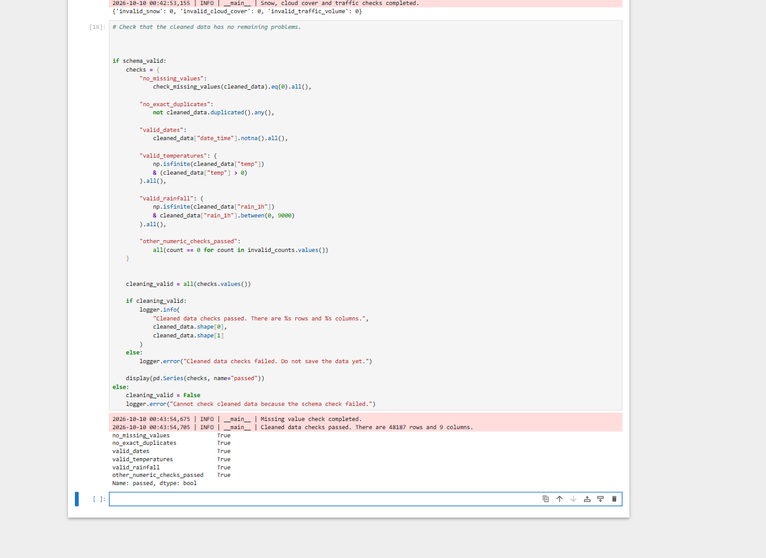

1.5 Run the standalone pipeline
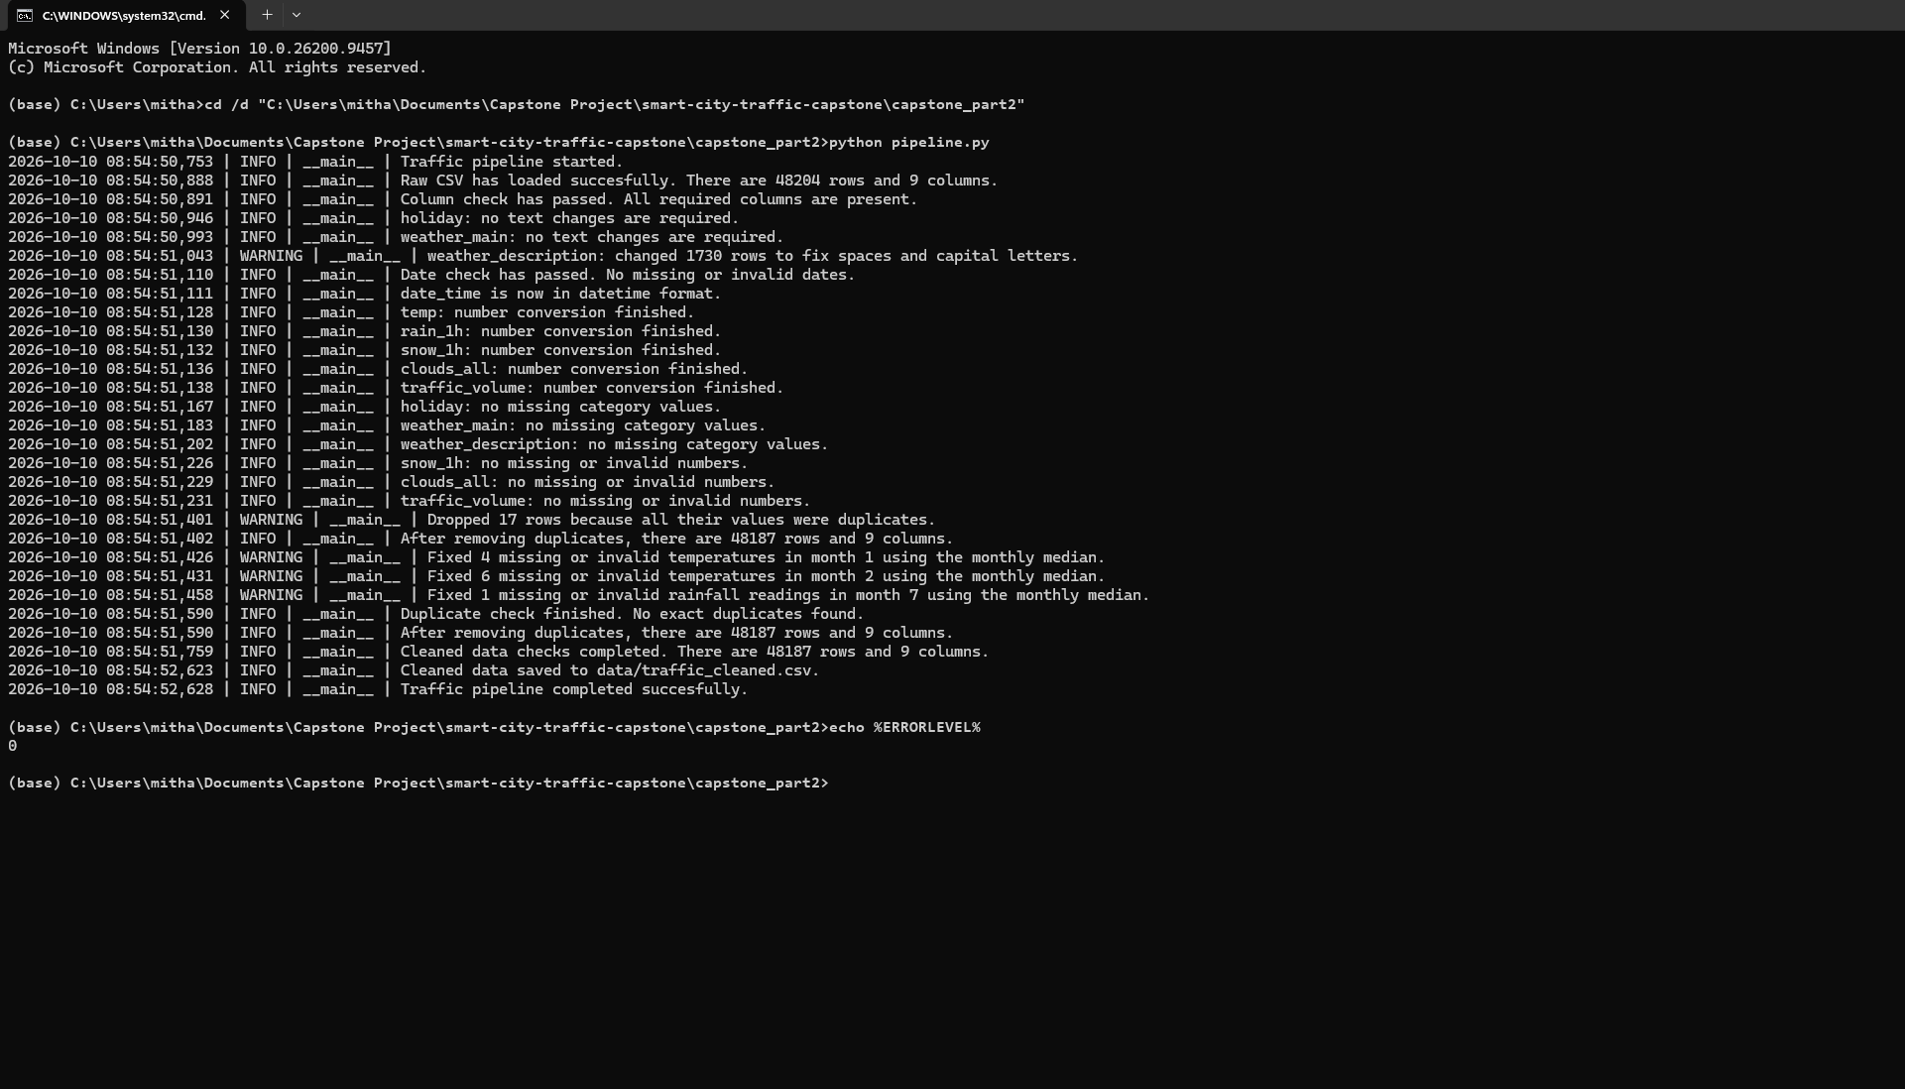
1.6 Check logging in debug mode
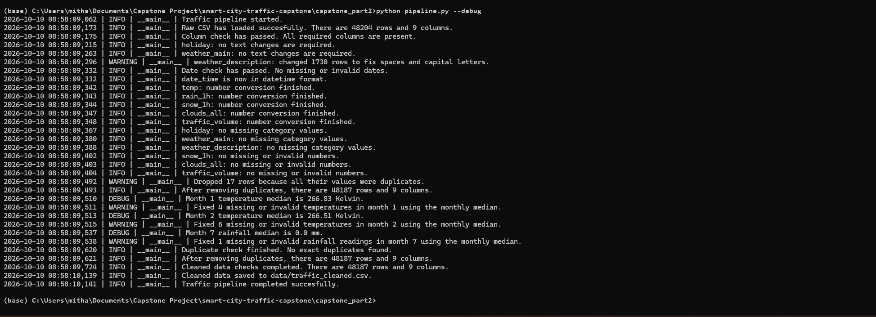
Debug mode shows the monthly medians and the pipeline completes successfully.

Task 2: Feature Engineering
2.1 Time features
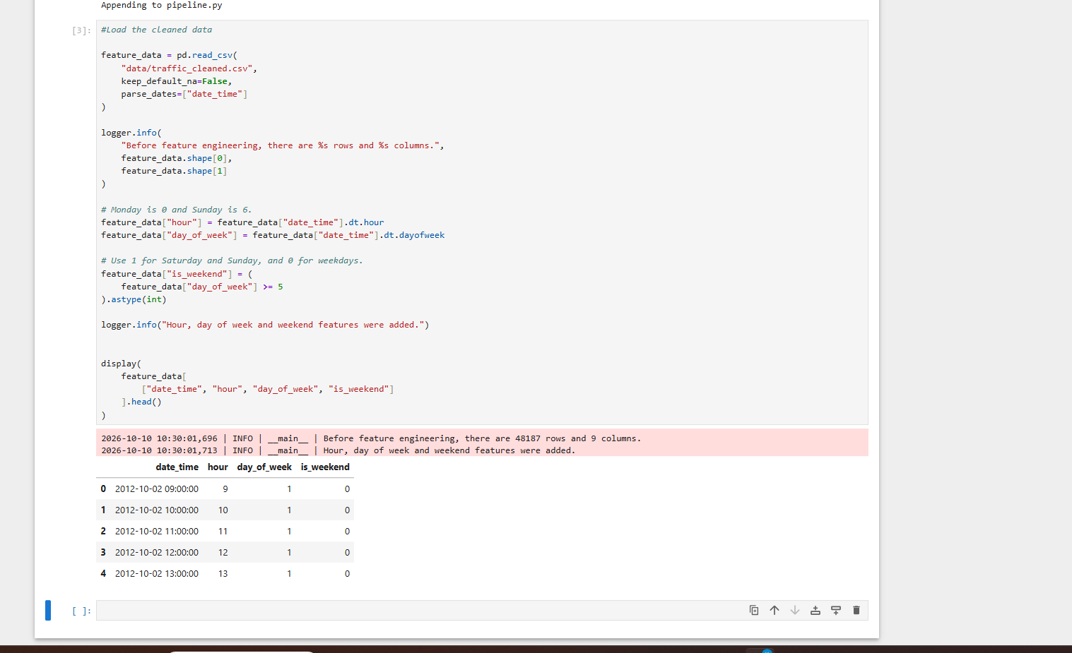
Hour encoded with sine and cosine using a 24-hour cycle. This keeps nearby hours close across midnight, including 23:00 and 00:00.

2.2 Cyclical encoding and weather features
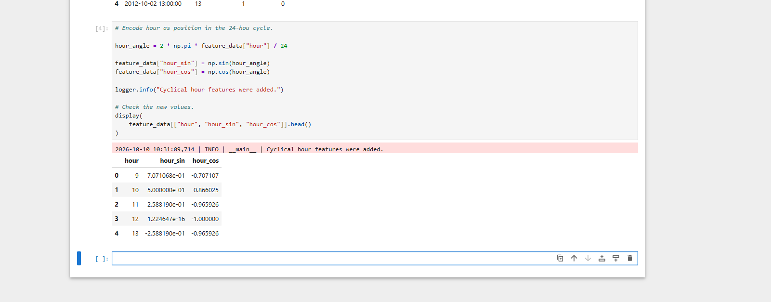
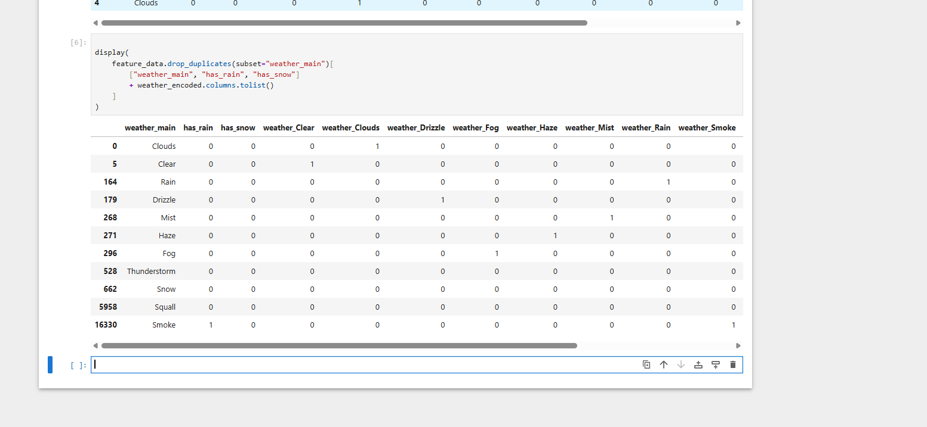
I tried to verify that each category is shown.

2.3 Numerical features
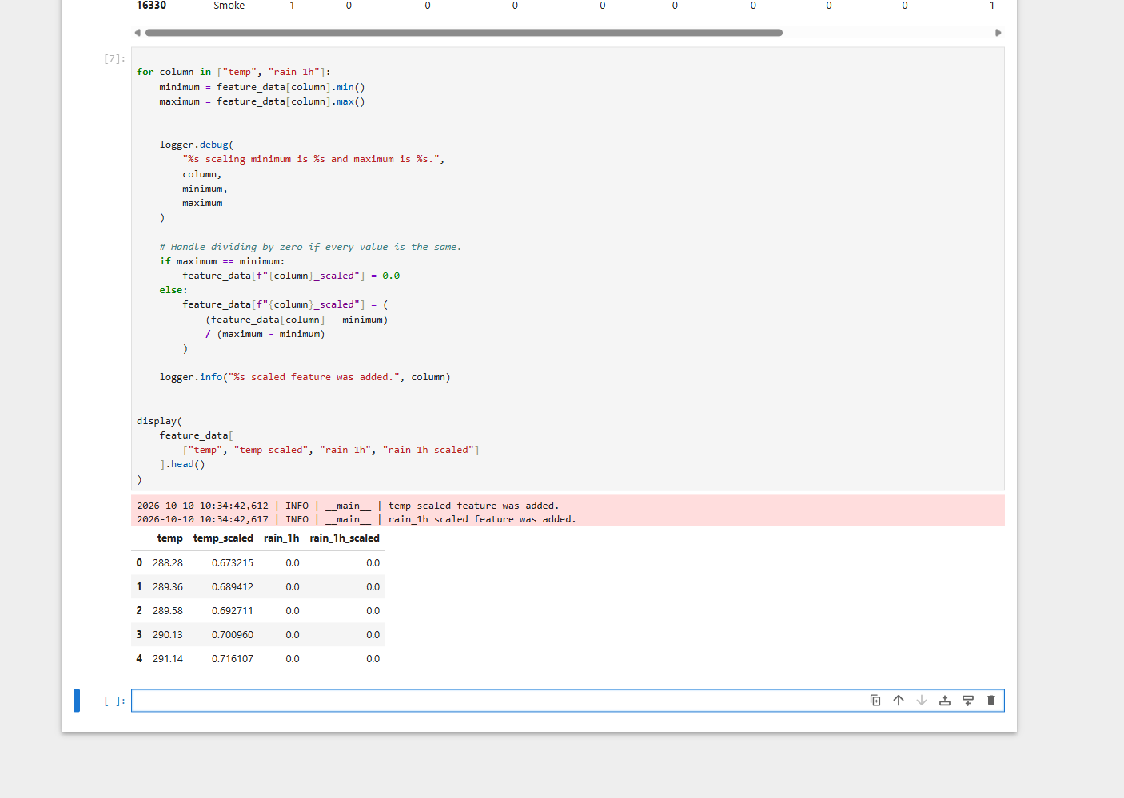
The temperature range was 243.39 to 310.07 Kelvin. The rainfall range was 0.0 to 55.63 mm.

2.4 Traffic target
I chose the 25th and 75th percentiles so the thresholds come from the cleaned traffic data. This separates lower and higher traffic records while keeping the middle range as Medium. Unlike the fixed 5500 threshold used in Part 1, these thresholds depend on the dataset. Equal values at a boundary can make the group sizes differ slightly from 25 percent, 50 percent and 25 percent.
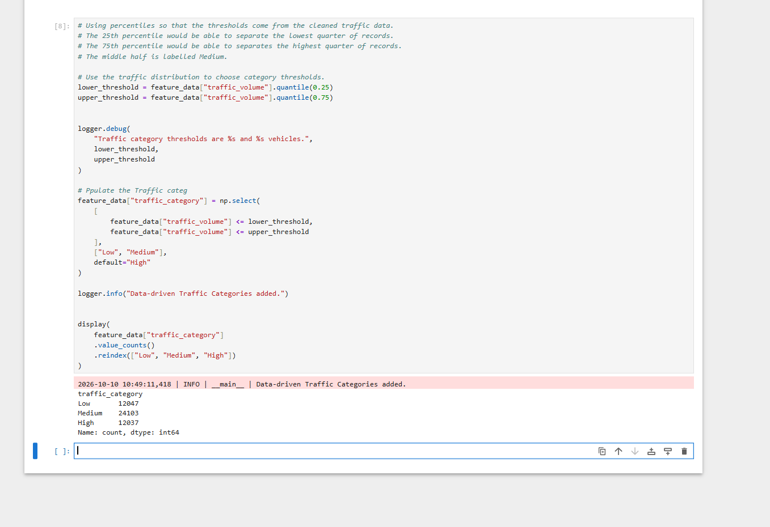
Low has 12047 records, Medium has 24103 records and High has 12037 records.

2.5 Validate and save the features
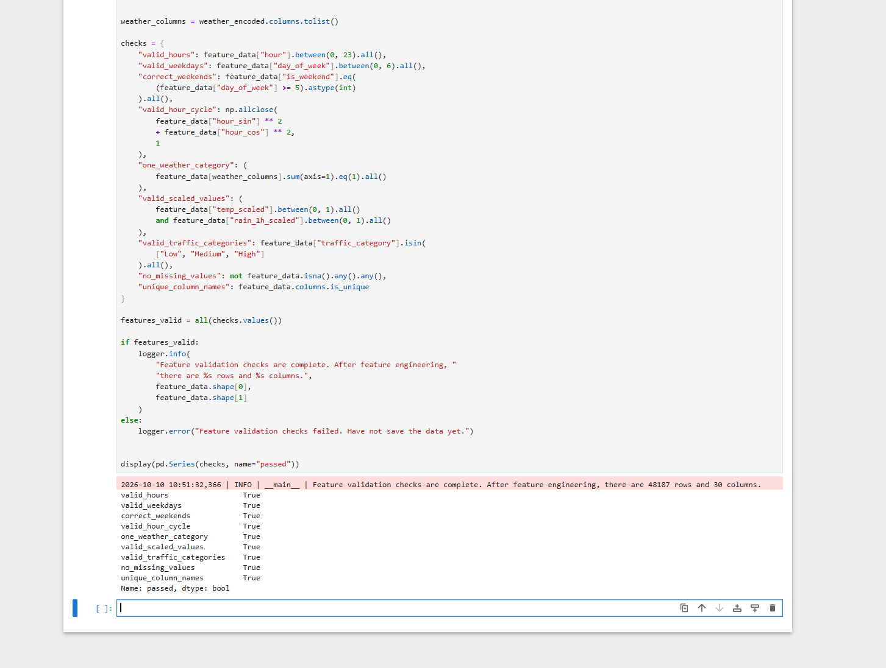

2.6 Run the standalone script and check logging
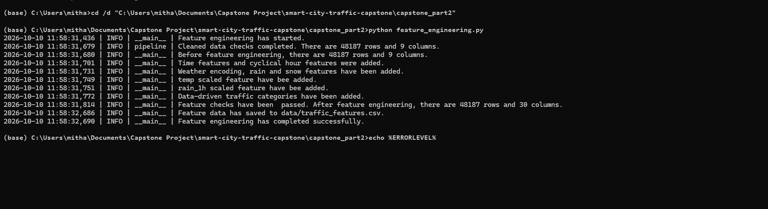
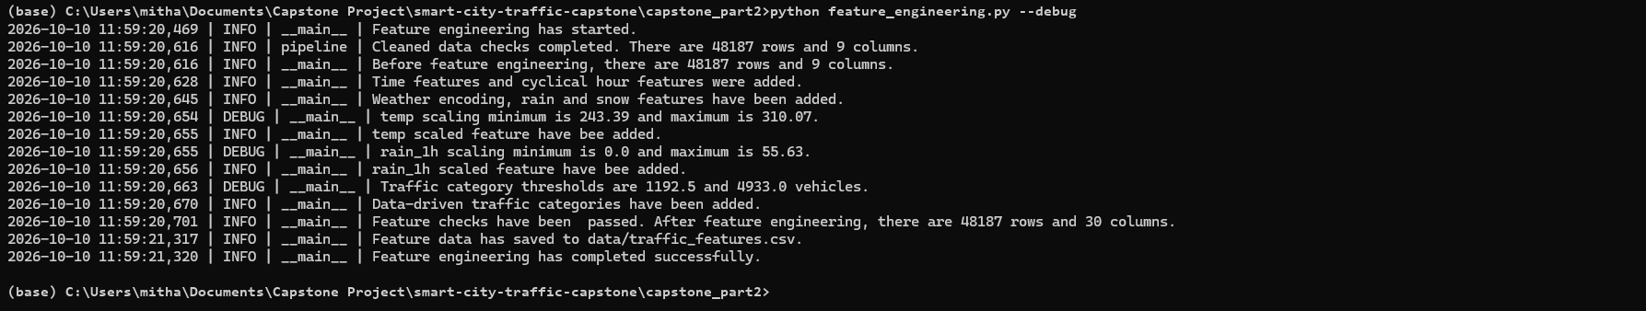
DEBUG s hows the scaling values and the thresholds 1192.5 and 4933.0.

