**Books.XML**

**<?xml version="1.0" encoding="UTF-8"?>**

**<?xml-stylesheet type="text/css" href="Rule.css"?>**

**<books>**

**<heading>Welcome To GeeksforGeeks </heading>**

**<book>**

**<title>Title -: Web Programming</title>**

**<author>Author -: Chrisbates</author>**

**<publisher>Publisher -: Wiley</publisher>**

**<edition>Edition -: 3</edition>**

**<price> Price -: 300</price>**

**</book>**

**<book>**

**<title>Title -: Internet world-wide-web</title>**

**<author>Author -: Ditel</author>**

**<publisher>Publisher -: Pearson</publisher>**

**<edition>Edition -: 3</edition>**

**<price>Price -: 400</price>**

**</book>**

**<book>**

**<title>Title -: Computer Networks</title>**

**<author>Author -: Foruouzan</author>**

**<publisher>Publisher -: Mc Graw Hill</publisher>**

**<edition>Edition -: 5</edition>**

**<price>Price -: 700</price>**

**</book>**

**<book>**

**<title>Title -: DBMS Concepts</title>**

**<author>Author -: Navath</author>**

**<publisher>Publisher -: Oxford</publisher>**

**<edition>Edition -: 5</edition>**

**<price>Price -: 600</price>**

**</book>**

**<book>**

**<title>Title -: Linux Programming</title>**

**<author>Author -: Subhitab Das</author>**

**<publisher>Publisher -: Oxford</publisher>**

**<edition>Edition -: 8</edition>**

**<price>Price -: 300</price>**

**</book>**

**</books>**

**Rules.css**

**books {**

**color: white;**

**background-color : pink;**

**width: 100%;**

**}**

**heading {**

**color: green;**

**font-size : 40px;**

**background-color : powderblue;**

**}**

**heading, title, author, publisher, edition, price {**

**display : inline; (block, inline-block)**

**}**

**title {**

**font-size : 25px;**

**font-weight : bold;**

**}**

**Output1:**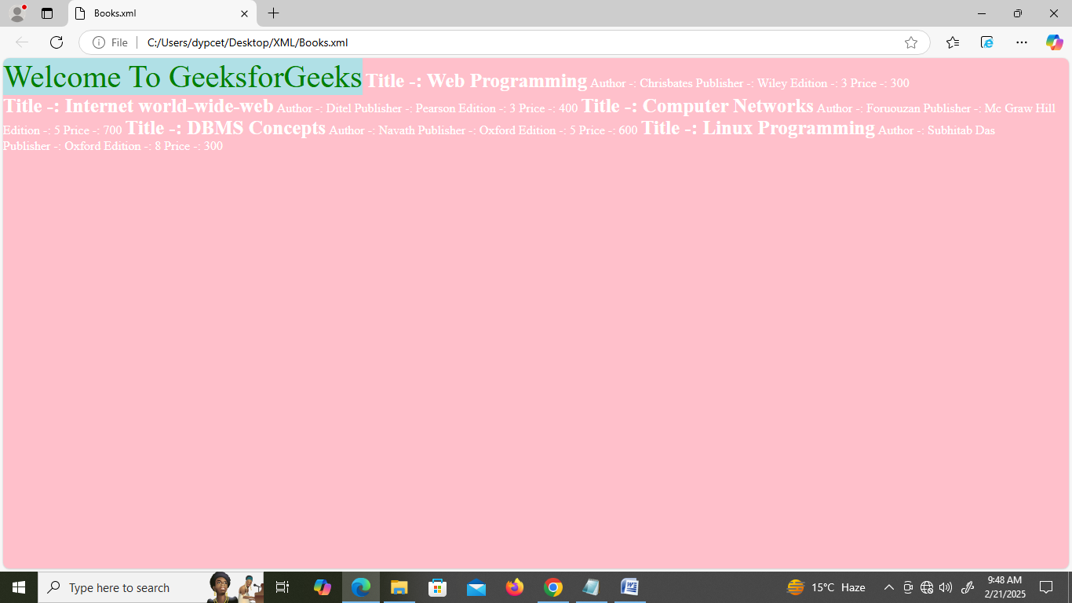

**Output2:**

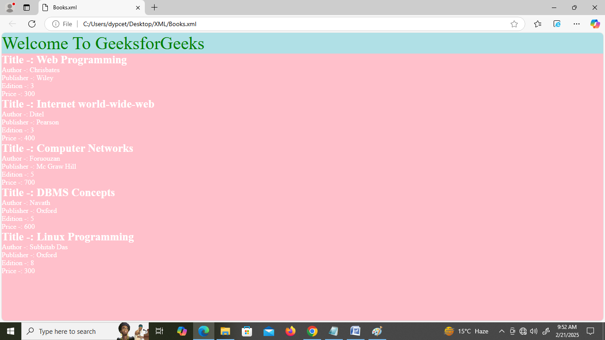

The display property specifies the display behavior (the type of rendering box) of an element.

**Link:-** [**https://www.w3schools.com/cssref/playdemo.php?filename=playcss_display**](https://www.w3schools.com/cssref/playdemo.php?filename=playcss_display)

|  |  |
| --- | --- |
| **Value** | **Description** |
| inline | Displays an element as an inline element (like <span>). Any height and width properties will have no effect. This is default. |
| block | Displays an element as a block element (like <p>). It starts on a new line, and takes up the whole width |
| contents | Makes the container disappear, making the child elements children of the element the next level up in the DOM |
| flex | Displays an element as a block-level flex container |
| grid | Displays an element as a block-level grid container |
| inline-block | Displays an element as an inline-level block container. The element itself is formatted as an inline element, but you can apply height and width values |
| inline-flex | Displays an element as an inline-level flex container |
| inline-grid | Displays an element as an inline-level grid container |
| inline-table | The element is displayed as an inline-level table |
| list-item | Let the element behave like a <li> element |
| run-in | Displays an element as either block or inline, depending on context |
| table | Let the element behave like a <table> element |
| table-caption | Let the element behave like a <caption> element |
| table-column-group | Let the element behave like a <colgroup> element |
| table-header-group | Let the element behave like a <thead> element |
| table-footer-group | Let the element behave like a <tfoot> element |
| table-row-group | Let the element behave like a <tbody> element |
| table-cell | Let the element behave like a <td> element |
| table-column | Let the element behave like a <col> element |
| table-row | Let the element behave like a <tr> element |
| none | The element is completely removed |
| initial | Sets this property to its default value. [Read about *initial*](https://www.w3schools.com/cssref/css_initial.php) |
| inherit | Inherits this property from its parent element. [Read about *inherit*](https://www.w3schools.com/cssref/css_inherit.php) |