In normal monitoring telemetry data will be in different places collected by using tools(logs, events, errors,….)

Instrumentation is required for anything(apps) we want to be visibility(performance)

More instrumentation more observability and more speed.

Newrelic is fully observability platform, anytype of data can be ingested from anywhere.

On this platform we can use any language and build app also for our observability

Tdp -> telemetric data platform, from tdp data will be ingested to newrelic

On top of tdp we have full stack observabilitry, newrelic apps. At tdp level we can query data

We can also build our own dashboards and we can integrate to any monitoring tools(Grafana) using plugins.

In newrelic , log in context(only specific logs related not all), serverless.

The way of treating data by newrelic is different from traditional monitoring tools like sumo-logic, splunk.

From traditional tools monitoring is log analysis perspective.

In newrelic correlation how your application performing and how your front end is performing, complete connected data from backend, logs, infrastructure and frontend, it will corelate every data, its is full stack observability( it will look from customer point of view)

In monitoring & observability

Logs (sequential, detailed events) -> logs are generated against events

Traces(casual chain of events) -> looking into specific event and how that event traversed the system

Metrics(aggregated events) ->roll-up of series of events over a period of time

Events (pillar of all above three)

Individual telemetry that happens about specific occurrence of activity

Monitoring:  
-----------

Four golden signals method:)(RED+S)

* Latency – transaction response time
* Traffic(throughput) – number of requests
* Errors
* Saturation – resources at 100%

Telemetry data is a performance real rime data for trouble shooting not for archiving or storage, used for analyzing feature

Newrelic apps

Apps -> account maturity( tells about to what extend we are using that it provides)

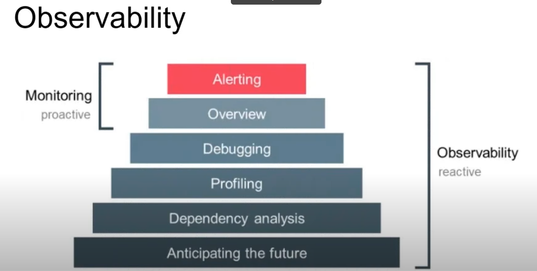

Observability means assembling all fragments from logs, monitoring tools and organize them in such a way which give actionable knowledge on the whole environment, thus creating an insight

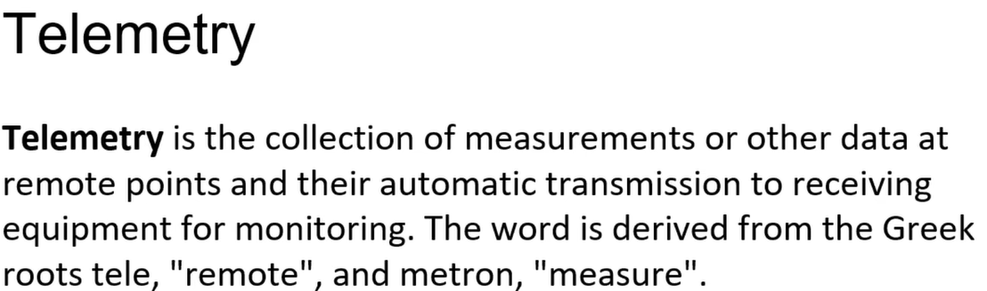

Four essential elements of telemetry are MELT

M->Metrics, E->events, L->logs & T->traces

Observability = logging + monitoring + tracing + visualization.

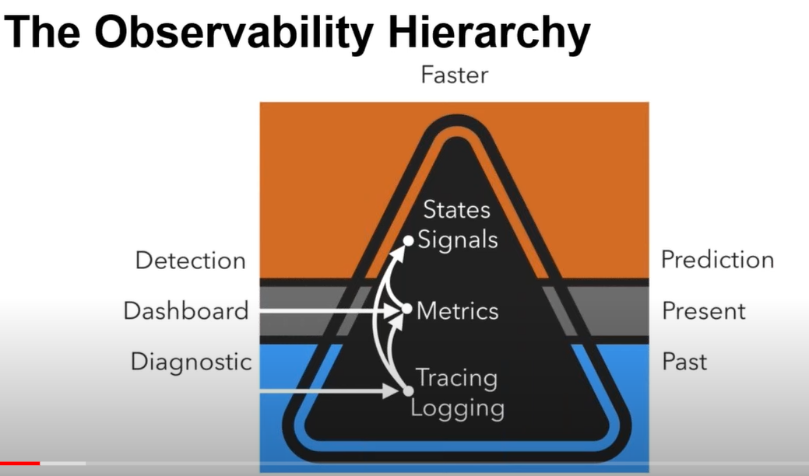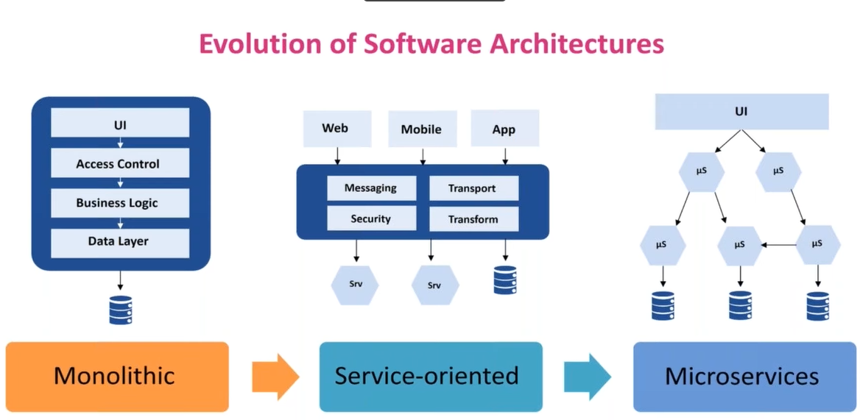

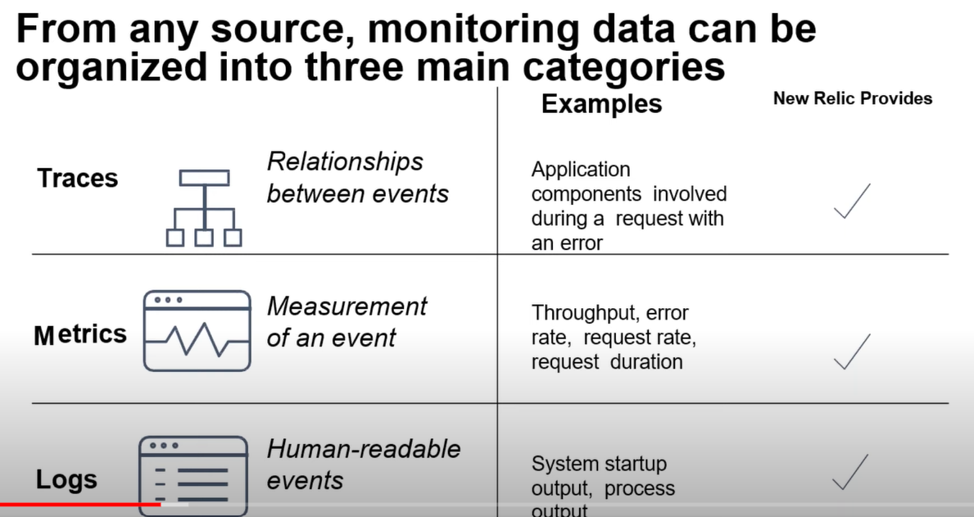

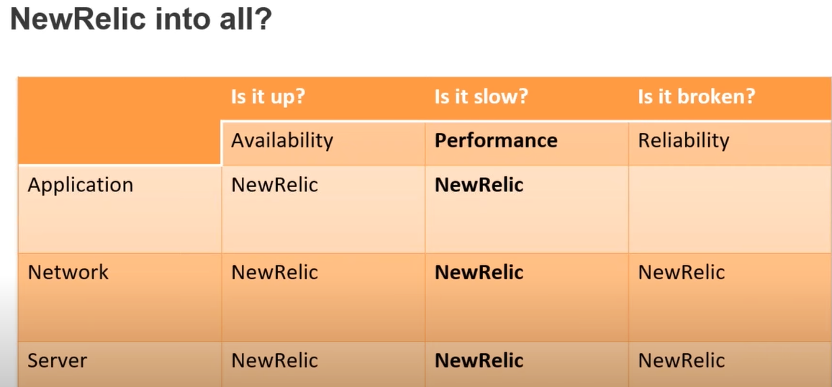

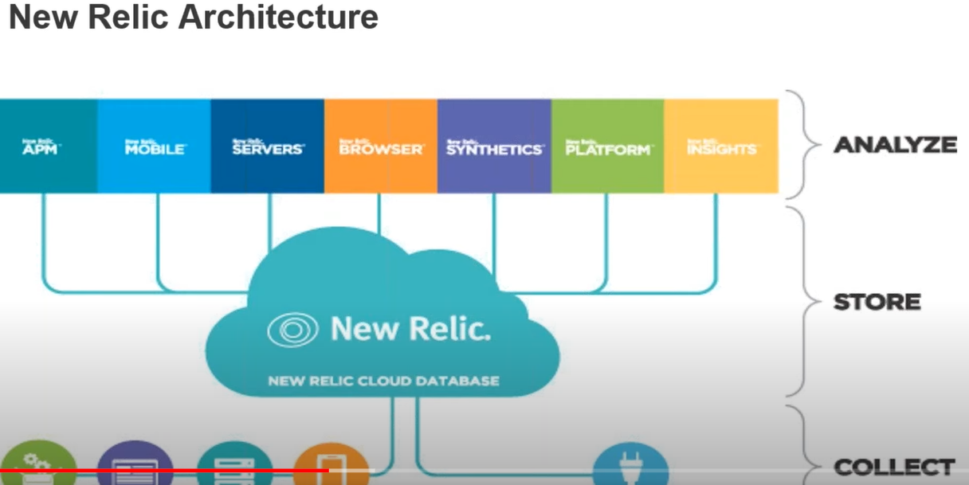

Newrelic manage complex systems 🡪logs, metrics and traces, applied intelligence, serverless

Ease of setup:;  
===========

* Enroll for newrelic 30 day trail
* Download appropriate sdks
* Configure sdks in startup script of app
* Data comes in minutes
* Ches/puppet/ansible package configuration management allows you to scale NR.

Infra agent:

Register -> install new relic infra agent on your m/c -> visualize metrics on newrelic cloud

After installing new relic infra agent on your system, its configurations are located at path:  
**/etc/newrelic-infra 🡪** integration.d, logging.d

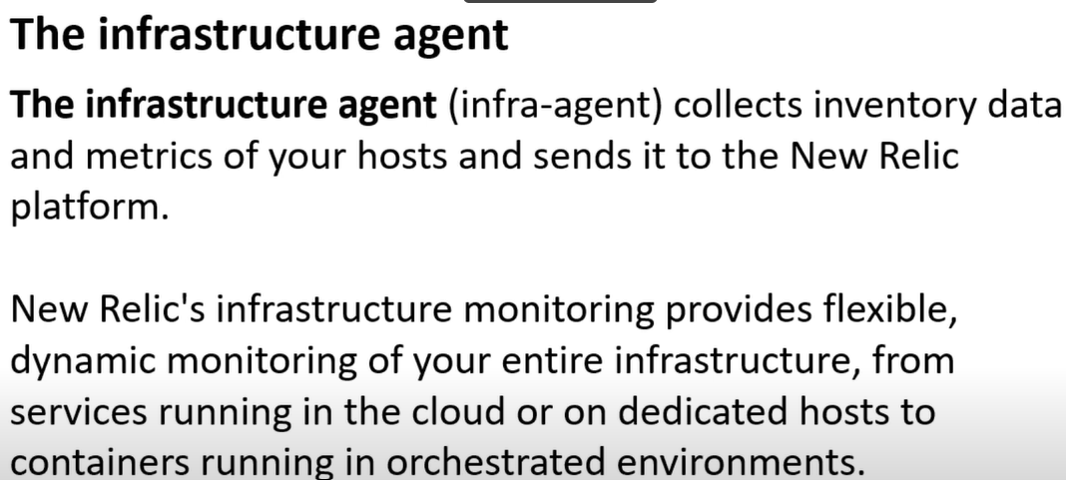

Newrelic infra configuration file is present at location

/etc/newrelic-infra.yml

Any behaviour of newrelic infra can be changes using newrelic-infra.yml file

/usr/bin/newrelic-infra 🡪 here default behaviour is defined

All details about parameters for newrelic-infra.yml will be present in

[infrastructure-agent/newrelic-infra-template.yml.example at master · newrelic/infrastructure-agent (github.com)](https://github.com/newrelic/infrastructure-agent/blob/master/assets/examples/infrastructure/newrelic-infra-template.yml.example)

when you start newrelic-infra agent 3 utlities will start

* newrelic-infra -> intefrations present in /etc/newrelic-infra/.
* newrelic-infra-service
* newrelic-ctl 🡪 for us to control

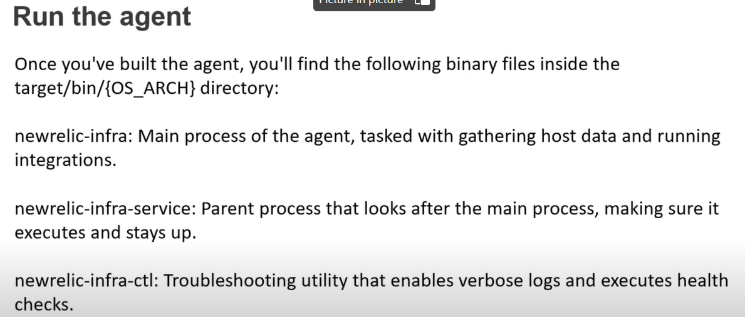

All above 3 utilities present in location “/usr/bin/”

# ls new*

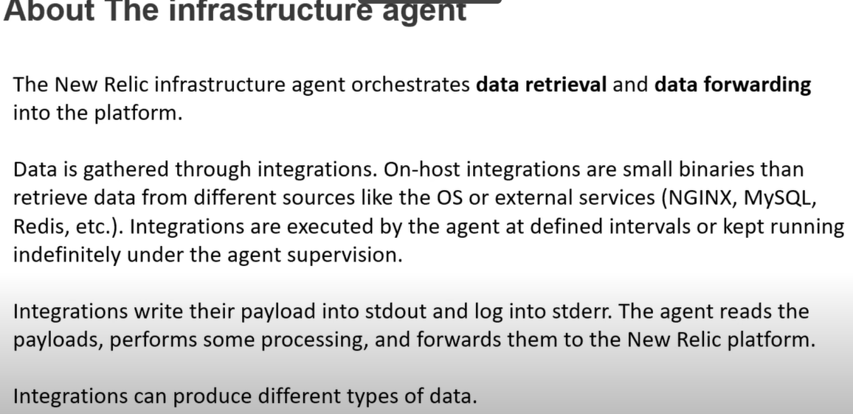

Types of integration data

* Cloud integrations -> aws, azure,acp
* On host integratrions ->mysql,nginx,kiubernetes..

How newrelic works?

3 different runtime steps

1. Startup
2. Main runtime
3. Shutdown

Newrelic configuration file is newrelic-infra.yml

This configurations can be called by using environment variables, arguments during run time

**StatsD integration** with http_server _enabled open an http port (by default 8001)for receiving data

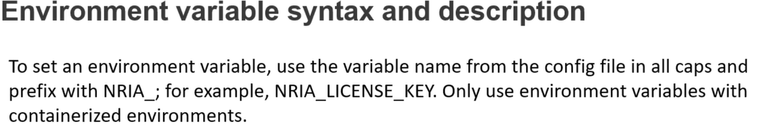

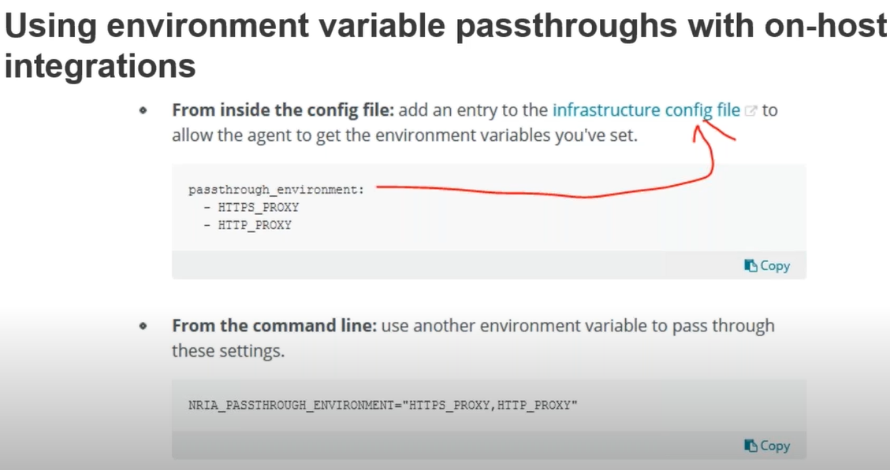

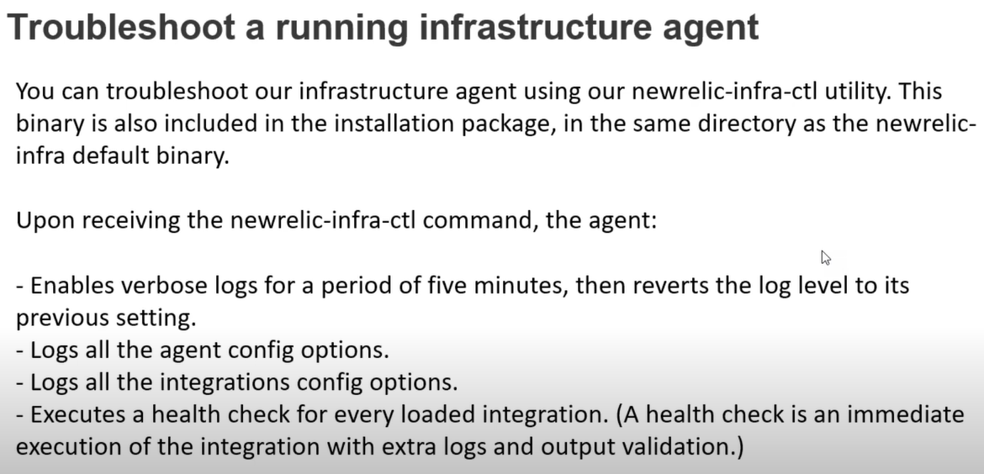

If you want to integrate docker to newrelic agent, then below path need to add docker-config.yml  
 /etc/newrelic-infra/integrations.d

Suppose if the file has extension .sample.yml means then that is not active, to make it active make that file with extension .yml

Installing integration for services in newrelic:  
======================================

Step1: Install and enable service

Step2: Enable service metrics

Step3: Enable newrelic to gather metrics

Restart service

Integrating httpd service to newrelic

Step 1 – Install , Enable and Start HTTPD service

$ sudo yum install httpd

$ sudo systemctl enable httpd

$ sudo systemctl start httpd

## Step 2 – Enable mod_status to Monitor Apache Web Server Load and Page Statistics

# $ sudo vi /etc/httpd/conf/httpd.conf

DocumentRoot "/var/www/html"

LoadModule status_module modules/mod_status.so

<Location /server-status>

SetHandler server-status

Order deny,allow

Deny from all

Allow from all

Allow from 172.31.0.16

</Location>

ExtendedStatus On

# Verify Syntax changes in httpd.conf and Restart HTTPD services

$ httpd -t

$ sudo systemctl restart httpd

Step 3 – Verify The Apache status page will be accessible via your domain name with “/server-status” at the following URL’s.

curl http://localhost/server-status  
curl http://localhost/server-status/?refresh=5

<http://65.0.100.226/server-status/?refresh=5>

To check endpoint in UI level

http://<ip-addr>/server-status

## Step 4 – Install the infrastructure agent

## Step 5 – nri-apache must be installed for Apache integration and change apache-config.yml configuration file as mentioned below;

# How to install nri-apache Apache integration in Linux Host?

$ sudo yum -q makecache -y --disablerepo='*' --enablerepo='newrelic-infra'

$ sudo yum install nri-apache

$ sudo systemctl restart newrelic-infra

# Change directory to the integration's folder:

cd /etc/newrelic-infra/integrations.d

# Copy of the sample configuration file:

sudo cp apache-config.yml.sample apache-config.yml