|  |  |
| --- | --- |
| **Topics**  1)Linux  2)Git & GitHub  3)Jenkins, Gitlab, bamboo, circleci  4)Ansible, chef, puffet  5) Terraform (IAC), CloudFormation (Aws), Templates (Azure)  6)Docker  7)Kubernetes  8)Nexus  9)Bash Scripting  10) Maven, Gradle, npm  11)NewRelic  12)Sql  13)Httpd & Tomcat  14)OpenShift  15)Helm charts  16)Elk  17)API/WEB  18)Java  19)Groovy  20)Python  21)Node Js  22)Clouds 🡪 AWS, Azure | **Timings**  1)9 – 11:30 🡪  2)12 – 9  [ 3 – 5 or 7 to 9]  3)9:30 – 11:30 🡪 DMP  ---------------------------------------   1. Maven, Gradle, npm 🡪 8 2. NewRelic 3. ELK 🡪 25 4. Sql 5. Httpd/Tomcat -- 30/12 6. Nexus |

**Devopsmasterprogram [DMP] -75-Days**

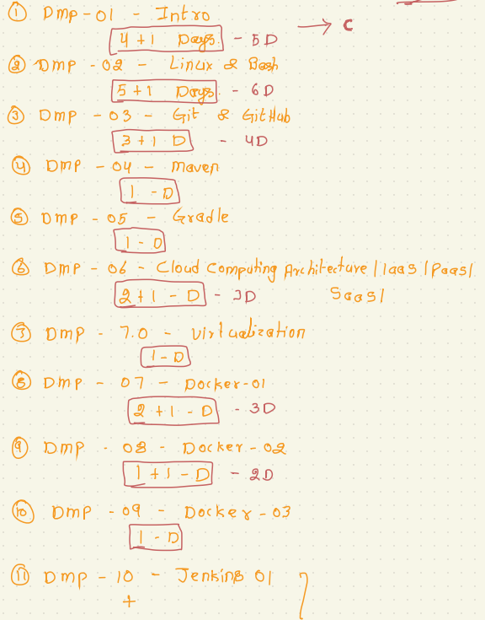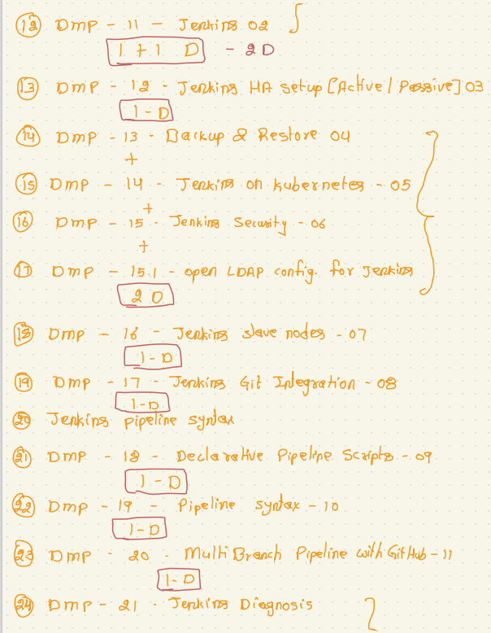

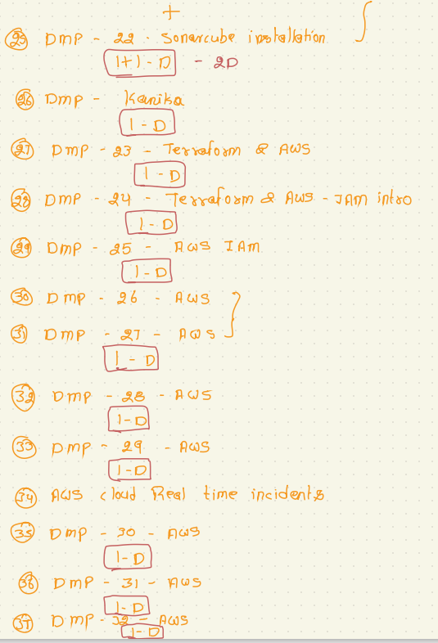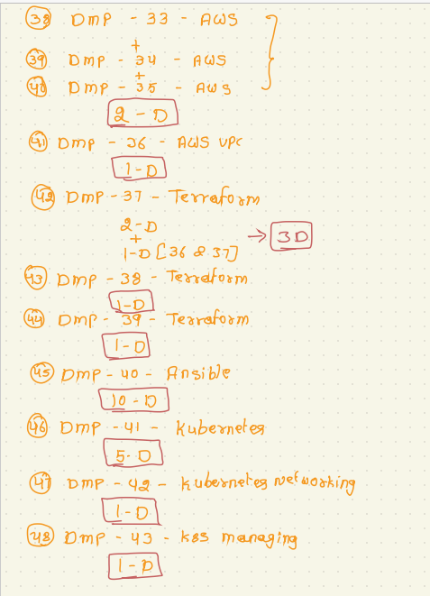

|  |  |  |  |  |  |  |
| --- | --- | --- | --- | --- | --- | --- |
|  |  |  |  |  |  |  |

|  |  |  |  |  |  |  |  |  |  |  |  |  |
| --- | --- | --- | --- | --- | --- | --- | --- | --- | --- | --- | --- | --- |
| OCTOBER-22 | | | | | | | | | | | | |
| Sun |  | Mon |  | Tue |  | Wed |  | Thu |  | Fri |  | Sat | |
|  |  |  |  |  |  |  |  |  |  |  |  | 1 | |
|  |  |  |  |  |  |  |  |  |  |  |  |  | |
| 2 |  | 3 |  | 4 |  | 5 |  | 6 |  | 7 |  | 8 | |
|  |  |  |  |  |  |  |  |  |  |  |  |  | |
| 9 |  | 10 |  | 11 |  | 12 |  | 13 |  | 14 |  | 15 | |
|  |  |  |  |  |  |  |  |  |  |  |  |  | |
| 16 |  | 17 |  | 18 |  | 19 |  | 20 |  | 21 |  | 22 | |
|  |  |  |  |  |  |  |  |  |  |  |  |  | |
| 23 |  | 24 |  | 25 |  | 26 |  | 27 |  | 28 |  | 29 | |
|  |  |  |  |  |  |  |  |  |  |  |  |  | |
| 30 |  | 31 |  |  |  |  |  |  |  |  |  |  | |

|  |  |  |  |  |  |  |  |  |  |  |  |  |
| --- | --- | --- | --- | --- | --- | --- | --- | --- | --- | --- | --- | --- |
| NOVEMBER-22 | | | | | | | | | | | | |
| Sun |  | Mon |  | Tue |  | Wed |  | Thu |  | Fri |  | Sat | |
|  |  |  |  | 1 |  | 2 |  | 3 |  | 4 |  | 5 | |
|  |  |  |  |  |  |  |  |  |  |  |  |  | |
| 6 |  | 7 |  | 8 |  | 9 |  | 10 |  | 11 |  | 12 | |
|  |  |  |  |  |  |  |  |  |  |  |  |  | |
| 13 |  | 14 |  | 15 |  | 16 |  | 17 |  | 18 |  | 19 | |
|  |  |  |  |  |  |  |  |  |  |  |  |  | |
| 20 |  | 21 |  | 22 |  | 23 |  | 24 |  | 25 |  | 26 | |
|  |  |  |  |  |  |  |  |  |  |  |  |  | |
| 27 |  | 28 |  | 29 |  | 30 |  |  |  |  |  |  | |
|  |  |  |  |  |  |  |  |  |  |  |  |  | |
|  |  |  |  |  |  |  |  |  |  |  |  |  | |

|  |  |  |  |  |  |  |  |  |  |  |  |  |
| --- | --- | --- | --- | --- | --- | --- | --- | --- | --- | --- | --- | --- |
| December-22 | | | | | | | | | | | | |
| Sun |  | Mon |  | Tue |  | Wed |  | Thu |  | Fri |  | Sat | |
|  |  |  |  |  |  |  |  | 1 |  | 2 |  | 3 | |
|  |  |  |  |  |  |  |  |  |  |  |  |  | |
| 4 |  | 5 |  | 6 |  | 7 |  | 8 |  | 9 |  | 10 | |
|  |  |  |  |  |  |  |  |  |  |  |  |  | |
| 11 |  | 12 |  | 13 |  | 14 |  | 15 |  | 16 |  | 17 | |
|  |  |  |  |  |  |  |  |  |  |  |  |  | |
| 18 |  | 19 |  | 20 |  | 21 |  | 22 |  | 23 |  | 24 | |
|  |  |  |  |  |  |  |  |  |  |  |  |  | |
| 25 |  | 26 |  | 27 |  | 28 |  | 29 |  | 30 |  | 31 | |
|  |  |  |  |  |  |  |  |  |  |  |  |  | |
|  |  |  |  |  |  |  |  |  |  |  |  |  | |