General Knowledge for IFS/IFoS

In this article, we will explore how candidates are expected to prepare General Knowledge Paper of Indian Forest Service.

**General Knowledge in IFoS Exam is not General Studies**, so you need to have an idea of a lot of topics. A fair amount of Depth in the topic would do the trick. Those preparing for civil services need not to prepare anything extra as they have already prepared for 4 grand papers of mains stage. But those people preparing solely for this exam should try to understand the syllabus first and then start their preparations.

Syllabus includes-General Knowledge including**knowledge of current events** and **of such matters of everyday observation and experience in their scientific aspects** as may be expected of an educated person who has not made a special study of any scientific subject. The paper will also include questions on**Indian Polity** including the political system and the Constitution of India,**History of India and Geography** of nature which the candidate should be able to answer without any special preparation,i.e. he/she should be aware about his surroundings and society.

Along with this syllabus, what I have observed is **that knowledge of Indian Economy is also required as it is part of current events.** Previously In this exam more focus was on Geography portion, but this time paper was very much balanced.

**Also, most of the candidates don’t prepare ancient and medieval India, but it would be a good boost to your score if you can read them from any of NCERT’s or Standard sources.**

**All these topics can be covered from the following sources, I have attached  2014 and 2015 questions also for ready reference.**

**1. History-Culture any one of the following combos**

1. Tamilnadu Class 11-12 history books +Spectrum
2. Old NCERT + Spectrum
3. General Studies Manual

Questions in GK, History are generally related to administrative setup or reforms of a particular king or era. Buddhism and Jainism or cultural aspect is also a repetitive part.

**2014 Questions**

1. How did Buddhism influence Ashoka in decision making and governance?
2. Discuss the efforts and strategy of Akbar towards social harmony.
3. Describe the salient features of Chola art.
4. Assess the importance of Champaran Satyagraha

**2015 Questions**

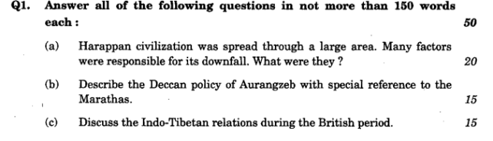

**2. Geography / Environment:**

1. For Theory: (NIOS + NCERTs)
2. For Current: newspapers.

Geography has also become current oriented and climate change is thrust area, Do basics well and follow newspapers for current changes in geographical landscape. Focus should be on **Environment, Wildlife and climate change.**

**2014 Questions**

1. What do you understand by Environmental Impact Assessment and Social Impact Assessment?
2. Discuss the causes of the recent devastating floods in Jammu and Kashmir. How do they compare with those of Uttarakhand disaster last year?
3. What do you understand by soil erosion Discuss its causes.
4. What are wet-lands? Discuss their importance.

**2015 Questions**

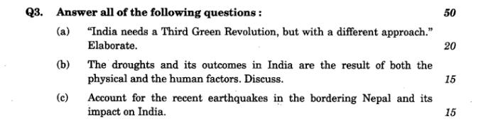

**3. Polity:**

1. Laxmikanth for theory + Hindu / Indian express for current affair/PRS legislative

No extra preparation is needed, If you have prepared this topic well for prelims, just practice last year questions. **Parliament, basic structure, Fundamental rights, Budget and Emergency provisions are important topics.**

**2014 Questions:**

1. How is the federal, structure of the Indian Constitution ensured?
2. Explain the Right of Constitutional Remedies given in the Indian Constitution.
3. How is a Money Bill different than a Financial Bill?
4. What do you understand by `minimum government and maximum governance’?

**2015 questions:**

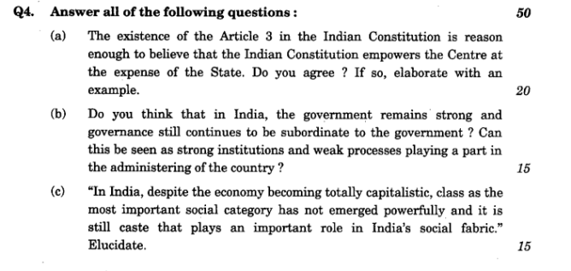

**4. Economy**

Budget, Survey, Schemes: Mrunal.org/economy, original survey and budget documents, forumias’s current updates. Focus here should be on the current economy and general awareness about current issues can do the trick. **ForumIAS 9PM brief updates can be really helpful here**, Chronicle weekly booklets can also help.

**2014 Questions**

1. Discuss the objectives of Prime Minister’s Jan-Dhan Yojana. What challenges do you foresee in its implementation?
2. What are the reasons for the persistent high rate of food inflation in India?
3. Explain demographic dividend and its relevance to India.
4. Discuss the recommendations of Rangarajan Panel on the estimates of poverty in India.

**2015 Questions**

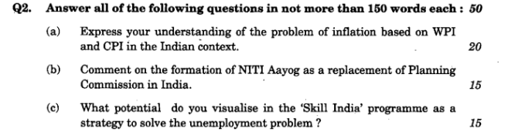

**5. IR/Diplomacy:**

1. For Theory: NIOS Political science or IGNOU PDFs.
2. For Current: Newspaper + Mrunal.org/diplomacy + ForumIas/Civil Services times.

Here also Questions are current affairs oriented, So above referred sources can do the help to cover these topics comprehensively.

**2014 Questions**

1. Comment on Israel-Palestinian conflict.
2. Write a note on Indo-Japanese collaboration.
3. Discuss the role of UNHRC in Indian perspective.
4. What are the objectives of the European Union?

**2015 Questions**

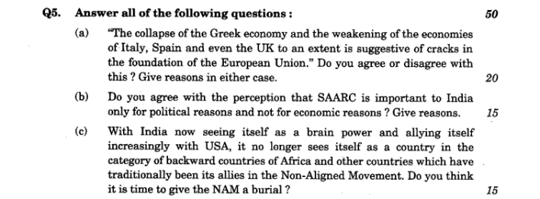

**6. Science-Tech: Theory/contemporary:**

Selected google search e.g. Nanotech, cryo-tech + current from newspapers.Here also questions in Science and tech are current affairs oriented so, ForumIAS 9 PM Updates can help if you are lazy in reading newspapers.

**2014 Questions**

1. Comment on ‘Digital India Programme’.
2. How is Indian mission of Mars different than that of other countries in recent times?
3. What do you understand by Nano technology? How is it critical in context with food industry?
4. How is Cryogenics different from Cryonics?

**2015 Questions**

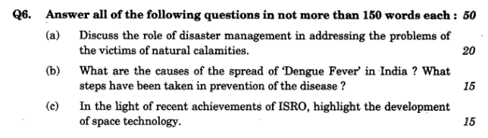

1. Self-Notes making and revision is essential (although I missed both).**Otherwise, it is hard to recall the points in the exam**( reflected in my scores ). Then even in easy questions like Champaran & Chola-art, you’ll end up writing average quality answers.
2. Newspaper means Hindu / Indian Express ONLY. Don’t need both. Anyone would suffice for IfoS.

*This guide has been co-authored by ForumIAS Editorial Team and Vipul Pandey IFoS (2015) Rank 49.*