Financial Markets Analyzer and Predictor

Software Requirement Specification

Prepared by-  
Rohan Yogi  
Sameer Kolpekwar  
Shreyas Dhoot  
Shantanu Trivikram

College of Engineering, Pune-05

17th October 2017

# Introduction

## Purpose

This Software Requirement Specification is written for the '**Financial Markets Analyzer and Predictor.'** It is a stand-alone product. The document is written for the purpose of helping the users and audience understand the document better.Hereafter, the document would also refer to the software as '**FMAP**.'

## Document Conventions

The SRS follows standard conventions as per industry standards. Necessary clarifications are made wherever necessary to help the reader understand any aspect of the product.

## Intended Audience and Reading Suggestions

The SRS is meant for all types of people and computer enthusiasts who want a deeper insight into the product and understand the idea that went behind creating the product. Despite our best efforts to keep it as simple as possible, the reader is expected to be familiar with basic concepts and terminologies used in financial markets and software industry to understand the document better.

## Product Scope

The FMAP, or Financial Market Analyzer and Predictor is being created as part of the Third-Year undergraduate project. The financial markets are one of the most volatile and unpredictable set of events. As such, any effort to try to understand them better and get an insight on how they function can prove beneficial to people involved in the financial sector. However, the product is being developed as an educational initiative and not as a business product. Hence, the emphasis is not on the accuracy of the product, but using existing and developing technologies in the world to create such a product. While we want to do real-time analysis, due to our emphasis on the educational aspect, we will be majorly working with historic data to track and update our methods and product.

# Overall Description

## Product Perspective

The FMAP is based on the idea of using mathematics, computing and artificial intelligence (machine learning) to create a meaningful product. While there are many applications of these existing technologies, nothing seems exciting than the world of financial markets. While humans are unable to compute the direction market takes, the FMAP tries to improve on methods devised by humans and make better analysis and in some cases predictions regarding what directions investors should be taken. However, we would again like to emphasize that the product is being developed from an educational standpoint.

## Product Functions

* Provide users with an easy to use interface to use the product
* Allow users to choose specific financial market and its corresponding stocks, options
* Look at the historic data of a specific market or stock and allow the product to predict its movement in the given time frame
* Compare the real-life movement, the prediction of the FMAP and provide analysis on its basis

## User Classes and Characteristics

We expect the primary users of product to be the people interested in the technologies we will be using to see what we have done with them. Since being a product from academic origins, we expect the percentage of users being actual bankers, or investors to be very less.

## Operating Environment

The product would be a software that would run a UNIX system, primarily Ubuntu Operating System.

## Design and Implementation Constraints

Being an educational product, there will be no restriction on its use. We will be trying to use open source components which users will be free to modify or use.

## Assumptions and Dependencies

With the pace with which new components are developed, it would be difficult to pick the exact products FMAP will require but it would primarily need Python, R libraries. We will be using open source libraries and frameworks to implement the machine learning algorithms. For showing the results of our ML algorithms, we will primarily use Python and R. R would be used to work with statistics and display graphs. Any additional components or libraries would be installed or mentioned along with the product.

# External Interface Requirements

## User Interfaces

The user interface is quite simple and intuitive. The template followed would be of the admin dashboard with menus on the left and the graphs, data and all the necessary dropdown menus and tools in the remaining space.

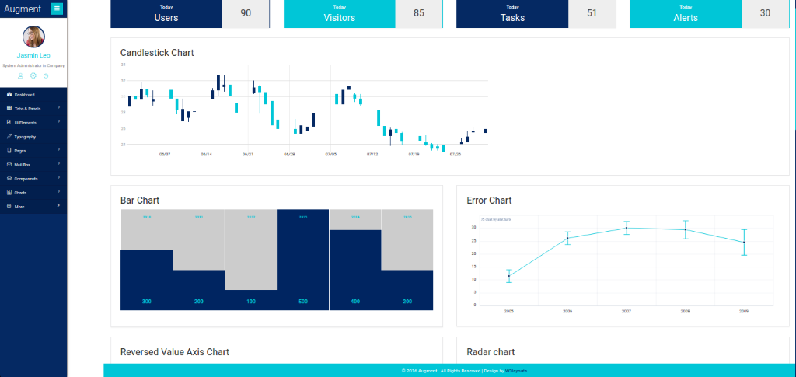

The image gives a rough idea as to what the interface would look like.

## Hardware Interfaces

Since the product works on a standard computer, it would use all the normal hardware interactions available to the software on any computer. While most of the data would be with the product itself, it may require internet communication for some functionality.

RAM : 6 GB

Storage

Client – 20 MB of disk space

Server – 150 MB of disk space

## Software Interfaces

The software does not require any data from other components installed on the computer or from the operating system. It operates independently on the data it has been provided with.

## Communications Interfaces

FMAP would require a latency of less than 100ms.

The product would require normal internet protocols to communicate and may use HTTP connections to send and receive data.

# System Features

## Predict Future Movement

### Description and Priority

This feature would try to predict the future movement of any stock or market user selects along with the timeframe he/she provides.

### Stimulus/Response Sequences

The system would take the input and produce a graph or chart to visually depict its analysis and predictions. The graphs would be produced on the basis of machine learning algorithms and data science methods used to work on the data.

### Functional Requirements

Since this is a stand-alone product, the only requirement is to have the product itself. Also the user should have a good internet connection to communicate with the server.

## Accuracy Tracker

### Description and Priority

The feature would allow the user to see the performance of the FMAP against the real-life movement of the stock. It would also rate its performance and show the user the accuracy it achieved.

### Stimulus/Response Sequences

The product would trigger this feature on the users' discretion and produce a pop-up with accuracy and produce charts with complementing aspects – the real movement and the predicted movement.

### Functional Requirements

Since this is a stand-alone product, the only requirement is to have the product itself.

# Other Nonfunctional Requirements

## Safety Requirements

The product produces nothing to indict the user with illegal activity.

## Security Requirements

The data received from the server should be encrypted to prevent the mishandling, corrupting of data which in hindsight would give inaccurate results.

Since the product works with freely available data, there is nothing confidential the user must submit or provide the product.