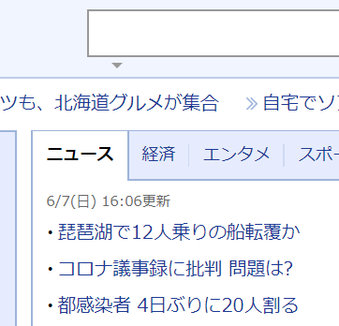

図1: yahoo_fig

表1: table

|  |  |  |
| --- | --- | --- |
|  |  |  |
|  |  |  |
|  |  |  |



図2:



図3: