# Installed Docker and Docker compose:

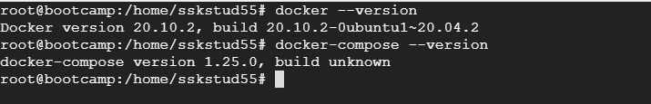

**Creating Dockerfile:**



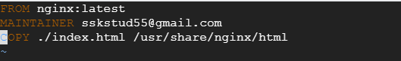

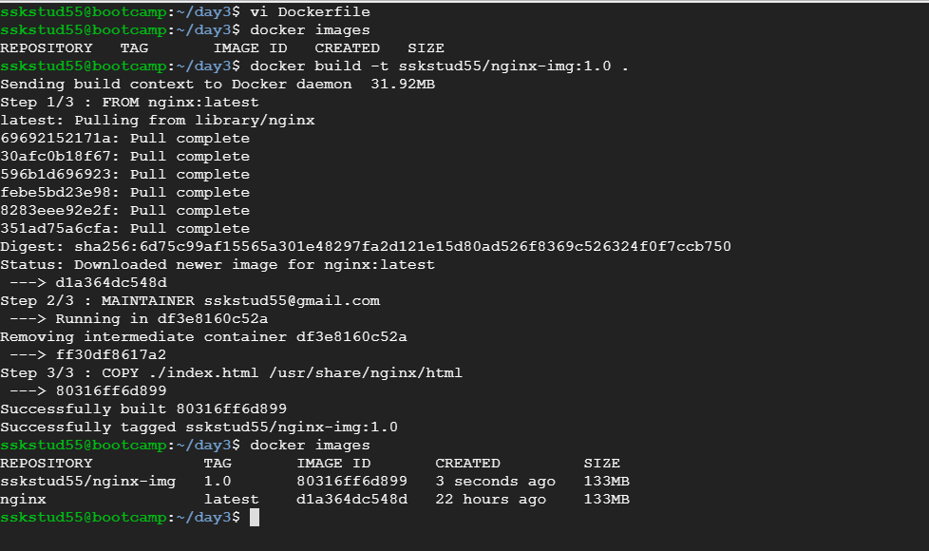

**Run nginx container:**





**Push docker image to docker Docker Hub:**

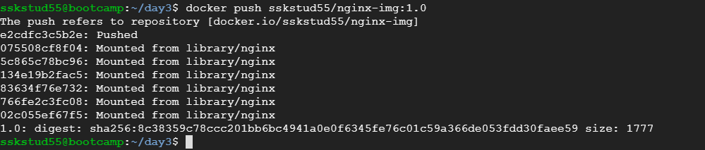

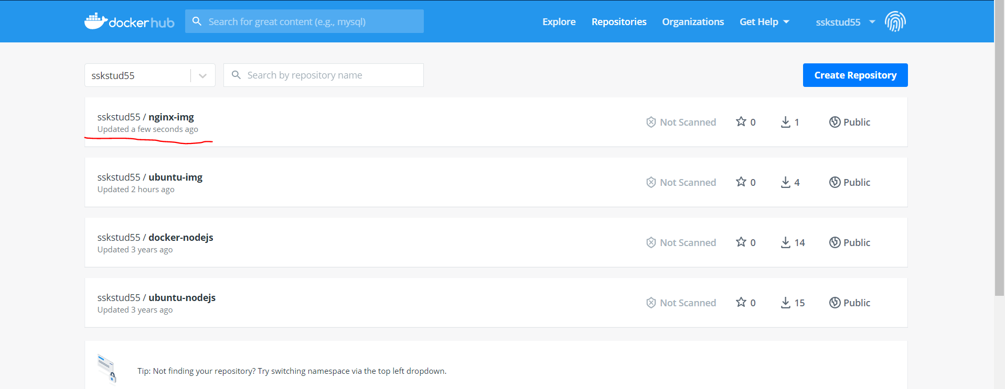

**Pull and Run the docker container in remote machine:**

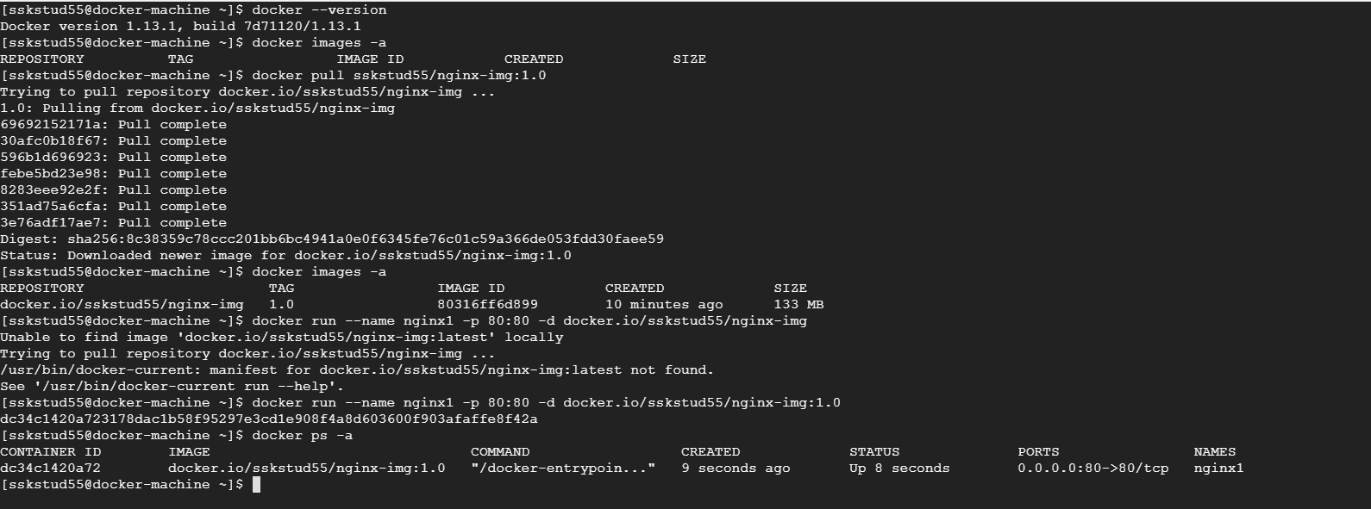



# Docker-Compose:

**docker-compose.yml to run application in provided git repo:**

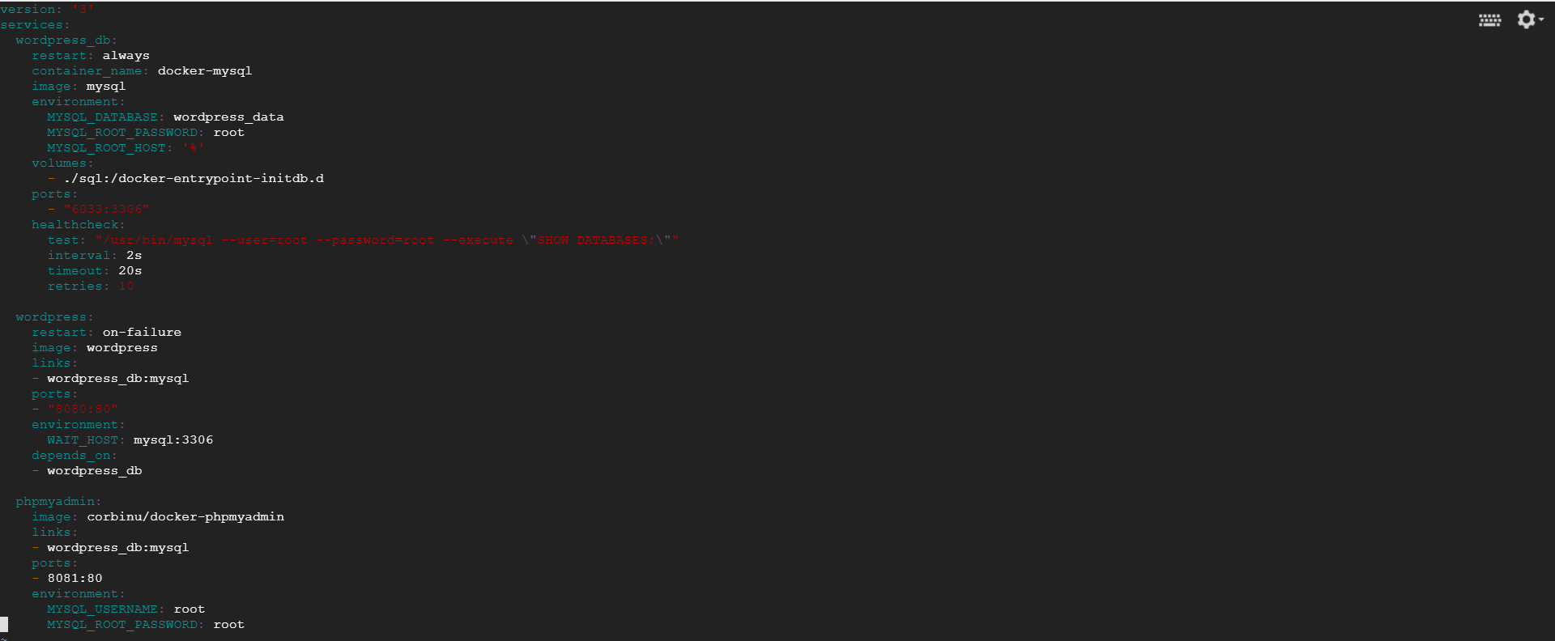

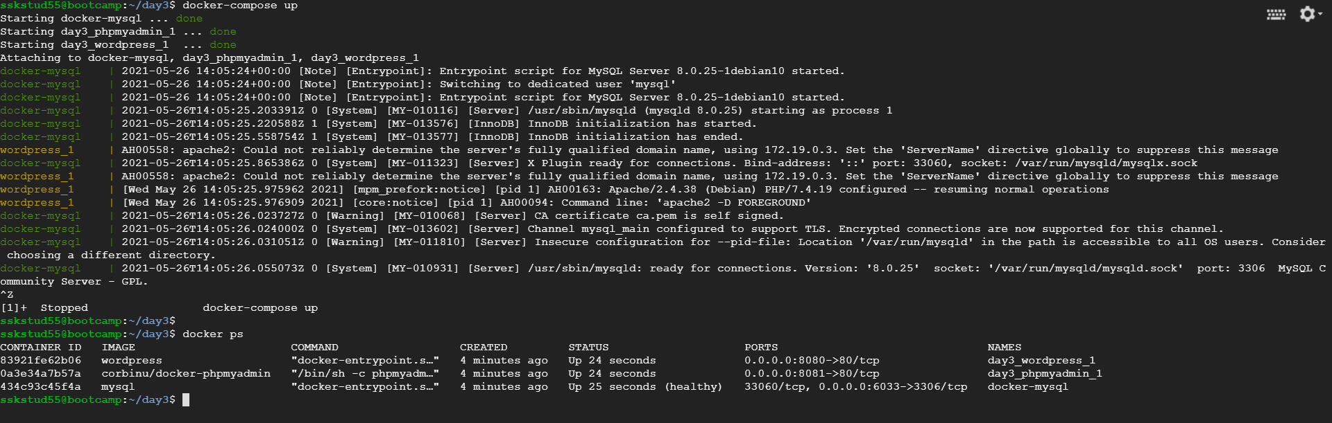

**Applications running:**

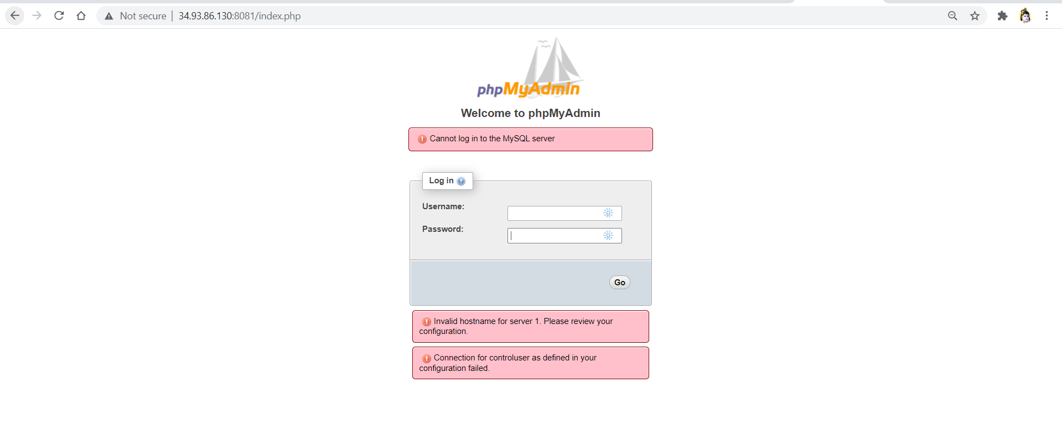

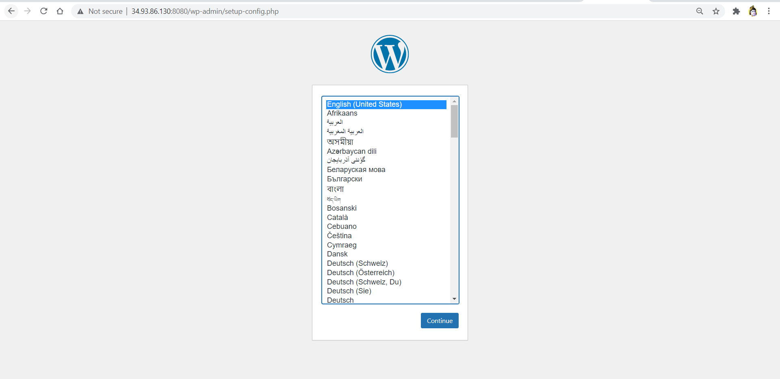

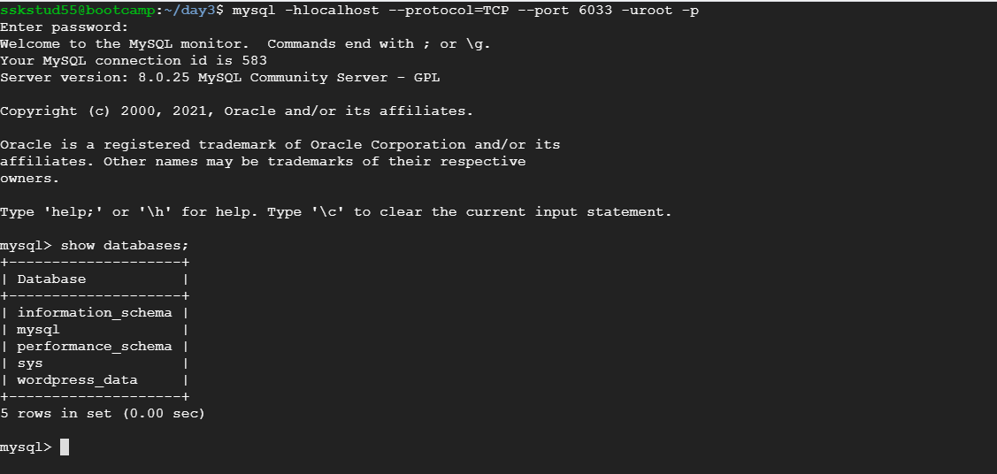

**Connect mysql using -it:**

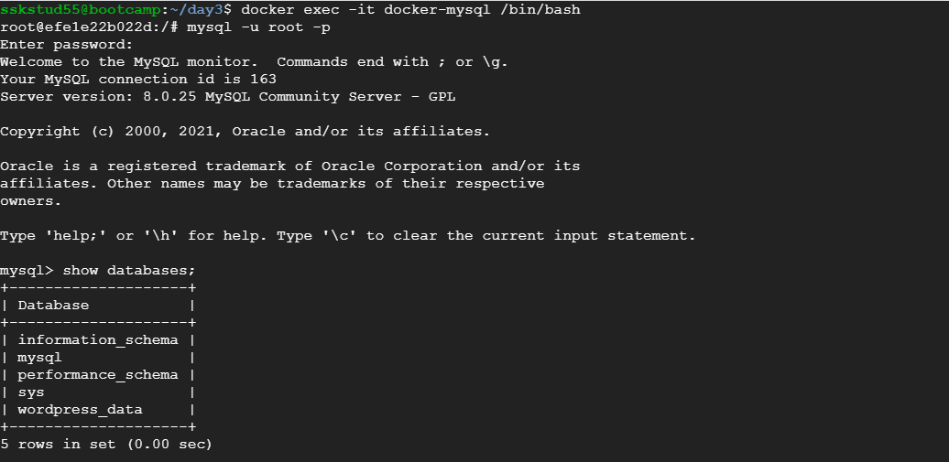

**Create test table:**

