Created Master and Slave nodes:



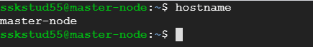

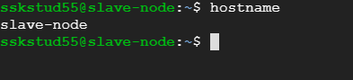

Passwordless authentication enabled from Master to slave node using ssh-keygen in GCP:

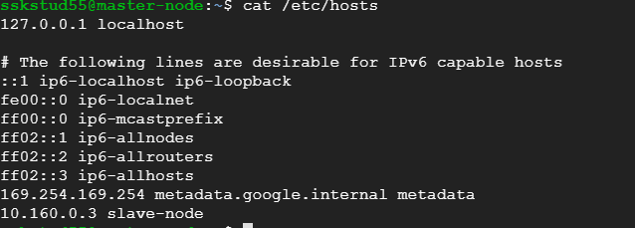

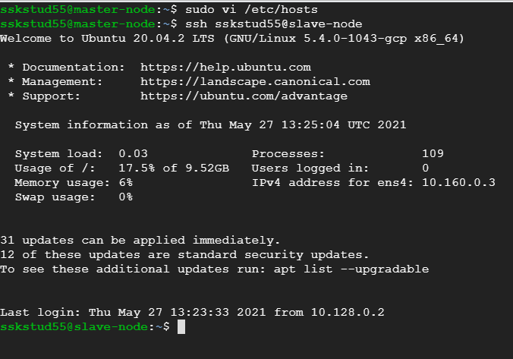

Installing Ansible:

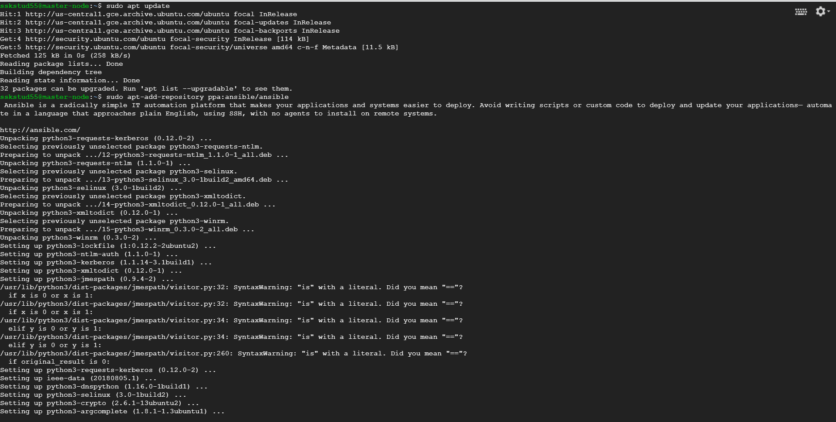

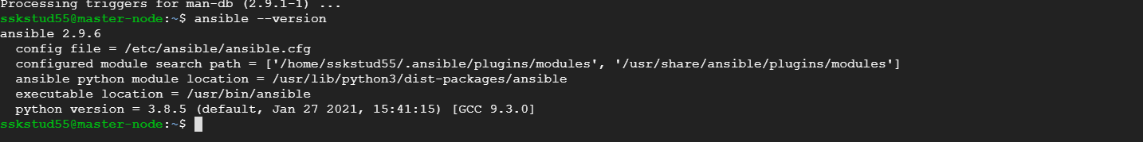

Slave node added into ansible host file:

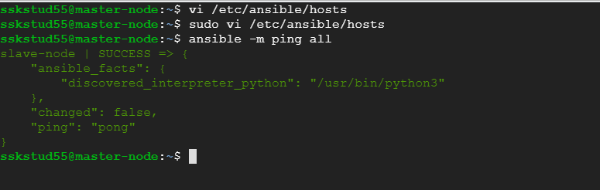

Write playbook to install Java, Maven, nginx and Docker:



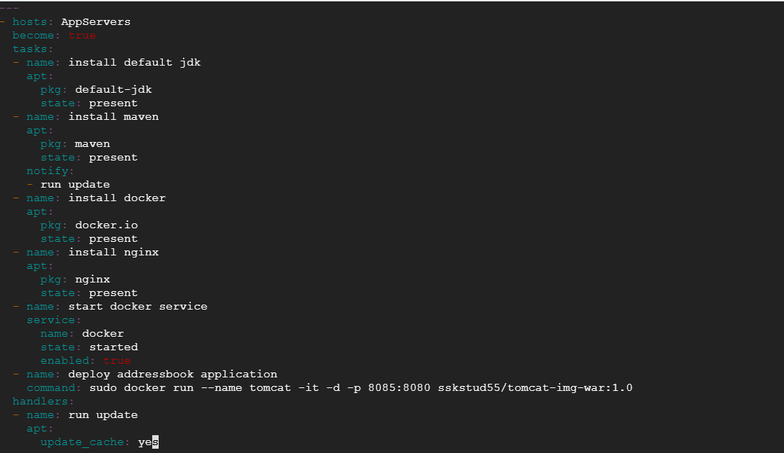

Configure playbook to deploy address book application in docker container:

1. Pushed a docker image into docker hub after deploying the address book application

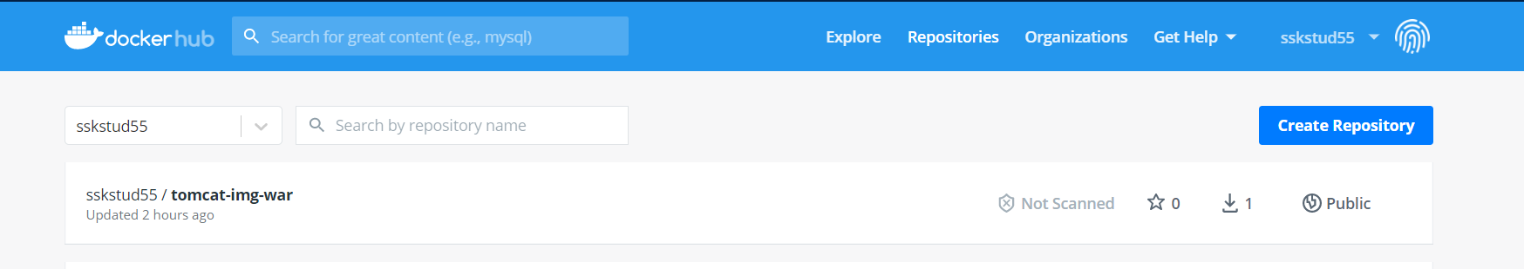

1. Added the image into ansible playbook to run

Running ansible playbook to perform actions in Slave:

1. Failed for one task due to spelling mistake  
   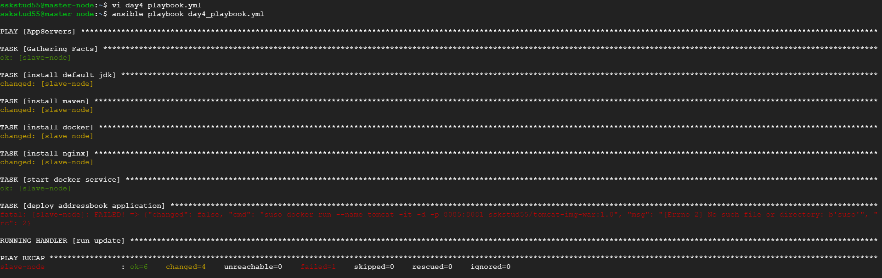
2. Fixed the spell issue and completed the activity  
   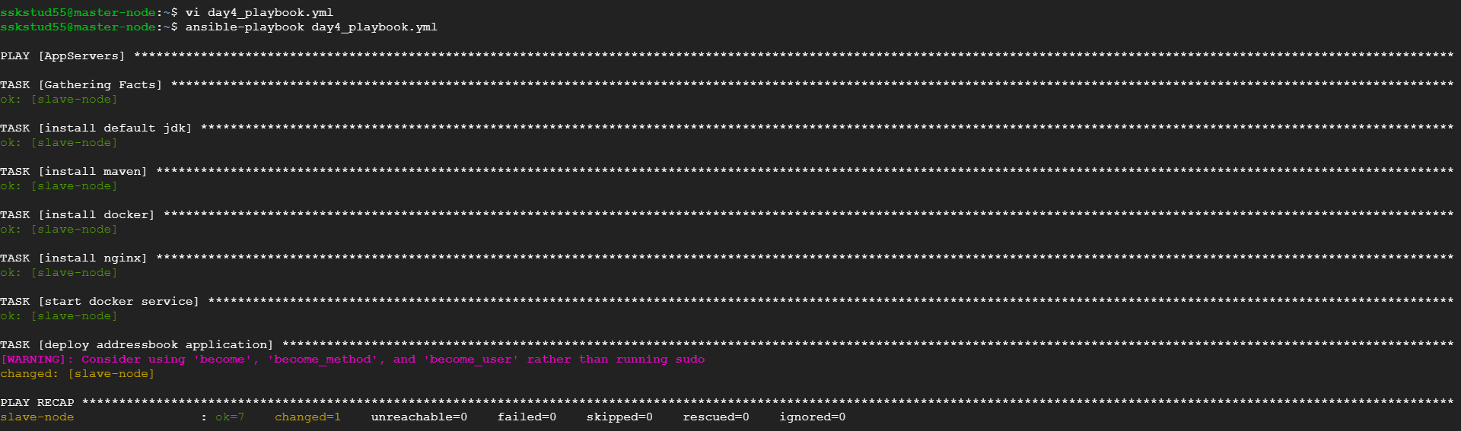

Verification in Slave node:

