**Assignment 1**

Login Credentials  
  
**To be logged in as a supervisor and see the supervisor menu:**  
Username: supervisor Password: supervisor

**To be logged in as regular employee and NOT see supervisor menu:**   
Username: employee Password: employee  
   
Statement of Requirements  
Our solution provides a user-friendly timesheet entry application with a login system to prevent unauthorized users. A supervisor level user will be able to manage the users that can access and edit the timesheets. In order to access any of this functionality, the user will be required to login with correct credentials. Users will be able to create their own timesheets with activities performed during the week. They will be able to view timesheets previously entered as well as edit a timesheet for the current week.  
  
Test PlanOur test plan is basically to make sure all the buttons do what they are intended to do for each of the pages we will be designing. This includes testing success and failure cases for each of the buttons and what should happen and what should not happen.  
  
An example would be going to the Login page and entering correct credentials. Upon pressing Login, user will be redirected to our home page.  
  
Another example would be going to the Login page and entering incorrect credentials. Upon pressing Login, user will stay on the same page with the fields cleared.  
  
One more example would be pressing the delete button for a certain row in the Employee manager. Upon pressing delete, the user will be redirected to the same page and the row the user clicked delete on will no longer be present.  
  
  
  
Design  
  
We will have 4 total pages: Login, Timesheet/Home, Manage Employees and Employee Details Form.  
  
The flow is as follows. Upon entry to the application, user will be presented with a login page. On successful login, user will be presented directly with a timesheet. The user will be able to add rows to the timesheet if he pleases.   
  
The timesheet page will be the user’s home page. On this page it will display a new timesheet for the user to add information to. Also on the page will be 4 buttons for the user to click: Logout, Save, Get Timesheet, and Manage Users.  
  
Logout button will redirect the user back to the login page. The save button will save the current timesheet and add it to the collection of timesheets to be accessed in the future. The Get Timesheet button will be accompanied by a text field that will request employee ID and will fetch the timesheet that is associated with that employee ID and display it. The Manage Users button will redirect the user to the Employee Management page.  
  
The Employee Management page will have a table of users that are associated with the current timesheet. The timesheet includes an edit checkbox as well as a delete link so the employee table is able to be edited easily.   
  
This page will have the employee sheet as well as 2 buttons: Back and Add Employee. The back button will redirect the user to Timesheet page and the Add Employee will redirect the user to the Employee Details Form.  
  
The Employee Details form will have all the necessary fields for the user to fill out including employee id, first name, last name and email as well as having 2 buttons: Cancel and Submit.  
  
Upon filling out the form and submitting, the user will be redirected back to the Employee Management page with the new employee being shown in the table. If the user presses cancel, user will be redirected back to the Employee Management page with no changes to the table.  
  
We designed this UI to be the most simple so the user will not have many problems using the application. Since the application is only 4 pages and the navigation is clear by using labelled buttons, we believe that it’s a simple point and click adventure for the user.

Class Diagram

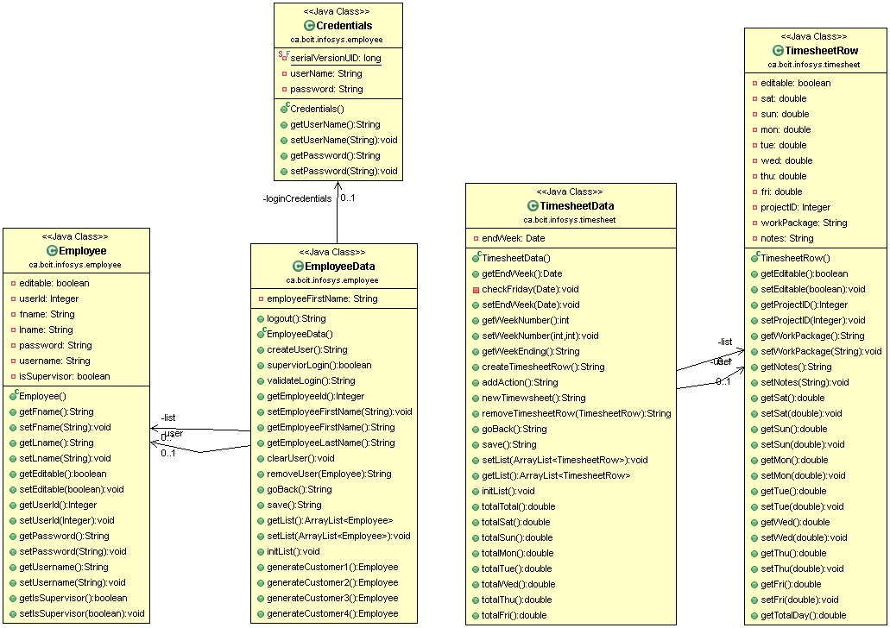

1. Login.xhtml

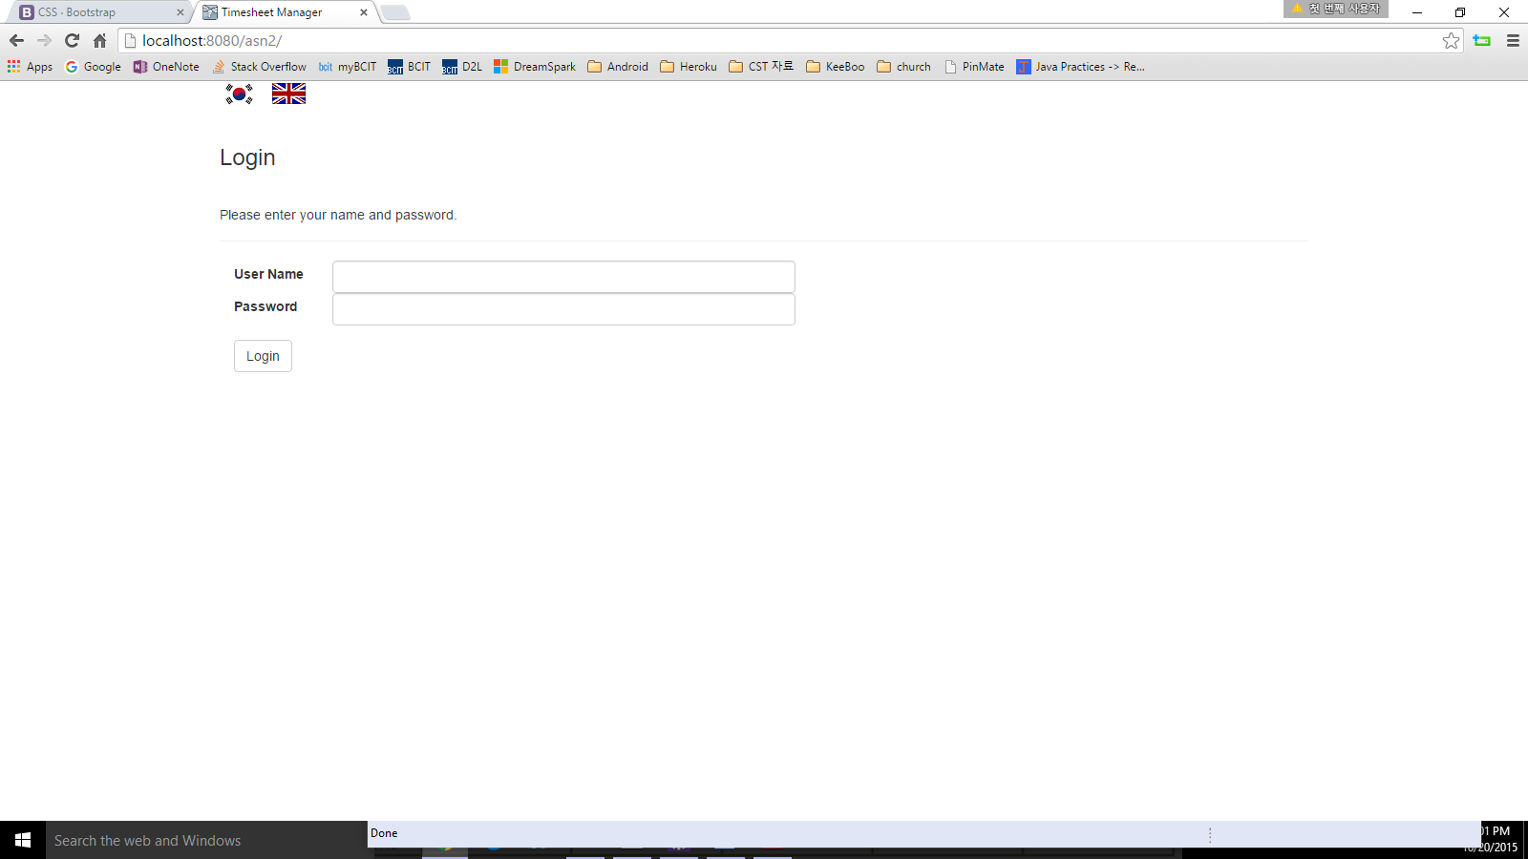

2. viewTimesheet.xhtml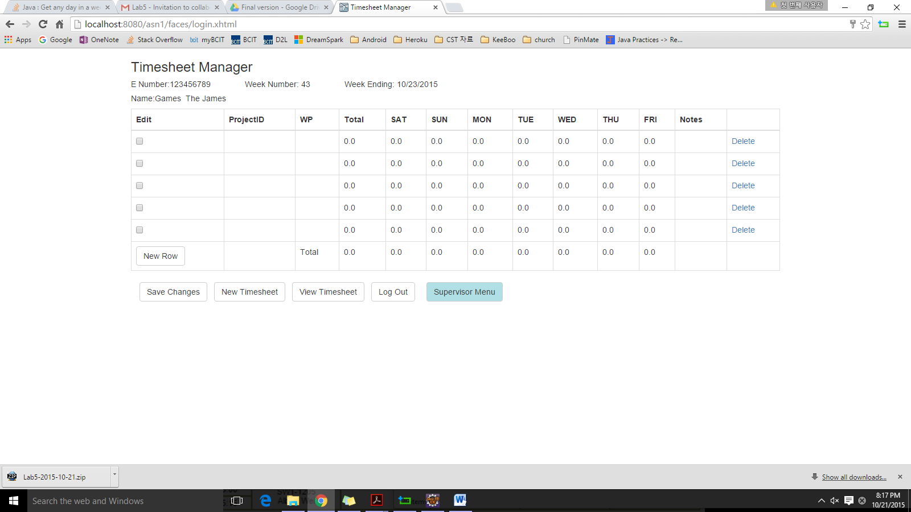

3. viewEmployee.xhtml 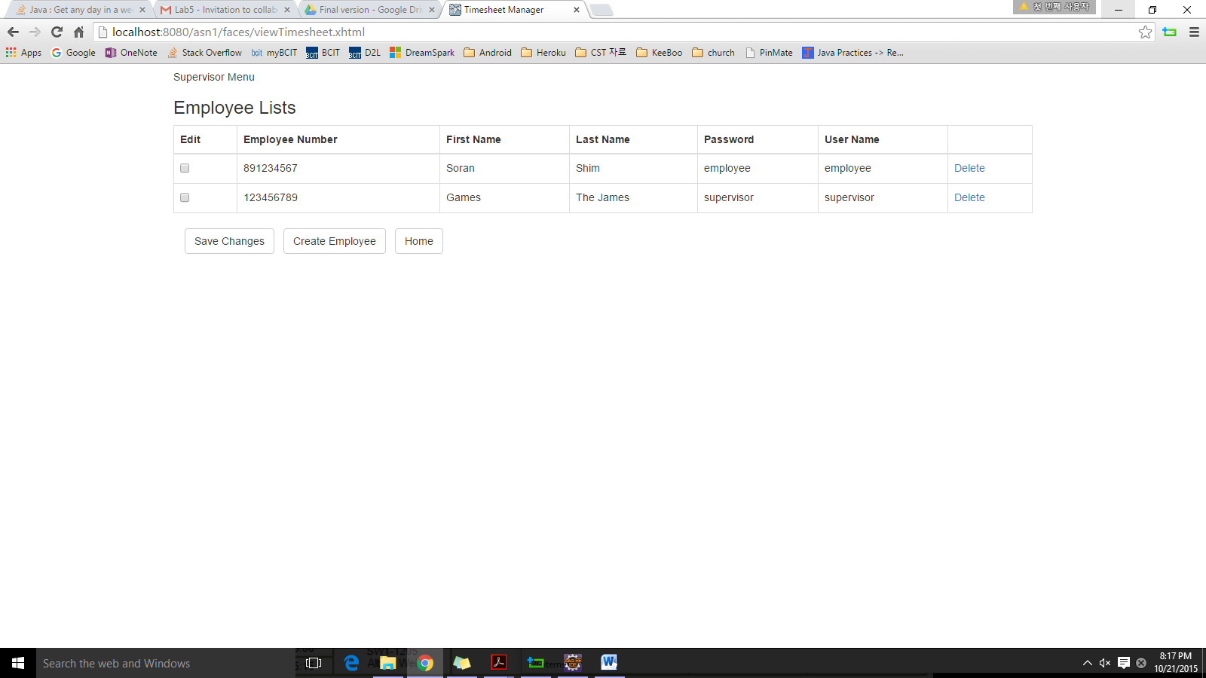

4. createEmployee.xhtml

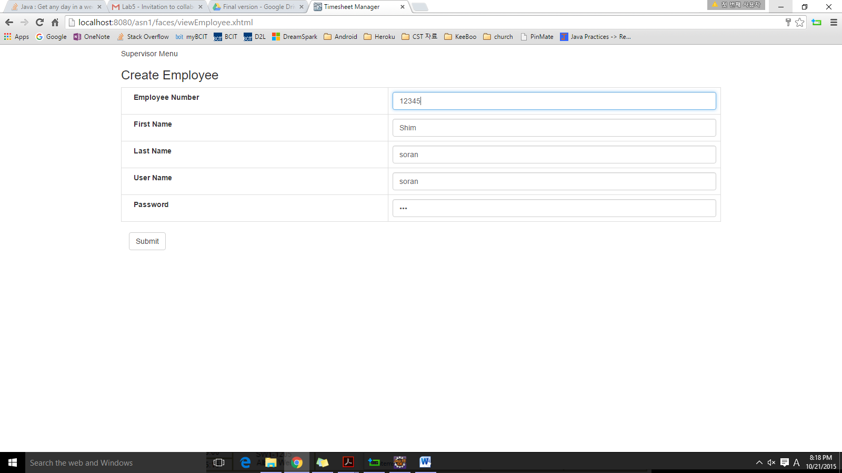

Test Results  
  
Note: Green means the test passed and Red means the test failed, included with explanation  
  
**Login Page Tests**  
Login button – After entering false credentials, eg, testing /// testing, redirects back to login page  
Login button – After entering correct credentials, supervisor /// supervisor, redirects to view timesheet page  
  
**Timesheet Page Tests**  
Timesheet UI – Employee number fetched from fake db, employee name fetched from fake db, date generated from date library, week number generated by date library as well. Table is displayed well and total is properly calculated from the values from Saturday to Friday. Edit checkbox as well as delete buttons are present as well as New Row button. Save changes, supervisor menu, logout, new timesheet and view specific timesheet buttons are rendered properly. If employee is not a supervisor the supervisor menu will not show up.  
Add new row button – Creates a new row for the timesheet  
Save Changes Button – Saves the timesheet into the fake database  
New Timesheet Button – Creates a new blank timesheet  
Edit Checkbox – Makes the row editable  
View Specific Timesheet Button – View a specific timesheet saved to the fake db  
Save Changes Button – If row is in editable mode, make it viewOnly mode.  
Delete link – Deletes a row from the timesheet  
Supervisor Menu Button – Appears when supervisor is logged in, does not render when not supervisor  
Logout Button – Takes user back to login page  
Supervisor Menu Button – Onclick, takes supervisor user to Employees page  
  
**Supervisor Menu Tests**  
Supervisor Menu UI – Shows a table with the employees associated with this specific timesheet. Includes edit checkbox and delete link for each row and also includes 4 buttons: Save Changes, Create User and Home.  
Home Button – Takes the user back to the timesheets page  
Edit Checkbox – Makes the row editable  
Delete Link – Deletes a row from the employee table  
Save Changes Button – If row is in editable mode, make it viewOnly mode  
Create User Button – Redirect user to the Employee Creation page  
**Create Employee Page Tests**Create Employee UI – Shows 5 different form fields for user to fill out, id, name, username and password. Also provides a submit button to submit the form.  
Submit Button – If any fields are invalid, will redirect to the same page  
Submit Button – If fields are all valid, redirect back to Supervisor Menu with new entry in table.  
  
Instructions For Running Project  
  
1) Unzip the project  
2) Import project into eclipse  
3) Right click project and build using folder as source path  
4) Run as -> Run on server (preferably on a Wildfly 9.0 > server)

Additional functionality

1) Implement a non-English language (Korean) for the user interface.

2) An enhanced UI by implementing bootstraps to the x html, creating a user friendly environment.