How to generate a new Break Schedule

Step 1
Login to MyMorri and click on My work then My schedule.
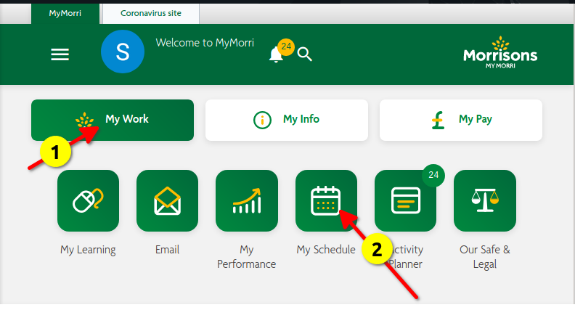
Step 2
We need to be on the Store Schedule.
Click the app draw icon to get this list open, then click store schedule.
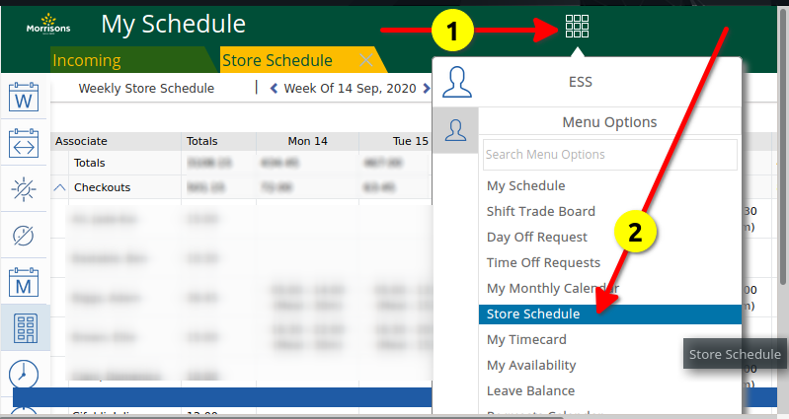
This will give us a list of everyone in the store and their shifts.
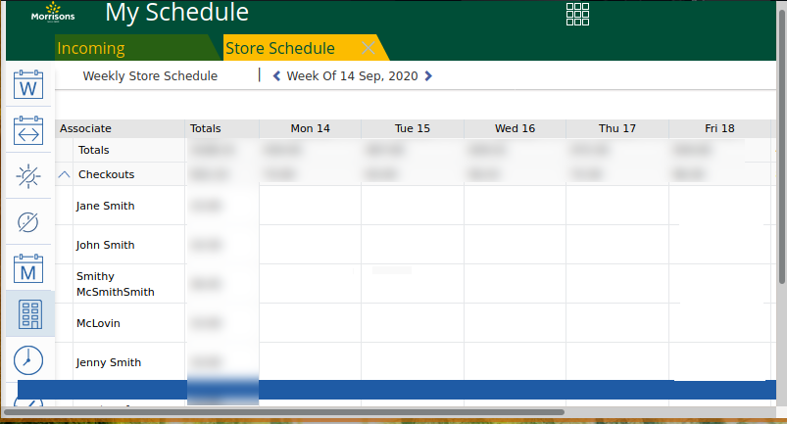

Step 3
Chrome
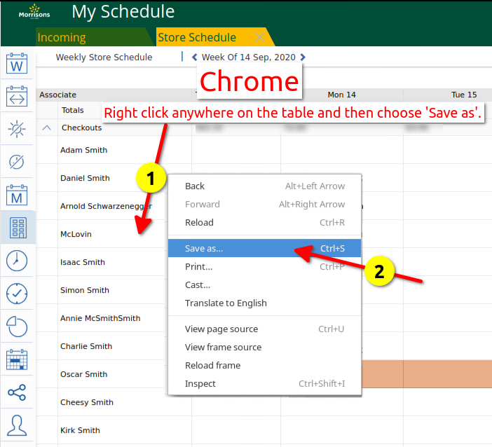
Step 4
Save it to the Break Schedule folder, but we MUST save it as “Webpage, Single File”.
This saves the table containing everyone’s hours.
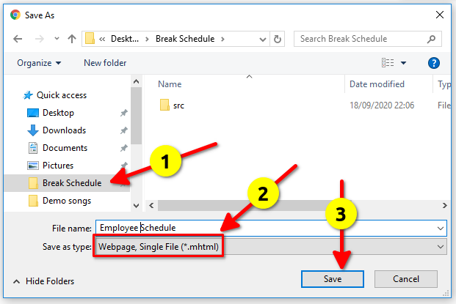

Step 3
Firefox
Right click on the table, and from the menu choose “This Frame”, then “Save Frame As”
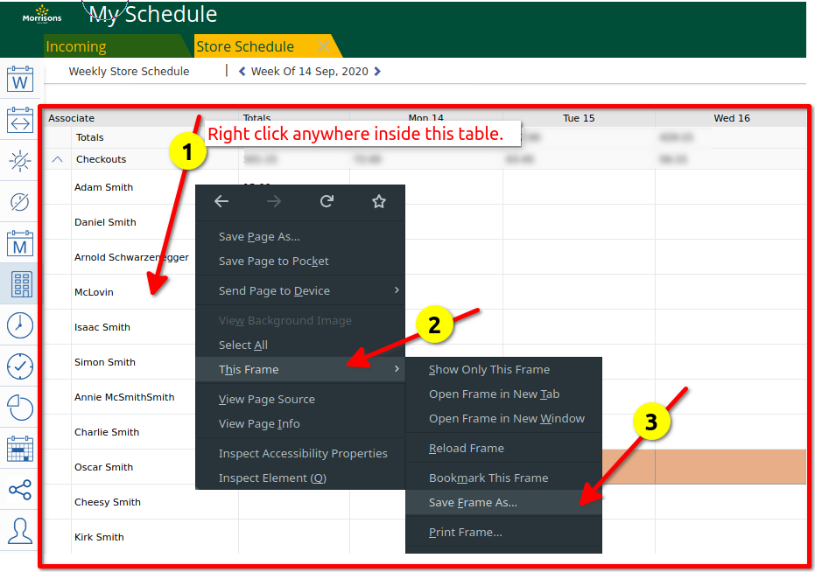

Step 4
Click on the Break Schedule folder and save it there. You can change the filename if you want.
You MUST save it as “Web Page, complete”.
This saves the table containing everyone’s hours.
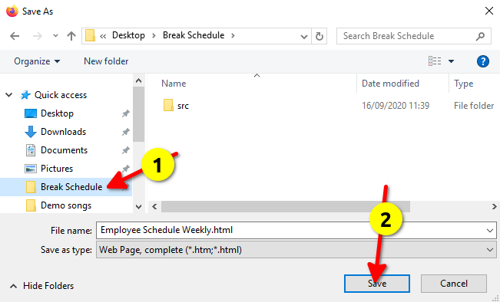

Step 5
Finally go to the break schedule folder, and drag and drop the file into the Break Schedule file.
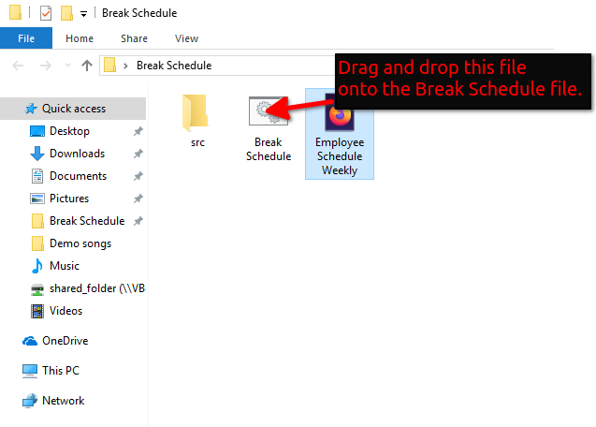

The break schedule will load for you, and will be saved in the break schedule folder with the week commencing date e.g. Break-Schedule-2020-09-21.html
