
W2 PRACTICE

Native HTTP and Manual Routing

At the end of this practice, you can
  - Create and run a native Node.js HTTP server
  - Manually implement route handling using conditionals.

  - Serve static files using fs.
  - Parse form data from POST requests.
  - Debug and enhance server code using console outputs.

 Get ready before this practice!
  - Read the following documents to understand Nodejs built-in HTTP module: https://nodejs.org/api/http.html
  - Read the following documents to understand Anatomy of an HTTP Transaction: https://nodejs.org/en/learn/modules/anatomy-of-an-http-transaction

 How to submit this practice?
    - Once finished, push your code to GITHUB
    - Join the URL of your GITHUB repository on LMS



Goal: Learn how to initialize a server and verify it's alive.
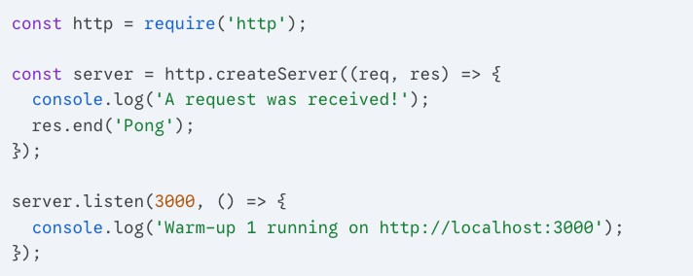

Task:

- Run the code.
- Open your browser to http://localhost:3000.
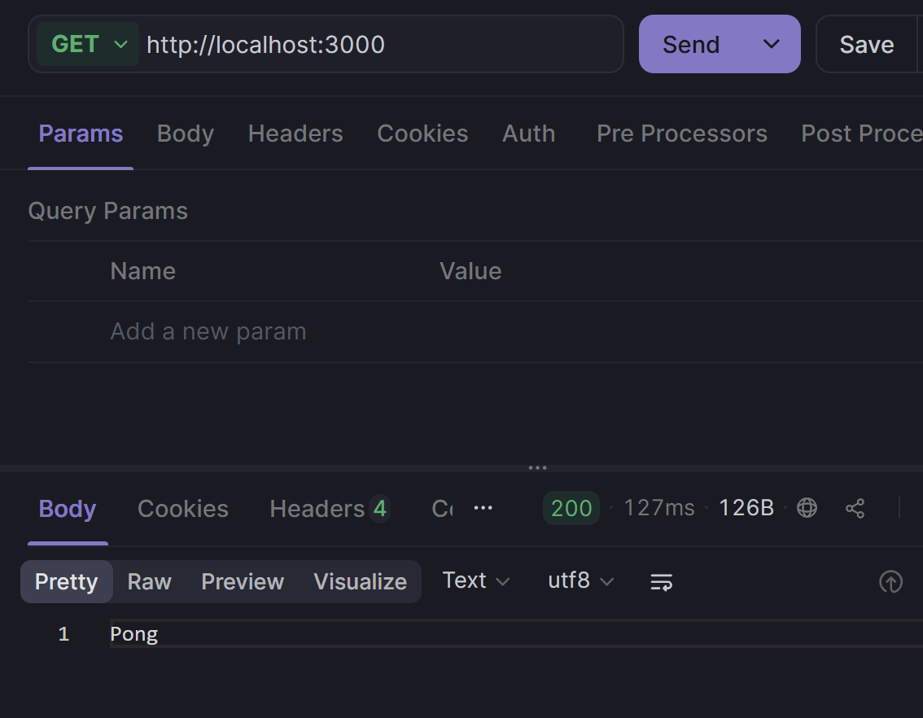

Lab2.2 The Modern Toolkit (Apidog Setup)
Goal: Install Apidog and use it to "talk" to your Node.js server. This replaces the need for using just the browser or complex curl commands.

Task 1: Installation
- Download: Go to apidog.com/download and download the desktop client for your OS (Windows, Mac, or Linux).
  - Tip: While there is a web version, the Desktop Client is better for beginners because it can easily access localhost without extra browser security headaches.
- Open & Guest Mode: You don't necessarily need an account to start. You can use it as a "Guest" or sign up to save your progress.

Task 2: The First Handshake
- Run your server: Use the code from Warm-Up 1 (the "Ping" server).

Create a Request in Apidog:
  - Click the "+" button to create a new tab.
  - Set the method to GET.
  - Enter the URL: http://localhost:3000.
  - Click Send.
- Inspect: Look at the Body tab in the response section at the bottom. Does it say "Pong"?

Goal: Understand that every request carries information about where it came from.
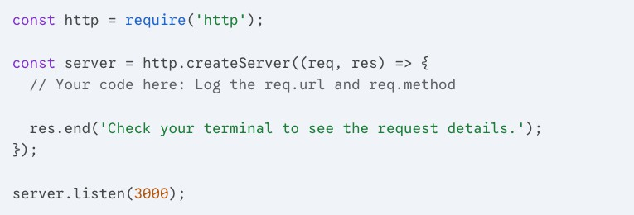

Task:

- Inside the function, use console.log() to print req.url and req.method.
- Visit http://localhost:3000/hello-world.
- Observe the terminal. What does the req.url show?
Answer: When visiting /hello-world, the terminal prints: req.url: /hello-world and req.method: GET. req.url contains everything after the hostname — the path and query string. It does NOT include the protocol or domain.

Lab2.4 Setting the Vibe (Status Codes)
Goal: Learn how to tell the browser if the request was successful or not using HTTP status codes.
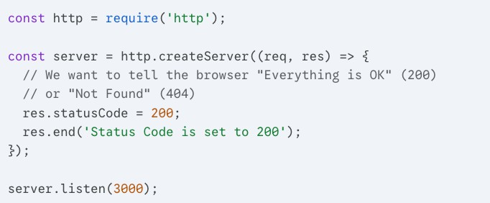

Task:

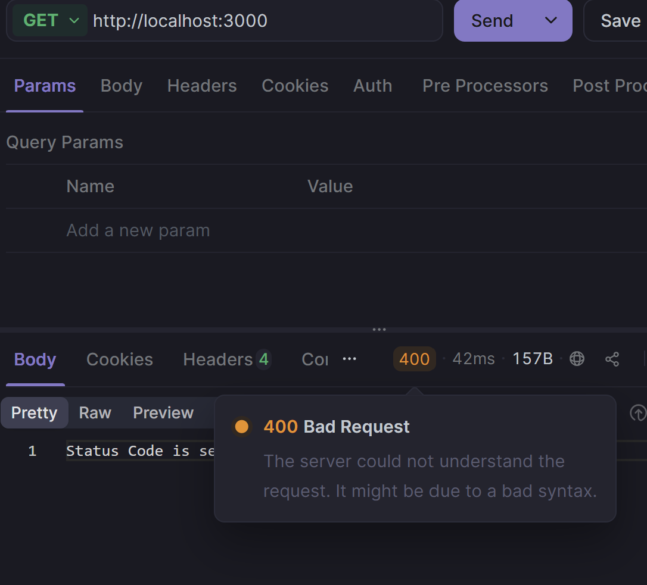
- Change the res.statusCode to 404.
- Refresh your browser.
- Open the Browser Developer Tools (F12) -> Network Tab. Refresh again and click on the "localhost" request. What color is the status code?
- The status code appears in RED (with a red X icon) in the DevTools Network tab. A 404 signals "Not Found" and the browser flags it in red. A 200 OK appears in white/green with no warning icon.

Goal: Use headers to tell the browser how to interpret the data you send.
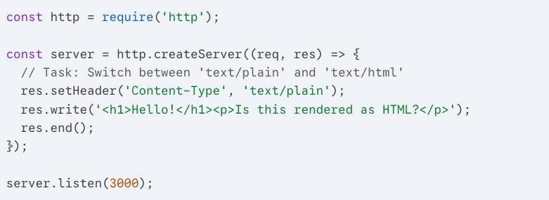

Task:

- Run the code as-is. Does the browser show the <h1> tags or a big heading?
- Change 'text/plain' to 'text/html'.
- Refresh the browser and observe the difference.
- With "text/plain": the browser shows the raw string <h1>Hello!</h1> — angle brackets appear as literal characters. With "text/html": the browser renders the tags and shows a large bold heading. Content-Type tells the browser HOW to interpret the bytes it receives.

Lab2.6 The Live Clock (Dynamic Content)
Goal: Realize that Node.js can execute logic before sending the response.
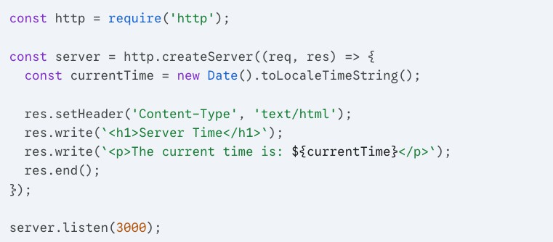

Task:

- Run the server and visit the page.
- Refresh the page 5 seconds later.
- Reflect: Why does the time change even though you didn't change the code? This is the power of a dynamic server vs. a static HTML file!
=> Because new Date() executes freshly on EVERY incoming request. Node.js runs the callback each time a client connects, so the time is calculated at that exact moment. A static HTML file would always show the same time. This is the power of a dynamic server.

- Identify and fix the bug.
- Understand the request-response cycle in Node.js using the http module.
- Explain the role of res.write() and res.end() in sending data back to the client.

 For this exercise, you are provided with a minimal server.js file. Read and run the code and observe how it behaves.

// server.js
const http = require('http');

const server = http.createServer((req, res) => { res.write('Hello, World!');
return res.endd();
});

server.listen(3000, () => {
console.log('Server running on http://localhost:3000');
});

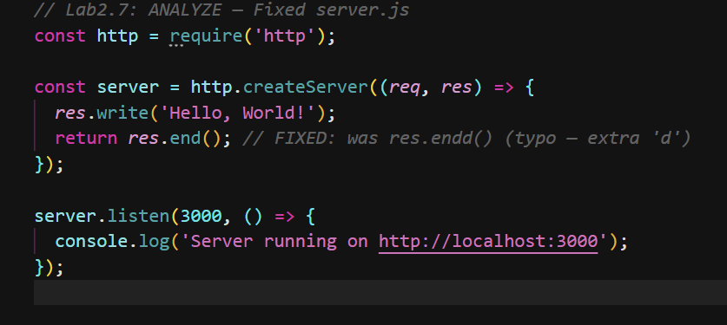

Q1 – What error message do you see in the terminal when you access
http://localhost:3000? What line of code causes it?
- Error: TypeError: res.endd is not a function — caused by line: return res.endd(); "endd" is a typo, the correct method is res.end(). The handler crashes and the browser gets no response.
Q2 – What is the purpose of res.write() and how is it different from res.end()?
- res.write(data) sends a CHUNK of the response body and can be called multiple times — it does NOT close the connection. res.end([data]) sends the final chunk and SIGNALS the response is complete, closing the connection. It must be called exactly once. Think of write() as filling a pipe and end() as sealing it.

Q3 – What do you think will happen if res.end() is not called at all?
- The browser keeps the connection open indefinitely and eventually shows a timeout/loading error. On the server, the request and response objects stay in memory forever, causing a memory leak.
Q4 – Why do we use http.createServer() instead of just calling a function directly?
- http.createServer() creates an event-driven listener that stays alive and fires the callback for EVERY incoming connection automatically. Calling a function directly would run once and exit. The Node.js event loop keeps the process running so multiple clients can connect at any time.

Q5 – How can the server be made more resilient to such errors during development?
- 1. Wrap handler code in try/catch so one bad request does not crash the whole server. 2. Add an uncaughtException handler to log unexpected errors. 3. Use nodemon for auto-restart during development. 4. Use pm2 in production for automatic crash recovery. 5. Validate all inputs before calling methods on them.

- Practice using req.url and req.method.
- Understand how manual routing mimics what frameworks (like Express) automate.
- Serve both plain text and raw HTML manually.

  - For this exercise you will start with a START CODE (EX-2)

TASK 1 - Update the code above to add custom responses for these routes:

ROUTE | HTTP METHOD | RESPONSE
/about | GET | About us: at CADT, we love node.js!
/contact-us | GET | You can reach us vai email…
/products | GET | Buy one get one…
/projects | GET | Here are our awesome projects

Use VS Code’s Thunder Client (or other tools (POSTMAN, INSOMIA) of your choice or curl on your terminal to make request.
Example output

curl http://localhost:3000/about >
About us: at CADT, we love node.js!
curl http://localhost:3000/contact-us -------------------------
-> You can reach us vai email…

TASK 2 – As we can see the complexitiy grow as we add more routes. Use switch statement to arrange the code into more organized structure.
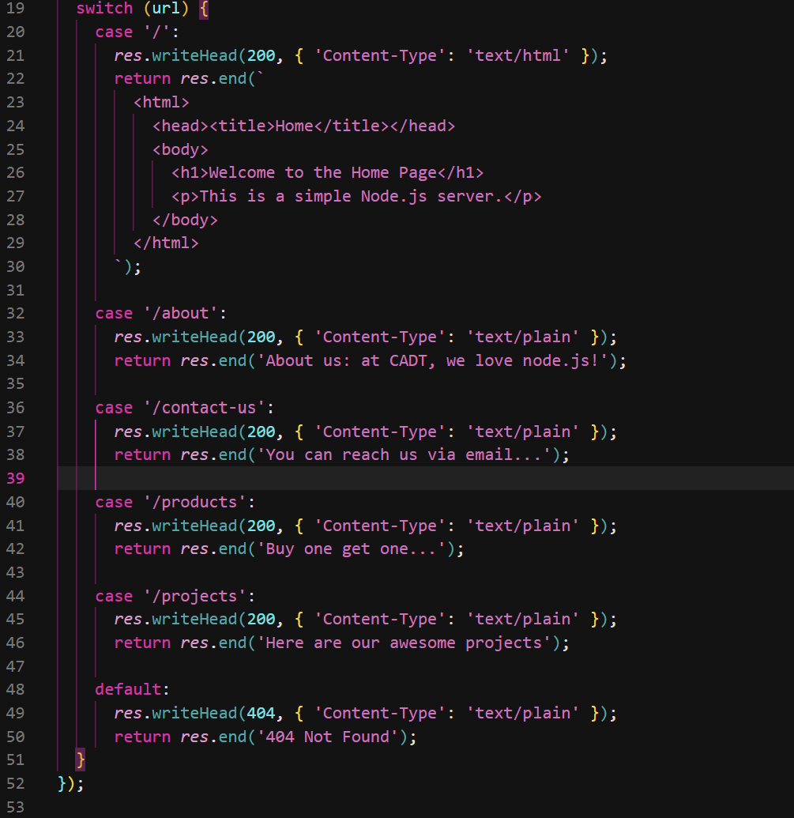

 Reflective Questions
- What happens when you visit a URL that doesn’t match any of the three defined?
The default case in the switch statement runs and sends back:
- 404 Not Found
When visiting http://localhost:3000/random and you'll see it. This is important because without a default case, the server would just hang and never respond to the browser.

- Why do we check both the req.url and req.method?
- Because the same URL can behave differently depending on the method. GET /contact shows the form; POST /contact submits it. If we only checked req.url, a POST to /about would get the same response as GET. URL = WHERE, Method = WHAT ACTION.
- What MIME type (Content-Type) do you set when returning HTML instead of plain text?
- Use "text/html" for HTML: res.writeHead(200, { "Content-Type": "text/html" }).
- Use "text/plain" for plain text. Without the correct Content-Type the browser shows raw HTML tags as text instead of rendering them.
- How might this routing logic become harder to manage as routes grow?
- With 10+ routes the switch becomes hundreds of lines with no organization, no dynamic URL support.

- What benefits might a framework offer to simplify this logic?
- Express.js provides: one clean line per route (app.get("/about", handler)), built-in error handling, and organized router files across multiple files.

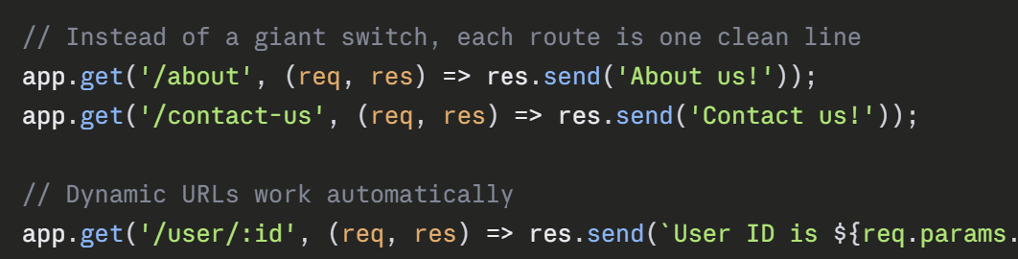
- Practice handling POST requests.
- Parse URL-encoded form data manually.
- Write and append to local files using Node.js' fs module.
- Handle async operations and errors gracefully.

  - For this exercise you will start with a START CODE EX-3

TASK 1 - Extend your Node.js HTTP server to handle a POST request submitted from the contact form. When a user submits their name, the server should:
- Capture the form data (from the request body).

Log it to the console.
- Write it to a local file named submissions.txt.
Testing, go to /contact on broswer and test

Requirements
  - Handle POST /contact requests.
  - Parse raw application/x-www-form-urlencoded data from the request body.
  - Write the name to a new line in submissions.txt.
Send a success response to the client (HTML or plain text).
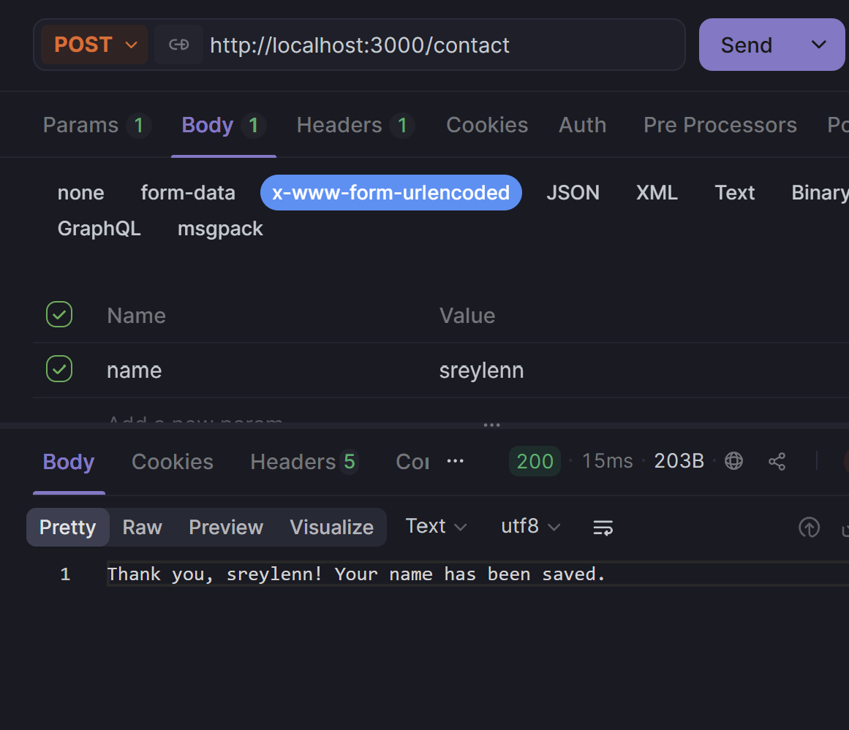

Discussion Questions
- Why do we listen for data and end events when handling POST?
- : HTTP request bodies arrive as a STREAM in multiple chunks. The "data" event fires per chunk — we concatenate them. The "end" event fires when the full body has arrived. Only then is it safe to parse. Streams are asynchronous so synchronous reading is not possible.
- What would happen if we didn’t buffer the body correctly?
- : If we used body before the "end" event, it would be incomplete — only the first chunk. For large payloads data would be missing. For small payloads it might work by coincidence but is unreliable and causes bugs.
- What is the format of form submissions when using the default browser form POST?
- URL-encoded format: name=John+Doe&email=john%40example.com with Content-Type: application/x-www-form-urlencoded. Spaces become +, special characters are percent-encoded (@→%40). URLSearchParams decodes this automatically.
- Why do we use fs.appendFile instead of fs.writeFile?
- : fs.writeFile OVERWRITES the entire file each time — only the latest submission would be saved. fs.appendFile ADDS to the end, preserving all previous submissions. We want a full log, so append is correct.
- How could this be improved or made more secure?
- 1. Sanitize input — strip HTML tags to prevent XSS. 2. Limit body size — reject requests over 1MB to prevent DoS. 3. Use HTTPS — encrypts form data in transit. 4. Add CSRF token — hidden token in form verified server-side. 5. Use a database instead of a flat file for proper querying and concurrent write safety.

Bonus Challenge (Optional)
  - Validate that the name field is not empty before saving.
  - Send back a small confirmation HTML page instead of plain text.
  - Try saving submissions in JSON format instead of plain text.

