**Sort lookup Experiment Report**

Class: 计科201

Student ID 1: 20401010119 Name 1: 周宸

Student ID 2：20401010110 Name 2： 徐彤

Student ID 3：20401010126 Name 3： 张雅康

Experiment Date:2021.12.7

**One. Experimental purpose**

1) Familiar with the basic operations of the sort.

2) Master the operation of various internal sorting.

3) Deepen the understanding of the sort, and to develop the programming ability of solving practical problems gradually.

**Two. Experimental environment**

Computers equipped with Visual C6.0/CFree.

The experiment lasted for 4 hours.

**Three. Experimental content**

A series of strings are stored in a two-dimensional array. Try to sort them with some sorting algorithms (at least two algorithms, such as insert sorting, bubble sorting, quick sorting, and heap sorting). You should sort them to dictionary order finally.

For example: two-dimensional array is :

char s[][20]={“while”，”if”，“else”，”do”，“for”，”switch”，“case”};

(see the instruction manual for the above three parts)

**Four. Important data structures**

1、Submit experimental reports and reports in groups (no more than 3 persons in each group).

2、Submit the source code individually for submission. The file name is named as:

Long student ID_Name_CE3.doc OR Long student ID_Name_CE3.pdf

The report template is shown as follows:

Insertion sort：

void sort(int a[])

{

int i, j, temp;

for (i = 1; i<=sizeof(a)+1; i++) //控制趟数

{

temp = a[i];

for(j = i; j > 0 && temp < a[j-1]; j--) // 无序区的数据与有序区的数据元素比较

{

a[j] = a[j-1]; //将有序区的元素后移

}

a[j] = temp;

}

for(int i=0;i<10;i++)

{

cout<<a[i]<<" ";

}

}

Shellsort：

void shellsort(int v[])

{

int gap, i, j, temp;

int n=sizeof(v);

int k;

for(gap = n/2; gap > 0; gap /= 2)

for(i = gap; i <= n+1; i++)

for(j = i - gap; j >= 0 && v[j] > v[j+gap]; j-= gap)

{

temp = v[j];

v[j] = v[j+gap];

v[j+gap] = temp;

}

for(k=0;k<=n+1;k++)

{

cout<<v[k]<<" ";

}

}

**Five. Realization idea analysis**

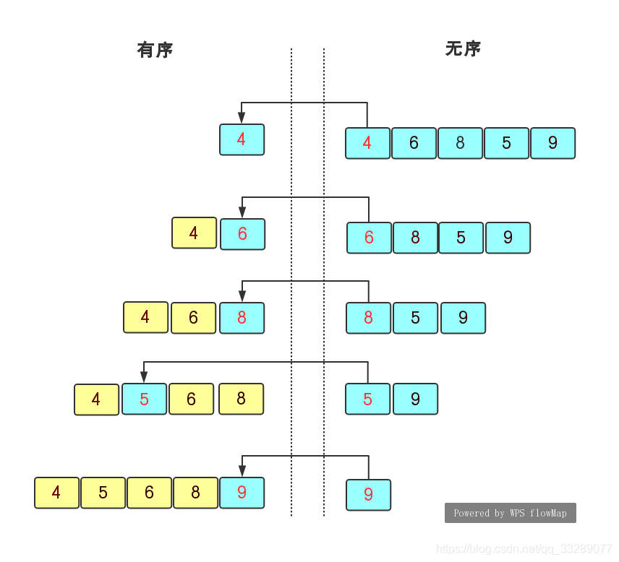

Insertion sort；

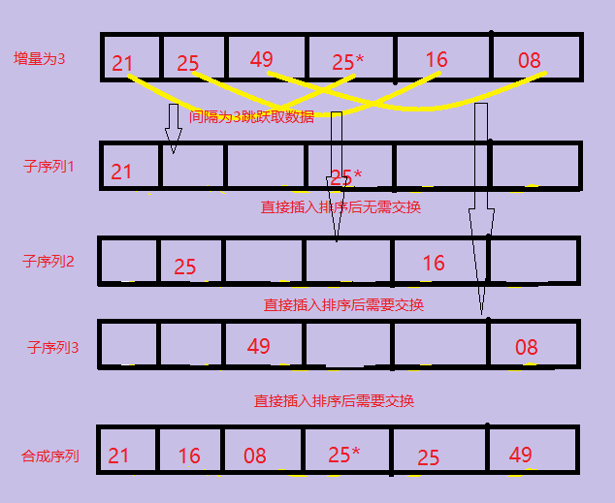

Shellsort；

The idea of an implementation or analysis of a flowchart

**Six. Program debugging problem analysis**

Problems encountered in debugging and Solutions

The two sorts involve multiple cycles, which is logically difficult. A variety of data debugging, a variety of calculus, and found the law of circulation.

**Seven. Experimental summary**

This experiment knowledge summary and own experience

Familiar with the basic operation of sorting, master various internal sorting operations, deepen the understanding of sorting, and gradually cultivate the programming ability to solve practical problems. Have a better understanding of the loop and the logic of sorting.

**Eight. Crew Division**

|  |  |  |
| --- | --- | --- |
| **Group division** | | |
| **Member name** | **Work done** | **Completion situation** |
| **周宸** | **代码和报告** | **100%** |
| **徐彤** | **代码和报告** | **100%** |
| **张雅康** | **代码和报告** | **100%** |