# Comprehensive Experiment 3 :

# Sort comprehensive experiment

## One. Experimental purpose

1) Familiar with the basic operations of the sort.

2) Master the operation of various internal sorting.

3) Deepen the understanding of the sort, and to develop the programming ability of solving practical problems gradually.

## Two. Experimental environment

Computers equipped with Visual C6.0/CFree.

The experiment lasted for 4 hours.

## Three. Experiment content

A series of strings are stored in a two-dimensional array. Try to sort them with some sorting algorithms (at least two algorithms, such as insert sorting, bubble sorting, quick sorting, and heap sorting). You should sort them to dictionary order finally.

For example: two-dimensional array is :

char s[][20]={“while”，”if”，“else”，”do”，“for”，”switch”，“case”};

## Four. Requirement

1、Submit experimental reports and reports in groups (no more than 3 persons in each group).

2、Submit the source code individually for submission. The file name is named as:

Long student ID_Name_CE3.doc OR Long student ID_Name_CE3.pdf

The report template is shown as follows:

**XXX Experiment Report**

Class:

Student ID 1: 20405050102 Name 1: 张子晗 Experiment Date:2021/12/5

Student ID 2 :20403070103 Name 2：翟聪

Student ID 3: 20410020101 Name 3：郑永坤

**One. Experimental purpose**

1) Familiar with the basic operations of the sort.

2) Master the operation of various internal sorting.

3) Deepen the understanding of the sort, and to develop the programming ability of solving practical problems gradually.

**Two. Experimental environment**

Computers equipped with Visual C6.0/CFree.

The experiment lasted for 4 hours.

**Three. Experimental content**

A series of strings are stored in a two-dimensional array. Try to sort them with some sorting algorithms (at least two algorithms, such as insert sorting, bubble sorting, quick sorting, and heap sorting). You should sort them to dictionary order finally.

For example: two-dimensional array is :

char s[][20]={“while”，”if”，“else”，”do”，“for”，”switch”，“case”};

**Four. Important data structures**

本次实验运用了排序算法对存储在二为数组里的字符串按照字典的顺序进行排序，运用了数据结构中的插入排序、快速排序以及冒泡排序。

**Five. Realization idea analysis**

**插入排序流程图**

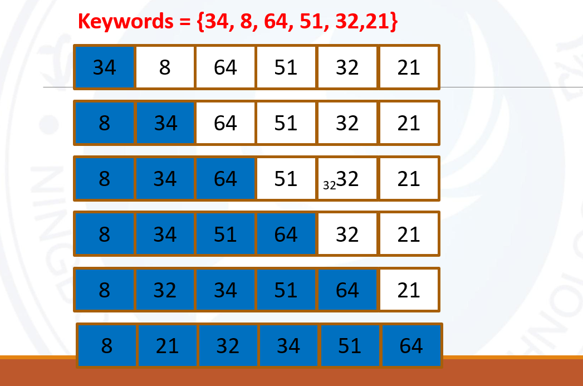

**快速排序流程图**

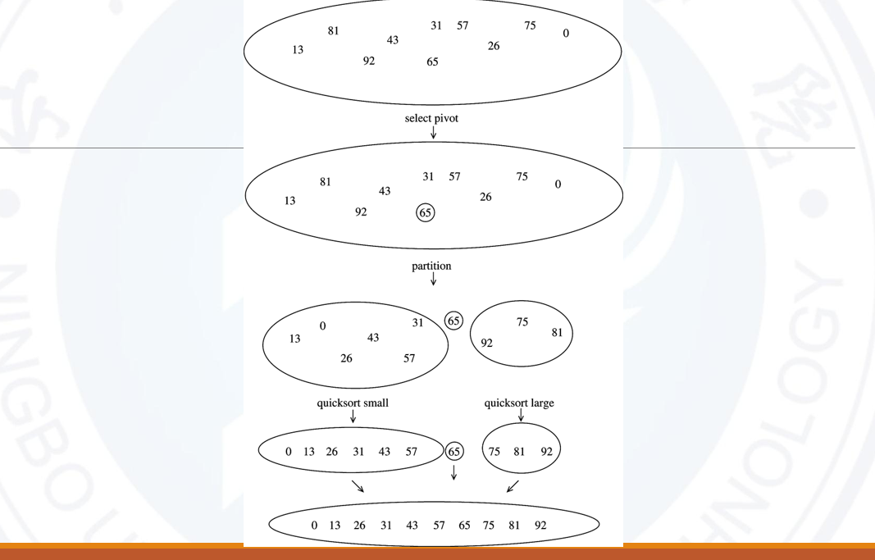

**冒泡排序流程图**

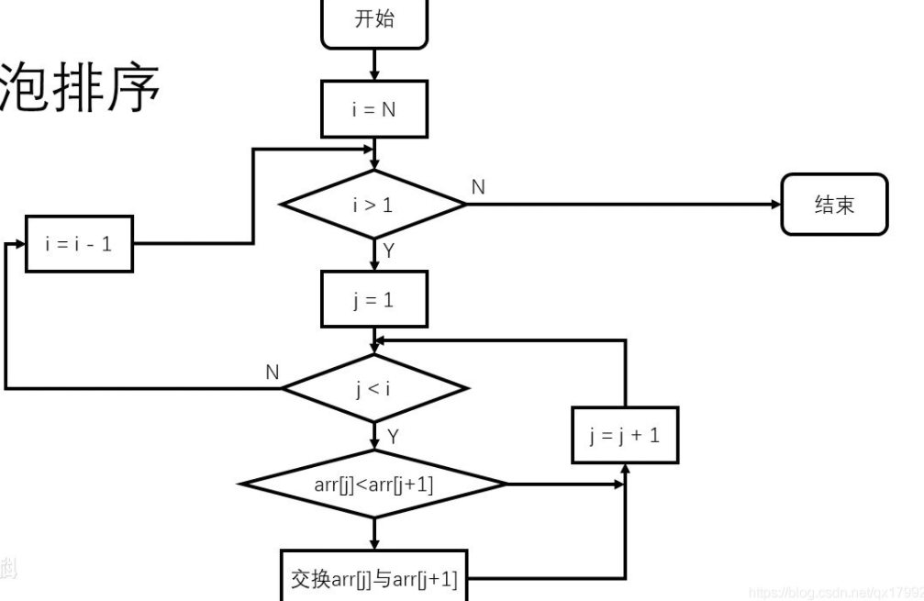

**Six. Program debugging problem analysis**

**在实验中，一开始不知道如何去判断字符串的先后顺序，经过查阅资料，找到比较字符串大小的函数strcmp函数，可一通过此函数的返回值来判断按照字典顺序的字符串的大小，还有学习到了strcpy函数相比于strcpy_s函数还是有一定的缺陷，后者相较于前者，更安全。通过查阅资料，解决了这个问题。**

**Seven. Experimental summary**

**通过这此实验，我们不仅学习了新的知识，而且增强了团队协作能力，收获颇丰。**

**Eight. Crew Division**

|  |  |  |
| --- | --- | --- |
| **Group division** | | |
| **Member name** | **Work done** | **Completion situation** |
| **张子晗** | **函数的编写** | **完成** |
| **翟聪** | **主函数的编写** | **完成** |
| **郑永坤** | **测试** | **完成** |