
T.C.
ANKARA YILDIRIM BEYAZIT UNIVERSITY
Faculty of Engineering and Natural Sciences

Second Report

Name: Sıla Elif Karaağaç
Student No: 23050211070
Abstract: How is Data sent & received?
In a standard digital communication system, a set of information bits which is data from higher layers (from MAC) is mapped to a format that is usable over a physical communication channel and is reconstructed at a receiver. The standard operations in a digital communication system begin with a sequence of bits, followed by adding redundant to communicate reliably over a noisy channel (channel coding or FEC, where error correction is possible at a receiver), and finally representing groups of bits as modulation symbols (such as BPSK [1 bit per symbol], QPSK [2 bits per symbol], QAM). These symbols are then communicated over a channel, where it is possible to encounter additive noise (AWGN), fading, and multipath effects, with system performance odelled and calculated by metrics such as BER vs. SNR. At the receiving end the set of operations performed in reverse to extract information bits is quite straightforward: detection, symbol synchronization, compensation of channel effects (equalization), symbol demodulation, and finally error correction to recover original information bits very reliably.
In our project, this general chain will be implemented somewhat differently in that the particular blocks will be implemented specifically for the IEEE 802.11a physical layer(PHY), in which OFDM is used effectively as a means of communicating data over wireless multipath channels. After FEC encoding, the bits are mapped onto BPSK/QPSK/16-QAM/64-QAM symbols, as well as pilot tones, utilizing an IFFT that maps the symbols onto numerous orthogonal sub-channels, with a cyclic prefix generally added to counter inter-symbol interference. At the receiver, the IEEE 802.11a sublayer synchronizes the time and frequency of the received signal, detects the arriving packet with the known preamble, performs an FFT, uses the known pilots to estimate the channel, equalize each sub-channel, as well as demodulate the bits. This is, of course, the abstract basis that we must have as a precursor even before jumping further into the implementation with simulation as well as FPGA.

Modulaiton
Modulation is the process of mapping digital bits into analog signal changes that an antenna can physically transmit. Since antennas radiate electromagnetic waves rather than raw 0/1 sequences, bits must be represented as continuous-time signal changes; in practice, groups of bits are mapped to complex-valued symbols from a constellation such as BPSK, QPSK, or QAM, where each symbol corresponds to a particular amplitude/phase state. Using a carrier at radio frequencies also makes practical antennas possible (antenna size is related to wavelength), supports efficient propagation over the air, and enables multiple transmissions to share the spectrum through frequency planning and channelization. Overall, modulation is a key tool for using bandwidth efficiently and for trading off data rate versus robustness: higher-order constellations carry more bits per symbol but require higher signal quality to maintain a low error rate. There are two types of modulation: Analog & Digital. Since we are concerned in digital communication on this project, digital modulation methods are: BPSK/QPSK/16-QAM/64-QAM.

BPSK(Binary shift phase keying): (1 bit per symbol) maps each single bit to one of two constellation points, so a 12 bit stream like 101100101110 is transmitted as 12 symbols. Because the receiver only needs to decide between two well-separated points, tolerates noise and distortion well, but it uses more symbols and time to send the same data. BPSK minimizes hardware confusion at the expense of throughput. Since it transmits only 1 bit per symbol which is half the capacity of QPSK it is considered inefficient compared to higher order modulation schemes.
QPSK(Quadrature phase shift keying): (2 bit per symbol) groups bits into pairs, so 101100101110 becomes 10 11 00 10 11 10 and is transmitted as 6 symbols. Each two-bit pair chooses one of four constellation points, so QPSK can send data about twice as fast as BPSK, and it still works well when the signal is stronger than the noise (SNR:signal strength to background noise) and it doesn’t break down as quickly as 16-QAM or 64-QAM. Although the receiver architecture is more complex due to the requirement for finer phase discrimination, the BER (bit error rate) performance remains identical to BPSK relative to bit energy. Essentially, QPSK provides higher throughput without an inherent power penalty.
We can intuitively determine what these four possible phase shifts should be: First we recall that modulation is only the beginning of the communication process; the receiver needs to be able to extract the original information from the modulated signal. Next, maximum separation between the four phase options, so that the receiver has less difficulty distinguishing one state from another. 360 of phase to work with and four phase states, and thus the separation should be 360°/4 = 90. So, QPSK phase shifts are 45°, 135°, 225°, and 315°.
QAM (Quadrature amplitude modulation): operates by combining two carrier waves that are 90 degrees out of phase with each other. These are known as orthogonal carriers: In-phase (I): represented by a cosine wave & quadrature (Q): represented by a sine wave. Because they are orthogonal, they can be transmitted over the same frequency channel and separated at the receiver without interfering with one another. This effectively creates a two-dimensional signal space. As the order of QAM increases, the constellation points become closer together. A higher SNR is required for higher order QAM. If the channel is noisy (high AWGN), the receiver cannot distinguish between the points, leading to a high BER. This is why your WiFi speed drops when you move further from the router. The system detects a lower SNR and automatically downshifts from 64-QAM to 16-QAM or QPSK to maintain a stable connection. The "number" associated with QAM (16-QAM, 64-QAM) represents the number of unique symbols in the constellation. The number of bits carried by each symbol is calculated as n=log2(M):
Modulation | Bits per Symbol | Complexity | Efficiency
16-QAM | 4 Bits (2^4) | Moderate | High
64-QAM | 6 Bits (2^6) | High | Very High
256-QAM | 8 Bits (2^8) | Very High | Extremely High

16 QAM groups bits into 4-bit chunks, so 101100101110 becomes 1011 0010 1110 and is transmitted as 3 symbols. Each chunk selects one of 16 amplitude/phase states, increasing throughput, but the constellation points are closer together, so the receiver needs higher SNR to keep errors low.
64-QAM groups bits into 6-bit chunks, so 101100101110 becomes 101100 101110 and is transmitted as 2 symbols. Each chunk selects one of 64 tightly spaced constellation points, which maximizes data rate, but it is much more sensitive to noise small disturbances can push a received point into a neighbouring decision region, causing symbol and bit errors unless SNR is high.
Therefore, that’s why we can not always use 64-QAM for modulation: 64-QAM has 64 constellation points, which are very close to each other. When the channel adds noise or distortion (low SNR, fading, multipath), the received point can easily move into the wrong region, so the receiver picks the wrong symbol and the bit error rate increases a lot. So 64-QAM is fast but fragile it works well only when the signal is strong compared to noise. In weaker conditions, systems switch to QPSK or BPSK to stay reliable.
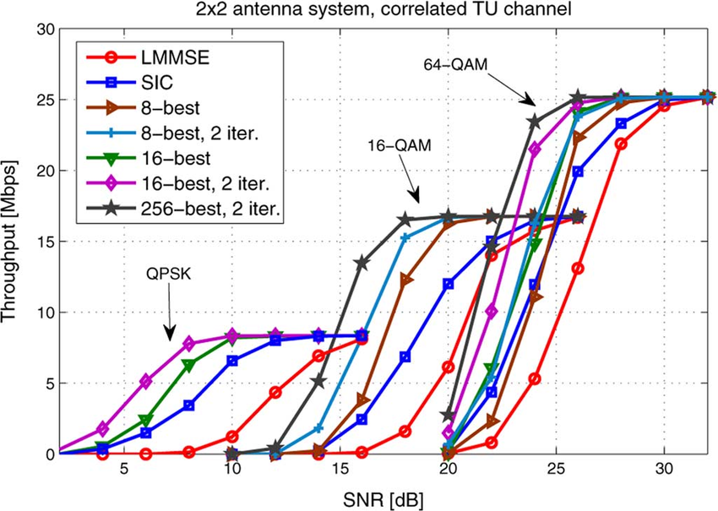

Channel Coding
Channel coding is a method of adding extra (redundant) bits to your data before you transmit it, so the receiver can detect and correct errors caused by the channel. So basically send a little extra information now, avoid wrong data later.
Channel coding is essential because wireless channels are inclined to bit errors caused by noise, fading, and interference. In IEEE 802.11a, reliability is achieved through a combination of techniques rather than a single tool. 802.11a uses convolutional coding (with puncturing for higher rates) and a defined per-OFDM-symbol interleaver.
FEC (Forward Error Correction) adds structured redundancy so the receiver can correct many errors without retransmission. To reduce the impact of burst errors (errors clustered in time, often due to a deep fade), interleaving rearranges the coded bits before modulation so that consecutive channel errors are spread across different parts of the codeword, making them easier for the decoder to handle. Finally, when errors remain beyond what FEC can correct, error detection and retransmission mechanisms are used: the receiver checks a CRC (Cyclic Redundancy Check is an error-detection code. The transmitter computes a short checksum value from the packet bits and appends it and the receiver recomputes the CRC from what it received and compares using XOR operations) to detect a corrupted frame and triggers ARQ (retransmission) when needed. This layered design involves trade-offs like extra redundancy, interleaving operations, and possible retransmission delays can reduce peak throughput but together they provide a much more reliable link, especially at lower SNR.
What Happens on Channel?
When a signal travels through a wireless channel, it rarely arrives at the receiver exactly as it was transmitted.
AWGN (Additive White Gaussian Noise) is the simplest model: it represents random background noise like thermal noise added to the signal, which blurs the constellation points and increases bit errors when SNR is low. It is the "static" or "hiss" you hear on an un-tuned radio. It simply adds itself to your signal, it contains all frequencies equally, its voltage follows a normal distribution (bell curve), it's mostly caused by the thermal vibration of electrons in the receiver's own circuitry and the environment, it limits the SNR if the noise floor is too high, the receiver can't distinguish between modulation points.
In real environments, the channel also causes fading, meaning the signal’s amplitude and phase change over time due to movement and reflections; this can create deep signal drops that suddenly increase errors. Another major effect is multipath, where the signal arrives through multiple paths with different delays because of reflections from walls, buildings. Those delayed copies can overlap with each other and distort the waveform; in single-carrier systems this produces strong inter symbol interference (ISI). In OFDM systems like IEEE 802.11a, multipath mainly shows up as different gain/phase on each subcarrier (frequency-selective distortion), which is then handled using channel estimation, equalization, and the cyclic prefix.

BER vs SNR
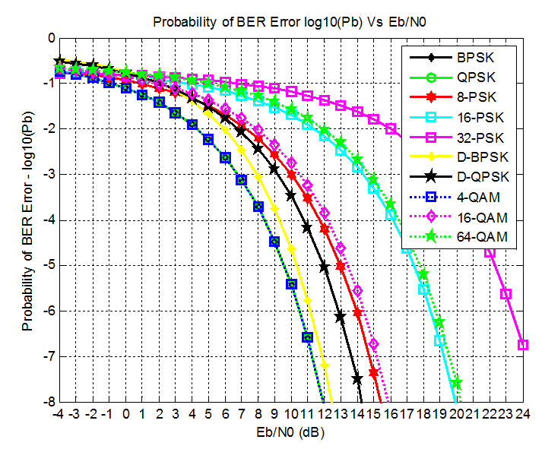
In the graph x- axis show us the SNR per bit and moving right means clean signal. Y-axis shows us the BER, because of BER is less than 1, log(Pb) is negative and lower on the graph means smaller BER which is better. The curves separated because: Simple modulations (BPSK, QPSK, 4QAM) achieve a low BER at lower, they are more robust. Higher-order modulations (16QAM, 64QAM,) need higher Eb/N0 to reach the same BER, they are faster but more sensitive. This directly supports the “why we can’t always use 64-QAM” idea: its constellation points are closer, so noise pushes symbols into wrong decision regions more easily.
To generate a BER vs SNR curve, we start by creating a long random bit sequence and passing it through the transmitter chain. The modulated symbols are then transmitted through an AWGN channel by adding Gaussian noise corresponding to a chosen Eb/N0 value. At the receiver, the noisy symbols are demodulated to obtain the recovered bit stream. The BER at that Eb/N0 point is computed as the number of incorrect bits divided by the total number of transmitted bits. This procedure is repeated for a range, and BER values are plotted to show how error probability decreases as SNR increases and how different modulation/coding choices shift the curve.
Why OFDM (IEEE802.11a)
OFDM is used in many systems such as Wi-Fi and 4G/5G because it works well in real wireless channels. In places like indoor or urban areas, signals reflect off objects and arrive at the receiver through multiple paths with different delays “multipaths”. In single-carrier systems, these delayed copies can overlap and cause ISI, especially at high data rates. OFDM reduces this problem by splitting one fast data stream into many slower streams and sending them on many orthogonal subcarriers, which makes the symbols longer and less sensitive to delay. A cyclic prefix (CP) is added at the start of each OFDM symbol as a short buffer that absorbs echoes. OFDM is also practical to implement because it uses IFFT at the transmitter to generate the time-domain signal and FFT at the receiver to convert it back to subcarriers and recover the data.

Receiver: How it detects?
The receiver does not automatically know when a packet starts, so it first looks for a known pattern called the preamble. When it detects this preamble, it decides “a packet is coming” and finds the correct start point. Next, it performs synchronization to fix timing errors (symbol boundaries) and frequency errors (carrier offset), because OFDM is very sensitive to these. After that, the receiver applies an FFT to convert the received time-domain OFDM signal into the frequency domain, separating the subcarriers. Then it does channel estimation using the preamble and pilot tones to learn how the channel changed the signal (gain and phase on each subcarrier). Using this estimate, it equalizes the subcarriers to undo the channel distortion. Finally, it demodulates the corrected constellation points back into bits and decodes the FEC to correct remaining bit errors, recovering the original data.

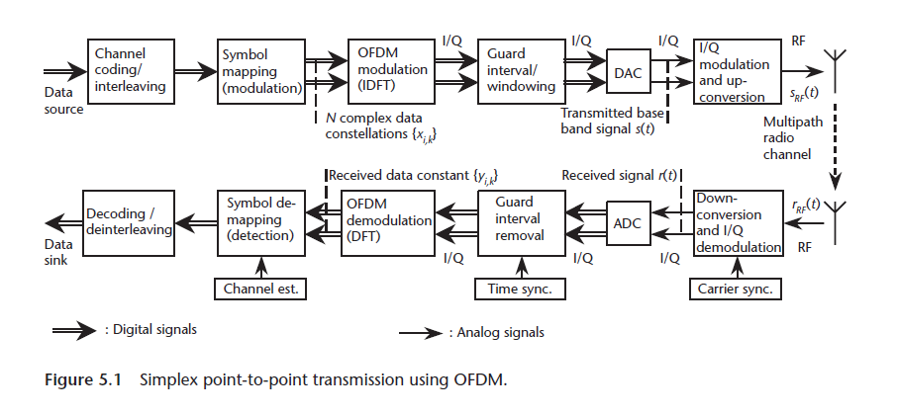

Simulations
First i simulated prepared documents from MATLAB “OFDM Synchronization”:
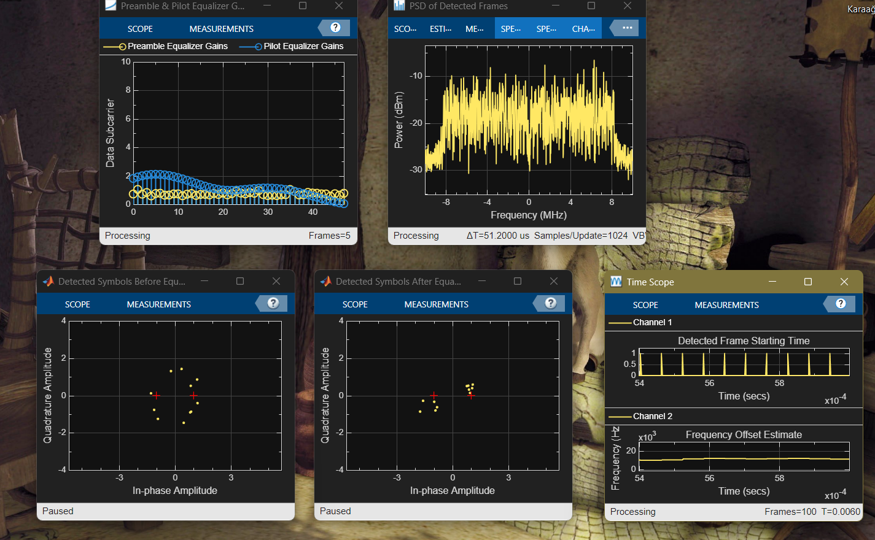
It basically shows receiver chain: preamble, sync, FFT, channel est, equalize, demod
Detected frame starting time plot: Top plot shows packet detection/timing. Each spike means the receiver found a new frame start. Bottom plot shows CFO estimation (carrier frequency offset). It shows the receiver’s estimate of how much the transmitter and receiver oscillators are mismatched.
Detected symbols before equalization: constellation plot before channel equalization. Yellow dots are the received symbols (after FFT, but before fixing the channel effect).The reason they look spread is: channel gaina and phase distortion (multipath/frequency response) or residual CFO/phase noise. The red “+” marks are the ideal points the receiver expects (where symbols should be). So basically it shows bwfore fixing it has HIGHER BER.
Detected symbols after equalization: Same constellation, but after channel estimation + equalization. As it seems they got more closer that means equalization is doing its job so demodulation becomes reliable. LOWER BER.
Preamble and pilot equalizer gains: This plot shows the equalizer gains across subcarriers. Shows that different subcarriers need different correction.
PSD of detected frames: basically, the frequency-domain shape of the OFDM signal.

My Simulation

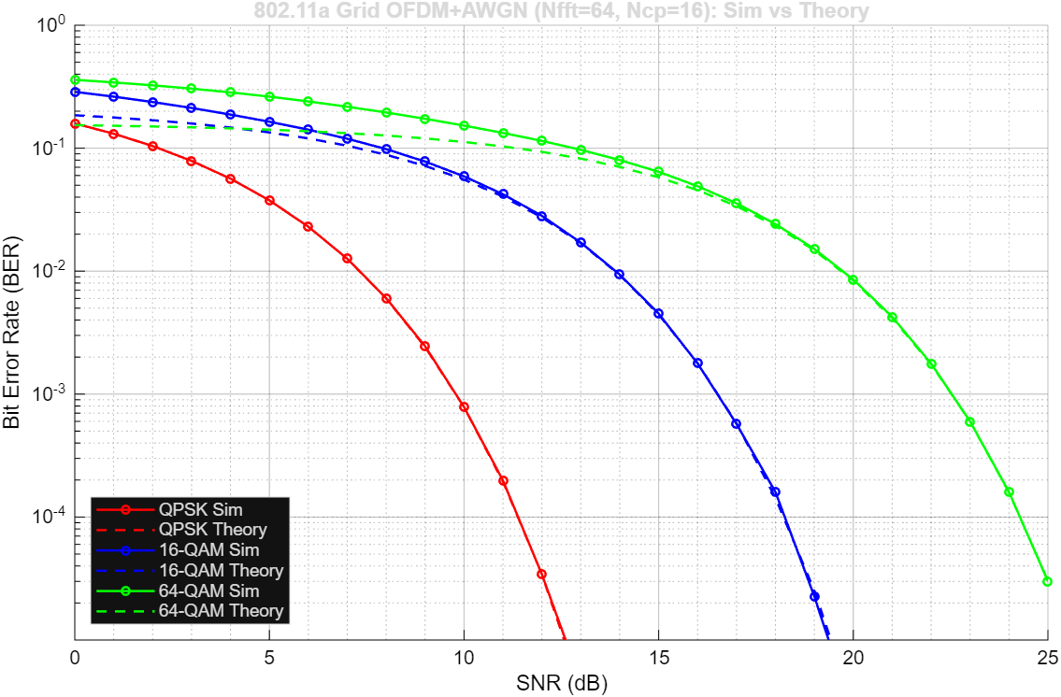
Explanation of the code:
- SNRdB = 0:1:25; % x-axis: Es/N0 (dB)
Higher SNR, less noise, lower BER so the curve drop as you move right

- semilogy(SNRdB, berSim(mi,:), ... )
semilogy(SNRdB, berTheory(mi,:), ... )
BER changes over many orders of magnitude, so log scale is the standard way to show it.
- if err == 0
berSim(mi,si) = 0.5/tot;
else
berSim(mi,si) = err/tot;
end
Also, prevented BER = 0 from breaking the log plot using and that keeps the curve from collapsing to zero at high SNR.
- higher order QAM packs more bits per symbol, but constellation points are closer more sensitive to noise. That’s why QPSK is best (lowest curve) and 64-QAM is worst (highest curve)
In code, bits per symbol is:
k = log2(M);
so, for QPSK: k=2, 16-QAM: k=4 and 64-QAM: k=6
- Create random bits and modulate to QAM symbols:
bitsTx = randi([0 1], nDataSC*Nsym*k, 1);
symData = qam_gray_mod(bitsTx, M);
- Place symbols on 802.11a data subcarriers and pilots:
X = zeros(Nfft, Nsym);
X(bin_data, :) = symDataMat;
X(bin_pilot, :) = repmat(pilotVal, 1, Nsym);
- OFDM modulation (IFFT) and cyclic prefix:
x = ifft(X, Nfft, 1) * sqrt(Nfft);
xcp = [x(end-Ncp+1:end,:); x];
tx = xcp(:);
- Add AWGN, then receiver: remove CP and FFT
rMat = reshape(rx, Nfft+Ncp, Nsym);
rNoCP = rMat(Ncp+1:end,:);
Y = fft(rNoCP, Nfft, 1) / sqrt(Nfft);
- Extract data subcarriers and demodulate, then count errors:
Ydata = Y(bin_data, :);
bitsRx = qam_gray_demod(Ydata(:), M);

err = err + sum(bitsRx ~= bitsTx);
tot = tot + numel(bitsTx);
- exact QPSK BER:
Pb = qfunc_local(sqrt(2*EbN0));
And
and an approximation for Gray-coded square QAM
Pb = (4/k)*(1-1/sqrt(M)).*Q - (4/k)*(1-1/sqrt(M)).^2 .* (Q.^2);

- Why my simulation and theorical results are close but not same: Because I used finite finite number of bits, used ideal and approximated formulas (for ex. used QSPK formula is exact formula), OFDM with pilots and unused carriers, while theory assumes plain QAM symbols and at the reciever ignored CP overheard.
- This figure plots BER vs SNR for an 802.11a style OFDM link in AWGN. For each modulation, random bits are QAM-modulated, mapped onto the 48 data subcarriers and 4 pilot subcarriers, converted to time domain via IFFT, and transmitted with a cyclic prefix. Complex AWGN is added according to the SNR. At the receiver, the CP is removed, FFT is applied, data subcarriers are demodulated, and BER is computed by error counting. The dashed curves are theoretical BER results computed from standard AWGNformulas.

Sources
https://youtu.be/TwKIizuV44k?si=8P2GJ9A4INpcC8-Z
https://youtu.be/c3eMoHuPRy0?si=QE8p7BCTsU8vJp93
https://youtu.be/IbUflaeJcU8?si=70bmjhHWOmqwc1aP
https://youtu.be/wlwjsla9Tc8?si=kvkCYU1W9zYB3CjC
https://youtu.be/vtJ6mAy3xMc?si=lDIUvpfaNwTjjDAI
https://youtu.be/mjsaJnLkzuE?si=820M4VcibcExb6HD
GitHub - open-sdr/openwifi-hw: open-source IEEE 802.11 WiFi baseband FPGA (chip) design: FPGA, hardware
Understanding Quadrature Phase Shift Keying (QPSK) Modulation - Technical Articles
Digital Phase Modulation: BPSK, QPSK, DQPSK | Radio Frequency Modulation | Electronics Textbook
Data transmission throughput versus SNR in a 2 2 2 H-BLAST system and... | Download Scientific Diagram
Forward Error Correction (FEC): A Primer on the Essential Element for Optical Transmission Interoperability - CableLabs
IEEE 802.11a - Speeding Up Wireless Connectivity in the Home - EE Times
print job
Simulink Model for IEEE 802.11b Physical layer at 1 Mbps used in the study | Download Scientific Diagram
BER vs SNR for M-ary QAM, M-ary PSK, QPSK, BPSK, ...

