
T.C.
ANKARA YILDIRIM BEYAZIT UNIVERSITY
Faculty of Engineering and Natural Sciences

Third Report

Name: Sıla Elif Karaağaç
Student No: 23050211070
What’s The Simulink Shows?
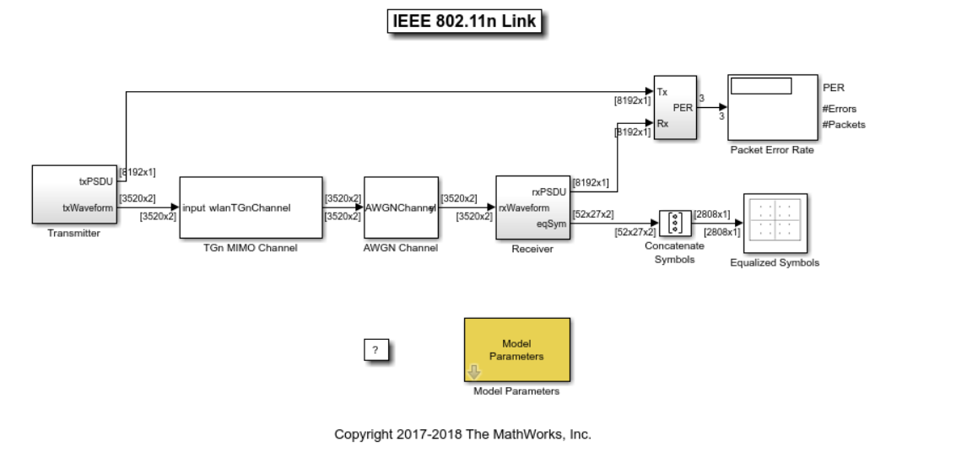
This model contains: Transmitter -> channel -> AWGN -> Reciever -> Analysis chain.
We can set up the system using classic MATLAB scripts or functions by directly calling WLAN Toolbox functions and perform a BER simulation with SNR sweeping.
Basically for the chain:
- Transmitter: wlanHTConfig, wlanWaveformGenerator
- TGn MIMO Channel: wlanTGnChannel
- AWGN Channel: awgn
- Receiver: wlanPacketDetect and synchronization, CFO(carrier frequence offset), timing + wlanHTLTF... channel estimate, wlanHTDataRecover
- Analysis: BER and for each packet is CRC(cyclic reduancy check) /PSDU (Physical Layer Service Data Unit) correct: PER (Packet Error Ratio)

MATLAB Code Explanations
For the start i used ONLY AWGN noise fort he meaningful BER graphic. Therefore i removed TGn affect.
I also only analyse BER graphic.
- mcsRange = 8:12;
MCS (Modulation and Coding Scheme) is the "speed/reliability standard" for data transmission over Wi-Fi. For choosing a MCS value, system determine modulation and coding rate. In 802.11n MCS is given by index numbers. And for 2 spatial stream (NSTS=2) 2x2 MIMO we use this interval: 8:12.
- cfgHT = wlanHTConfig;
HT (802.11n) config object
- cfgHT.ChannelBandwidth = 'CBW20';
could be 20 or 40 MHz for 802.11n. OFDM FFT size / subcarrier structure changes.
- cfgHT.NumTransmitAntennas = 2; % 2 Tx antennas
cfgHT.NumSpaceTimeStreams = 2; % 2 STS (spatial multiplexing)
For MIMO these should be 2.
- chanEst = zeros(ofdmInfo.NumTones, 2, 2);
chanEst(:,1,1) = 1;
chanEst(:,2,2) = 1;
fort he ideal channel estimaiton.
Output:
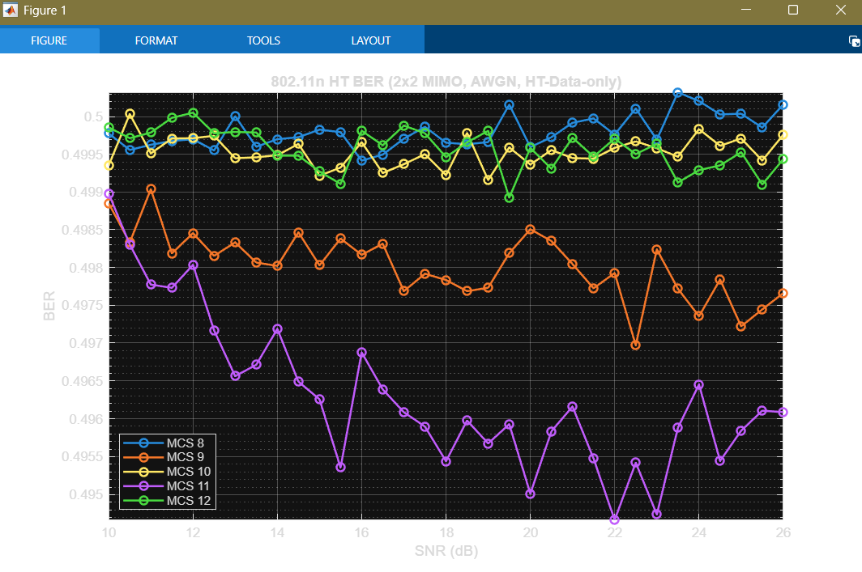
- Fort this result BER is around 0.5 which is not really correct because of:
chanEst(:,:,)=I (1 on the diagonal, 0 else)
But in 802.11n 2x2 with 2 streams, the transmitter uses spatial mapping, cyclic shifts, so the “effective channel” is not exactly identity. Therefore wlanHTDataRecover equalizes with a wrong channel, so it cannot decode well. BER stays near 0.5 and the BER–SNR curve looks zigzag instead of smoothly going down. So we should compute chanEst automatically from HT-LTF using wlanHTLTFChannelEstimate.
HT-LTF (High Throughput Long Training Field) is a known training part at the beginning of an 802.11n packet. The receiver uses it to estimate the channel (amplitude and phase) for each subcarrier, and in MIMO it also estimates how the streams mix. This channel estimate is then used for equalization to decode the data correctly.
We also have different training fields:
- L-STF: packet detection and coarse sync
- L-LTF: initial channel estimate / fine sync
- HT-STF: helps sync/AGC (Automatic Gain Control) in HT mode
- HT-LTF: main channel estimation for HT MIMO

After changing channel est. The code works better:

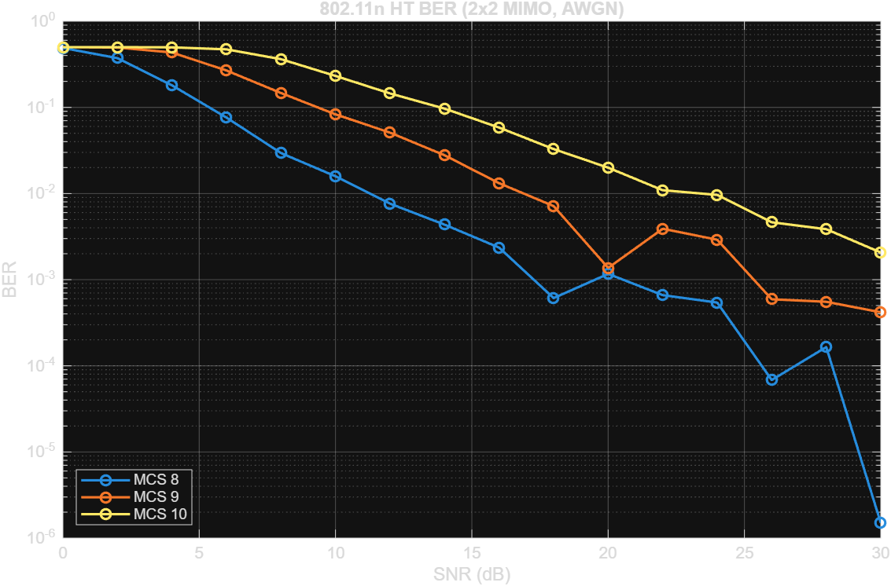
A smoother plot requires a finer SNR step and more packets/bits, but it takes longer to simulate.

