Video 1.2
The template below will help you structure your video using the PowerPoint slides and content flow given. Like storyboarding you can use this template as a reference doc to create your video. Please DO NOT FILL, it is for your reference only.
Planning your narration using this template
Introduction
Action on Screen (Code /imagery to support the narration) |  | Narration  (The corresponding explanation to the Action on Screen)
[Mandatory slide] Use this slide to introduce the video.   |  | Start by introducing the topic at hand. Mention what was done in the previous video or where we stopped at previously to keep up the continuous flow of the course. The goal of the video should be clear from the word go.
[Mandatory slide] -  Use this slide to add the main highlights that we will be covering in this video.  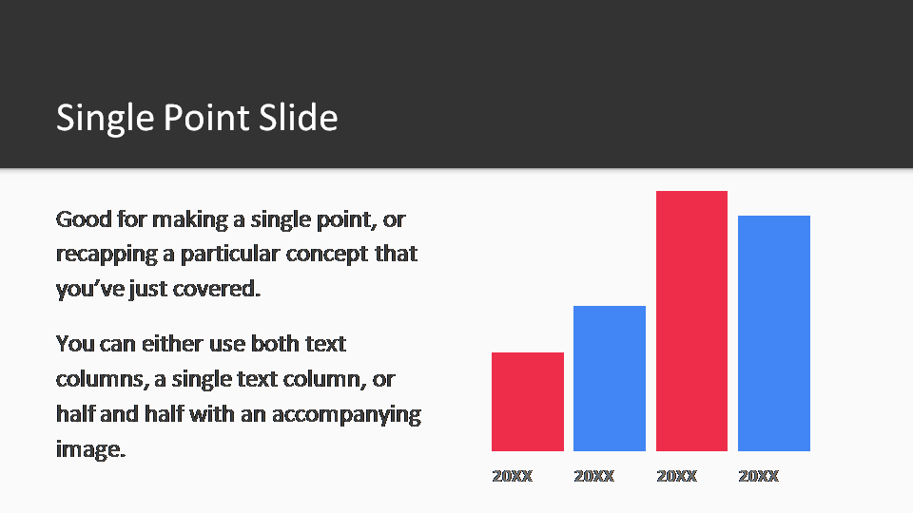 |  | Cover the topics/concepts that we will touch upon in this video.  Since you have already said the goal of the section, you now have to brief the viewers on what they will be learning in this video.
Steps or Tasks
Action on Screen  (Code / The action occurring on screen) | Narration  (The corresponding explanation to the Action on Screen)
This will mostly comprise of the coding screen that will go hand in hand with the narration.  If there is any static content or concept that needs explanation, you can use the different slides provided in the slide deck accompanying this template. | This part is the actual work area; the crux of the topic that you are to cover in this video.  The narration should basically be the elaboration of the steps you take to reach the aim/goal you have set for this video.  This is where you’d be coding and explaining concepts to your viewers. Plan the narration well and try to keep it interesting to capture the viewers attention at all times.
Summary
 | In conclusion, narrate what the viewer has accomplished so far and stress on the key learning.
[Mandatory slide] – Next Video   | Narrate what is waiting next for the viewers. This will help them anticipate a fresh learning experience on an interesting topic and keep them engaged to the course.

