<Homework1>

2014-17831 JaeWon Kim

Default MLE Graph

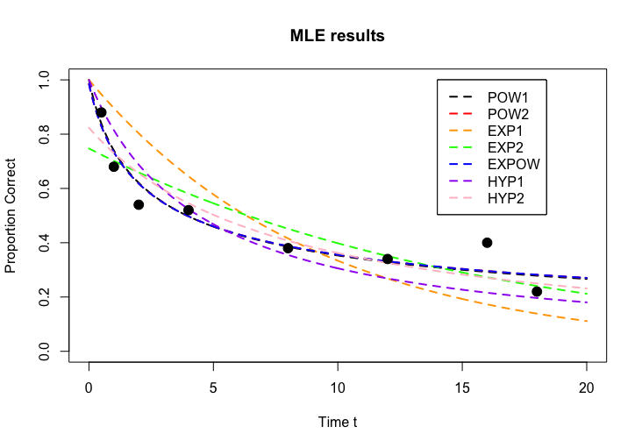

MLE Graph w/ modified code

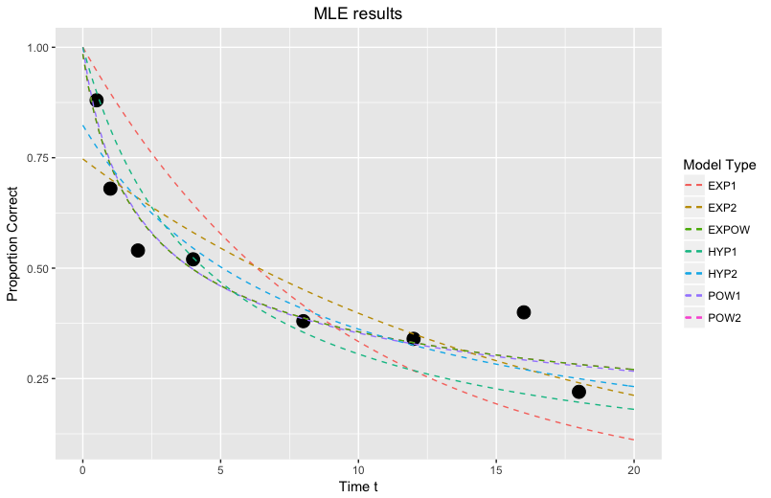

LSE Graph

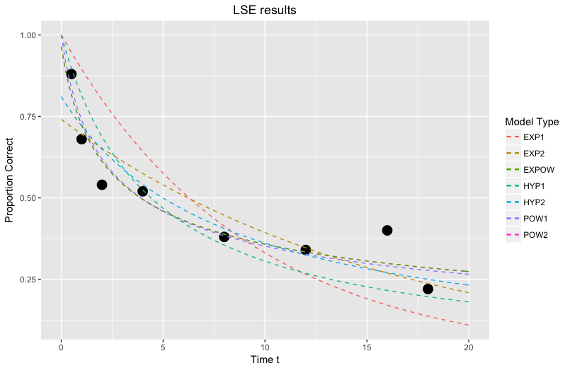

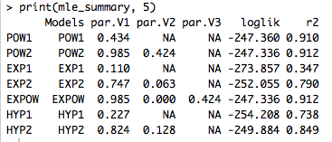

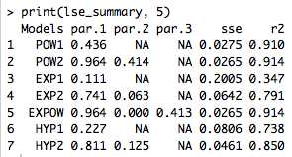

The two methods yield similar results. In fact, the parameters and r2 value of HYP1 model are (almost) the same. The worst model is perhaps the EXP1 model seeing from the very low r2 value. The best fitting model, according to the r2 value, is the EXPOW model. However, the r2 values of POW1 and POW2 models are very close and they have fewer parameters than the EXPOW model. Thus, it would be safe to conclude that the POW1 model with a single parameter is the best model amongst the seven different models that we have.