Can COVID-19 vaccines control disease transmission?

Introduction

More than half a billion population has been infected with COVID-19 worldwide, with more than six million deaths. It was postulated that once a significant proportion of the population becomes immune to the disease by vaccination, the transmission rate of the infection would fall below a critical level. This study aims to evaluate if this concept of ‘herd-immunity’ actually behaved as was expected by retrospectively analyzing the epidemic curve and vaccination data in Sri Lanka.

Methodology

The number of daily reported COVID-19 patients and the number of COVID-19 vaccines daily administered were extracted from the Epidemiology Unit of Sri Lanka. A validated stochastic process-based disease transmission model was calibrated to each wave of COVID-19 infection observed in Sri Lanka to estimate initial model parameters. The pattern of vaccine coverage was simulated inside the model, and the expected overall efficacy of the vaccine for transmission-blocking was estimated. Expected epidemic curves were computed under different vaccine coverage levels and transmission-blocking efficacies.

Results

The first COVID-19 patient in Sri Lanka was reported on 27 January 2020, and since then, more than six hundred thousand patients have been detected by June 2022.

The cumulative caseload on the log scale is depicted in figure 01, from which three distinct waves of transmission can be identified. The first phase of the COVID-19 vaccination began in February 2021, during the third wave of transmission.

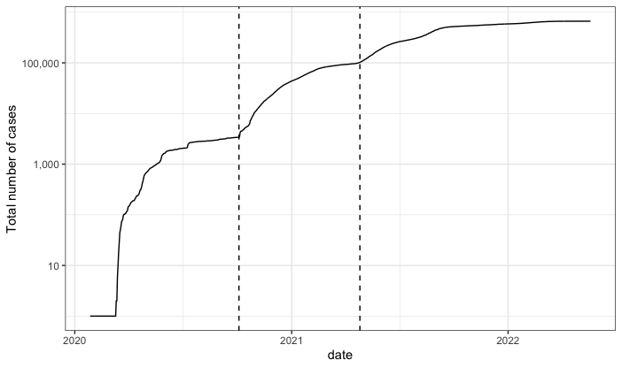Sri Lanka’s total caseload on the log scale

The end of the first wave was observed on 2020-10-04. The calibrated stochastic model simulation of the isolated first wave is shown in figure 02, along with the observed cumulative caseload.

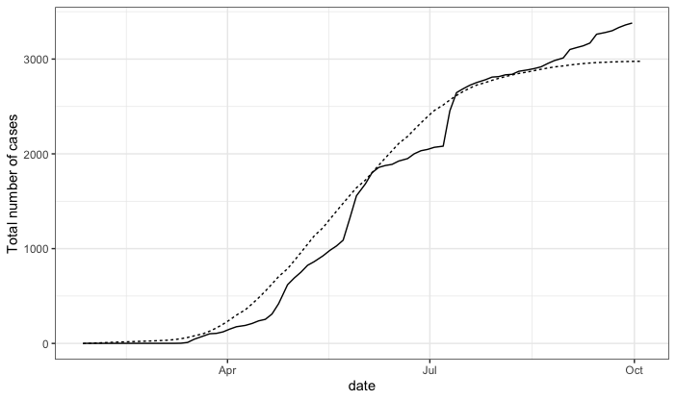

The observed cumulative caseload vs stochastic model predictions for the first wave

The pattern of vaccination is shown in figure 03.

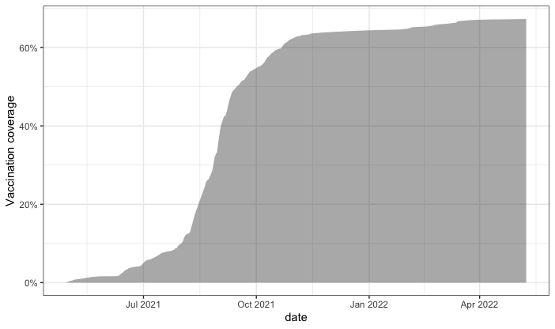

The observed caseload in the third wave after initiation of vaccination and the model estimations are plotted in figure 04.

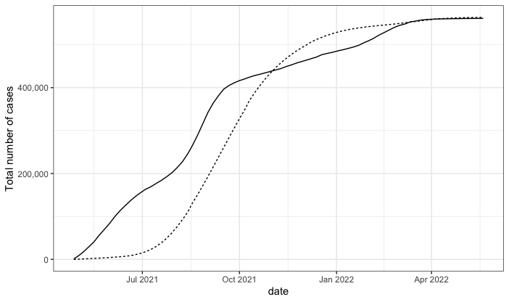

The model estimated vaccine efficacy for transmission-blocking was 42.06%.

The estimated cumulative caseload in different vaccine efficacies, if the pattern of vaccination coverage was the same, is shown in figure 05.

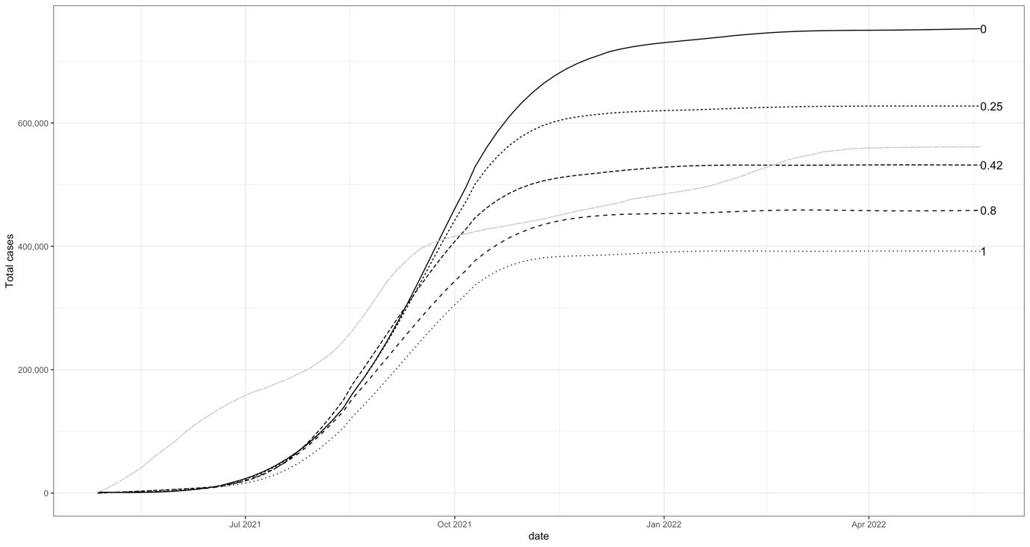

Estimated cumulative caseloads under different vaccine coverages when the transmission-blocking efficacy is held constant at the model estimate are shown in figure 06.

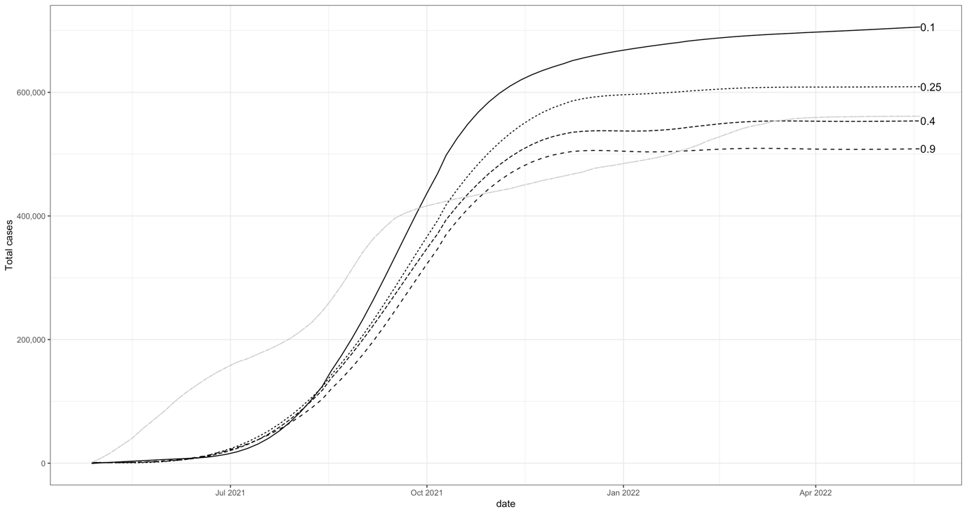

Discussions

The critical proportion of the population to be vaccinated (p) to curb the transmission can be calculated using the formula 01. R0 is the basic reproduction number.

$$p=1- \frac{1}{R0}$$

The variation of this critical proportion with R0 is shown in figure 07.

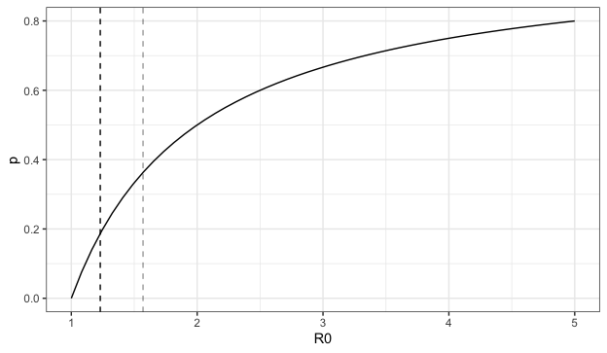

The estimated basic reproduction number (R0) for the COVID-19 in Sri Lanka was 1.23 with a 95% confidence interval of 0.94 to 1.57. Therefore, vaccinating only 18.6% (CI 0 – 36.3%) of the population should be sufficient to control the spread of the disease. But the expected level of transmission control was not achieved even with a much higher proportion of full vaccination. This can be attributed to two reasons; lower than expected efficacy of vaccines for blocking disease transmission and the inability to apply classic epidemiological model assumptions to the COVID-19 pandemic.

The type of vaccine administered depended on the phase of the vaccination program and the geographical area. Additionally, special groups identified were provided with specific types of vaccines. The vaccines deployed were Oxford–AstraZeneca, Pfizer–BioNTech, Sinopharm BIBP, Sputnik V and Moderna. The efficacies reported for each of these vaccines by randomized placebo-controlled studies are summarized in table 01.

|  |  |  |
| --- | --- | --- |
| **Institution** | **Vaccine candidate** | **Efficacy** |
| Pfizer–BioNTech | Comirnaty/  BNT162b2 | 95% |
| Sinopharm | BBIBP-CorV | 50.65-83.5% |
| Oxford–AstraZeneca | ADZ1222 | 70% |
| Gamelaya Research Institute | Sputnik V | 91.6% |
| Moderna | mRNA-1237 | 94.1% |

In contrast, the retrospectively estimated overall efficacy of the vaccines by the stochastic model was only 42.06%.

The concept of herd immunity threshold can be explained through compartment epidemiological models. They assume the population receives the vaccine before the onset of the epidemic and remains immune for life after vaccination. The vaccine is also assumed to be 100% effective in blocking the transmission. These assumptions are valid for a certain extent for diseases like measles, mumps and rubella, where vaccination is routinely carried out at an early stage in life which mount long standing immunity.