**ADXL362 and Thermistor VE/AFM**

**Accelerometer:**

Input variables

**Measurement Range**: allowed values are +2g, +4g, +8g

**Ambient g**: check that it is between min/max of range

**Output Data Rate**:12.5 Hz, 25 Hz, 50 Hz, 100 Hz (default), 200 Hz, 400 Hz

**Bandwidth**: Output Data Rate/2 or Output Data Rate/4 (this is default)

**Mode**: Normal Operation, Low Noise, Ultralow Noise – Ultralow noise is default

Interface: SPI

**Write Address**: 0x0A2C (to write to the 3 registers to configure the part)

Need to think about more and how to present in VE.

**Read Register** : 0x0B2C (to read the 3 registers to confirm settings)

Need to think about more and how to present in VE.

**Measurement Command**:0x0B0E (to read the data. This will be 3 x 1 byte for 8 bit conversions and 3 x 2 bytes for 12 bit conversions)

**Resolution** : 8 bits/12 bits

No needed: Translation: 1000 LSB/g for +/- 2g, 500 LSB/g for +/-4g, 250 LSB/g for +/-8g

Calculations

The accelerometer is a digital out sensor so it has a linear relationship. Only need to take the ambient ‘g’ value entered and display.

Timing: ADXL362 is always powered up so SensorSettlingTime = 0.0005, this value being equal to the FrontEnd or Module settling time of 0.0005.

**Thermistor :**

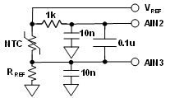

The thermistor uses VDD as its reference for the conversion. VDD also supplies the thermistor and 10K resistor (this is not a reference but a sense resistor now to sense the current through the thermistor). Note, the overall conversion will take 2 ADC conversions.

Conversion 1: Measure voltage across the thermistor

Converison 2: Measure voltage across 10K sense resistor to calculate the current through the thermistor. There is a 510 headroom resistor on the low side of the 10K.

Gain = 1

Reference = VDD

Panasonic 10K Thermistor:

**Tmin**: -40 degC

**Tmax**: 125 degC

**Tambient**: 25 degC

**Calculations**

1. From customer entered value, get equivalent thermistor resistance from hypermap.
2. Current through thermistor = VDD/(10K + thermistor resistance + 510).
3. Thermistor voltage Vntc = current through thermistor x thermistor resistance

Similar to the RTDs, voltage = RSS (thermistor voltage + 0.5 p-p noise + INL) for Accuracy plot with temperature swept from Tmin to Tmax.

For waveform plot, randomize the +0.5 p-p noise by +/-1.

Convert the voltage back to temperature using the equations below

RNTC = Vntc/current through thermistor. The temperature is then obtained from the formula

|  |  |
| --- | --- |
| $R=R_{0}.e^{-β.\left(\frac{1}{T_{0}}-\frac{1}{T}\right)}$**giving $T=\frac{1}{\frac{ln\left(\frac{R_{NTC}}{R_{0}}\right)}{β}+\frac{1}{T_{0}}}$** | **Where**  **R0 = 10 kΩ**  **T0 = 298.15 K**  **β = 3435 K** |

Error = Measured Temperature from above minus user entered temperature

44004/44031 Thermistor:

**Tmin**: -80 degC

**Tmax**: 150 degC

**Tambient**: 25 degC

The process is the same as above but the calculations to temp are different. Steinhart-Hart equations are used instead. Equation is

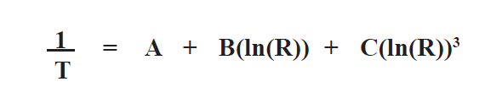

Where A, B and C can be obtained from the table below (for the 44006/44031).

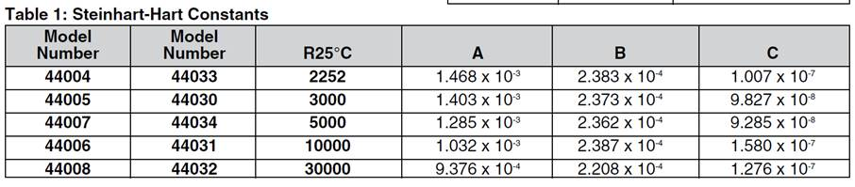

NOTE: variables that will be adjustable later are Beta, A, B, C. So, keep these generic.