<html>

<head>

<body>

<table border="1" cellpading="2" width="50%">

<caption>this is table</caption>

<tr>

<th>name</th>

<th>com</th>

<th>age</th>

</tr>

<tr>

<th>ssm</th>

<th>google</th>

<th>38</th>

</tr>

<tr>

<th>krishna</th>

<th>world</th>

<th>100</th>

</tr>

</table>

</body>

</head>

</html>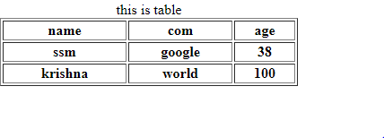

Div :-it Is the block level of element

<div>

|  |  |
| --- | --- |
| logo | Home about |
|  |  |
|  |  |

<div>

Logo

</div>

<div>

menu

</div>

</div>