Brain Ball – Programming and Electronics

Sofia Salguero Montaño   
*5th semester*  
sofia.salguero@ucb.edu.bo

Adrian San Martin Ugrinovic  
*5th semester*  
adrian.sanmartin@ucb.edu.bo

Eng. Francisco Javier Suarez Pedraza   
*Programación Superior [IMT-231]*  
*Mechatronics Engineering Department*

Erick Jhamil Rodriguez Hurtado   
*5th semester*  
erick.rodriguez@ucb.edu.bo

*Abstract*— This paper details the design, development, and implementation of "Brain Ball," an interactive mechatronic game controlled by a Brain-Computer Interface (BCI). The system translates the real-time cognitive state of two competing players into the physical movement of a ball along a linear track. Using commercial Electroencephalography (EEG) headsets, the system quantifies each player's level of focused attention. An ESP32 microcontroller serves as the central processing unit, receiving the attention data wirelessly, executing a comparative algorithm, and generating a PWM signal to control a DC motor-driven pulley system. The player demonstrating a higher level of sustained attention gains control, moving the ball toward their opponent's goal. The project integrates a comprehensive feedback system, including an I2C LCD scoreboard, audio-visual goal indicators using RGB LEDs and an MP3 module, and an automated ball-homing mechanism employing proximity sensors. This work successfully demonstrates a practical and engaging application of neurofeedback and BCI technology in a non-clinical, competitive environment.

Keywords— Brain-Computer Interface (BCI), Electroencephalography (EEG), ESP32, Mechatronics, PWM Control, Human-Computer Interaction.

# Introduction

The field of Brain-Computer Interfaces (BCIs) has rapidly evolved, extending its reach from clinical and assistive applications to novel domains such as entertainment, education, and personal wellness. At the core of many BCI applications is the principle of neurofeedback, a process in which users learn to self-regulate their brain activity by observing its real-time feedback. This project, titled "Brain Ball," aims to harness these principles to create a tangible and intuitive demonstration of mind-matter interaction.

Brain Ball is a two-player competitive game where the primary control input is not a joystick or button, but the players' own focused attention. By translating a user's mental state directly into a physical action—the movement of a ball—the system provides a powerful and immediate neurofeedback loop. The core challenge lies in seamlessly integrating neuro-sensing technology, real-time data processing, and precise electromechanical actuation into a single, cohesive system.

This paper presents the complete design and implementation of the Brain Ball project. It will detail the problem statement addressed, the specific engineering objectives pursued, and the practical framework that outlines the system's electronic architecture, component interfacing, and software design. The result is a fully realized mechatronic system that serves as both an engaging game and an educational tool for demonstrating the capabilities of modern BCI technology.

# Problem Definition

The fundamental challenge of this project is to engineer a closed-loop mechatronic system capable of translating an abstract cognitive state—focused attention—into controlled, bidirectional physical motion in a competitive game environment. This overarching problem is composed of several distinct engineering and integration challenges.

## Core Challenge: Neuro-Physical Transduction

The primary problem is to reliably acquire non-invasive neurological signals from two users simultaneously, interpret these signals to determine a dominant "attention" level, and use this differential to actuate a physical object. The system must be responsive enough to create a direct and intuitive connection between a player's mental effort and the resulting movement of the game ball.

## System Integration Requirements

To solve the core challenge, the system must address the following sub-problems:

* **Real-Time Data Acquisition**: Establishing a robust wireless communication link to receive continuous streams of processed EEG data from two separate BCI headsets without significant latency or data loss.
* **Differential Control Logic**: Developing a control algorithm that fairly compares the incoming attention data from both players and translates the difference into a directional and proportional speed command for a motor.
* **Electromechanical Actuation**: Designing and building a mechanical system, including a motor, drive train (pulleys and belt), and linear track, that can smoothly and accurately move the ball based on the electronic control signals.
* **Game State Management and Feedback**: Implementing a complete game logic system that can detect goals, manage scoring, reset the game state by returning the ball to a central position, and provide clear, multi-modal feedback (visual and auditory) to the players.

# Objectives

## General Objective

To design, construct, and program a fully functional, two-player "Brain Ball" game that uses non-invasive EEG signals to control the movement of a physical ball, thereby creating a practical and engaging demonstration of BCI and neurofeedback principles in an interactive, competitive context.

## Secondary Objectives

* To successfully interface two NeuroSky Brainwave headsets with an ESP32 microcontroller, using Bluetooth modules to acquire real-time "Attention" data from both players concurrently.
* To implement a control algorithm on the ESP32 that compares the attention levels of the two players and generates a variable-duty-cycle PWM signal to precisely control the speed and direction of a DC motor.
* To build a mechatronic system consisting of a DC motor, an L293D H-bridge driver, and a pulley-and-belt mechanism to translate the motor's rotation into the linear movement of the ball.
* To integrate a sensor array for autonomous game state management, utilizing limit switches for goal detection and two proximity sensors for accurately detecting the ball's central "home" position for game resets.
* To develop a comprehensive user feedback system featuring a 16x2 I2C LCD for displaying the score and game status, RGB LEDs for visual goal celebration, and a DFPlayer Mini MP3 module to provide auditory feedback, such as a "GOOOL!" announcement.
* To structure the ESP32 software using a multitasking paradigm (via FreeRTOS tasks) to ensure the responsive and concurrent handling of data acquisition, game logic, motor control, and user interface updates.

# Theorical Framework

This theoretical framework elucidates the fundamental principles and underlying scientific concepts that govern the Brainball project. This interactive system was conceived to demonstrate the practical application of neurofeedback for the volitional control of a physical mechanism within a competitive paradigm. The system architecture fundamentally integrates electroencephalographic (EEG) signal acquisition from a consumer-grade device, advanced signal processing for attentional state determination, and a real-time electromechanical actuation system, thereby embodying a tangible Brain-Computer Interface (BCI).

## Foundations of Brain-Computer Interfaces (BCI) and Neurofeedback

The domain of Brain-Computer Interfaces (BCIs) represents a critical research area focused on establishing direct communication channels between the human brain and external computational or robotic systems. The overarching aim of BCI development is to enable users to exert control over devices or applications through the modulation of their neural activity, bypassing conventional peripheral neuromuscular pathways.

Within the BCI landscape, neurofeedback stands as a pivotal technique. This methodology involves the real-time presentation of information pertaining to an individual's intrinsic brain activity, thereby facilitating a learning process wherein users can voluntarily modulate specific neural patterns. In the context of the Brainball system, neurofeedback principles were employed to continuously monitor and subsequently leverage participants' real-time attentional states as the primary source of control input.

## Electroencephalographic (EEG) Signal Acquisition and Cognitive State Assessment

Electroencephalography (EEG), a widely adopted non-invasive neurophysiological technique, was utilized for the capture of electrical potentials generated by the synchronized activity of cortical neuronal populations. These EEG signals, characterized by distinct oscillatory frequency bands, are known to correlate with various cognitive and arousal states.

For the Brainball project, the NeuroSky MindWave Mobile 2 (or similar "Brainwave Starter Kit" sensor) was employed as the EEG acquisition front-end. This consumer-grade, single-channel EEG device internally processes raw brainwave signals to extract specific cognitive metrics, including a quantized "Attention" value. The methodology for attentional state determination is thus predicated upon the proprietary algorithms embedded within these sensors, which typically analyze spectral power distributions (e.g., alpha and beta bands) to infer levels of focused attention and mental engagement. The processed "Attention" metric, ranging from 0 to 100, directly reflects the user's cognitive focus as interpreted by the sensor's internal chipset.

## Wireless Data Transmission and Centralized Processing Unit

The extracted attentional data from each participant's NeuroSky EEG acquisition unit was wirelessly transmitted to a central processing unit. Bluetooth wireless communication, a widely adopted standard for low-power, short-range data transfer, was employed to ensure reliable and low-latency data streaming from the headsets to the central system, a critical requirement for real-time BCI applications.

An ESP32 microcontroller-based system served as the core processing and decision-making unit. This central controller was engineered to receive and parse the incoming serial data streams, containing the "Attention" values, from both NeuroSky devices. Its primary function involved executing a comparative algorithm to determine which participant exhibited the highest instantaneous level of cognitive attention. The selection of the ESP32 was driven by its integrated dual hardware serial interfaces, robust processing capabilities, and direct interfacing capabilities for electromechanical actuators, enabling efficient real-time data handling and rapid algorithmic execution.

## Electromechanical Actuation and Competitive Control Logic

The system's output manifested as the controlled linear displacement of a physical object (the "ball"). This was achieved via an electromechanical actuation system, comprising a DC motor driven by a dedicated motor driver circuit. The motor's speed and direction were dynamically modulated by the central microcontroller, directly reflecting the comparative attentional states of the participants.

The competitive control logic was implemented as a direct mapping: the participant demonstrating superior attentional focus at any given moment gained executive control over the ball's movement, propelling it towards their opponent's goal. This real-time, attention-driven feedback loop fostered an intuitive and immersive competitive dynamic, where sustained mental concentration directly translated into tangible progress within the game. The objective was to achieve a pre-defined scoring condition, thereby concluding the game.

# System Design and Implementation

This section details the practical hardware and software engineering of the Brain Ball system. It covers the electromechanical architecture, the software design philosophy centered on multitasking, and the power management strategy that supports all system components.

## Hardware Architecture and Component Interfacing

The system's architecture is centralized around an ESP32-DEVKITC-V4 microcontroller, chosen for its dual-core processing power and extensive peripherals. All components are interconnected to achieve the required functionality, as detailed in the electronic schematic in Annex A.

**-Bio-signal Acquisition Units:** Two NeuroSky MindWave Mobile 2 headsets were utilized as the primary bio-signal acquisition devices.

**-Wireless Data Receivers:** Two HC-05 Bluetooth modules were employed to receive data wirelessly from the NeuroSky headsets.

**-Motor Control:** An L293D H-bridge motor driver was interfaced with a DC motor for linear ball displacement.

**-Game State Sensors:** Multiple limit switches and proximity sensors provided critical positional feedback.

**-User Interface & Feedback:** An I2C-interfaced 16x2 Liquid Crystal Display (LCD), an RGB LED, and a DFRobot DFPlayer Mini MP3 module constituted the user interface and audio-visual feedback mechanisms.

### EGG Data Acquisition and Wireless Communication Pathway

Each NeuroSky MindWave Mobile 2 headset autonomously processes raw EEG signals, outputting a pre-analyzed "Attention" value. This processed data is transmitted via the headset's integrated Bluetooth radio.

To receive these data streams, two HC-05 Bluetooth modules were hardwired to the ESP32 MCU. Each HC-05 module was configured to operate in receiver (slave) mode and was connected via a dedicated hardware serial peripheral. Specifically, the first HC-05's Transmit (TX) pin was connected to the ESP32's Receive (RX) pin (GPIO 9), and its Receive (RX) pin to the ESP32's Transmit (TX) pin (GPIO 10). Similarly, the second HC-05 was connected to the ESP32's GPIO 16 (RX) and GPIO 17 (TX). This configuration allowed the ESP32 to concurrently receive serial data packets from both headsets at a communication speed of 57600 baud.

### Microcontroller and Motor Control Interfacing

The ESP32 MCU centrally processed the received attention data and generated control signals for the electromechanical actuator.

The DC motor responsible for the ball's linear movement was directly interfaced with an L293D H-bridge motor driver. The L293D's enable pin (EN) was connected to the ESP32's GPIO 25, configured as a Pulse Width Modulation (PWM) output channel. This PWM signal, operating at 5000 Hz, controlled the effective voltage supplied to the motor, thereby regulating its speed. The direction control pins of the L293D (IN1, IN2) were connected to the ESP32's GPIO 26 and GPIO 27, respectively. By selectively asserting high or low voltage states on these two GPIOs, the H-bridge was commanded to reverse the motor's polarity, dictating the ball's direction of travel.

### Sensor Integration and Feedback System

Various sensors provided critical input to the ESP32:

-**Goal Detection:** Two limit switches were positioned at the extreme ends of the linear track, serving as goal sensors. These switches were wired as digital inputs to the ESP32's GPIO 18 and GPIO 19, providing an active-low signal upon activation.

**-Ball Home Position:** Two proximity sensors were strategically placed along the track to detect the ball's central or "home" position. These sensors were connected to the ESP32's GPIO 32 and GPIO 33, providing digital input signals to confirm the ball's reset state.

**-Game Start:** A physical Start button was connected as a digital input to GPIO 15.

The system's user interface and feedback mechanisms included:

-**Liquid Crystal Display (LCD):** A 16x2 character LCD, equipped with an I2C communication module, was connected to the ESP32's dedicated I2C bus pins (GPIO 21 for SDA, GPIO 22 for SCL). This allowed for efficient data transfer for displaying scores, game states, and messages.

-**RGB LED Indicator:** A common-cathode RGB LED strip was connected to the ESP32's GPIO 14 (Red), GPIO 2 (Green), and GPIO 4 (Blue). By controlling the voltage levels on these pins, various colors were produced to indicate different game states.

-**Audio Feedback:** A DFRobot DFPlayer Mini MP3 module was interfaced with the ESP32 via its dedicated hardware serial port (using GPIO 12 for TX and GPIO 13 for RX) operating at 9600 baud. This allowed the ESP32 to trigger playback of pre-loaded audio files, such as goal announcements.

### Power Management

The entire electronic subsystem was primarily powered by a 12V DC source. To supply the lower voltage requirements of the ESP32 MCU and other 5V logic components (e.g., HC-05 modules, LCD), a LM7805 linear voltage regulator was incorporated. This regulator efficiently stepped down the 12V input to a stable 5V output, ensuring proper operation and protection for sensitive low-voltage components. The L293D motor driver, capable of operating at higher voltages, directly utilized the 12V supply for motor actuation. The design ensured stable and efficient power delivery across all operational states.

## Software Architecture and Module Interaction

The software for the "Brain Ball" project is designed with a modular architecture, centered around a main control program (*pruebaproyectoprograsuperior.ino*) that runs on the ESP32 central processing unit. This main program orchestrates several specialized software modules, each responsible for a distinct aspect of the system's functionality.

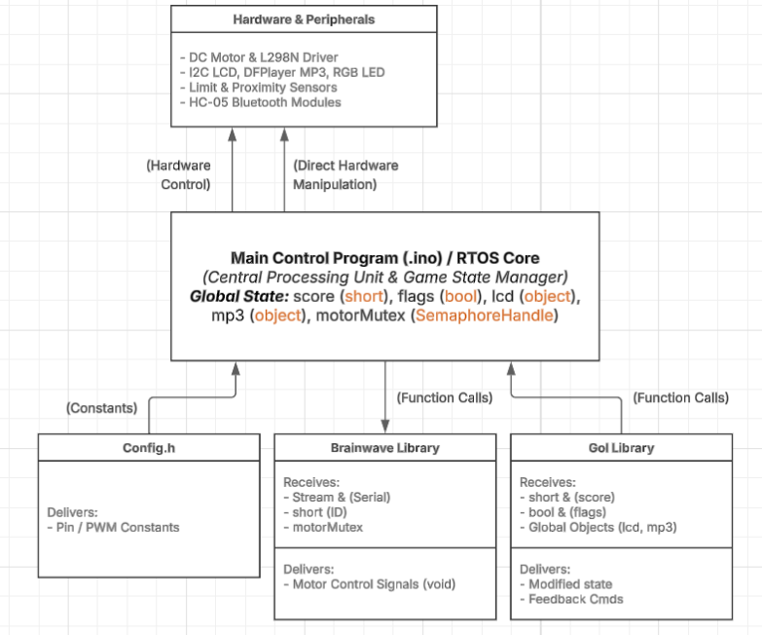

1. Interaction Block Diagram

The architecture leverages the FreeRTOS multitasking capabilities of the ESP32 to handle concurrent operations, ensuring responsive data acquisition and real-time control. The interaction between the main program and its subordinate libraries is detailed in figure 1.

### Config.h (Configuration Header)

This header file serves as a centralized repository for static hardware and system parameters. It does not contain executable logic.

* ***Purpose***: To define and manage all hardware pin assignments and system constants, improving code readability and maintainability.
* ***Receives from main***: Nothing.
* ***Delivers to main***:
  + *Hardware Pin Definitions (#define):* Provides GPIO pin numbers for all connected components, including the motor driver (GPIO 25, 26, 27) , goal sensors (GPIO 18, 19) , proximity sensors (GPIO 32, 33) , start button (GPIO 15) , RGB LED (GPIO 14, 2, 4) , and serial communication lines for the MP3 player and Bluetooth modules.
  + *System Constants (const int):* Defines parameters for the PWM signal, such as frequency (5000 Hz) and resolution , as well as communication baud rates.

**

1. Flux Diagram of ‘Config.h’

### Brainwave Library (Brainwave.h, Brainwave.cpp)

This module is the core of the BCI-to-motion interface. It is responsible for parsing data from the EEG headsets and directly actuating the motor.

* ***Purpose***: To interpret the "Attention" data stream from a NeuroSky headset and translate it into a corresponding PWM signal and directional control for the DC motor.
* ***Receives from main***: The generating_res function is called concurrently by two separate FreeRTOS tasks, one for each player.
  + *Stream &stream*: A reference to a HardwareSerial object, which provides the raw data stream received from the corresponding HC-05 Bluetooth module.
  + *short num*: An integer identifier (1 or 2) to specify which player's task is running, determining the direction of motor rotation.
  + *SemaphoreHandle_t motorMutex (External Global)*: This FreeRTOS mutex is used to ensure that only one task can control the motor driver pins at any given moment, preventing data corruption and hardware conflicts.
* ***Delivers (Outputs)***:
  + *Direct Hardware Control (void)*: The function does not return a value. Its output is the direct manipulation of GPIO pins to control the L293D H-bridge motor driver.

*ledcWrite():* Generates a variable-duty-cycle PWM signal on GPIO 25 to regulate the motor's speed based on the player's attention level.

*digitalWrite()*: Sets the state of GPIO 26 and GPIO 27 to control the motor's direction of rotation.

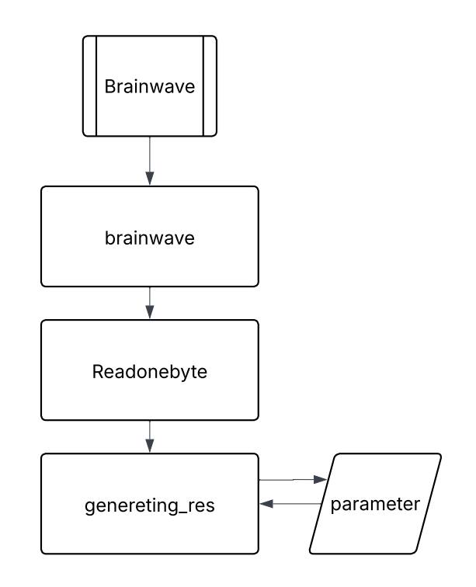

1. Flux Diagram of the ‘Brainwave’ Library

### Gol Library (Gol.h, Gol.cpp)

This module encapsulates the logic for game state transitions, specifically handling goal events and sensor debouncing.

* ***Purpose***: To manage the sequence of events when a goal is scored, including updating the score, providing user feedback, and resetting the game state.
* ***Receives from main***:
  + Pass-by-Reference Arguments (&): The functions in this library receive references to variables in the main program's scope, allowing them to directly modify the game's state. This includes:

*short &Contador*: The player's score counter.

*bool &Toco, bool &Gol*: Flags used for sensor debounce logic and signaling a goal event.

*unsigned long &TiempoDebounce*: Timestamp variable for debounce timing.

* + Global Objects and Variables (extern): The functions directly access global objects to trigger feedback.

*lcd*: The LiquidCrystal_I2C object to display the updated score on the LCD.

*mp3*: The DFRobotDFPlayerMini object to play pre-loaded goal announcements.

*start, Partido*: Global boolean flags to control the overall game flow.

* ***Delivers (Outputs):***
  + *Modified State Variables (void)*: Functions return void but alter the state of the main program by modifying the variables passed by reference.
  + *Peripheral Feedback Control*: The library commands the user feedback systems by calling methods on the global lcd and mp3 objects and by setting the state of the RGB LED pins to create visual goal indicators.

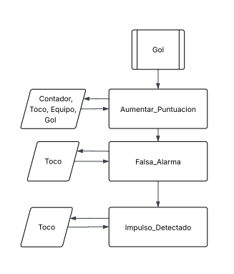

1. Flux Diagram of the ‘Gol’ Library

# Results

This section presents the experimental outcomes and performance validation of the developed two-player "Brain Ball" system. The primary objective was to demonstrate real-time control of a physical ball's movement using non-invasive electroencephalography (EEG) signals, specifically leveraging attention level data from two separate Brainwave headsets.

The system successfully achieved its core functionality: the physical ball's lateral movement was accurately controlled by the differential attention levels between the two participants. Initial testing confirmed the robust and consistent operation of all integrated components, including:

-**EEG Signal Acquisition:** Both Brainwave headsets reliably captured and transmitted individual attention level data.

-**Data Processing and Interpretation:** The system effectively processed the real-time EEG attention metrics to determine the directional control signal for the ball.

**- Physical Ball Actuation:** The mechanism responsible for moving the physical ball responded precisely and smoothly according to the calculated control signals.

During validation, the "Brain Ball" game demonstrated effective real-time interaction, with the ball consistently moving towards the player exhibiting a higher attention level. This confirmed that the designed system performed as intended, providing a clear and engaging demonstration of Brain-Computer Interface (BCI) principles and neurofeedback in a competitive, interactive environment.

# Recommendations

To further enhance the "Brain Ball" system's robustness, performance, and user experience, the following recommendations are proposed for future iterations:

**-Custom Printed Circuit Board (PCB) Implementation:** The current prototype's use of a breadboard for circuit connections introduced potential for signal noise and mechanical instability. Developing a custom PCB would significantly improve connection reliability, minimize wiring complexity, reduce electromagnetic interference, and create a more compact and durable final product.

-**Transistor Cooling System:** For sustained operation and enhanced longevity, particularly under continuous load, integrating a dedicated cooling system for the power transistors is highly recommended. This would prevent thermal degradation, ensuring consistent performance and increasing the lifespan of critical components.

-**Enhanced Audio Feedback:** To elevate the immersive and competitive nature of the game, incorporating dynamic crowd audio effects is suggested. Simulating a cheering audience, similar to a sporting event, would significantly enrich the user experience and heighten engagement.

-**Audio Output Power Improvement:** The current speaker's audio output power could be improved to better match the immersive experience. Upgrading the audio amplification stage or selecting a more powerful speaker would ensure that all sound effects, including the proposed crowd noise, are delivered with clarity and impact, even in varying environmental conditions.

# Conclusions

-A practical and engaging "Brain Ball" game was successfully designed, constructed, and programmed. It effectively uses non-invasive EEG signals to control a physical ball, demonstrating BCI and neurofeedback principles in an interactive, competitive context.

-The system successfully interfaced two NeuroSky Brainwave headsets with an ESP32 microcontroller via Bluetooth, enabling the concurrent acquisition of real-time "Attention" data from both players.

-A robust control algorithm was effectively implemented on the ESP32. This algorithm accurately compared player attention levels and generated a variable-duty-cycle PWM signal for precise DC motor speed and direction control.

-A reliable mechatronic system was successfully built. This system, comprising a DC motor, an L293D H-bridge driver, and a pulley-and-belt mechanism, accurately translated motor rotation into the linear movement of the ball.

-An effective sensor array was integrated for autonomous game state management. Limit switches provided accurate goal detection, and two proximity sensors reliably detected the ball's central "home" position for game resets.

-A comprehensive user feedback system was successfully developed. This system featured a 16x2 I2C LCD for score and status display, RGB LEDs for visual goal celebration, and a DFPlayer Mini MP3 module for distinct auditory feedback, including a "GOOOL!" announcement.

-The ESP32 software was effectively structured using a multitasking paradigm (FreeRTOS tasks). This ensured the responsive and concurrent handling of all critical operations: data acquisition, game logic, motor control, and user interface updates.

##### References

1. Adafruit Industries. (s.f.). *Speaker - 3" Diameter - 4 Ohm 3 Watt* [Página de producto]. Recuperado el 21 de noviembre de 2023, de [https://www.adafruit.com/product/1314](https://www.google.com/url?sa=E&q=https%3A%2F%2Fwww.adafruit.com%2Fproduct%2F1314)
2. DFRobot. (s.f.). *DFPlayer - A Mini MP3 Player SKU:DFR0299* [Página de producto y Wiki]. Recuperado el 21 de noviembre de 2023, de [https://wiki.dfrobot.com/DFPlayer_Mini_SKU_DFR0299](https://www.google.com/url?sa=E&q=https%3A%2F%2Fwiki.dfrobot.com%2FDFPlayer_Mini_SKU_DFR0299)
3. Espressif Systems. (2023, mayo). *ESP32-WROOM-32E & ESP32-WROOM-32UE Datasheet* [Hoja de datos]. Recuperado el 21 de noviembre de 2023, de [https://www.espressif.com/sites/default/files/documentation/esp32-wroom-32e_esp32-wroom-32ue_datasheet_en.pdf](https://www.google.com/url?sa=E&q=https%3A%2F%2Fwww.espressif.com%2Fsites%2Fdefault%2Ffiles%2Fdocumentation%2Fesp32-wroom-32e_esp32-wroom-32ue_datasheet_en.pdf)
4. Guangzhou HC Information Technology Co., Ltd. (2011). *HC-05/HC-06 Bluetooth Serial Port Module User Manual V2.0* [Manual de usuario]. Recuperado el 21 de noviembre de 2023, de [https://www.olimex.com/Products/Components/RF/BLUETOOTH-SERIAL-HC-06/resources/HC-Serial-Bluetooth-Products-201104.pdf](https://www.google.com/url?sa=E&q=https%3A%2F%2Fwww.olimex.com%2FProducts%2FComponents%2FRF%2FBLUETOOTH-SERIAL-HC-06%2Fresources%2FHC-Serial-Bluetooth-Products-201104.pdf)
5. Hitachi, Ltd. (2003). *HD44780U (LCD-II) Dot Matrix Liquid Crystal Display Controller/Driver* [Hoja de datos]. Recuperado el 21 de noviembre de 2023, de [https://www.sparkfun.com/datasheets/LCD/HD44780.pdf](https://www.google.com/url?sa=E&q=https%3A%2F%2Fwww.sparkfun.com%2Fdatasheets%2FLCD%2FHD44780.pdf)
6. Pololu. (s.f.). *250:1 Metal Gearmotor 25Dx54L mm LP 12V* [Página de producto]. Recuperado el 21 de noviembre de 2023, de [https://www.pololu.com/product/4753](https://www.google.com/url?sa=E&q=https%3A%2F%2Fwww.pololu.com%2Fproduct%2F4753)
7. SparkFun Electronics. (s.f.). *Proximity Sensor Breakout - 20cm, Sharp GP2Y0A41SK0F* [Página de producto]. Recuperado el 21 de noviembre de 2023, de [https://www.sparkfun.com/products/12728](https://www.google.com/url?sa=E&q=https%3A%2F%2Fwww.sparkfun.com%2Fproducts%2F12728)
8. Texas Instruments. (2020, octubre). *L293D Quadruple Half-H Drivers* [Hoja de datos]. Recuperado el 21 de noviembre de 2023, de [https://www.ti.com/lit/ds/symlink/l293d.pdf](https://www.google.com/url?sa=E&q=https%3A%2F%2Fwww.ti.com%2Flit%2Fds%2Fsymlink%2Fl293d.pdf)

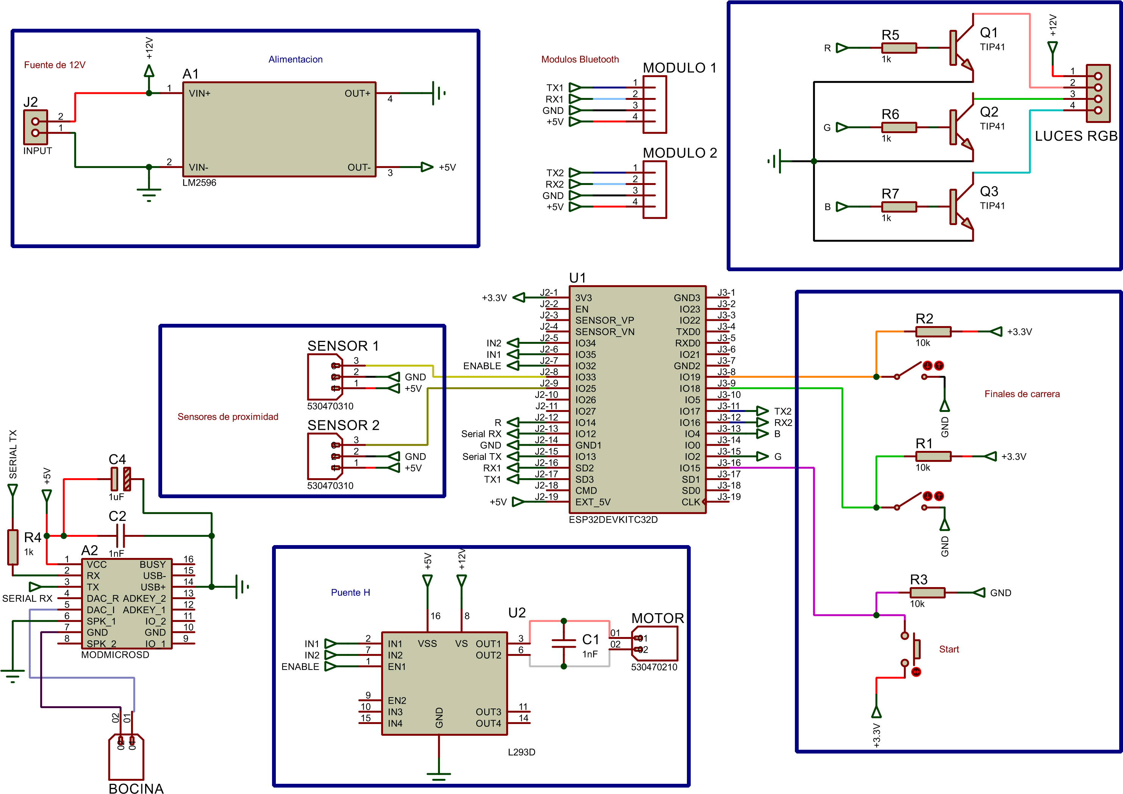Annex A – Electronic Schematic

Annex B – Component’s List

|  |  |  |
| --- | --- | --- |
| **Component** | **Quantity** | **Detail** |
| ESP32 | 1 unit | Main Components |
| NeuroSky MindWave Mobile 2 Headsets | 2 units |
| HC-05 Bluetooth Modules | 2 units |
| L293D H-Bridge Motor Driver | 1 unit |
| DC Motor | 1 unit |
| Proximity Sensors | 2 units | Sensors |
| Limit Switches | 2 units |
| Push Button | 1 unit |
| 16x2 I2C Liquid Crystal Display (LCD) | 1 unit | User Feedback Components |
| DFRobot DFPlayer Mini MP3 Module | 1 unit |
| Speaker | 1 unit |
| RGB LED or LED Strip | 1 unit |
| 12V DC 2A Power Source | 1 unit | Power System |
| LM7805 Linear Voltage Regulator | 1 unit |
| Capacitors | Multiple |
| Resistors | Multiple | Discrete Components |
| Transistors | 3 units |

Annex C – Flow diagram

