**Report on the Identity Verification**

**Sanjina Shrestha - 2417503**

**Person 1 : Pieter Mouthaan**

Provided description:

* + 1. Pieter Mouthaan
    2. Developer, entrepreneur
    3. From the Netherlands
    4. Master's in Business Administration and Entrepreneurship
    5. Self-employed
    6. Created Photo AI

**Introduction:** This report aims to verify the identity of Pieter Mouthaan, described as a Dutch developer, entrepreneur, and AI image creator with a Master’s in Business Administration and Entrepreneurship.

**Findings**

* A search across online platforms, including LinkedIn and AI-related websites, yielded no definitive matches.
* A professional named Peter Mouthaan from the Netherlands was found, who has been self-employed, but does not fully match the provided description.
* No evidence links Pieter Mouthaan to AI-generated images or self-employment in this field.
* The LinkedIn profile of Peter Mouthaan can be found here: [Peter Mouthaan LinkedIn](https://nl.linkedin.com/in/petermouthaan).

**Conclusion** Pieter Mouthaan’s" identity cannot be verified. The lack of credible online evidence suggests that this person may not exist or their details have been fabricated.

**Person 2: Michael Moore**

Provided Description:

* + 1. Michael Moore
    2. Owns a business
    3. Lives in Manhattan
    4. Widower for 7 years+
    5. Has a daughter that lives in Madrid, Spain with her husband that is a doctor
    6. Has twin granddaughters
    7. Has a German shepherd named Jack
    8. 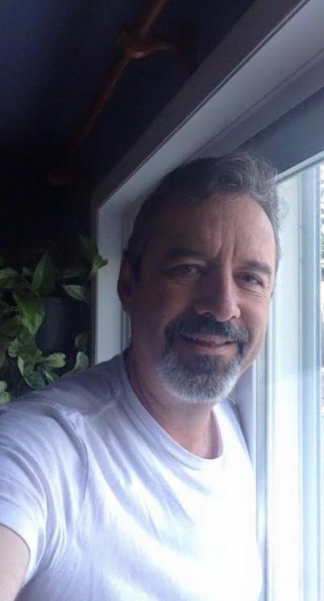
    9. 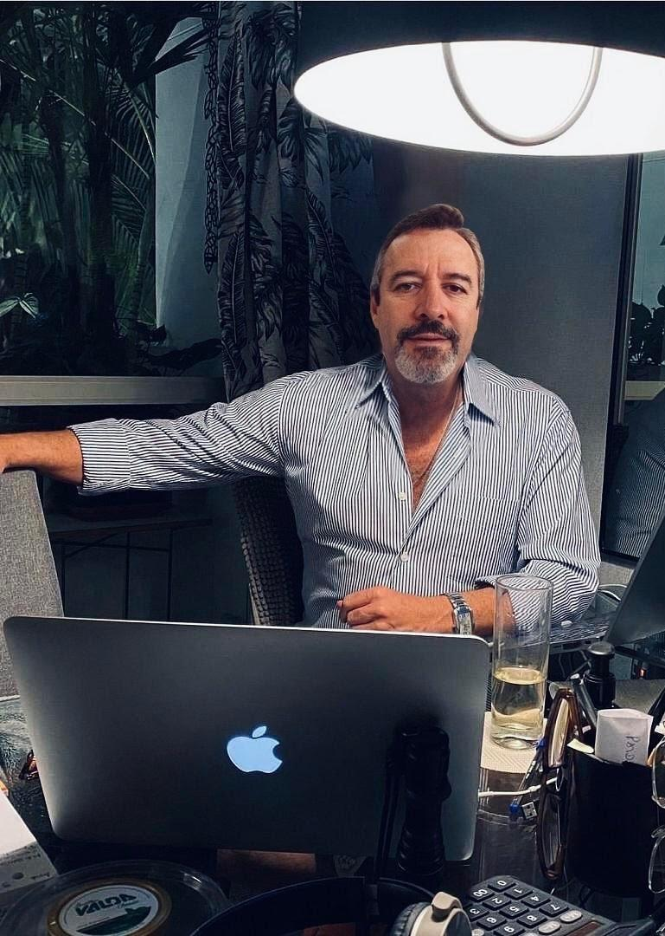

**Findings:**

* The most prominent Michael Moore is a filmmaker from Michigan, not a Manhattan-based businessman.  
   [en.wikipedia.org](https://en.wikipedia.org/wiki/Michael_Moore?utm_source=chatgpt.com)
* Several individuals named Michael Moore are associated with businesses in New York:
  + Michael Moore, Global Director of Events at Gagosian in New York.  
     [linkedin.com](https://www.linkedin.com/in/michael-moore-118ba83?utm_source=chatgpt.com)
  + Michael Moore, associated with Apollo Global Management, Inc. in New York.  
     [linkedin.com](https://www.linkedin.com/in/michael-moore-8541aba7?utm_source=chatgpt.com)
* No public records or social media profiles confirm the existence of a Michael Moore in Manhattan with the specific personal details and the pictures provided (widower status, daughter in Madrid, twin granddaughters, German shepherd named Jack).

**Conclusion:** Based on the available information, the identity of this specific Michael Moore cannot be verified. While multiple individuals named Michael Moore are associated with businesses in New York, none match the detailed personal description provided. So, there is a high chance that person 2 is a fake.

**Person 3: Kenneth Dean**

Provided Description:

* + 1. Kenneth Dean
    2. Lives in Washington D.C., USA
    3. VP at a real estate development and property management company
    4. 

### **Findings:**

### S.C. Herman & Associates, Inc. is a commercial real estate development and property management company based in Washington, D.C. [scherman.net](https://www.scherman.net/?utm_source=chatgpt.com)

### A LinkedIn profile for Kenneth Dean lists him as Vice President of Administration at S.C. Herman & Associates, Inc., with a focus on cybersecurity and project management. [LinkedIn Profile](https://www.linkedin.com/in/kenneth-dean-pmp/)

### This profile does not explicitly mention involvement in real estate development or property management.

### **Conclusion:** While S.C. Herman & Associates, Inc. is a legitimate real estate development and property management company, the LinkedIn profile for Kenneth Dean indicates a role focused on administration, cybersecurity, and project management. Without further information, it is difficult to fully verify the alignment between the claimed identity and the available details.

### **Final Assessment:**

**Based on online searches, no verifiable evidence confirms the existence of "Pieter Mouthaan" or "Michael Moore" as described. While "Kenneth Dean" is associated with a legitimate company, the specifics of his role differ from the provided description. The absence of public records, business affiliations, or social media profiles matching these specific identities raises concerns about their legitimacy.**

**Recommendation: With the advancement of AI, it is now easier than ever to create realistic fake identities, complete with professional-looking profiles and AI-generated images. This makes it increasingly difficult to differentiate between real and fabricated person. Always verify credentials through multiple reliable sources before trusting or engaging with unknown individuals online or in professional settings.**

**Also,** [**www.linkedin.com**](http://www.linkedin.com) **is a crazy thing. While I did know there was something called Linked In, I never really tried using it. Thanks to this assignment, it will be easier for me in the future to make a good and promising resume in case someone tries to find me like I tried to find these 3 individuals and also land good job opportunities.**

### 