Assignment

1. Installation with creation of file system using fdisk (manual) with at least one logical partition.

The fdisk command is a text-based utility for viewing and managing hard disk partitions on Linux

List Partitions

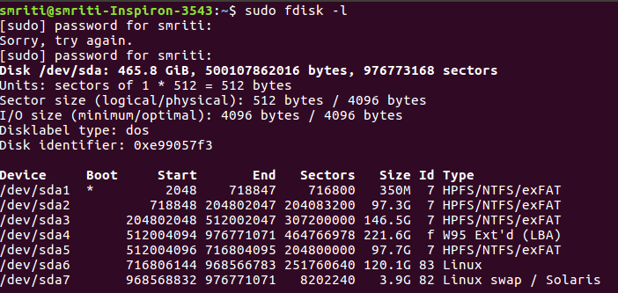
The sudo fdisk -l commands lists the partitions on system.

Entering Command Mode

To work on a disk’s partitions, enter into command mode using command sudo fdisk /dev/sda1
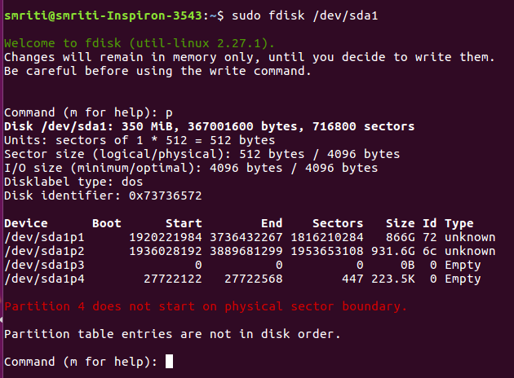

Using Command Mode

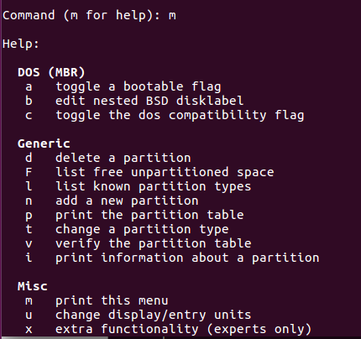

Viewing the Partition Table

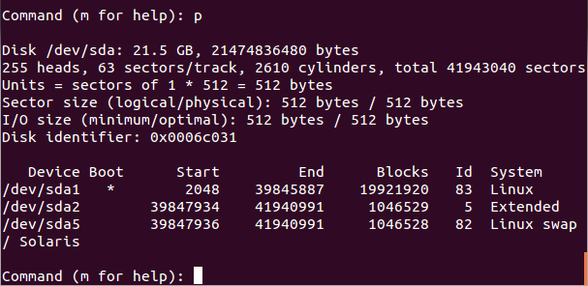

Deleting a Partition

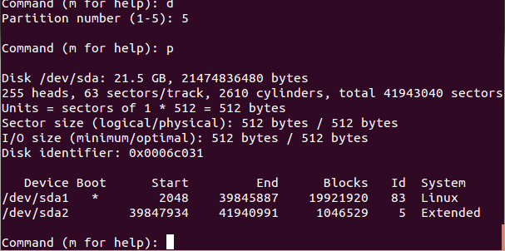

Creating a Partition

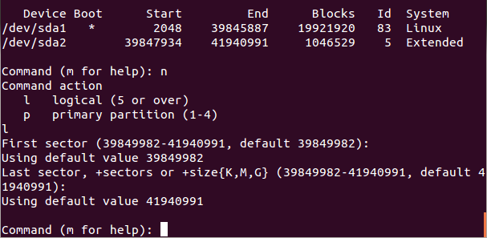
Use w to write the changes you’ve made to disk.
Use q if you want to quit without saving changes.

Formatting a Partition
Format the newly created partition using commend sudo mkfs.ext4 /dev/sda1

2. Root password change through boot loader options.

At the GRUB boot menu, select the boot entry and press e to edit the selected item.
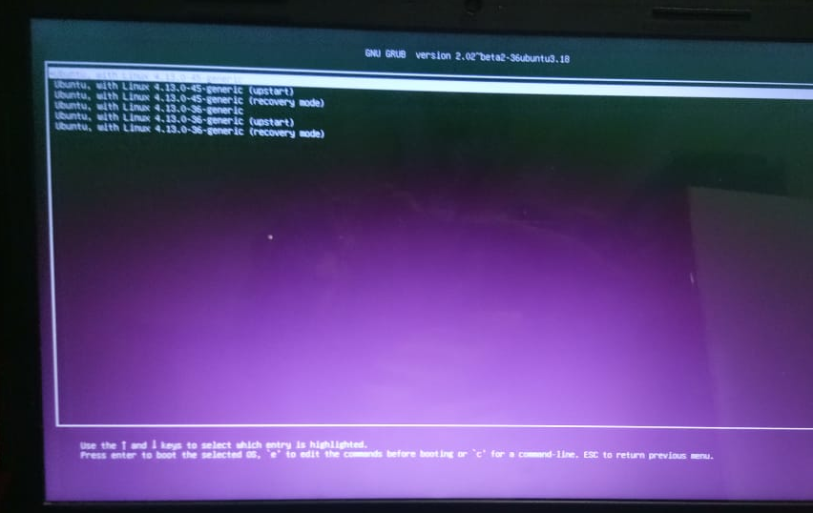

Find the line that starts with word linux. Add the following line at the end.
init=/bin/bash

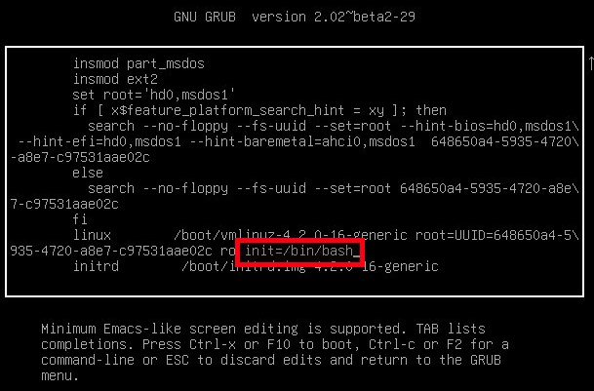
Then, press CTRL-X or F10 to boot in to single user mode.
Type the following command to mount root (/) file system in to read/write mode.
mount -o remount,rw /
Then, change the password of your administrative account using command:
passwd sk
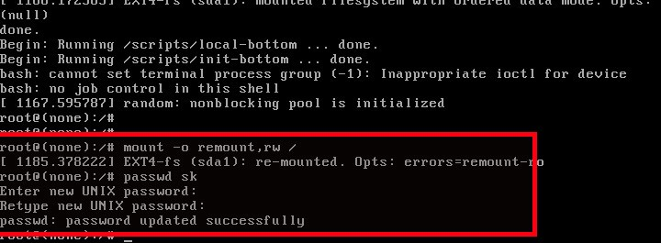
3. Directory creation in which all can write but only owner can delete files.
Create a directory using mkdir command
Assign it with the following mode and set its sticky bit
Chmod 1777 Directory_name
Create a file inside directory using touch command.It will have the property where all can write but only owner can delete the file

4. WAP to modify a file. Only owner can have permission to modify the file. Change the permission of your complied program in such a way so everyone can execute it and are able to modify your owned file.

Owner Script(src.sh file):
read file_name
read content
echo $content>$file_name

By other user:
Make a folder with its sticky bit set by setting its mode to 1777
Execute the code of src.sh
Try to create a file in the folder which can be only modified by the owner.

5.Apply quota in /home partition.

A disk quota is a limit set by a system administrator that restricts certain aspects of file system usage on modern operating systems. The function of setting quotas to disks is to allocate limited disk-space in a reasonable way.
Install quota-tools package.
Edit etc/fstab/ file
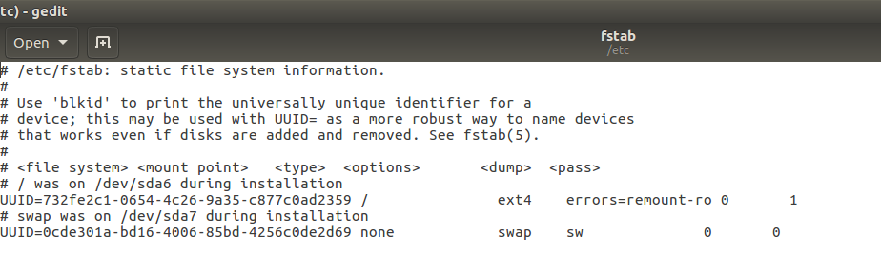
Edit file to enable the quota mount option(s) on selected file systems

/dev/sda6 ext4 defaults,usrquota,grpquota 0 2
Remount the partition to apply the change:
# mount -vo remount /dev/sda6
6.Modify/change password through script password is in file

echo "Enter name of user to modify the password"
read user_name
echo "Enter old password"
read old_pass
echo "Enter new password"
read new_pass
echo "confirm new password"
read confirm_pass
if [ new_pass -eq confirm_pass ]
then
passwd <<EOF
$user_name
$old_pass
$new_pass
EOF
echo "password changed"
else
echo "password do not match"
fi
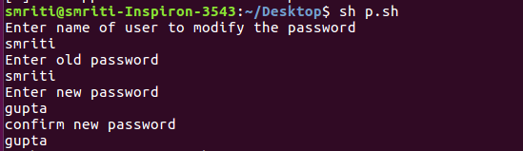

7. Configure DHCP for static IP assignment based on client MAC address.
Open the file using command sudo nano /etc/dhcp3/dhcpd.conf
add the following lines:

host Accountant {
hardware ethernet 00:1F:6A:21:71:3F;
fixed-address 10.0.0.101;
}
Save file and exit.
Now the DHCP server will always assign 10.0.0.101 to the 00:1F:6A:21:71:3F MAC address.
Restart DHCP
service dhcpd restart
Open the “/etc/network/interfaces” file.
sudo nano /etc/network/interfaces

Add/edit as described below:
auto eth0
iface eth0 inet static
address 192.168.1.20
Network 192.168.1.0
netmask 255.255.255.0
Broadcast 192.168.255.255
gateway 192.168.1.1
Save the file and exit. This will set its IP address to “192.168.1.20”. Reboot

8. Configure remote booting using pxeboot, DHCP and TFTP tool.
PXE (Preboot Execution Environment) Server allows the user to boot a Linux distribution from a network and install it on hundreds of PCs at a time without any Linux iso images.
1. First set up PXE server to use a static IP. To set up a static IP address in your system, you need to edit the “/etc/network/interfaces” file.

Open the “/etc/network/interfaces” and edit the file.
sudo nano /etc/network/interfaces
Save the file and exit. This will set its IP address to “192.168.1.20”. Restart the network service.

2. DHCP, TFTP and NFS are essential components for configuring a PXE server. Install these components.
sudo apt-get update
sudo apt-get install isc-dhcp-Server inetutils-inetd tftpd-hpa syslinux nfs-kernel-Server
3. Configure DHCP server

1. Edit the “/etc/default/dhcp3-server” file.
sudo nano /etc/default/dhcp3-server
Add/edit as described below:
INTERFACES="eth0"
Save and exit the file.

2. Edit the “/etc/dhcp3/dhcpd.conf” file:
sudo nano /etc/dhcp/dhcpd.conf
Add/edit as described below:
default-lease-time 600;
max-lease-time 7200;
subnet 192.168.1.0 netmask 255.255.255.0 {
range 192.168.1.21 192.168.1.240;
option subnet-mask 255.255.255.0;
option routers 192.168.1.20;
option broadcast-address 192.168.1.255;
filename "pxelinux.0";
next-Server 192.168.1.20;
}
Save the file and exit.
3.Start the DHCP service.
sudo /etc/init.d/isc-dhcp-server start
4.Configure TFTP server
The TFTP server is always listening for PXE clients on the network. When it detects any network PXE client asking for PXE services, then it provides a network package that contains the boot menu.
1. To configure TFTP, edit the “/etc/inetd.conf” file.
sudo nano /etc/inetd.conf
Save and exit the file.
2.Edit the “/etc/default/tftpd-hpa” file.
sudo nano /etc/default/tftpd-hpa
Save and exit the file.
3. Enable boot service for inetd to automatically start after every system reboot and start tftpd service.
sudo update-inetd --enable BOOT
sudo service tftpd-hpa start
4. Check status.
sudo netstat -lu
5. Configure PXE boot files
Now you need the PXE boot file “pxelinux.0” to be present in the TFTP root directory. Make a directory structure for TFTP, and copy all the bootloader files provided by syslinux from the “/usr/lib/syslinux/” to the “/var/lib/tftpboot/” path

Set up PXELINUX configuration file
The PXE configuration file defines the boot menu displayed to the PXE client when it boots up and contacts the TFTP server. By default, when a PXE client boots up, it will use its own MAC address to specify which configuration file to read, so we need to create that default file that contains the list of kernels which are available to boot.
Edit the PXE Server configuration file with valid installation options.
To edit “/var/lib/tftpboot/pxelinux.cfg/default,”
sudo nano /var/lib/tftpboot/pxelinux.cfg/default
Edit the “/var/lib/tftpboot/pxelinux.cfg/pxe.conf” file.
sudo nano /var/lib/tftpboot/pxelinux.cfg/pxe.conf

Add Ubuntu 14.04 Desktop Boot Images to PXE Server
For this, Ubuntu kernel and initrd files are required. To get those files, you need the Ubuntu 14.04 Desktop ISO Image. You can download the Ubuntu 14.04 ISO image in the /mnt folder by issuing the following command:
sudo cd /mnt
sudo wget http://releases.ubuntu.com/14.04/ubuntu-14.04.3-desktop-amd64.iso
Mount the ISO file, and copy all the files to the TFTP folder
6.Configure NFS Server to Export ISO Contents
To configure the NFS server, edit the “/etc/exports” file.
Run commands to reflect changes
sudo exportfs -a
sudo /etc/init.d/nfs-kernel-server start
7. Configure Network Boot PXE Client
A PXE client can be any computer system with a PXE network boot enable option. Now your clients can boot and install Ubuntu 14.04 Desktop by enabling “Boot From Network” options from their systems BIOS.

9. Write a cronjob to remote power up a system in a LAN.

The software utility cron is a time-based job scheduler in Unix-like computer operating systems. People who set up and maintain software environments use cron to schedule jobs to run periodically at fixed times, dates, or intervals.
Each user has their own "crontabs" which control what jobs are executed and when. The general format of a crontab is:
* * * * * command to be executed
- - - - -
| | | | |
| | | | +----- day of week (0 - 6) (Sunday=0)
| | | +------- month (1 - 12)
| | +--------- day of month (1 - 31)
| +----------- hour (0 - 23)
+------------- min (0 - 59)
So, for example, this will run ls every day at 14:04:
04 14 * * * ls

To set up a cronjob for remote shutdown:
- Create a new crontab by running sudo crontab -e.
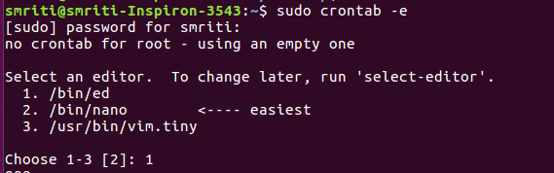

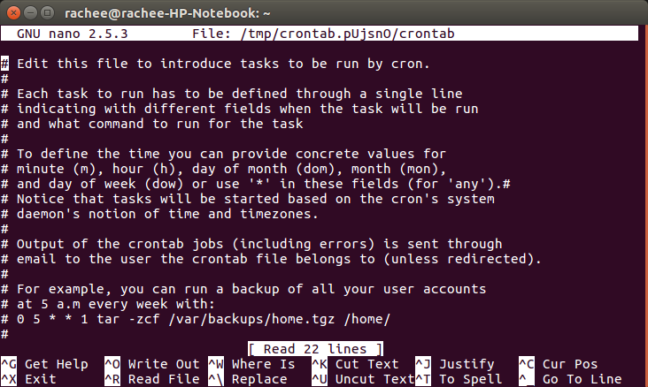

2. Add this line to the file that just opened.
3. 34 14 15 5 wakeonlan 23:34:e3:ac:12:a3
4. Save the file and exit the editor.

10. Wirte a cronjob to remotely shutdown a linux system.
All the steps are same as above

Step 3 is modified as
34 14 15 5 shutdown

11. Proxy DNS with split DNS and DNS cache.

What is Split DNS
Split DNS is simply a configuration in which the IP address to which a DNS name resolves is dependent on the location of the client. It is most often used in a NAT environment to insure that local clients resolve the DNS names of local servers to their RFC 1918 addresses while external clients resolve the same server names to their public counterparts.

Setting up Split DNS
Setting up Split DNS is extremely simple:
- Be sure that your firewall/router can resolve external DNS names.
- Install the dnsmasq package (http://www.thekelleys.org.uk/dnsmasq/doc.html) and arrange for it to start at boot time. Add your local hosts to /etc/hosts on the firewall/router using their local RFC 1918 addresses. Here's an example:
- # This file describes a number of hostname-to-address
# mappings for the TCP/IP subsystem.It is mostly
# used at boot time, when no name servers are running.
# On small systems, this file can be used instead of a
# "named" name server.
# Syntax:
# IP-Address Full-Qualified-HostnameShort-Hostname
#
127.0.0.1 localhost
172.20.0.1 openvpn.shorewall.net openvpn
172.20.0.2 vpn02.shorewall.net vpn02
2002:ce7c:92b4::1 gateway6.shorewall.net gateway6
2002:ce7c:92b4:1::2 mail6.shorewall.net mail6
2002:ce7c:92b4:1::2 lists6.shorewall.net lists6
2002:ce7c:92b4:2::2 server6.shorewall.net server6
- If your local hosts are configured using DHCP, that is a simple one-line change to the DHCP configuration
- local clients will resolve those names in the firewall/router's /etc/hosts file as defined in that file. All other names will be resolved using the firewall/router's Name Server as defined in /etc/resolv.conf.
Example:
From an Internet Host:
gateway:~ # host linksys.shorewall.net
linksys.shorewall.net has address 206.124.146.180
gateway:~ #
From Tipper (192.168.1.132):
teastep@tipper:~$ host linksys
linksys.shorewall.net has address 172.20.1.1
teastep@tipper:~$

Apache web server for virtual hosting for multiple domain names.
All of the configuration files for Apache are located in /etc/httpd/conf and /etc/httpd/conf.d. The data for the websites is located in /var/www by default. With multiple websites, you will need to provide multiple locations, one for each site you host.

12. Apache web server for virtual hosting for multiple domain names.

Name-based virtual hosting
With name-based virtual hosting, you can use a single IP address for multiple websites. Modern web servers, including Apache, use the hostname portion of the specified URL to determine which virtual web host responds to the page request. This requires only a little more configuration than for a single site.
Even if you are starting with only a single website, I recommend that you set it up as a virtual host, which will make it easier to add more sites later. In this article, I'll pick up where we left off in the previous article, so you'll need to set up the original website, a name-based virtual website.

Preparing the original website
add the following stanza to the bottom of /etc/httpd/conf/httpd.conf configuration file

<VirtualHost 127.0.0.1:80>
DocumentRoot /var/www/html
ServerName www.site1.org
</VirtualHost>
This will be the first virtual host stanza, and it should remain first, to make it the default definition. That means that HTTP access to the server by IP address, or by another name that resolves to this IP address but that does not have a specific named host configuration stanza, will be directed to this virtual host. All other virtual host configuration stanzas should follow this one.

Restart the HTTPD server to enable the changes to the httpd configuration. You can then look at the website using the Lynx text mode browser from the command line.
[root@testvm1 ~]# systemctl restart httpd
[root@testvm1 ~]# lynx www.site1.org

Configuring the second website
Create a new website directory structure with the following command:
[root@testvm1 html]# mkdir -p /var/www/html2
Notice that the second website is simply a second html directory in the same /var/www directory as the first site.

Create a new configuration stanza in httpd.conf for the second website and place it below the previous virtual host stanza (the two should look very similar). This stanza tells the web server where to find the HTML files for the second site.

<VirtualHost 127.0.0.1:80>
DocumentRoot /var/www/html2
ServerName www.site2.org
</VirtualHost>

Restart HTTPD again and use Lynx to view the results.
[root@testvm1 httpd]# systemctl restart httpd
[root@testvm1 httpd]# lynx www.site2.org

